Exploration of N-Queens Utilizing a Hybrid Genetic Algorithm (Wisdom of Crowds)
Ethan Scoggins, Keenrruy Murillo
Speed School of Engineering, The University of Louisville
Abstract—This paper presents a novel approach to solving the N-Queens completion puzzle, a classic NP-complete problem in combinatorial optimization. The proposed solution employs a hybrid genetic algorithm (GA) integrated with a wisdom of artificial crowds (WoAC) approach to efficiently find optimal or near-optimal solutions within a reasonable timeframe. The algorithm is implemented in Python and features a graphical user interface for user interaction. For the algorithm itself, it creates populations of possible solutions, iterates it through generations, evaluates the fitness of the individuals, and creates a new generation using mutation and crossover. For the WoAC approach, the highest fitness individuals are kept, used to reinitialize the population and the genetic algorithm is run as described previously, giving the populations a sort of guidance. The GUI allows users to define parameters such as the number of queens, WoAC loops, generations, population size, and mutation rate. Upon execution, the best solution's fitness is displayed, and the arrangement of queens is visualized on a chessboard, with options to zoom and switch between top-performing individuals.

Index Terms—Experimental Design, Genetic Algorithm, NP-Complete, N-Queens, Wisdom of Artificial Crowds

INTRODUCTION
This project is a culmination of previous work in the Artificial Intelligence course for problem solving. By leveraging previous experiences and applications in solving TSP, we are expected to research a different problem, and implement an algorithm that either solves it or finds the closest solution.
Previously, by using the genetic algorithm to cycle through a random assortment of individuals that represent possible solutions, ranking them by fitness, and building off the best individuals, we were able to advance to an optimal solution. Then when implementing the hybrid Wisdom of crowds approach and utilizing the different experts from different crowds, we were able to further push the solutions to use parts of these experts into both exploring other possibilities and maintaining a high fitness. With these concepts, we can create a new program to solve an NP-complete problem of our choice and visualize it within a GUI.
Regarding combinatorial optimization, the N-Queens completion puzzle represents a classic opportunity to solve an NP-complete problem. The challenge revolves around placing several chess queens N on a chessboard of size N x N in such a manner that no queen poses an immediate threat to another.
This problem sees exponential growth in computational complexity given the nature of the challenge wherein the chessboard grows in accordance with any increases to the number of queens. It is for this reason that traditional algorithms such as brute force search are not ideal for deciphering such a problem. As such, in this project, the primary goal is to develop an algorithm that can solve the N-Queens problem for an optimal or near-optimal solution within a reasonable time frame. To achieve this end, an innovative approach utilizing a hybrid genetic algorithm paired with wisdom of artificial crowds was developed and implemented via Python. This approach allows for the computational benefits of the genetic algorithm to be further expanded upon by utilizing collective intelligence to better discover the most optimal answer possible. Furthermore, for increased user experience, a graphical user interface was to be created through which parameters specific to the problem could be defined and the final arrangement of queens could be visually displayed.

Methods and approach

Overview
As an overview, the program is divided into two files. A main file and a utility file. The former houses the initialization parameters for the genetic algorithm (GA), the wisdom of artificial crowds’ (WoAC) functions, and the code for the GUI visualization. The latter houses the WoAC implementation, Genetic Algorithm implementation, corresponding functions for populations, crossovers, mutations, and variables to keep track of the experts.

Initialization
Within the main file, there exists a stopping criterion for the algorithm. Until either the user given parameters have been exhausted or a combination with fitness one has been found, continue to run the algorithm. This allows for an exhaustive time-consuming search or a quick brief one at the user’s choice. In our case, it allowed us to experiment which of these parameters would yield the best results within a reasonable execution time.
With this criterion in mind, the algorithm is told to run, and we initialize our variables. These variables include statistic tracking variables for overall highest performing individuals, generation specific high performers, and the population. The population is created using the provided N, as each individual is generated with the integers one to N. The values in these individuals are indicative of their positions; value indicating column position while index indicates row position. This does not make only readability simpler but saves the need to keep a separate variable for each queen’s position or chessboard state.

Fitness Function and Preserving Individuals
With initialization complete, the nested generations loop begins afterwards. We find the fitness scores of this population and place them into a list of fitness scores. The fitness’s are found individually for everyone with a separate function.
The function in question takes an individual list and the number of queens; By setting a counter equal to the number of queens, finding the row column values for a singular queen, then looping through all other queens, we can check if the current queen being checked is a validly positioned queen. If the row or column is found to be the same, then it is marked as invalid. To check diagonally, a statement checks if the absolute value of the difference in the two queens’ columns and rows are equal, and if they are, then the queens being checked share a diagonal square, which then marks the queen as invalid. When a queen is marked invalid, 1 is subtracted from the counter and the loop is broken, then checking for a new set of queens. This counter is divided by the total N queens passed, giving a fitness value between 0 and 1, where this ratio is the percentage of validly positioned queens in the chromosome/individual.
With the fitness scores found, we preserve the best individual from those fitness scores, and if this value for the current generation is better than our overall best individual, it is replaced with this newly found individual. Regardless of this, the best individuals and their fitness’s by generation are saved into a list for future reinitialization. Finally, the population is modified using a new generation function.

Creating New generations
The new generation function specified before creates a fitness list of the current population being passed and uses it to randomly pick two parents from the population. A separate function that picks one parent, although choosing randomly, will choose a parent with greater fitness more often than those with lower fitness, still giving every individual a chance to be picked.
From there, crossover and mutation functions are ran utilizing the selected parents and the child is appended to a new population variable. This new population is then returned and replaces the population within the generations loop. This being the last line within the nested generations loop, the loop continues until the criteria of fitness 1 is met or we have completed all generations.

The WoAC Loop and Reinitialization
With the generations nested loop complete, we continue running the outer WoAC loop. A statement within the loop, checking that if this is not the first WoAC loop, then reinitializes the population, using a separate population reinitialization function. This function takes the population size, n, and a list of the best paths found variable as parameters. A population variable is initialized using the initial population initialization function but now, by taking ten percent of the population size parameter, we randomly overwrite ten percent of the population with random high performing individuals preserved previously, then return this new modified population as Gen 0. This is to be utilized by the nested generations loop. Since we are maintaining a 90% level of randomness, we still are able to push the population in the correct direction for finding high fitness individuals while exploring other combinations. From here, once more, the outer WoAC loop and nested generations loop continue to run until one of our stopping criteria is met.

Graphical User Interface
Regarding the GUI, this is where the pre-defined parameters of N queens, WoAC loops, generations, population size, and mutation rate are defined by the user in entry boxes. This can be seen in figure 3 below, where we can click on run GA, and the processes mentioned earlier in this paper will be run. When the best combination is found, its fitness is displayed, and the combination is visualized on a chessboard. The user is allowed to zoom in, zoom out, and change between two of the best performing individuals if two were found.

Preparation for testing
After rigorous experimentation, it was decided that running the algorithm at 5 generations with 400 WoAC loops, resulting in 2000 total generations, produced the optimal output. Increasing the number of generations but reducing the number of WoAC loops produced a worse result as each new population was found to converge near the 5th generation mark; therefore, lowering the amount of WoAC loops to increase the number of generations would result in less wisdom from the crowd and less exploration as the increase in generations would mostly be wasted on data that has already converged. Conversely, decreasing the number of generations to too little, and increasing the amount of WoAC loops had a similar effect given that each new population would not have enough time to progress to a point of convergence.

Test Data, Figures, and Results
In this study, multiple executions of the algorithm were adopted to accurately measure efficiency and accuracy of the returned output. Greater focus was placed on the changes in output as the given N was made to increase and complicate the search for a valid combination.

Example Figures of GUI for various N
The following figures 1.1 through 1.6 are taken from the GUI once parameters are given and the algorithm is set to execute. What is output is the combination found with the highest fitness. It is visualized on an NxN chessboard with N-queens placed in the position dictated by the combination found. Additionally, a separate improvement curve is shown to display improvement in fitness with advancing generations. It should be noted that these figures are for the hybrid algorithm (with WoAC and GA implemented together).

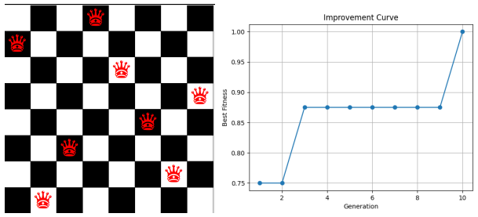
Fig. 1.1 Example GUI output for eight queens with respective fitness improvement curve
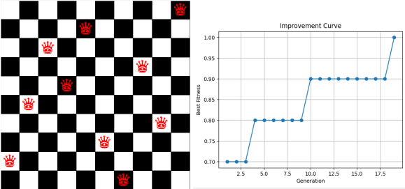
Fig. 1.2 Example GUI output for ten queens with respective fitness improvement curve

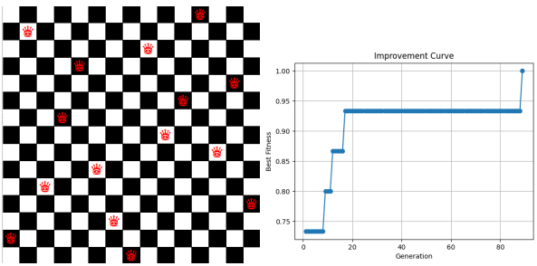
Fig. 1.3 Example GUI output for fifteen queens with respective fitness improvement curve

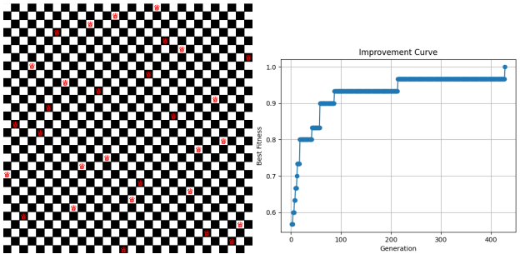
Fig. 1.4 Example GUI output for thirty queens with respective fitness improvement curve


Fig. 1.5 Example GUI output for one hundred queens GUI has been zoomed out.

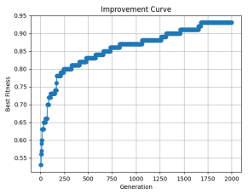
Fig. 1.6 Example improvement curve output for figure 1.5 (one hundred queens)

Data Collection Figures for Various N
As seen in figures 2.1 through 2.2 below, ten executions for each number of N were chosen for experimentation. Regarding experimental procedures, averages, and medians for fitness scores as well as execution times were calculated then compared across N sizes. N sizes chosen for experimentation were specifically, 15, 25, and 100 queens/rows/columns. With greater focus on the hybrid nature of the algorithm, the performances of the algorithm without WoAC were also included to measure improvement across different implementations and levels of parameter stress.

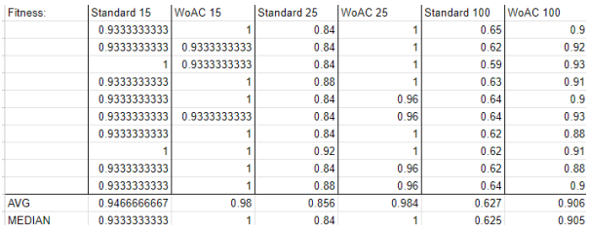
Fig 2.1 A compilation of fitness data for standard genetic algorithm (GA) implementation and hybrid WoAC GA implementation for multiple levels of N

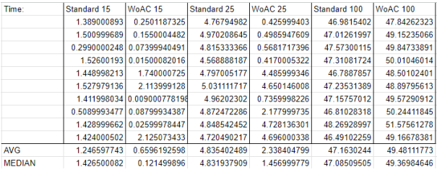
Fig 2.2 A compilation of execution time for standard genetic algorithm (GA) implementation and hybrid WoAC GA implementation for multiple levels of N

Initial Program Execution
Figure 3 below displays the initial interface presented to the user when the program is executed. The GUI is used to visualize the best-found combination of Queens on the chessboard as well as to visualize the improvement curve of fitness across generations. As can be observed, all parameters going into the algorithm can be chosen by the user, run when the user decides, and the respective path as well as fitness found are presented in text format alongside the visuals. Zooming functions have been added for the chessboard as well as the ability to expand the GUI to visualize multiple best-found combinations.

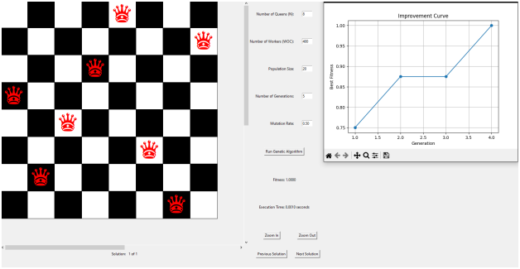
Fig. 3 The graphical interface present when first executing.

Results and Discussion of Findings
Test data was generated using a consistent input as seen in the figures and tables section. By differentiating input N’s, running the algorithm multiple times, finding the average and median of each of these groups, and changing between the standard GA code with the hybrid wisdom of crowds approach. This places every run under the same parameters every time, with only the implementation differentiating. Observing the averages and medians produced in figures 2.1, and 2.2, often, the hybrid approach performs better than standard GA. In figure 2.1, while average fitness improvement is marginal, when looking at median, hybrid tends to find a perfect solution far more often than the standard GA implementation; for 100 N’s, however, for both average and median we find major improvement in solution fitness. In figure 2.2, the hybrid approach, aside from 100 N’s, displays a fraction of standard GA’s execution time for both the average and medians; for 100 N’s however, this provides diminishing returns as there is a marginal increase in execution time for the hybrid approach relative to the standard, which could be explained by the algorithm actually finding a high performing solution as shown in figure 2.1, but taking a little longer to do so due to increased computational complexity. The reason for which the lower N’s produce a lower execution time for the Wisdom of Crowds implementation is that the algorithm ceases upon finding a perfect solution, and the hybrid implementation had a higher propensity of finding perfect solutions than the standard GA. As N increases then we see a tradeoff in execution time for accuracy where the benefits far outweigh the costs.

Conclusion
Tasked with the creation of a hybrid algorithm, what we had presented in this paper not only ran as intended but displayed a considerable improvement when comparing standard GA with the hybrid approach. On average, regardless of size n, fitness performs better with WoAC implemented. When comparing execution times, however, there's diminishing returns as n grows. The WoAC approach allows for gradual improvement and greater fitness collection.

Future Experimentation
Regarding future experimentation and optimization there were a few considerations. A future implementation could include new functionality that could exclude already explored combinations overtime that have been documented as performing poorly. This would ensure that they are not part of reinitialized populations and re-explored. The list of paths being inserted when the population is reinitialized could be condensed to a list of lists, as to only hold the final generation run before reinitialization as by then, the combinations have converged on a high fitness combination. The algorithm could also be expanded to visualize multiple solutions.

References
- A. Lambora, K. Gupta and K. Chopra, "Genetic Algorithm- A Literature Review," 2019 International Conference on Machine Learning, Big Data, Cloud and Parallel Computing (COMITCon), Faridabad, India, 2019, pp. 380-384, doi: 10.1109/COMITCon.2019.8862255.
- M. Srinivas and L. M. Patnaik, "Genetic algorithms: a survey," in Computer, vol. 27, no. 6, pp. 17-26, June 1994, doi: 10.1109/2.294849.
- Yampolskiy, Roman V., and Ahmed El-Barkouky. "Wisdom of artificial crowds algorithm for solving NP-hard problems." International Journal of Bio-inspired computation 3.6 (2011): 358-369.
- Ashby, Leif H., and Roman V. Yampolskiy. "Genetic algorithm and wisdom of artificial crowds algorithm applied to light up." 2011 16th International Conference on Computer Games (CGAMES). IEEE, 2011.
- Port, Aaron C., and Roman V. Yampolskiy. "Using a GA and Wisdom of Artificial Crowds to solve solitaire battleship puzzles." 2012 17th International Conference on Computer Games (CGAMES). IEEE, 2012.
- Hughes, Ryan, and Roman V. Yampolskiy. "Solving Sudoku Puzzles with Wisdom of Artificial Crowds." Int. J. Intell. Games Simul. 7.1 (2012): 24-29.
- De Jong, Kenneth A., and William M. Spears. "Using genetic algorithms to solve NP-complete problems." ICGA. 1989.
- “Difference between NP Hard and NP Complete Problem.” GeeksforGeeks, 8 May 2020, www.geeksforgeeks.org/difference-between-np-hard-and-np-complete-problem/.
- “Introduction to NP-Completeness.” GeeksforGeeks, 22 Aug. 2013, www.geeksforgeeks.org/introduction-to-np-completeness/.
- Wikipedia Contributors. “List of NP-Complete Problems.” Wikipedia, Wikimedia Foundation, 17 Dec. 2019, en.wikipedia.org/wiki/List_of_NP-complete_problems.

- ‌
- ‌
- ‌

.

