ЛАБОРАТОРНА РОБОТА № 11

« Використання CSS фреймворка Bootstrap»
Завдання 1. Зверстати головну сторінку сайту туристичної агенції з використанням фреймворку Bootstrap:
Лiстинг index.html:
<!DOCTYPE html>
<html lang="en">
<head>
<meta charset="UTF-8">
<title>Bootstrap 4</title>
<link rel="stylesheet" href="css/bootstrap.css">
<link rel="stylesheet" href="css/style.css">
<link href="https://fonts.googleapis.com/css?family=Lobster+Two:400i|Raleway&display=swap" rel="stylesheet">
</head>
<body>
<header class="header flex">
<!--navigation-->
<div class="navigation">
<nav class="navbar navbar-expand-lg navbar-dark bg-dark">
<div class="collapse navbar-collapse" id="navbarNav">
<ul class="navbar-nav">
<li class="nav-item">
<a class="nav-link" href="#">ABOUT</a>
</li>
<li class="nav-item">
<a class="nav-link" href="#">HOT TOURS</a>
</li>
<li class="nav-item">
<a class="nav-link" href="#">SPECIAL OFFERS</a>
</li>
<li class="nav-item">
<a class="nav-link" href="#">BLOG</a>
</li>
<li class="nav-item">
<a class="nav-link" href="#">CONTACTS</a>
</li>
</ul>
</div>
</nav>
</div>

<!--logo-->
<h1 class="logo">YOUR TRIP</h1>

<!--carousel-->
<div id="carouselExampleControls" class="carousel slide" data-ride="carousel">
<div class="carousel-inner">
<div class="carousel-item">
<img src="img/rome.jpg" class="d-block w-100" alt="...">
<div class="carousel-caption flex">
<h1 class="city">ROME</h1>
<h3>FROM</h3>
<h1>$900</h1>
<button type="button" class="btn btn-primary btn-lg">LEARN MORE</button>
</div>
</div>
<div class="carousel-item active">
<img src="img/london.jpg" class="d-block w-100" alt="...">
<div class="carousel-caption flex">
<h1 class="city">LONDON</h1>
<h3>FROM</h3>
<h1>$1000</h1>
<button type="button" class="btn btn-primary btn-lg">LEARN MORE</button>
</div>
</div>
<div class="carousel-item">
<img src="img/new-york.jpg" class="d-block w-100" alt="...">
<div class="carousel-caption flex">
<h1 class="city">NEW-YORK</h1>
<h3>FROM</h3>
<h1>$1200</h1>
<button type="button" class="btn btn-primary btn-lg">LEARN MORE</button>
</div>
</div>
</div>
<a class="carousel-control-prev" href="#carouselExampleControls" role="button" data-slide="prev">
<span class="carousel-control-prev-icon" aria-hidden="true"></span>
<span class="sr-only">Previous</span>
</a>
<a class="carousel-control-next" href="#carouselExampleControls" role="button" data-slide="next">
<span class="carousel-control-next-icon" aria-hidden="true"></span>
<span class="sr-only">Next</span>
</a>
</div>
</header>

<main class="main">
<!--cards-->
<div class="cards flex">
<div class="card-group">
<div class="card">
<img src="img/barcelona.jpg" class="card-img-top" alt="...">
<div class="card-body">
<div class="card-info flex">
<h1 class="small-city">BARCELONA</h1>
<h4>FROM</h4>
<h1>$1000</h1>
<button type="button" class="btn btn-card btn-primary btn-lg">LEARN MORE</button>
</div>
</div>
</div>
<div class="card">
<img src="img/goa.jpg" class="card-img-top" alt="...">
<div class="card-body">
<div class="card-info flex">
<h1 class="small-city">GOA</h1>
<h4>FROM</h4>
<h1>$1500</h1>
<button type="button" class="btn btn-card btn-primary btn-lg">LEARN MORE</button>
</div>
</div>
</div>
<div class="card flex">
<img src="img/paris.jpg" class="card-img-top" alt="...">
<div class="card-body">
<div class="card-info flex">
<h1 class="small-city">PARIS</h1>
<h4>FROM</h4>
<h1>$1600</h1>
<button type="button" class="btn btn-card btn-primary btn-lg">LEARN MORE</button>
</div>
</div>
</div>
</div>
</div>

<!--form-->
<div class="main-content">
<div class="form">
<h1 class="h1-form">BOOKING FORM</h1>
<form>
<div class="form-row">
<div class="form-group col-md-6">
<input type="text" class="form-control" id="inputName" placeholder="Name:">
</div>
<div class="form-group col-md-6">
<input type="email" class="form-control" id="inputEmail" placeholder="Email:">
</div>
</div>
<div class="form-row">
<div class="form-group col-md-6">
<input type="text" class="form-control" id="inputCountry" placeholder="Country:">
</div>
<div class="form-group col-md-6">
<input type="text" class="form-control" id="inputHotel" placeholder="Hotel:">
</div>
</div>
<div class="form-row">
<div class="form-group col-md-2">
<label for="inputCheck-in">Check-in</label>
</div>
<div class="form-group col-md-10">
<input type="date" class="form-control" id="inputCheck-in" placeholder="Country:">
</div>
</div>
<div class="form-row">
<div class="form-group col-md-2">
<label for="inputCheck-out">Check-out</label>
</div>
<div class="form-group col-md-10">
<input type="date" class="form-control" id="inputCheck-out" placeholder="Country:">
</div>
</div>
<div class="form-row">
<div class="form-group col-md-12">
<label for="inputCheck-out">Comfort</label>
</div>
</div>
<div class="form-row">
<div class="form-group col-md-12">
<input type="radio" aria-label="Cheap" name="comfort" checked>
<label for="" class="rd-label">Cheap</label>
<input type="radio" aria-label="Standart" name="comfort">
<label for="" class="rd-label">Standart</label>
<input type="radio" aria-label="Lux" name="comfort">
<label for="" class="rd-label">Lux</label>
</div>
</div>
<div class="form-row">
<div class="form-group col-md-2">
<label for="exampleFormControlSelect1">Adults</label>
</div>
<div class="form-group col-md-4">
<select class="form-control" id="exampleFormControlSelect1">
<option>1</option>
<option>2</option>
<option>3</option>
<option>4</option>
<option>5</option>
</select>
</div>
<div class="form-group col-md-2">
<label for="exampleFormControlSelect1">Children</label>
</div>
<div class="form-group col-md-4">
<select class="form-control" id="exampleFormControlSelect2">
<option>1</option>
<option>2</option>
<option>3</option>
<option>4</option>
<option>5</option>
</select>
</div>
</div>
<div class="form-row">
<div class="form-group col-md-2">
<label for="exampleFormControlSelect1">Rooms</label>
</div>
<div class="form-group col-md-4">
<select class="form-control" id="exampleFormControlSelect3">
<option>1</option>
<option>2</option>
<option>3</option>
<option>4</option>
<option>5</option>
</select>
</div>
</div>
<div class="form-group">
<textarea class="form-control" id="exampleFormControlTextarea1" rows="6" placeholder="Massage:"></textarea>
</div>
<button type="submit" class="btn btn-form">Submit</button>
</form>
</div>
<div class="welcome">
<div class="information">
<h1 class="h1-form">WELCOME</h1>
<p>Lorem ipsum dolor sit amet, consectetur adipiscing elit. Morbi ut lobortis velit, a sodales arcu.</p>
<p>Vivamus tortor orci, tempus placerat semper nec, aliquam pulvinar ex. </p>
<p>Fusce et malesuada eros, in molestie mi. Nullam et arcu eget nisi dapibus tristique eu nec metus.</p>
<p>Maecenas in euismod dui. Ut tincidunt purus eu ante placerat, eu aliquam tellus luctus. Integer
molestie, enim non convallis convallis, dui magna dictum libero, at elementum lectus metus in eros.</p>
<p>Morbi sit amet efficitur diam. Vestibulum eu pretium dui, id porta magna. </p>
</div>
<div class="clients">
<h1 class="h1-form">CLIENTS' QUOTES</h1>
<p>Lorem ipsum dolor sit amet, consectetur adipiscing elit. Morbi ut lobortis velit, a sodales arcu.
Vivamus tortor orci, tempus placerat semper nec, aliquam pulvinar ex.
Fusce et malesuada eros, in molestie mi. Nullam et arcu eget nisi dapibus tristique eu nec metus.</p>
<button type="submit" class="btn btn-form">More</button>
</div>
</div>
</div>
</main>

<!--footer-->
<footer class="footer flex">
<p>YOUR TRIP (C) 2014 | PRIVACY POLICY | WEBSITE TEMPLATE DESIGNED BY TEMPLATEMONSTER.COM</p>
</footer>
<!--JS-->
<script src="https://code.jquery.com/jquery-3.3.1.slim.min.js" integrity="sha384-q8i/X+965DzO0rT7abK41JStQIAqVgRVzpbzo5smXKp4YfRvH+8abtTE1Pi6jizo" crossorigin="anonymous"></script>
<script src="https://cdnjs.cloudflare.com/ajax/libs/popper.js/1.14.7/umd/popper.min.js" integrity="sha384-UO2eT0CpHqdSJQ6hJty5KVphtPhzWj9WO1clHTMGa3JDZwrnQq4sF86dIHNDz0W1" crossorigin="anonymous"></script>
<script src="https://stackpath.bootstrapcdn.com/bootstrap/4.3.1/js/bootstrap.min.js" integrity="sha384-JjSmVgyd0p3pXB1rRibZUAYoIIy6OrQ6VrjIEaFf/nJGzIxFDsf4x0xIM+B07jRM" crossorigin="anonymous"></script>

</body>
</html>

Лiстинг style.css:
body{
font-family: 'Raleway', sans-serif;
}

.flex{
display: flex;
}

/*header decoration*/

.header{
justify-content: center;
}

.navigation{
width: 835px;
position: absolute;
font-size: 16.5px;
z-index: 1;
}

.carousel-caption, .card-info{
height: 400px;
flex-direction: column;
flex-wrap: wrap;
justify-content: center;
align-items: center;
}

.logo{
position: absolute;
margin-top: 180px;
z-index: 1;
font-family: 'Lobster Two', cursive;
font-size: 40px;
color: white;
}

.carousel-item:before, .card-body:before{
content: '';
position: absolute;
top: 0; left: 0; right: 0; bottom: 0;
background-color: #333;
opacity: 0.5;
}

.city{
font-size: 70px;
color: #f9c221;
}

.small-city{
font-size: 50px;
}

.btn{
margin: 70px auto 10px;
background-color: #e73a2e;
border-radius: 20px;
box-shadow: 0px 3px 5px #232323;
border: none;
font-family: 'Raleway', sans-serif;
width: 200px;
}

.btn:hover{
background-color: #f94333;
}

.bg-dark{
background: linear-gradient(#e73a2e, #f48484, #e7302e);
border-radius: 0 0 5px 5px;
box-shadow: 0px 2px 3px #555;
}

.nav-item{
border-right: 1px solid #8c9093;
border-left: 1px solid #bdc1c4;
padding: 0 30px;
}

.nav-link{
color: #323232 !important;
}

.nav-link:hover{
color: #dbdfe2 !important;
}

.nav-item:last-child{
border-right: none;
}

.nav-item:first-child{
border-left: none;
}

/*main decoration*/

.main{
margin-bottom: 100px;
}

/*card of city*/
.cards{
position: relative;
top: -70px;
justify-content: center;
align-items: center;
}

.card{
width: 400px;
height: 600px;
margin-right: 30px;
border: none;
color: #fff;
}

.card:last-child{
margin-right: 0;
}

.card-info{
position: relative;
height: 500px;
}

.card-body{
z-index: 1;
}

.card-img-top{
position: absolute;
}

.btn-card{
background-color: #fff;
color: red;
}

/*form and welcome*/
.main-content{
display: grid;
grid-template-columns: 1fr 1fr;
margin: auto 15%;
}

.form{
padding: 20px;
}

.h1-form{
margin-bottom: 40px;
}

label{
font-size: 18px;
vertical-align: center;
}

.rd-label{
font-size: 20px;
margin-right: 40px;
}

.btn-form{
background-color: #d3d3d3;
color: #5d5d5d;
margin: 20px auto;
}

.btn-form:hover{
background-color: #fff;
color: #333;
}

.form-control{
background-color: #d7dcdf;
opacity: .8;
border: none;
border-radius: 2px;
}

/*welcome*/

.welcome{
margin-left: 100px;
display: grid;
grid-template-rows: 50%;
}

/*footer decoration*/

.footer{
width: 100%;
height: 100px;
background-color: #002142;
color: white;
justify-content: center;
align-items: center;
}
Результат виконання:
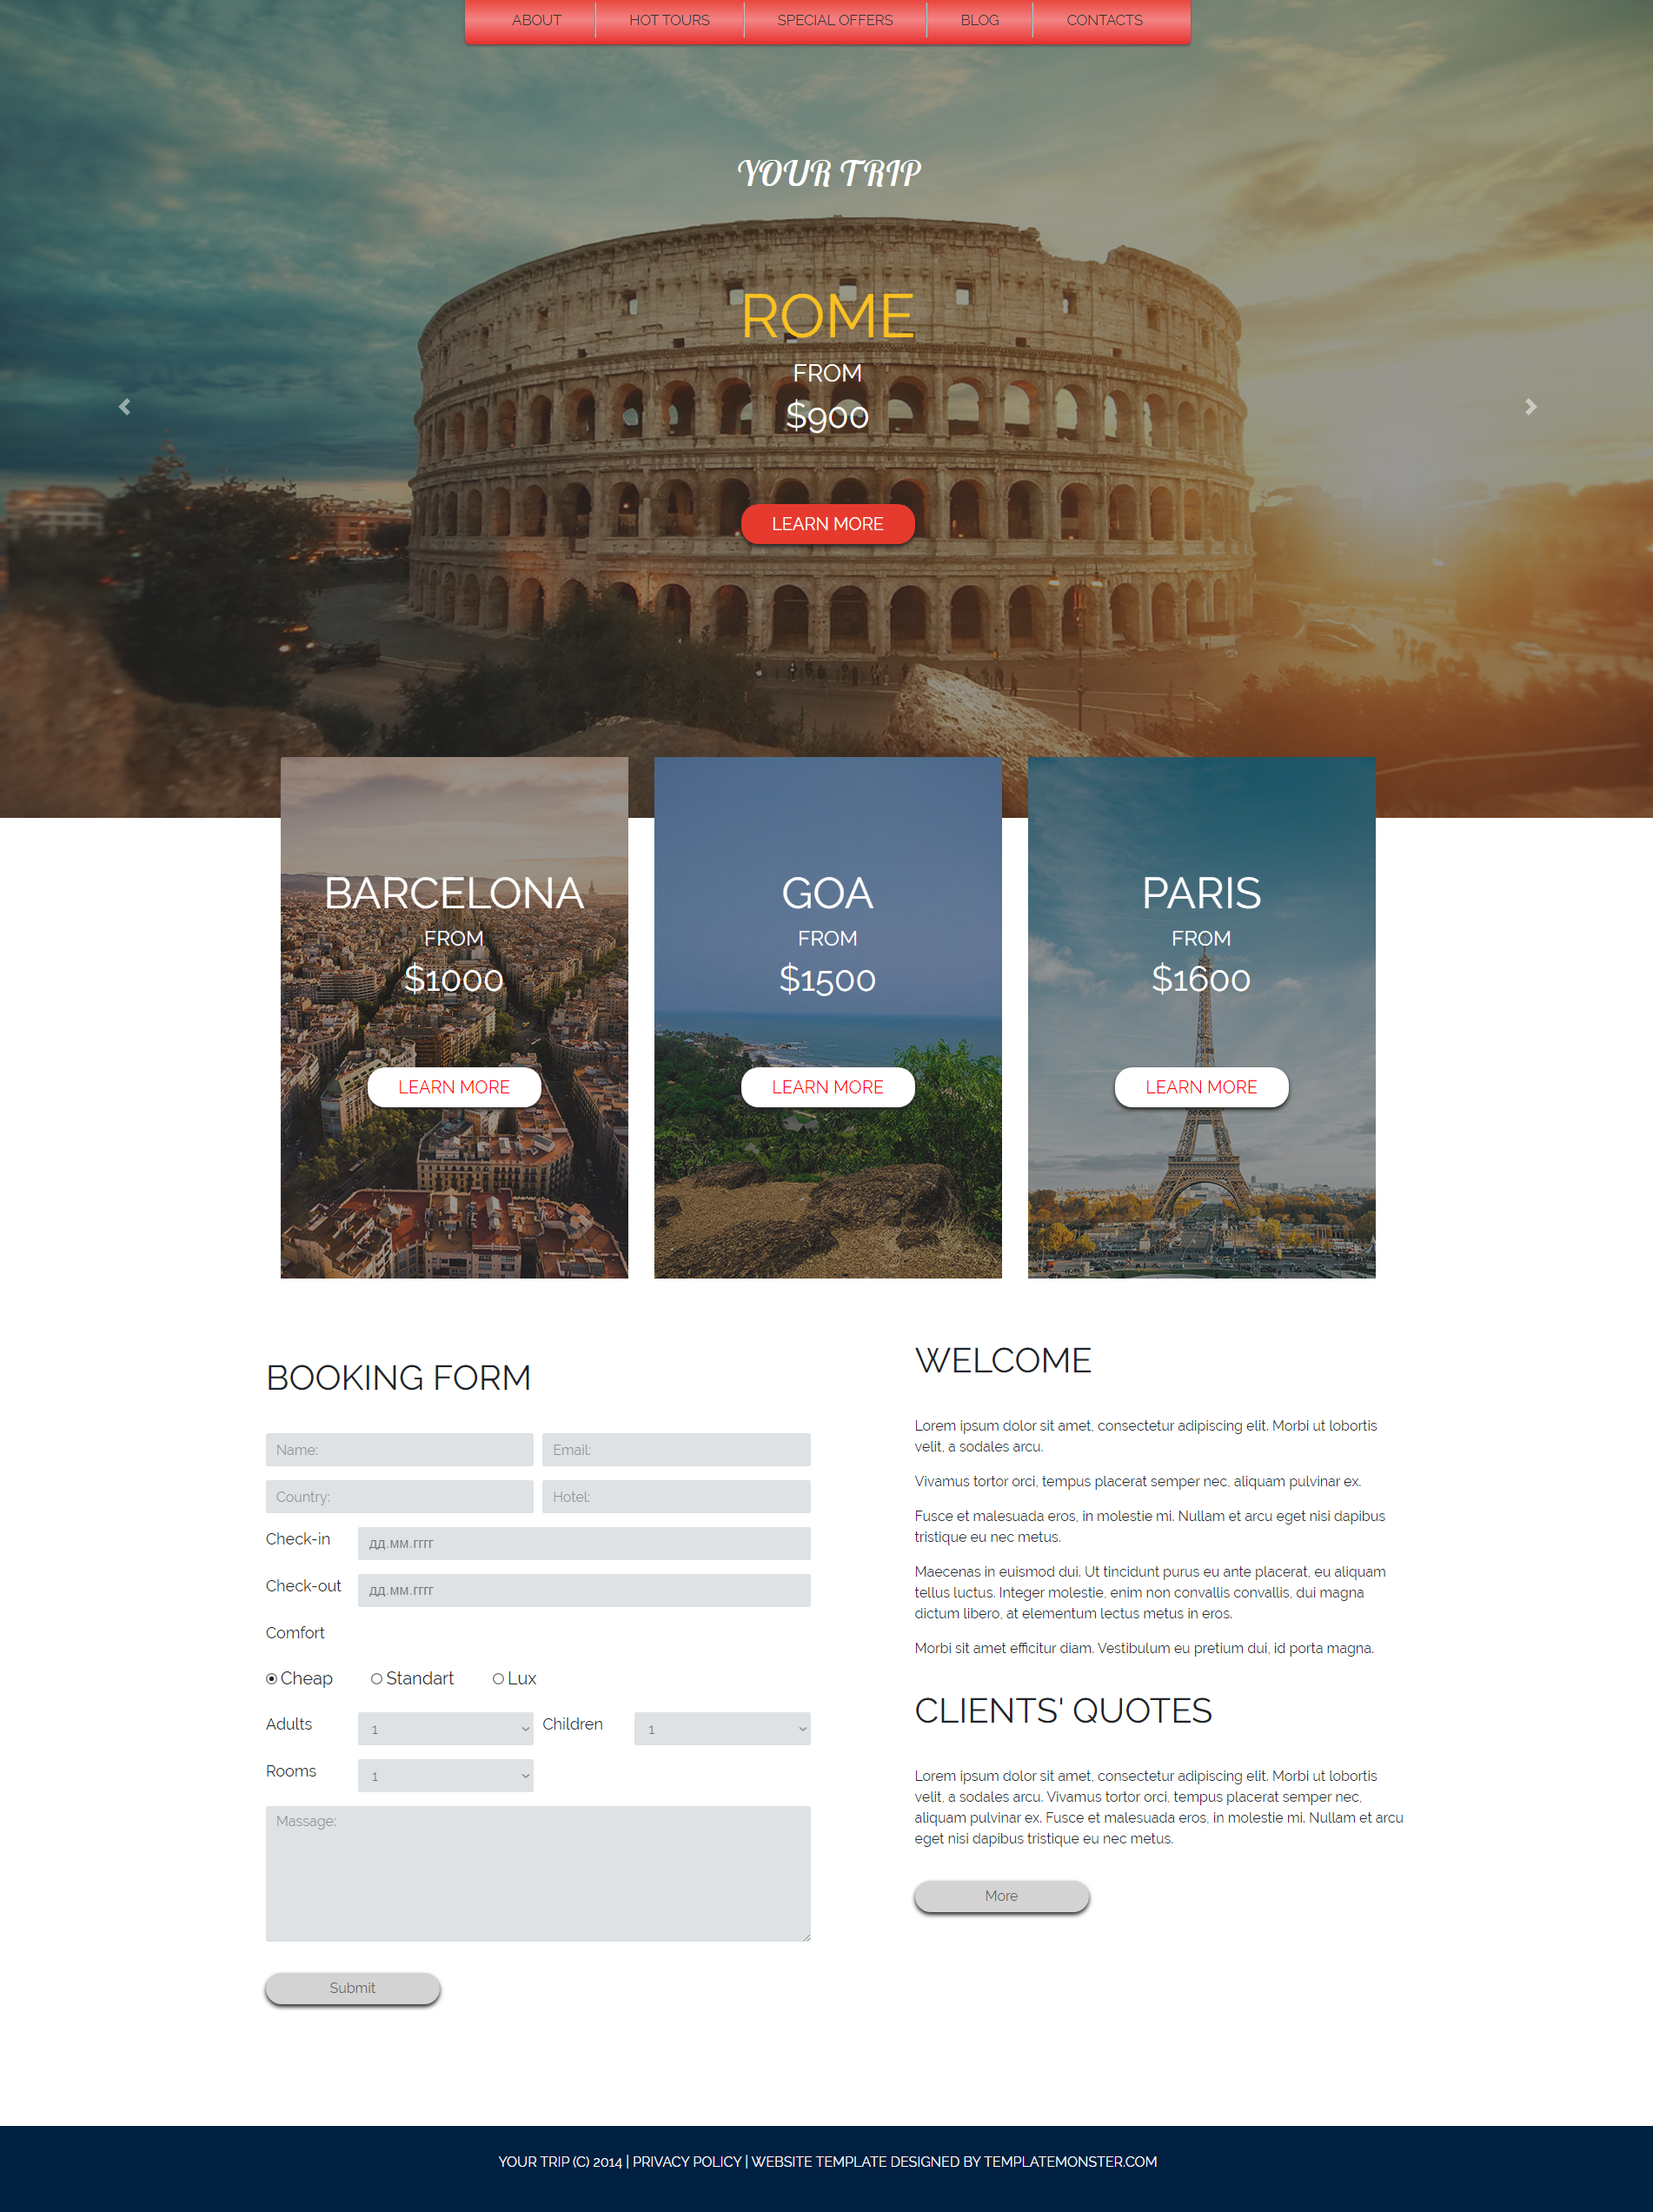

Рис.1 Результат виконання

Висновок: Я навчився працювати з Bootstarp 3.

