**Group 10 (Svapnarajsinh Bhadola, Tommy Nguyen, Liu Xiaoqing)**

**COSC 4353 Software Design**

**Raj Singh**

**June 18, 2021**

**Assignment 1**

**1. Discuss your initial thoughts in details on how you will design this application? (2 points)**

* For this project, we will be prioritizing functionality and usability when we are building this application. We will focus on a user-friendly interface with a backend that will take care of failures and errors from the user and server.
* We are thinking of using tools such as MongoDB or Postgres for out database, Flask for the backend, and HTML and CSS for the frontend and Figma for the design of the website.
* This seems like an interesting project where we can use good APIs to get the results, we need for the gas prices. The software will include a modular login system that allows user authentication and also let them sign up as new users.
* We will have a database to keep track of all the users and have a good profile management system.
* Through the APIs we want to be able to get fuel quotes for any particular location and provide it accordingly.
* We will be keeping track of fuel history for each user. This will also help us keep track of all the transactions that occurs in the application.

**2. Discuss what development methodology you will use and why? (2 points)**

For this application we will be using the waterfall methodology. We love the strict structure that the waterfall methodology brings. We already have a solid outline provided; however, it does not limit just the required features. We know our goals and what is required of the application. The waterfall methodology will help us stay on track because its main advantage is giving us clear objectives which will help develop the application faster.

**3. Provide high level design / architecture of your solution that you are proposing? (6 points)**

Presentation Layer

Interface

Application Interface

FRONTEND

Business Layer

Frontend use with Backend Support

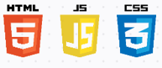



BACKEND

Service Layer

Manipulate Data/Control Application

Data Access Layer

Accessing the Database

Data Layer

Processing Data

DATABASE



 

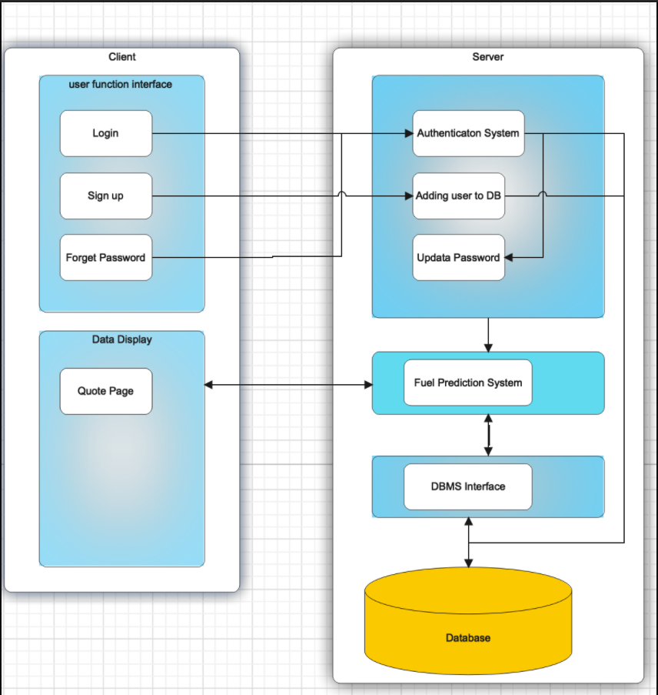

**4. IMPORTANT: list who did what within the group. TAs should be able to validate in GitHub, otherwise team members who didn't contribute will receive a ZERO.**

**Bhadola, Svapnarajsinh:** Worked on the design of the high-level architecture of the application, initial brainstorm, and identified the necessary technology stack for the requirement.

**Nguyen, Tommy:** Worked on the high-level design of the application and initial brainstorm of what this application entails As well as what methodology would be best fit for the identified project.

**Liu, Xiaoqing:** Worked on the initial thoughts and ideas of how this application will be designed and helped in identifying necessary technology stack for the given project.