Assignment 2

Group 10

1. Provide link to GitHub repository for TAs to view the code? (1 point)

<https://github.com/KeerMom/COSC6353-Project/>

2. Discuss if your design and development methodology has changed since assignment 1 and why? (1 point)

Our design and development methodology has been consistent throughout the whole project so far. For the frontend we are continuing with HTML and CSS and Javascript.

3. List what front end technologies you are using and why. List who is responsible of doing what in your group? (2 points)

The current frontend technologies that we are using are: Python, HTML5, CSS3, and JavaScript. We are inexperienced with web development and found that Flask is more user-friendly, because we chose that as our frameworks.

Work distribution: Xiaoqing and Tommy worked on the HTML templates and Svapnarajsinh working on the CSS portion of the assignment.

4. Provide screen shots of your front end, each page? (5 points)

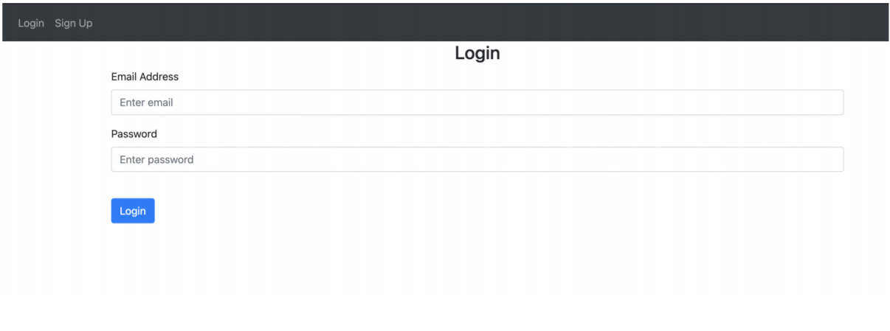 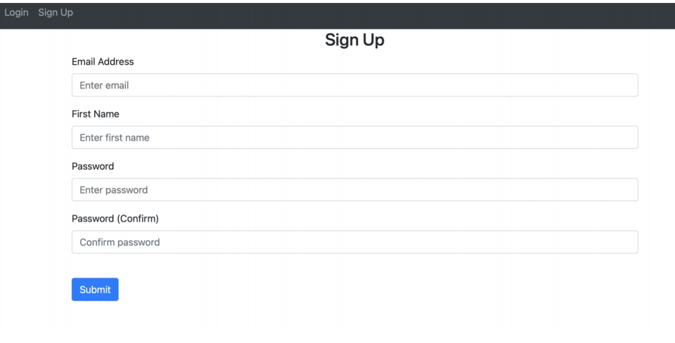

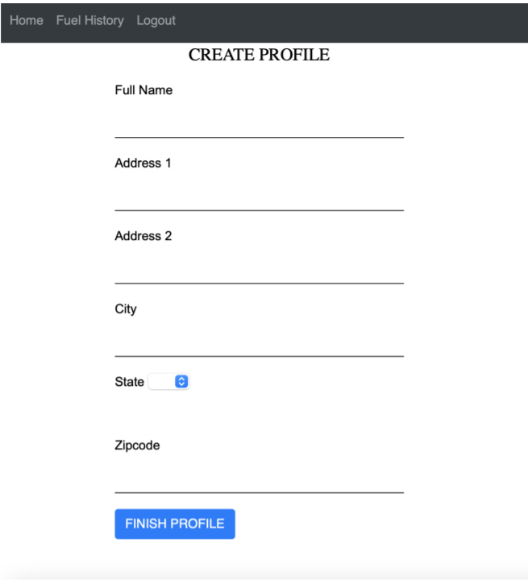

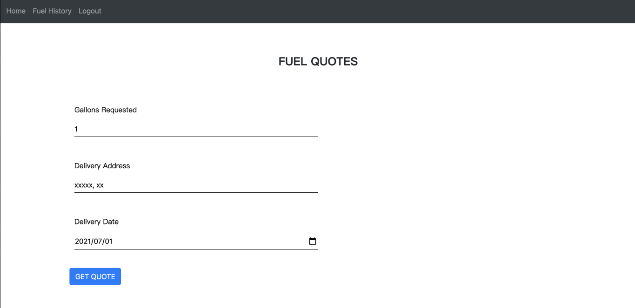

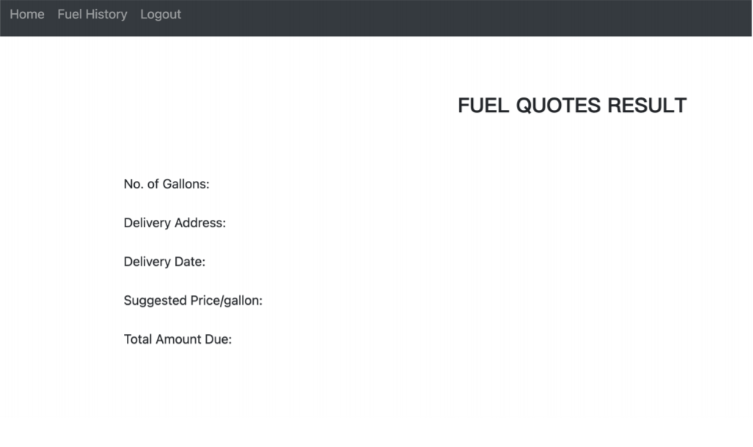

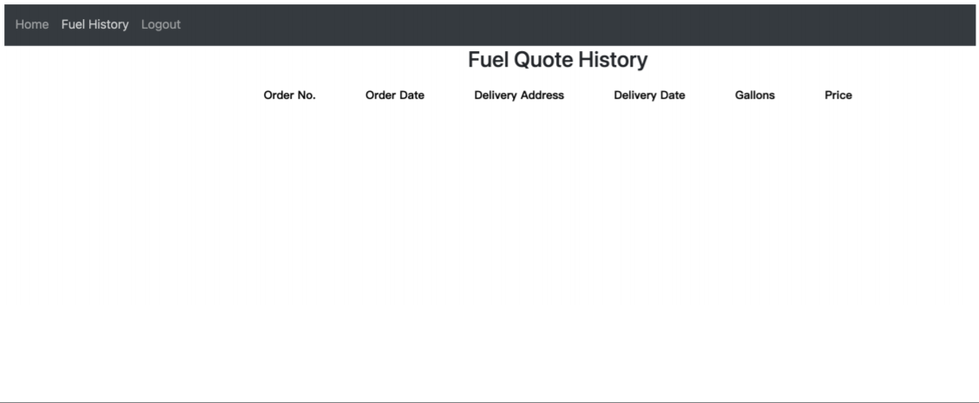

**5. IMPORTANT: list who did what within the group. TAs should be able to validate in GitHub, otherwise team members who didn't contribute will receive a ZERO.**