Assignment 3

Group 10

**1. Provide link to GitHub repository for TAs to view the code.(5 points)**

<https://github.com/KeerMom/COSC6353-Project/>

**2. List what backend technologies you are using and why? (2 points)**

We are using the flask framework for our backend for oriented small deployments instead of large deployments. It gives us the flexibility for request handling and to use any database, more will be discussed in assignment four. Flask is convenient because it requires minimal library importing, while maintaining simplicity in usage and syntax.

**3. Provide code coverage report. (3 points)**

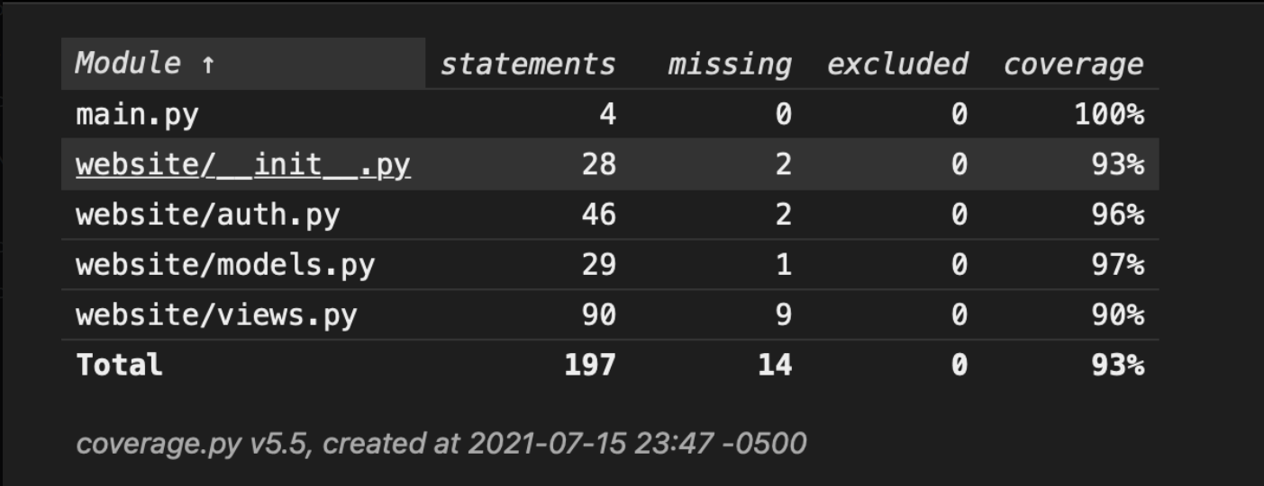

**4. IMPORTANT: list who did what within the group. TAs should be able to validate in GitHub, otherwise team members who didn't contribute will receive a ZERO.**

* Xiaoqing: Backend for Login Html, Sign Up, and Create Profile html
* Tommy: Backend for Fuel Quote Form and Fuel Quote History html
* Svapnarajsinh: Code Coverage Report