Assignment 4

Group 10

1. Provide link to GitHub repository for TAs to view the code.(5 points)

<https://github.com/KeerMom/COSC6353-Project/>

2. Provide SQL statements to create database.(3 points)

DROP TABLE User;

DROP TABLE Profile;

DROP TABLE Quote;

CREATE TABLE User(

id VARCHAR(255) NOT NULL PRIMARY KEY,

email VARCHAR(255) NOT NULL,

password STRING(255) NOT NULL,

first_name VARCHAR(255) NOT NULL,

);

CREATE TABLE Profile(

id VARCHAR(255) NOT NULL PRIMARY KEY,

full_name VARCHAR(255) NOT NULL,

address1 VARCHAR(255) NOT NULL,

address2 VARCHAR(255) NOT NULL,)

city VARCHAR(255) NOT NULL,

state VARCHAR(255) NOT NULL,

zipcode INT NOT NULL,

user_id VARCHAR(255) NOT NULL,

FOREIGN KEY(user_id) REFERENCE User(id)

);

CREATE TABLE Quote(

id VARCHAR(255) NOT NULL PRIMARY KEY,

date INT NOT NULL,

delivery_address VARCHAR(255)

gallons_requested VARCHAR(255)

suggest_price VARCHAR(255)

total_price VARCHAR(255)

user_id VARCHAR(255) NOT NULL,

FOREIGN KEY(user_id) REFERENCE User(id)

);

3. Rerun the code coverage report and provide it. (2 points)

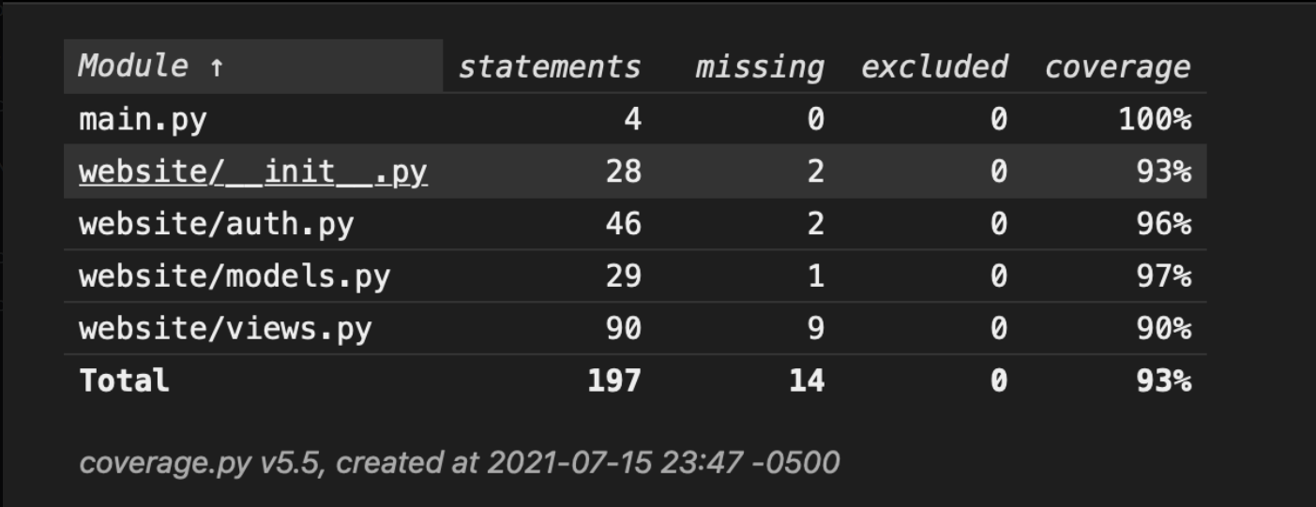

**4. IMPORTANT: list who did what within the group. TAs should be able to validate in GitHub, otherwise team members who didn't contribute will receive a ZERO.**

Svapnarajsinh - Code coverage, Unit testing

Tommy - Database for Login/Register page, Hash password to be inserted in the database

Xiaoqing - Database for reate profile page, design DB schema, display info from DB to history page