IMDB Project Report

Abstract— This report provides an analysis of scraped IMDB data for a selection of the most popular movies. The dataset includes information such as titles, release dates, genres, ratings, directors, and cast members. The report aims to explore trends and patterns within the dataset, including which genres have been the most popular over time, which movies have received the highest ratings, and which director has made the most successful films. The report also uses numerous machine learning algorithms like decision trees, linear regression as regression algorithms; and random forest, k-nearest neighbors as classification algorithms to examine the relationship in the dataset. The results of the analysis provide insights into the movie industry and may be useful for filmmakers, producers, and investors looking to make informed decisions about which movies to produce or invest in.
Keywords— Scraping, Analysis, Machine Learning, Supervised, Unsupervised.

Web Scraping
Web Scraping is the process of extraction of data from web pages using software or tools; the information can then be retrieved and stored in a database, CSV file, or JSON file format. We are using the IMDB website which stands for Internet Movie Database, it is an online database that contains data about movies, TV shows, and video games. One of the most well-known websites for movie and TV shows, it offers abundant information regarding both mediums, such as plot summaries, actors, reviews and ratings, release dates, etc.
The steps involved in web scraping are choosing the appropriate website, gathering the URLs of the sites from which you want to extract the data, sending a request to these URLs to obtain the page's HTML, utilizing locators to locate the data in HTML, and lastly save the data in a structured manner, such as a JSON or CSV file. One of the most effective methods in python is to use the Beautiful Soup library for web scraping. This python web scraping library can be used to analyze and scrape HTML and XML websites; you can browse, locate, and modify data with the aid of a parser which significantly helps to cut down on time.
The raw data we have extracted from the IMDB website is:
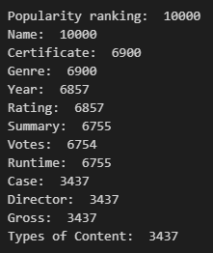
Figure 1: List of information extracted.
From the figure you can identify only two elements; ‘Popularity Ranking’ and ‘Name’ have full data. The remaining elements have missing values which need to be handled so we can extract more data. Let’s say we encounter a missing value in the ‘Genre’ tag, even if that data block contained more relevant values like ‘Year’ or ‘Rating’; we are ignoring those values initially which isn’t optimal since we are losing valuable data.

Data Wrangling
Data Wrangling is mainly used to transform and map the data, remove errors, and prepare raw data suitable for research for better analysis & accessibility. The need to store and organize massive amounts of data for analysis is growing due to the quick expansion of accessible data and data sources today. Simply put in words, it is the process of cleaning, and organizing data in the desired format for analysis to make quick decisions from it. With the help of data wrangling, companies can handle more complex data in a short period and generate more precise results.
Data wrangling mainly contains six important steps which are:
- Discover: This is the step where you must look at your data and think about how you want your data to be organized in order to make it simpler for data analysis. Throughout the discovery phase, the data may reveal trends or patterns which will affect all following activities. Moreover, it identifies apparent issues like missing or insufficient data.
- Structure: Raw data that is insufficient or structured incorrectly is generally unusable for the intended use. Data structuring is the process of taking raw data and changing it so that it may be utilized more conveniently. This technique is used to retrieve crucial information and will make it more usable, making it simpler for the analyst to utilize in his analysis.
- Cleaning: Eliminating embedded errors from your data will help your analysis be more accurate and valuable. Ensuring that the final data for analysis is unaffected by outliers, corrupt data, duplicate values, etc. This is the goal of data cleaning or remediation.
- Enriching: Adding more context to the data is simply what is meant by enriching. For instance, putting together two client information databases, when one has the address, and the other doesn't. Enriching the data is an optional step and may increase the precision of your analysis if the data you currently have doesn’t meet your requirements.
- Validating: To make sure that the data is accurate, consistent, secure, and legitimate, repeated programming processes are necessary. This process may highlight issues that need to be resolved or lead to the conclusion that the data is ready for analysis.
- Publishing: The final stage in data wrangling is publishing, which summaries the whole procedure. It involves locating the freshly wrangled data in a location where you and other stakeholders can locate and utilize it with ease. The data may be entered into a brand-new database. You'll get high-quality data for insights, business reports, and more if you stick to the prior instructions.

In our data, after discovering the missing values and identifying that we are not extracting all the information, we have implemented the structuring phase. By imputing missing values with NAN values and getting the rest of the data that we were initially missing.

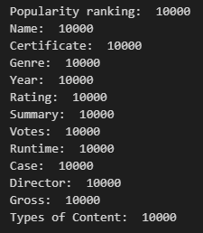
Figure 2: After filling in Missing values.

After structuring and saving our data in a database we began with the cleaning phase. Where we formatted some features like ‘Year’, ‘Genre’, ‘Summary’, and ‘Popularity Ranking’ using string function and python regular expression library. We also omitted some values from our dataset to increase the overall quality of the data.

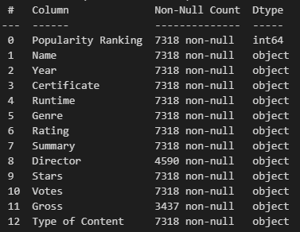 Figure 3: Cleaned Data

Some attributes like ‘Director’ and ‘Gross’ still contain missing values in our data, but we are not imputing those values. Imputing a column with a lot of missing values might not correctly reflect real values, which will lower our overall data quality. By doing some testing we have confirmed that ‘Director’ and ‘Gross’ have missing values generally in the Series ‘Type of Content’ data that we created. And, by removing these values we will be left with very little Series data which will affect our analysis to compare Movies and Series type of content. We are also dividing the ‘Year’ column into two parts; ‘Released’ and ‘Finished’ to get more insight into series data.
Finally, this modified data will be saved into a CSV file to further perform analysis on the data.

Exploratory data analysis
Data scientists utilize exploratory data analysis (EDA), which frequently makes use of data visualization techniques, to examine and analyze data sets and summarise their key properties. It makes it simpler for data scientists to find patterns, identify anomalies, test hypotheses, or verify assumptions by determining how to modify data sources to achieve the answers they need.
EDA helps with a better understanding of the variables in the data collection and their relationships and is usually used to investigate what data might disclose beyond the formal modeling or hypothesis testing assignment. It can assist in determining the suitability of the statistical methods you are contemplating using for data analysis. It can also help in finding glaring mistakes, better understanding data patterns, spotting outliers or unusual occurrences, and discovering intriguing relationships between the variables.
To make sure the findings they create are reliable and relevant to any targeted business objectives and goals, data scientists might employ exploratory analysis. EDA aids stakeholders by assuring them that they are posing the proper questions. Standard deviations, categorical variables, and confidence intervals are all topics that EDA may aid with. EDA's characteristics can then be utilized for more complex data analysis or modeling, including machine learning when it is finished, and conclusions have been formed from it.
Before continuing with the EDA, we are removing rows that contain ‘Upcoming’ values to better visualize the data.

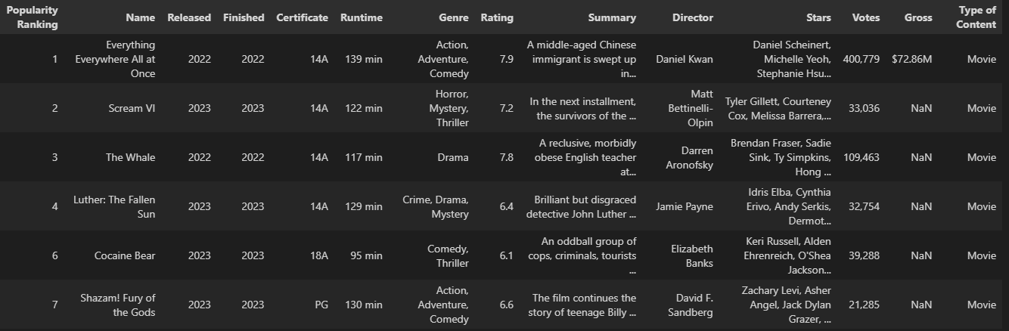Figure 4: Dataset for visualization
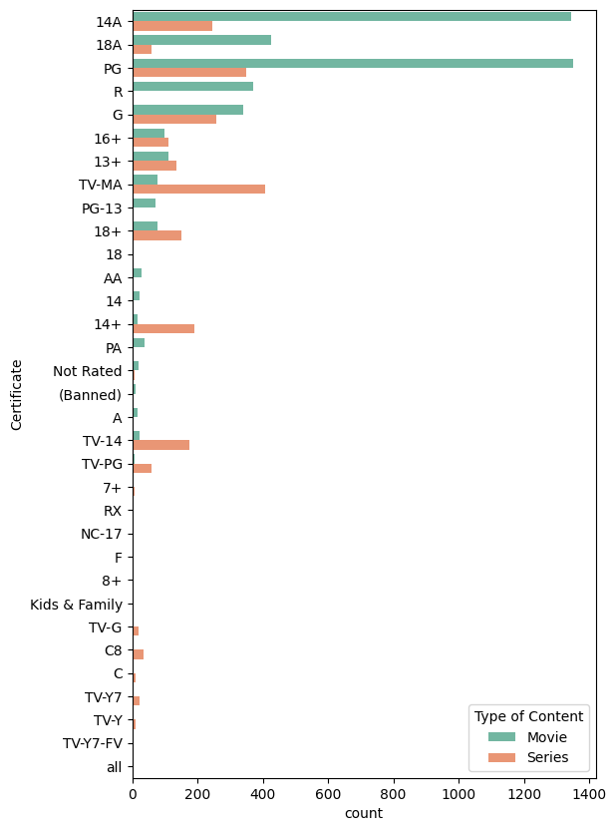 Figure 5
This bar graph represents the number of movies and series that are of specific ‘Certificate’. This gives us an insight that movies are mostly ‘14A’ or ‘PG’ and there is almost zero R-rated series content.

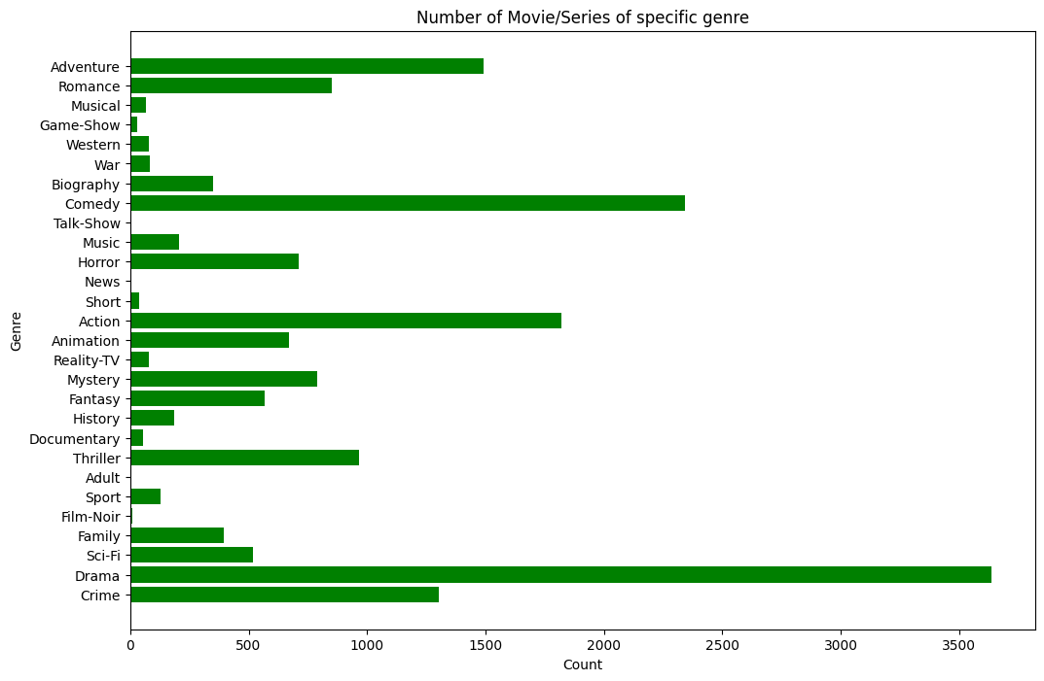
Figure 6
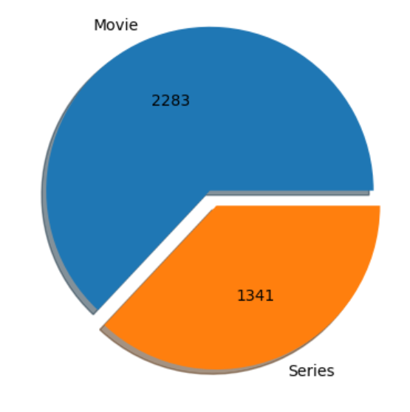
Figure 7

Figure 6 bar graph helps us understand different genres of movie and series; and how prevalent each type of genre is. For visualization we are using 6754 rows and around 50% of which is a type of drama. Our pie chart represents the ratio of movies and series in drama category. This concludes that around one third of our data is a movie with drama genre.

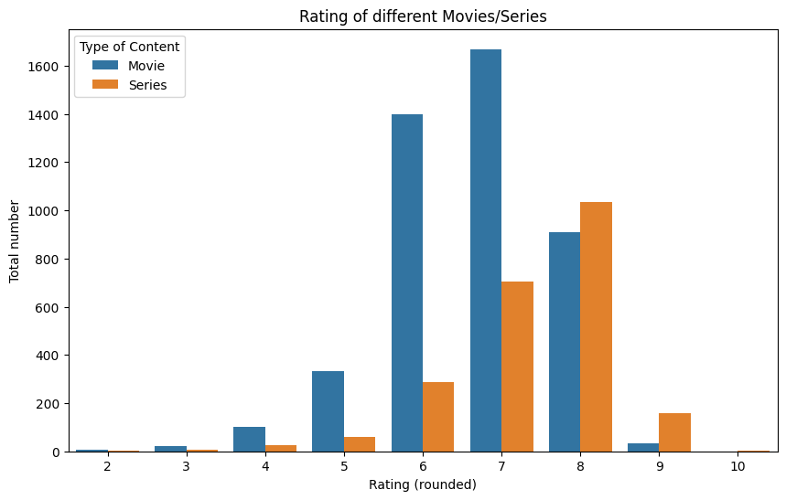
Figure 8

Now we are doing a comparison of movies and series based on their average rating. We can find that even though the total number of series is less than movies, their overall average rating is around 8 which for movies will be around 7.

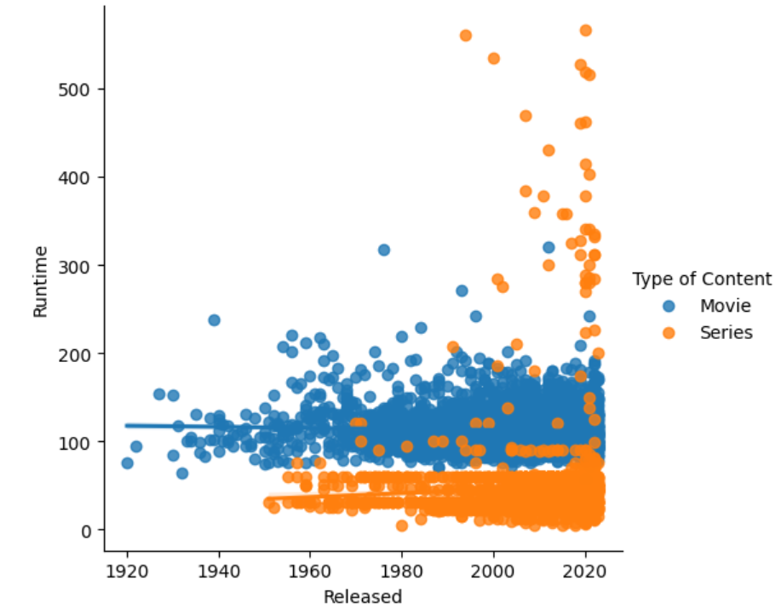
Figure 9

Using linear regression, we are trying to see if there is any increase or decrease in runtime with release date. As per our graph there are some series whose runtime is 5 times of what they used to be, but in general we can say that there has been no11 change.

Pandas Profiling
Pandas profiling is an open-source Python module that allows us to rapidly perform an EDA with only a few lines of code. It produces interactive results in web format that can demonstrate to anyone, even if they are not familiar with programming. In other words, pandas profiling saves us from having to visualise and comprehend the distribution of each variable. It produces a report that contains all the readily available information.

Encoding Methods
As we all know computers can’t understand categorical data, thus all independent and dependent variables, or input and output characteristics, must be numerical to be used with machines. This implies that before fitting our data to the model, we must encode any categorical variables present in our data.
For the machine to learn from the data and provide the appropriate model, it is important to transform the categorical values of the feature into numerical ones. Encoding is the term used to describe the transformation of category data into numerical data.
In our dataset, data types of columns are mostly object type, that is; it contains string value in that specific feature. The ‘Released’ column is also generated from year during our initial data wrangling process and we will apply some feature engineering techniques on ‘Runtime’, ‘Rating’, and ‘Votes’ column.
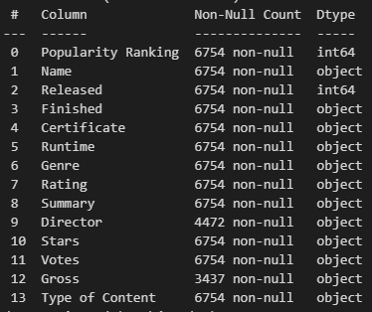
Figure 10

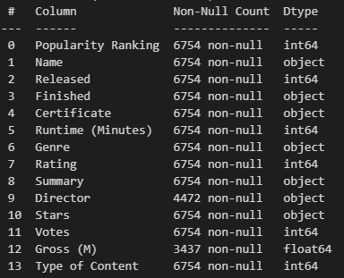
Figure 11

We have also applied encoding method on ‘Type of Content’ column, where we changed ‘movies’ and ‘series’, previously two string values with 0 and 1 respectively.

Outliers detection
In a dataset, outliers are data points that are regarded as extreme, false, or not representative of the data's description. Either genuine outlier observations or incorrect data collection can result in these outliers. There are mainly two ways to detect outliers:
- Visualizing: In this method, you use plotting techniques such as scatter plot, boxplot, and histogram to look for outliers in your data.
- Statistical: This method uses a statistical approach to detect outliers, the most common being interquartile range (IQR) and z-score.

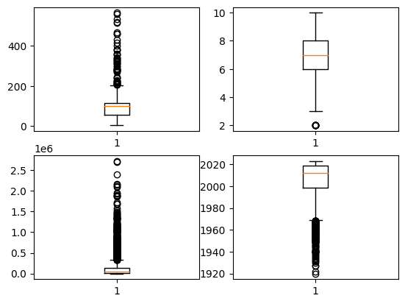
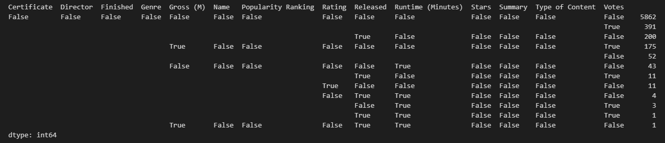 Figure 12

We are using boxplot to visualize outliers in our data for the ‘Runtime’, ‘Rating’, ‘Votes’, and ‘Released’ columns respectively. And, after implementing IQR we can check total number of outliers we have in our dataset.

Addressing outliers
Now that we know what outliers are, and how we can detect them. Let’s look at some outliers addressing techniques.

Quantile-Based Flooring and Capping
In this approach, we limit the values above a certain range. For example, by doing a 95% capping and 5% flooring; we are factoring the outliers in those ranges. Using this method, we can observe a visual change in our outlier detection.

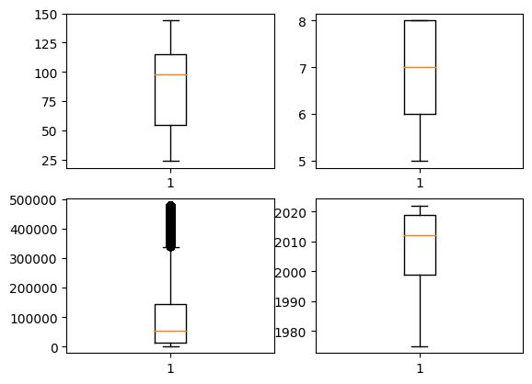
Figure 13

Trimming
In this method, we remove the data values that are outliers or values that are outside required range by deleting those rows. Our dataset had 6754 rows but after implementing trimming on 25 and 75 percentiles, we are left with 5817 rows.

Log Transformation
Log transformation is used to lessened and normalize data skewness. Data is not always made normal by log transformation; occasionally, it can make the data more skewed. It thus relies on the information and to transform something, we must control the outcome.
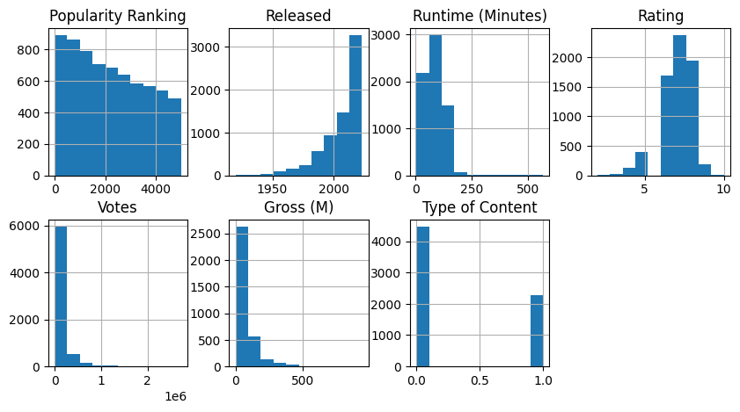
Figure 14
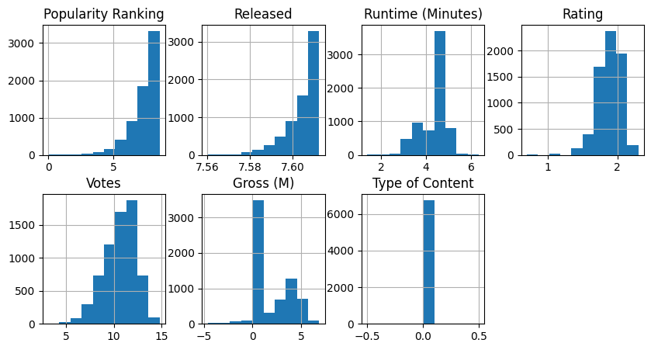
Figure 15
The above two figure shows how our data looks before and after applying log transformation. And as we can see that column such as ‘Rating’, and ‘Votes’ have normalized but ‘Popularity Ranking’ on other hand is left-skewed.
After applying all the above techniques and some analysis we have decided not to remove any outliers from our data, since outliers in ‘Votes’ and other columns can occur.

UnSupervised learning
Unsupervised machine learning utilizes machine learning techniques to analyze and classify unlabeled datasets. These algorithms locate data clusters or hidden patterns without the aid of a person. Due to its ability to identify informational similarities and differences, it is the best choice for exploratory data analysis, cross-selling strategies, consumer segmentation, and image identification.

Elbow Method
K-means clustering is a simple unsupervised learning algorithm that is used to solve clustering problems. It uses a straightforward process to divide a given data set into several clusters, each of which is denoted by the predetermined letter "k." The clusters are then placed as points, and all observations or data points are connected to the closest cluster, calculated, and adjusted. The procedure is then repeated using the new adjustments, and so on until the desired outcome is obtained. For our analysis, we will be clustering against the ‘Age’ and ‘Hours per Week’ columns.

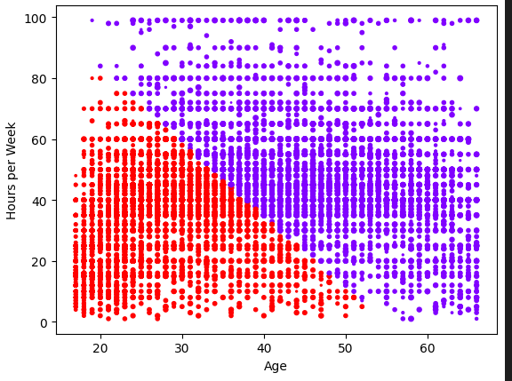
For the K value, of 2 our data have been clustered as seen above, but is that the best cluster we can form for this problem? Or we can do something better. To figure this out, we will be using the Elbow method.

K-Means Algorithm
The elbow method gives us an idea of what a potential k number of clusters might be based on the sum of squared distance (SSE) between data points and the centroids of their assigned clusters. We select k at the spot where SSE starts to flatten out and form an elbow.
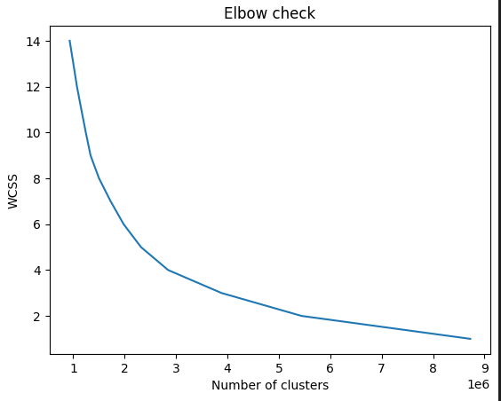

From the above graph, we can see an elbow being formed at k=3, which will be a good representation for clustering.

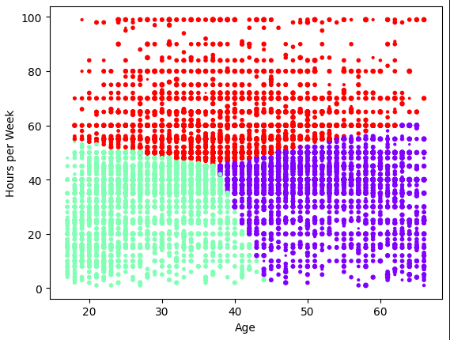

NLP techniques
Asdfasdfdsafd

Conclusion
In conclusion, the analysis of the IMDB dataset has provided valuable insights into the entertainment industry. The data has revealed trends in genre, popularity, high-rated movies/series, and runtime. These findings can help filmmakers, producers, and investors make informed decisions about which movies to produce or invest in.

It is clear from the data that these industries are constantly evolving, with changing trends and preferences of audiences. Therefore, it is important to continue analyzing and monitoring IMDB data to stay up to date with the latest trends and developments. Overall, this analysis demonstrates the power of data to provide valuable insights into the entertainment industry, and the potential for such analysis to inform decision-making and drive success in the movie business.

References

- Arvai, K. (n.d.). K-Means Clustering in Python: A Practical Guide – Real Python. Realpython.com. https://realpython.com/k-means-clustering-python/
- Delua, J. (2021, March 12). Supervised vs. unsupervised learning: What’s the difference? IBM. https://www.ibm.com/cloud/blog/supervised-vs-unsupervised-learning
- Feature Scaling Techniques | Why Feature Scaling is Important. (2021, May 18). Analytics Vidhya. https://www.analyticsvidhya.com/blog/2021/05/feature-scaling-techniques-in-python-a-complete-guide/
- Grolemund, G., & Hadley Wickham. (2019). 7 Exploratory Data Analysis | R for Data Science. Had.co.nz. https://r4ds.had.co.nz/exploratory-data-analysis.html
- IBM Cloud Education. (2020, September 21). What is Unsupervised Learning? Www.ibm.com. https://www.ibm.com/cloud/learn/unsupervised-learning
- Letelier, M. (2021, November 8). Clustering With More Than Two Features? Try This To Explain Your Findings. Medium. https://towardsdatascience.com/clustering-with-more-than-two-features-try-this-to-explain-your-findings-b053007d680a
- Patil, P. (2018, March 23). What is Exploratory Data Analysis? Towards Data Science; Towards Data Science. https://towardsdatascience.com/exploratory-data-analysis-8fc1cb20fd15
- python - how to use pandas filter with IQR. (n.d.). Stack Overflow. Retrieved December 7, 2022, from https://stackoverflow.com/questions/34782063/how-to-use-pandas-filter-with-iq
- Random split operator. (n.d.). Www.ibm.com. Retrieved December 7, 2022, from https://www.ibm.com/docs/en/db2/9.7?topic=operators-random-split-operator
- Sequitin, K. (2021, October 5). Data Analytics Explained: What Is an Outlier? Careerfoundry.com. https://careerfoundry.com/en/blog/data-analytics/what-is-an-outlier/
- Sharma, P. (2021, April 26). K Means Clustering Simplified in Python | K Means Algorithm. Analytics Vidhya. https://www.analyticsvidhya.com/blog/2021/04/k-means-clustering-simplified-in-python
- UCI Machine Learning Repository: Adult Data Set. (2019). Uci.edu. https://archive.ics.uci.edu/ml/datasets/Adult
- What is K-Means Clustering? - Definition from Techopedia. (2019). Techopedia.com. https://www.techopedia.com/definition/32057/k-means-clustering

- https://www.zyte.com/learn/what-is-web-scraping/
- https://www.simplilearn.com/data-wrangling-article#:~:text=Data%20wrangling%20is%20the%20process%20of%20removing%20errors%20and%20combining,analysis%20is%20becoming%20increasingly%20necessary
- https://www.questionpro.com/blog/data-wrangling/
- https://www.ibm.com/topics/exploratory-data-analysis#:~:text=Exploratory%20data%20analysis%20(EDA)%20is,often%20employing%20data%20visualization%20methods.
- https://medium.datadriveninvestor.com/what-is-encoding-and-its-importance-in-data-science-6a2b0cce8e8e
- https://stephenallwright.com/remove-outliers-pandas/#:~:text=Outliers%20are%20data%20points%20in,11%20May%202022

