**Problem Statement :Reasons Behind Decrease and Increase of Sales in an E-commerce Platform.**

Over the past quarter, the e-commerce platform OZONA has witnessed a decline in sales. Despite a consistent flow of website traffic, there has been a decrease in the percentage of visitors making purchases. Conversely, the purchases of some products have shown an increase. This decline is of significant concern as it directly impacts the revenue and overall success of the organization.­­­

**Assumptions:**

1. Data Sets is Normalized Manner.
2. Each Data is Independent to each other.
3. For Increase of Purchases is related to discount on Products.
4. There is corelation with Offline Spend and Online Spend for increase of sales.
5. Maybe more Women’s are purchasing in Online.
6. So Women’s category products are sold more When compare to Men Category Products.
7. Assumed that more products are sold from New york and Washington DC.

**Research** **Questions:**

1. Find the Reasons Behind The sales Increased and Decreased on Some products.
2. What factors may increases the sales of products?
3. In Which people are prefering to buy the products whether in Online or Offline.
4. How to Over come the sales declined which help to generate the revenue.
5. Finding Recent Trends which Category products are brought more.

**Hypothesis:**

1. Increased Sales because of Coupons.
2. Some Category products may have high delivery charges and GST
3. people spends more amount in an month in offline when compare to online because of Reliablity or quality­­­­­ reasons.
4. Products sold in high volume may be having Fare price.

**Analysis and Findings:**

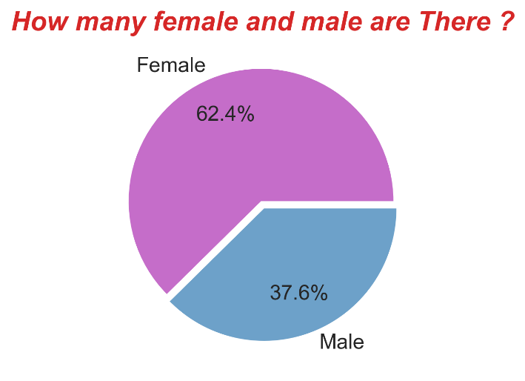

* According to pie chart shows the percentage of male and female buying the products. Female are Purchasing in a significant numbers more than Male.

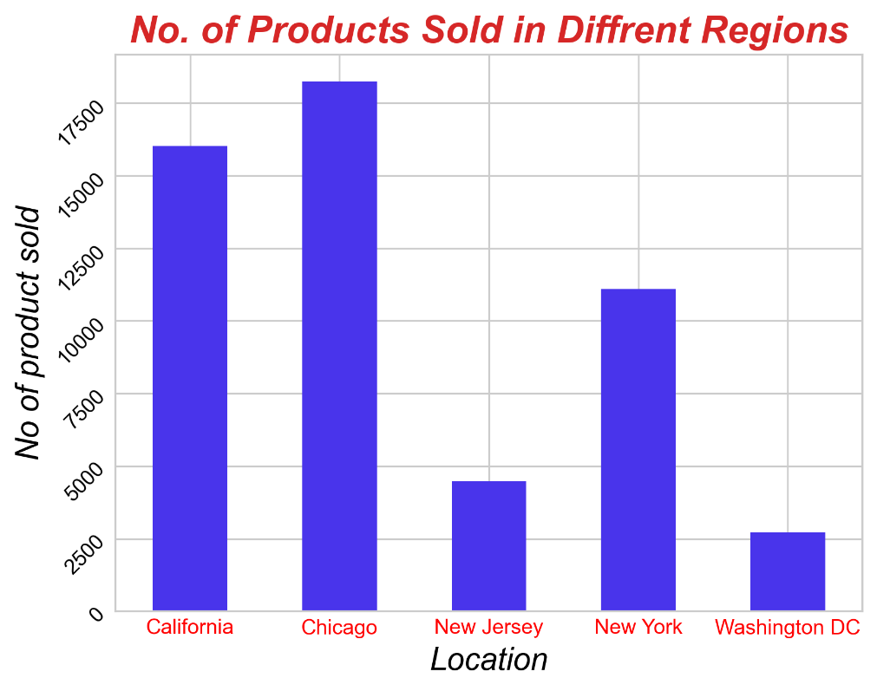

* As Bar graph says that major Products are sold at chicago and Califorinia so that people from this region are having major share in making revenue for organization.

**Now let we see why the products are sold more and reasons Behind it**

By knowing that it helps to make decisions and growth of company:

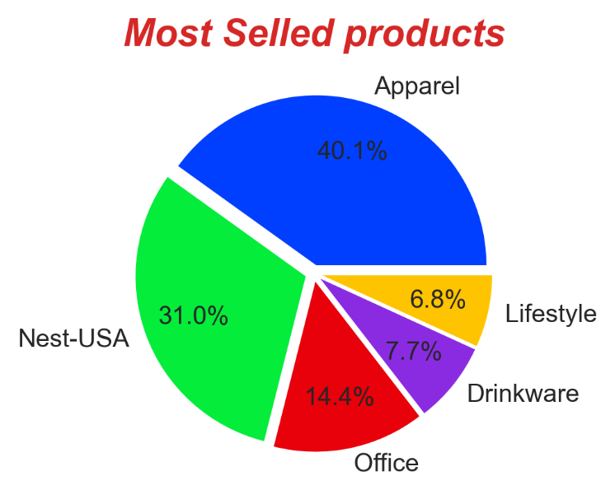

* As we can see that major products are Apparels and Nest-USA where apparel means Clothes espically formal clothes
* Nest-USA is where they are Camera Indoor and outdor,Security Camera,Alarm basically a Nest is company of USA
* These products are sold in high volume.

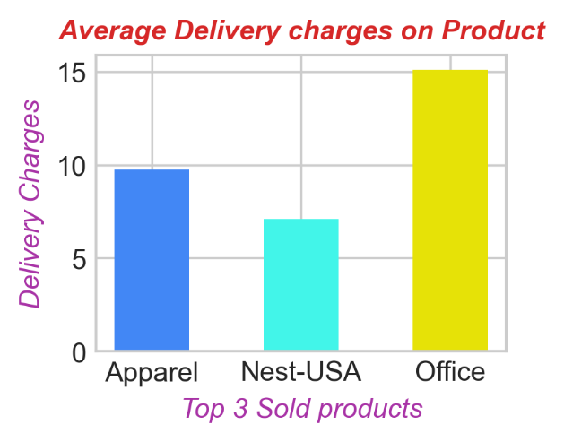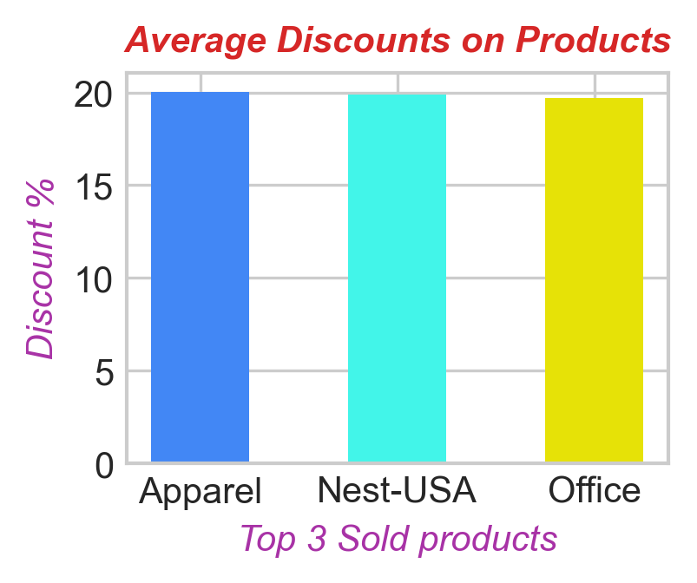

* These are main reasons why sells are increased where people are pefering these Category of product that having more discounts as we can see that top 3 products are having the average discounts around 20% which makes a huge diffrence when compared to other products and also these top 3 products are sold more because of the delivery charges range around (10-15) This is also one of the main reason for high volume of sells.

**Let us see Now why the Sells are decreased:**

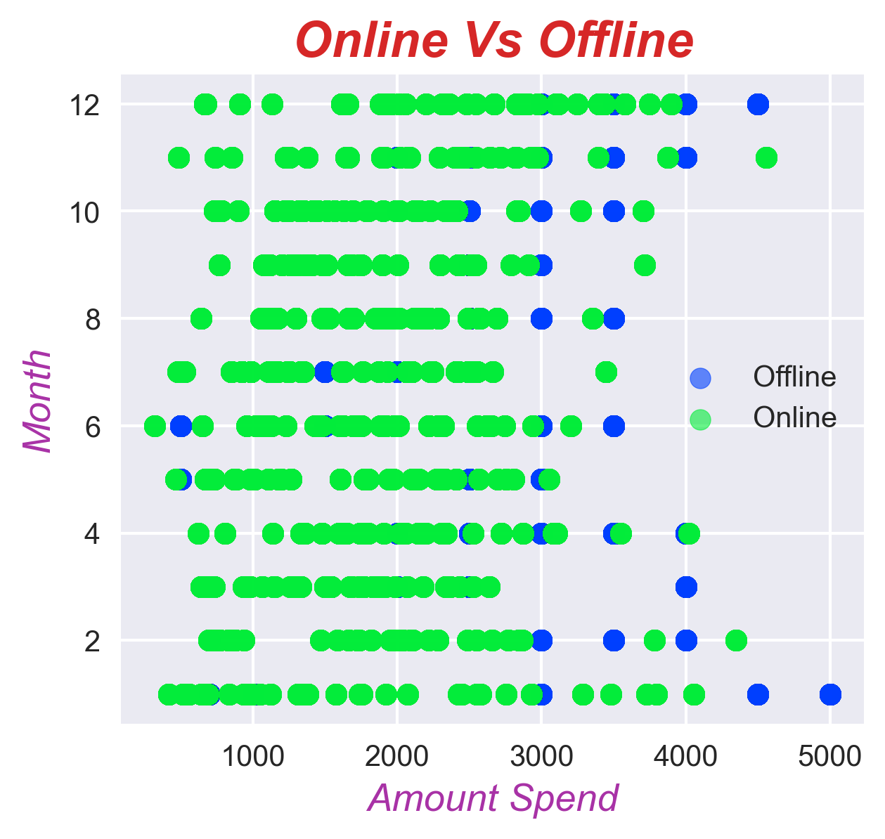

* More peoples are often buying through offline then online.This is as we assumed that there more chance are there that people are buying on offline only.

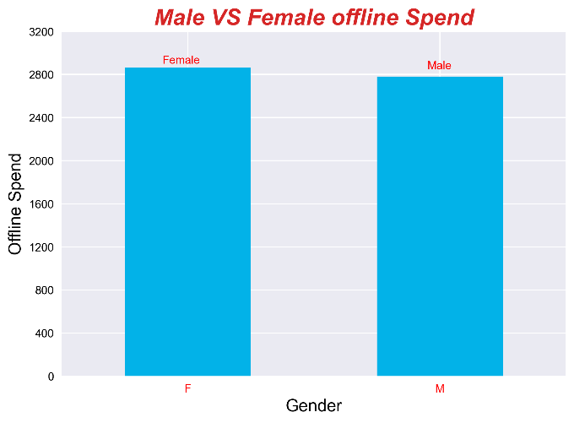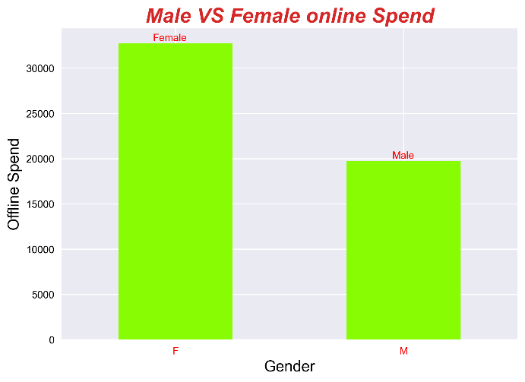

* As both bar graph as a clear picture that the females and males are been purchasing in offline and offline more buying are in offline because of trust or not aware of the products that available in the online or other factors may be reasons. Woman’s are perfering to by daily use category products in offline then online.

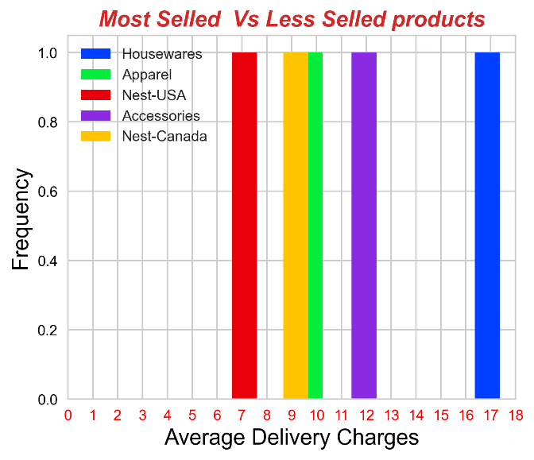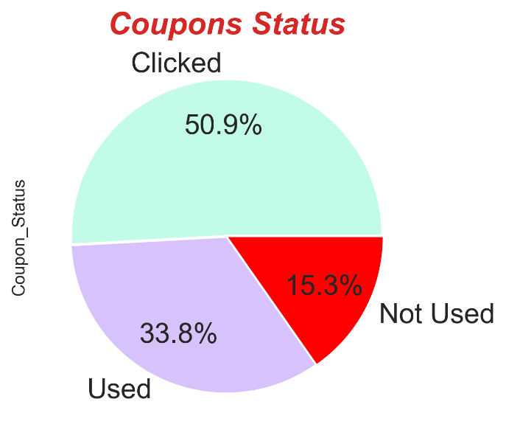

* As delivery charges on apparel products are been less and also according to graph we can see that accessories and housewares products are having the high average delivery charges so this is one the reason for the products sells declined.
* Coupons are not used by many of people only around 33.8% people are utiliized it and rest of people are just clicked and some people are not used it at all. Coupons clicked means they saved coupon code but not buy any products by using it.

**Now let we see Recent Trends:**

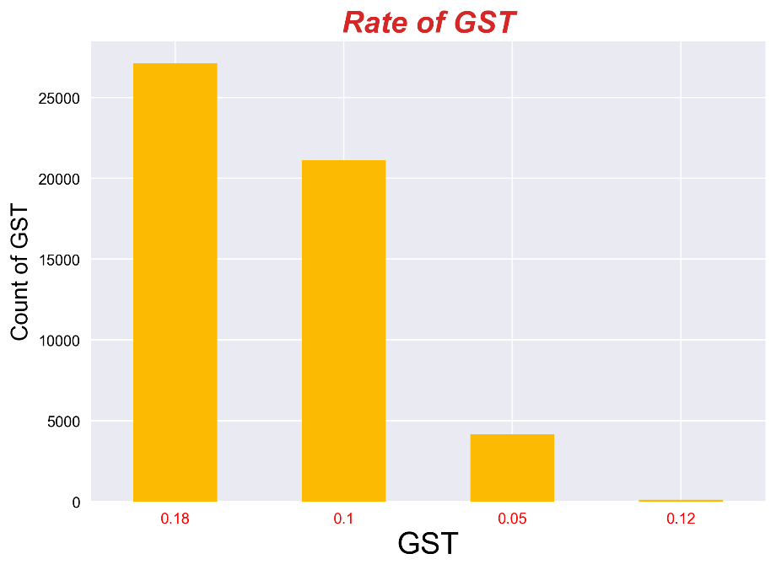

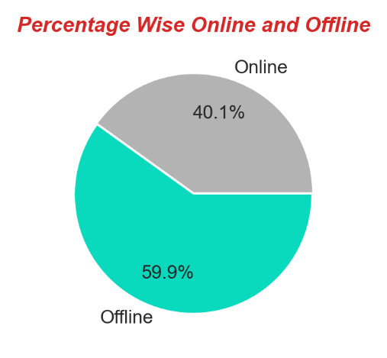

* Even though Rate of GST are high on Some Category of products are sold in high volume.
* Also people are prefered to buy in offline 59.9% and 40.1% in online only.

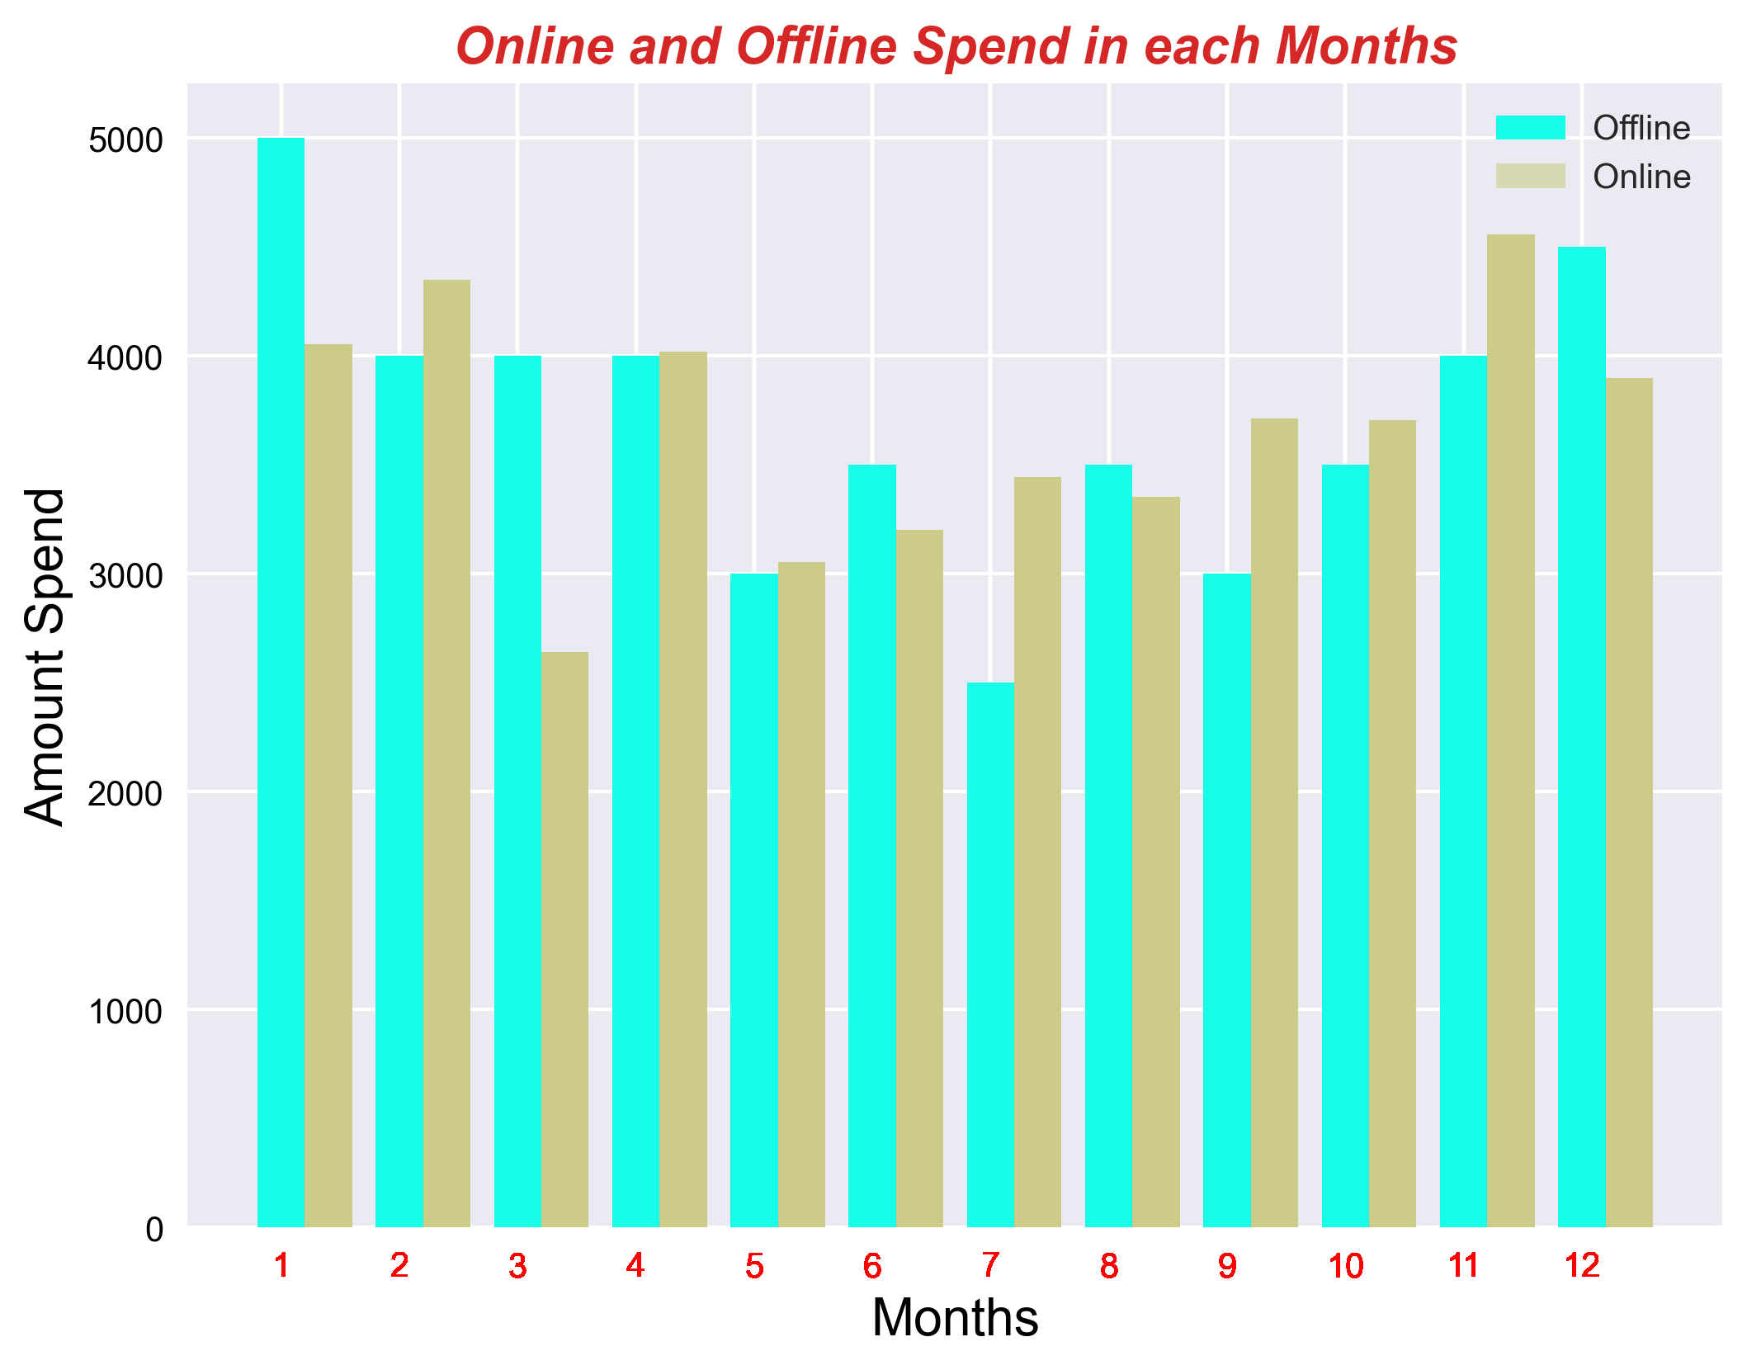

* As we can see more balance in online spend when compared offine spending.In offline spending the there is no consistence as online spending as steadly spending in online which is a good sign for organization to make profit and generate revenue.

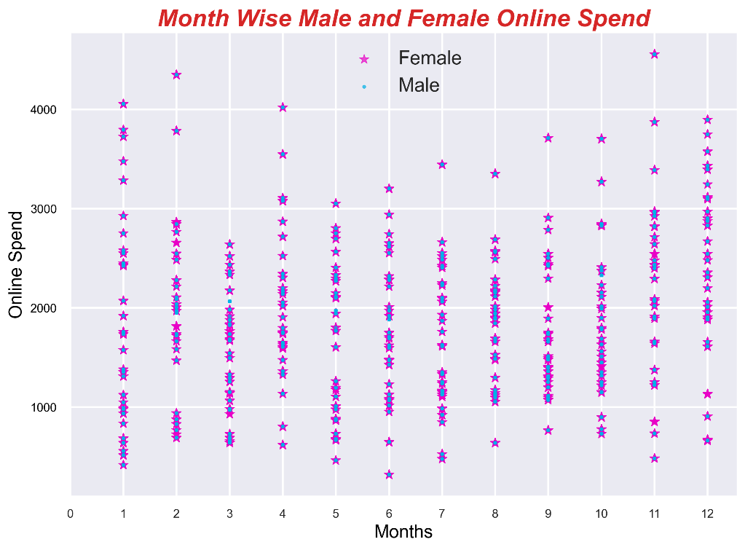

* In scatter plot we can see Both Men and Women are purchasing the products more in online but the women’s are buying the products frequently then men’s.

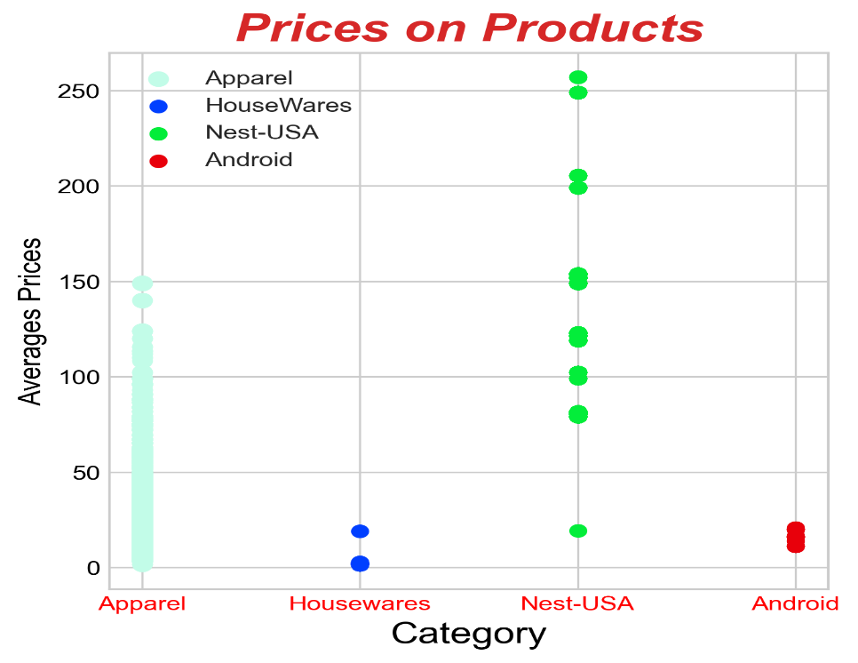

* Prices are very high in products which is sold in huge volume but the declined sales products like Housewares and android there prices can be instead increased and also the quality of those products because people may like to buy these products in offline due reliablity and quality based on price.

**Indirectly related to increase of sales declined of sales and what actions can be taken:**

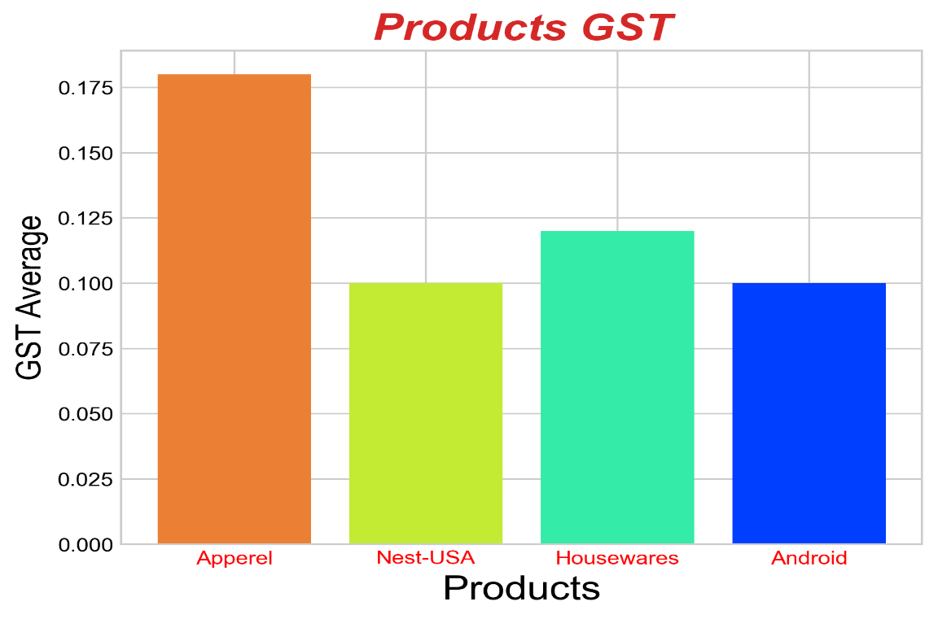

* As we see bar graph it is clear that even though the average GST is high on the products they are perfering towards those one only it is because of the supply demand of the product. Whereas these products like apparel are brought more by Woman’s only.It clear shows that the people not bother about the price but we can’t make like that for all products. So concentrate on the quality the products and sell it in a fare prices.

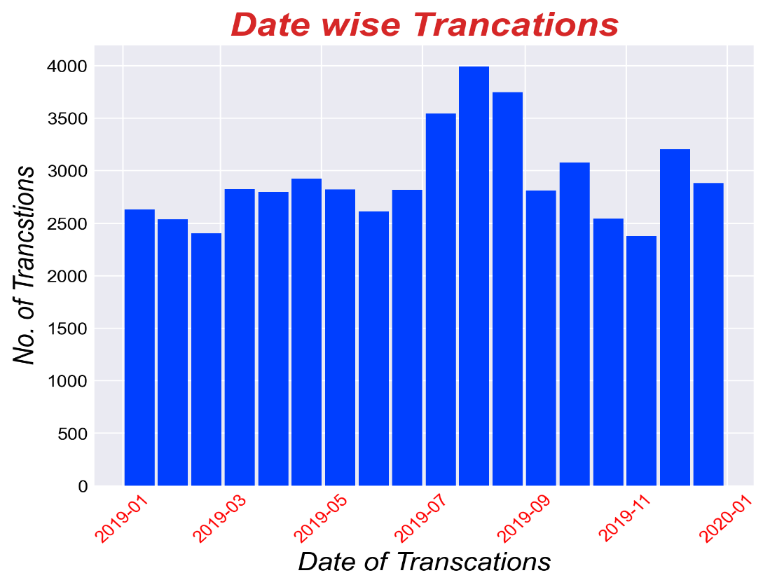

* More Transcations are taken place in the month of july-September on this date of transcations are taken place around 3500-4000 on these Monthson this date we can provide some excieting offers to our customers

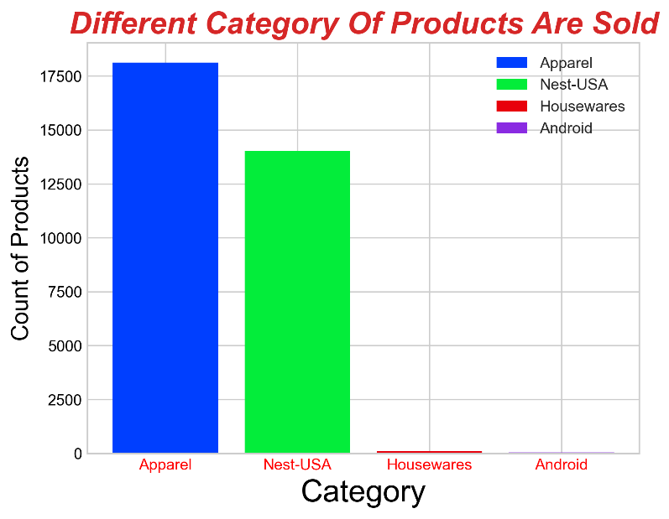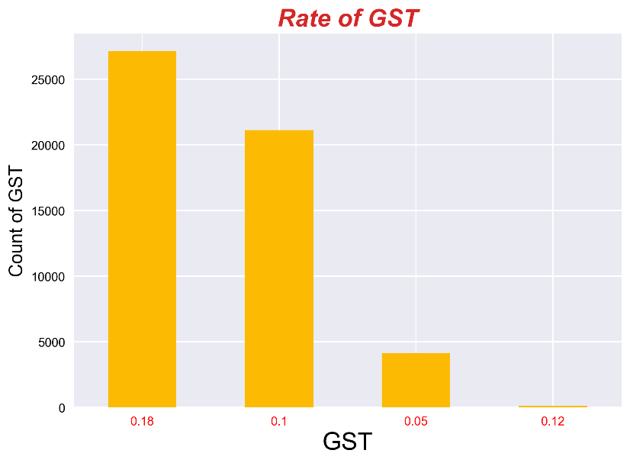

* As above all graphs clearly shows as that when the products GST is high even then people are pefering to buy that products example Apparel (0.175%) and other products which sells are very high those products GST is more. Because of need of it and they are comfort to buy these products in online then offline. So Other products like housewares, giftcards and Android Category products should improve there quality and trust among the people.

**Suggestions:**

1. Profit are declined due to average prices of product so it better to decrease and increase the prices according to location.
2. As sales are high in month of july to september so it should be planned to give more discounts in prices and also the delivery charges.
3. They should change the quality of the products which are having the less sells.
4. As female buying are more so that it should be concentrated increase the consistency of buying in online than offline it should be maintainend by giving special coupons and offers for for both men and women according to there needs.
5. Even it it also important that to make awareness of coupons code where are not using it effectively.
6. It is important to increase the prices of the products and the mainly quality at a same time (housewares,android etc..).
7. These declined products are essentail for day to day life but people are not perfering to buy it through online. So it should concerned that to give exciting offers and discounts by it is more chance to attract the people and make it to buy.
8. Offer exciting deals on products, such as apparel and Nest-USA, to boost sales. Implement attractive promotions like buy-one-get-one-free or special offers on housewares, gift cards, and Android devices. When customers experience the high quality of our products, they are more likely to become repeat buyers.
9. Provide special discounts and offers considering that new jersey and washington DC states people buying products is very less from that location.