**COMPUTER NETWORKS PROJECT**

**Name** **SRN**

Athreya KM PES1201700951

Sahazeer PES1201700949

Keerthan PES1201700963

**Project** **Title**: Railway Reservation System

Description: We create a railway reservation system using socket programming. It allows multiple clients to login at a time with their username and password. Clients can book tickets, cancel tickets and check the status of the train. To implement this we used the concept of multithreading and established a TCP connection between the client and server. Whenever client sends a request server responds it by updating the database and sends the confirmation if it is successful.For Responsive Interaction we have used tkinter module.

**Topology**:

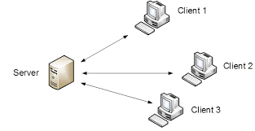

List of modules developed:

1. Client Module: Which uses Tkinter to send a request to the server.
2. Server Module: Which responds to client if the requested operation is possible.

**Network Concepts used:**

1. TCP connection
2. Socket Programming
3. Sending and receiving data with encryption

**New concepts learnt:**

1. How to use Tkinter
2. Understanding threading in python

**Sample Input and Output:**

1.User-Login

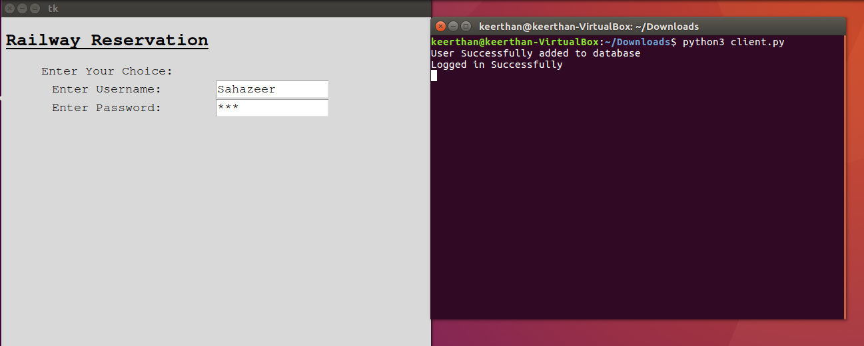

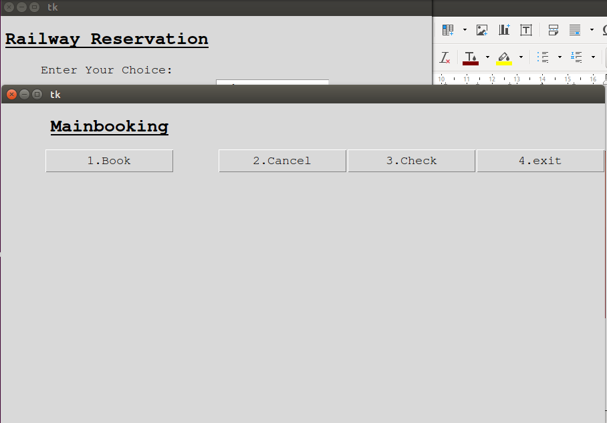

2.Booking:

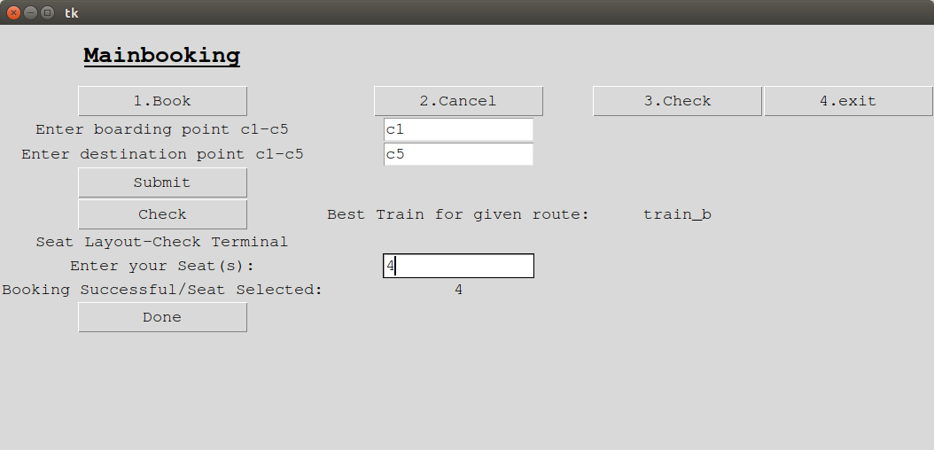

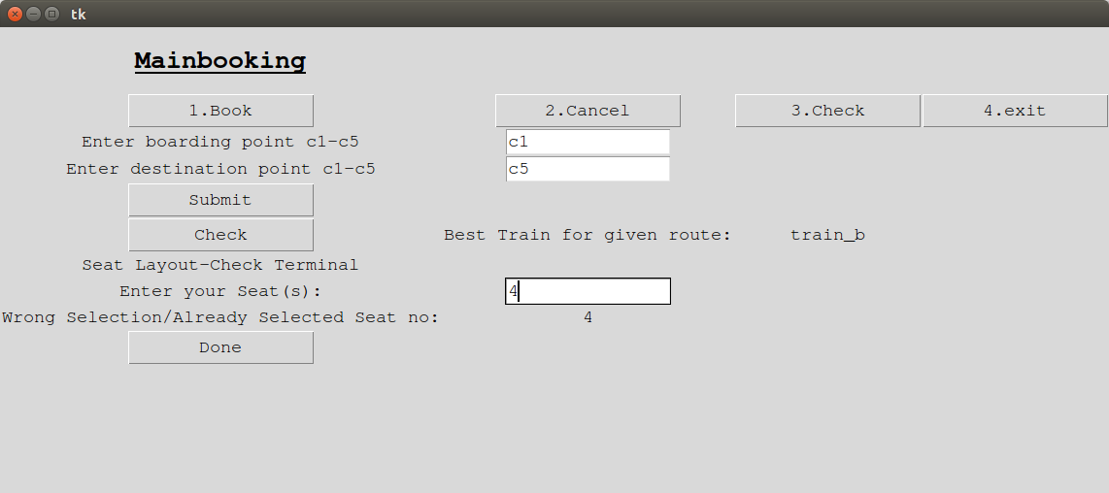

3.Check Status:

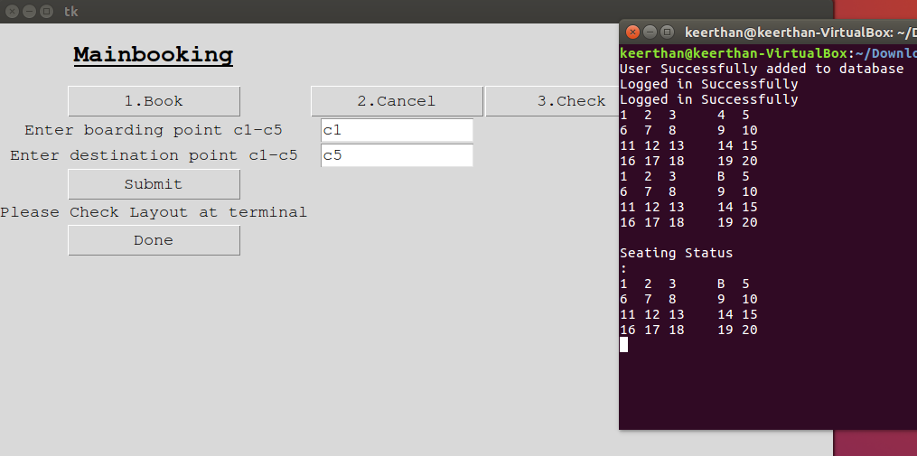

3.Cancelling Seats:

a.) Cancel all :

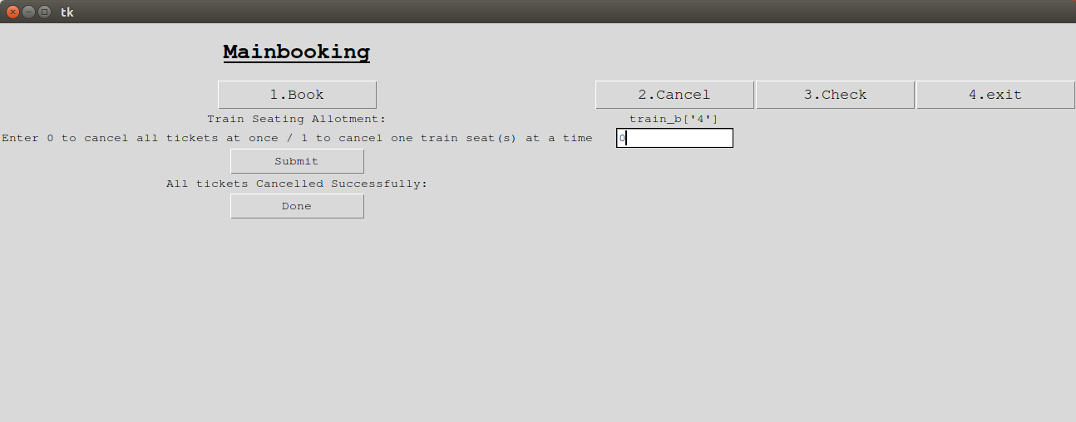

b) No Tickets to Cancel:



c)Cancel tickets one at a time :

