**DVD MANAGEMENT SYSTEM**

DVD store management system is specially designed for the purpose of adding daily DVD records in a CD/DVD store. This system makes easy for storing records as it is not time consuming. It easy to store, user just has to select DVD categories like : Movies, series, musics, animated, adults. Each of the record contains unique DVD id no. which makes easy to search. All the DVD records are maintained with their Availability Status (yes/no), their price and quantity. Each and every records are displayed in a systematic way so that the user won’t find difficulties in viewing records. The whole project is designed in ‘C’ Programming language and different variables and strings have been used for the development of this project. It’s easy to operate and understand by users. There’s no any error and warning contents in the project and the design is simple and user won’t find it difficult to use and navigate.

DVD store management system is specially designed for the purpose of adding daily DVD records in a CD/DVD store. This system makes easy for storing records as it is not time consuming. It easy to store, user just has to select DVD categories like : Movies.

**Proposed System**

As this new system will be fully automated, so manual processing will be not required to achieve any task. This system will not only keep records of the cassettes which are being sold under this shop but it will also able to maintain records or their customers and make modifications as and when required. Admin will have the option of getting all the records by using single option provided under the cd shop menu section. To make easy processing work, admin have to only enter the correct option without pressing any other button and this system will identify their choice and take action based on their selected option.

**REQUIREMENTS**

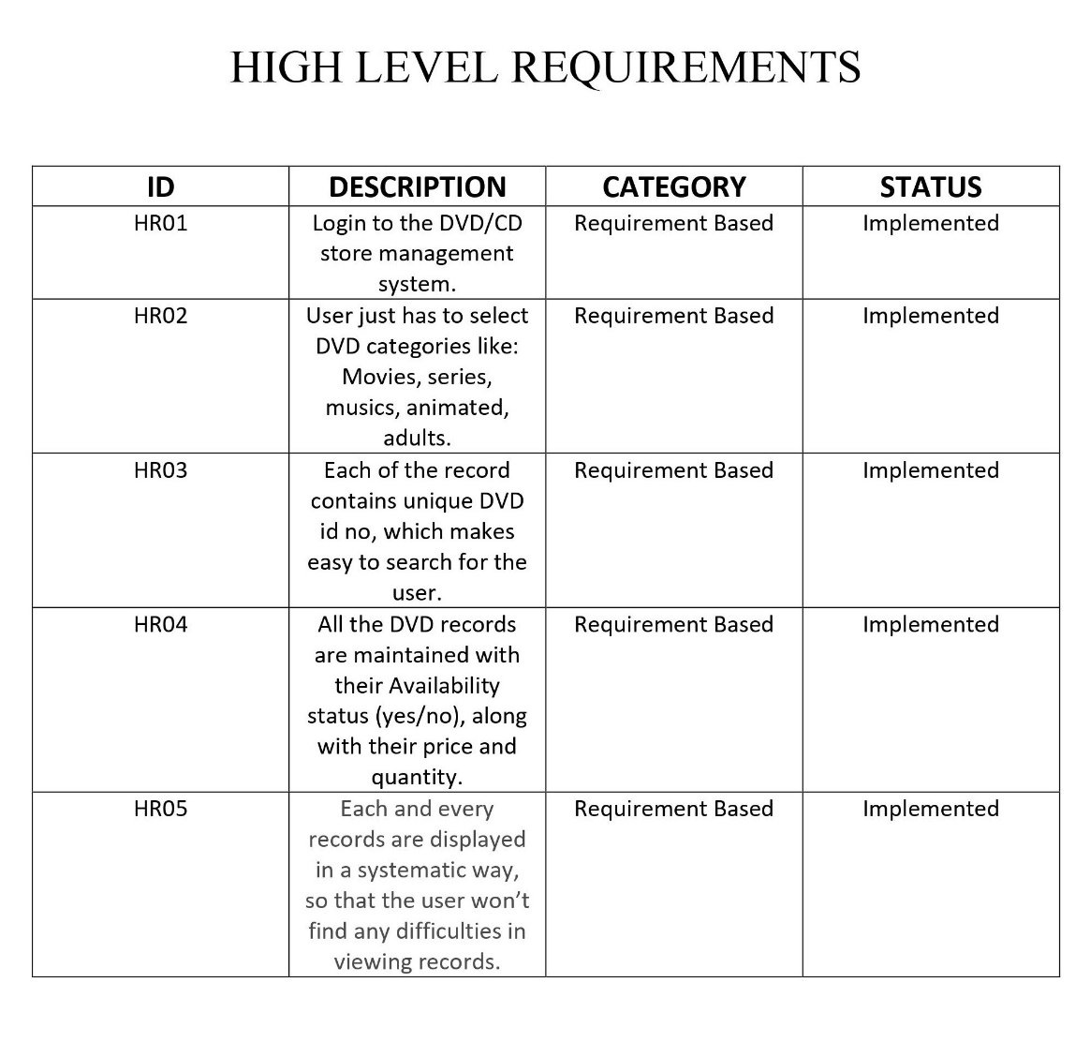

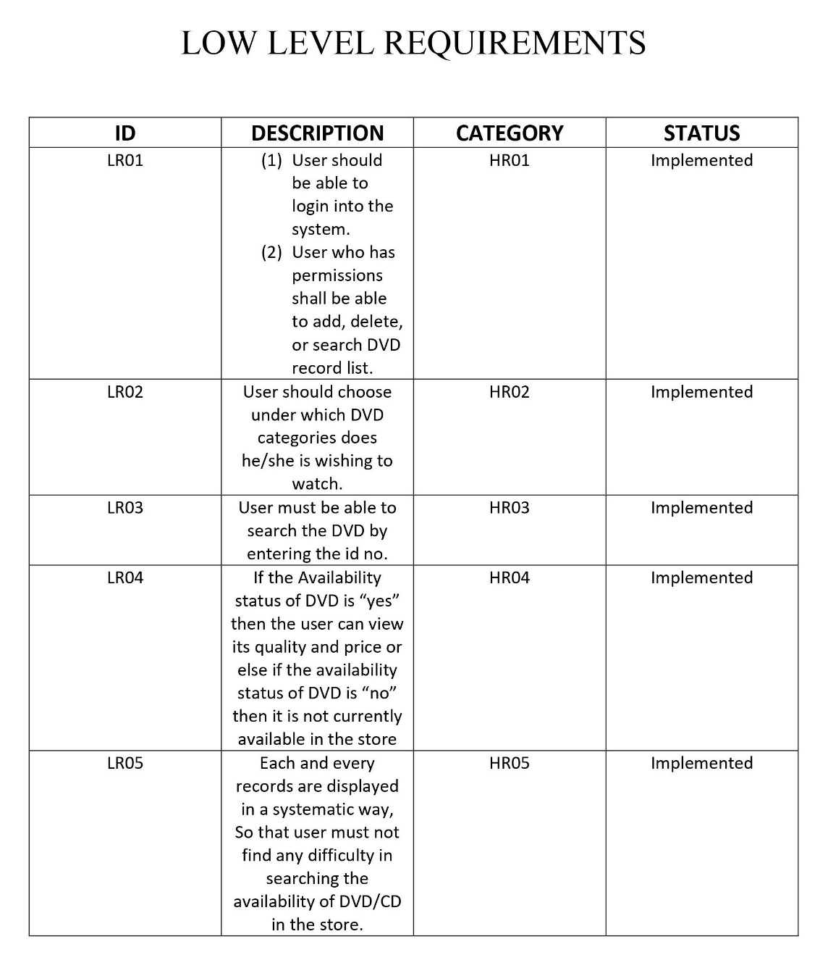

**SWOT ANALYSIS**

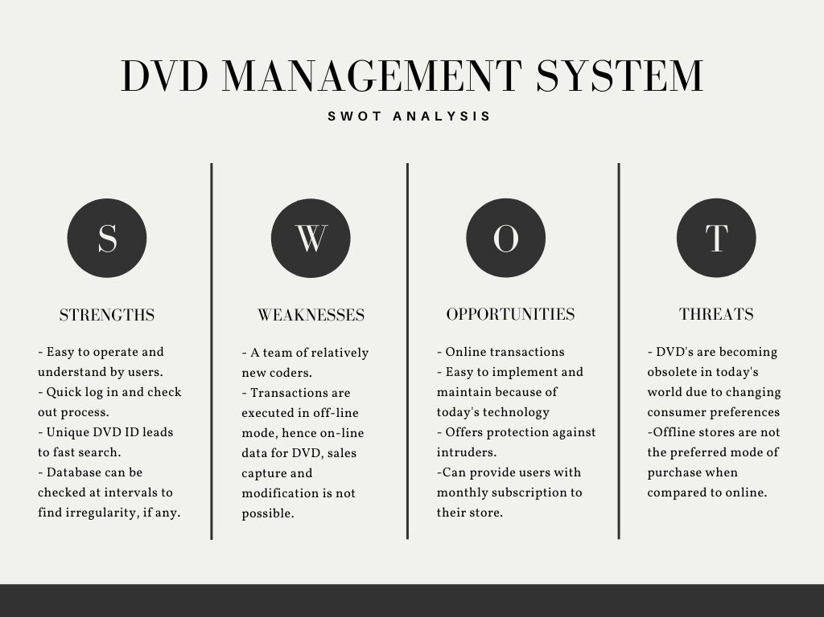

# Requirements

[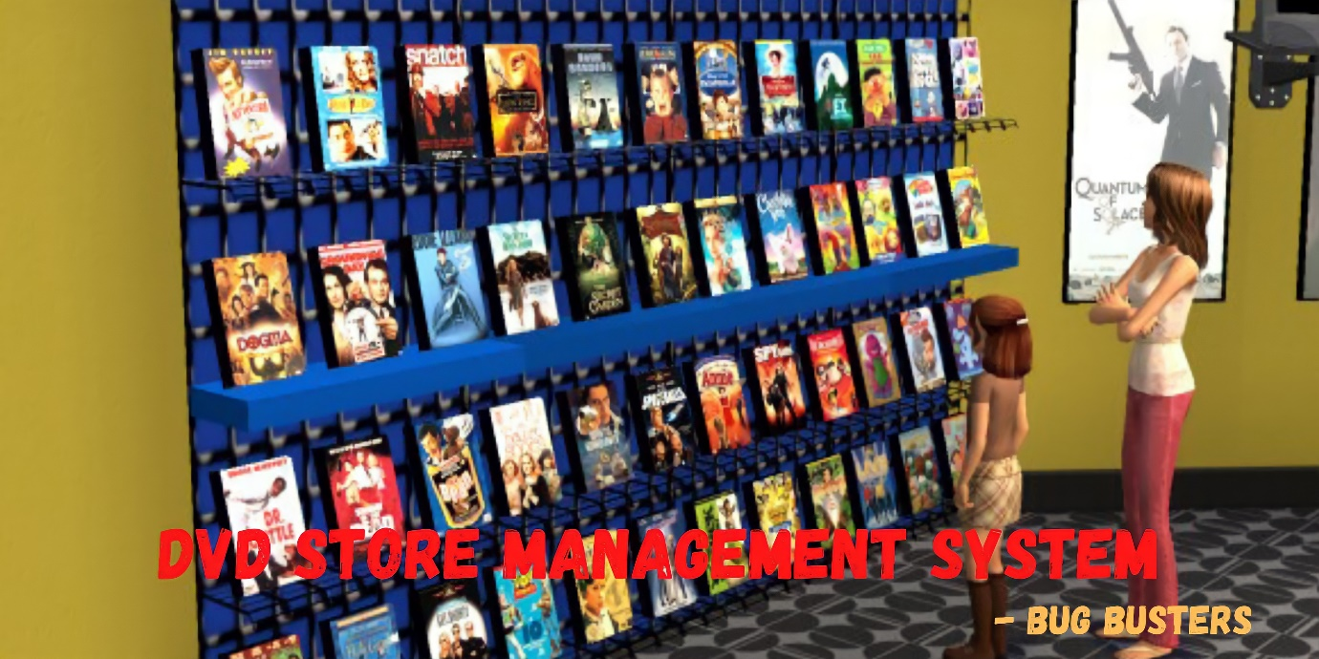](https://github.com/abhinavrj/Project-Centauri/blob/main/5_IMAGES_AND_VIDEOS/DVD%20STORE%20MANAGEMENT%20SYSTEM.jpg)

## Introduction

* DVD store management system is specially designed for the purpose of adding daily DVD records in a CD/DVD store. It easy to store, user just has to select DVD categories like : Movies, series, musics, animated, adults. Each of the record contains unique DVD id no. which makes easy to search.

## BENEFITS

1. Gaining access to a much wider collection.
2. Saving time.
3. Saving money.
4. Managing your entertainment budget.

## Cost and Features and Timeline

* This was a costless application and we have features like 1.AddDvd 2.DeleteDvd 3.SearchDvd 4.ViewDvd 5.EditDvd 6.Exit

## Defining Our System

* This application can store all DVD details, such as their category, id, quantity, availability and price.

## SWOT ANALYSIS

[](https://github.com/abhinavrj/Project-Centauri/blob/main/1_REQUIREMENTS/SWOT%20ANALYSIS.png)

# **Detail requirements**

## High Level Requirements:

# **4W's and 1'H**

## Who: Users who need to store movies, images, videos, etc and admin who need to maintain records.

## What: This system will add, modify, view, delete, access CD/DVD contents.

## When: The user can store their contents here to make a record of it.

## Where: In the management system which performs function by adding, deleting, modifying, viewing, etc the data stored.

## How: By using the different operations given after login into the system.

[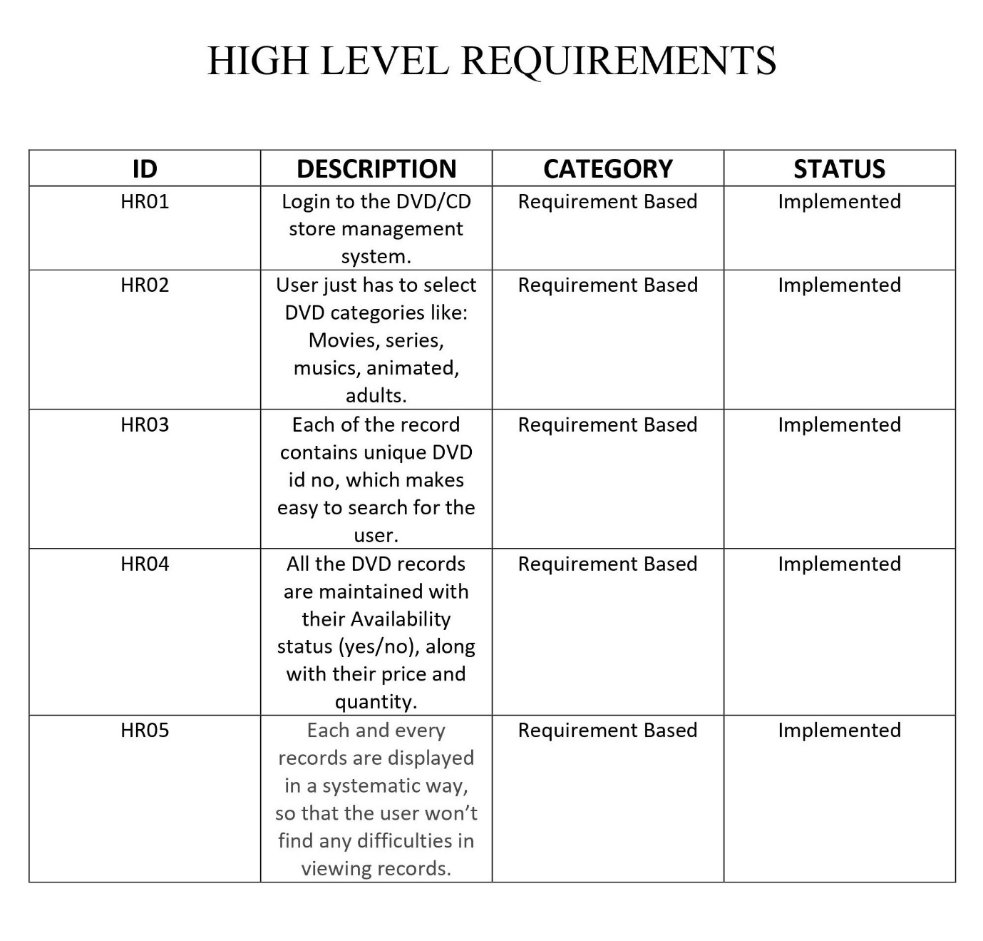](https://github.com/abhinavrj/Project-Centauri/blob/main/1_REQUIREMENTS/HIGH%20LEVEL%20REQUIREMENTS.jpg)

## Low level Requirements:

[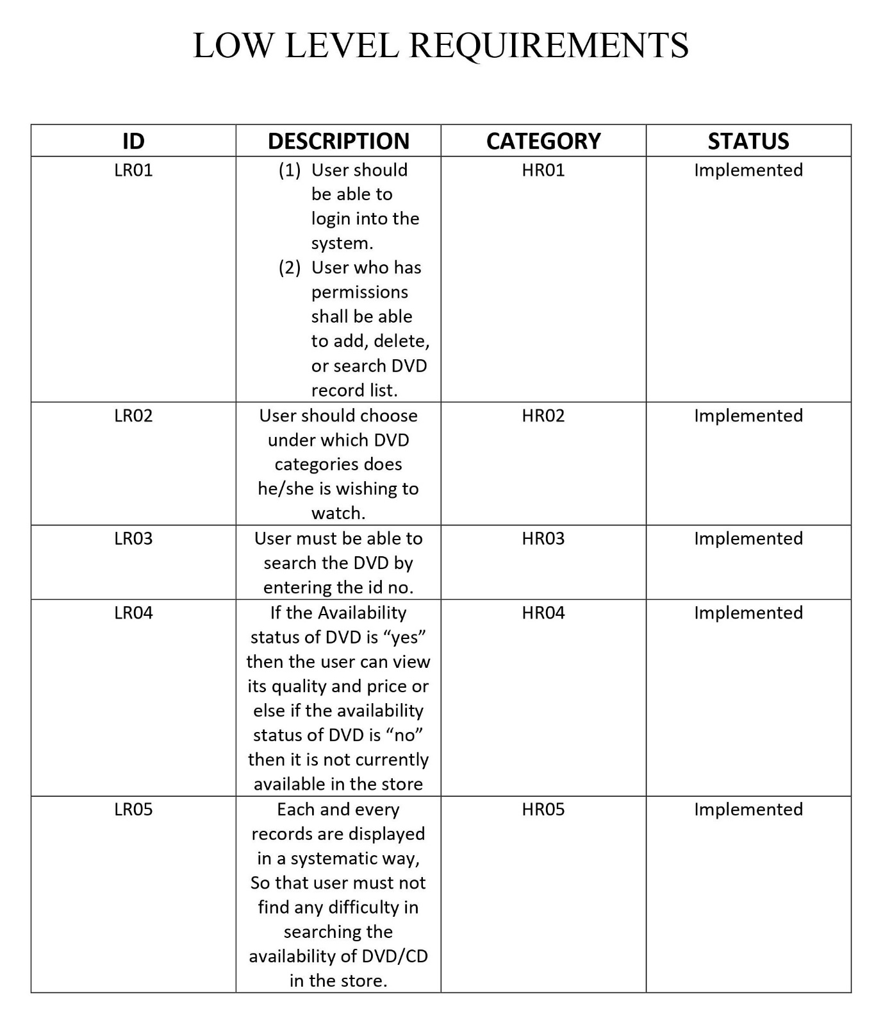](https://github.com/abhinavrj/Project-Centauri/blob/main/1_REQUIREMENTS/LOW%20LEVEL%20REQUIREMENTS.jpg)

**DESIGN**

**Architecture:**

## High Level Architecture Design

### **Architecture Design** :

[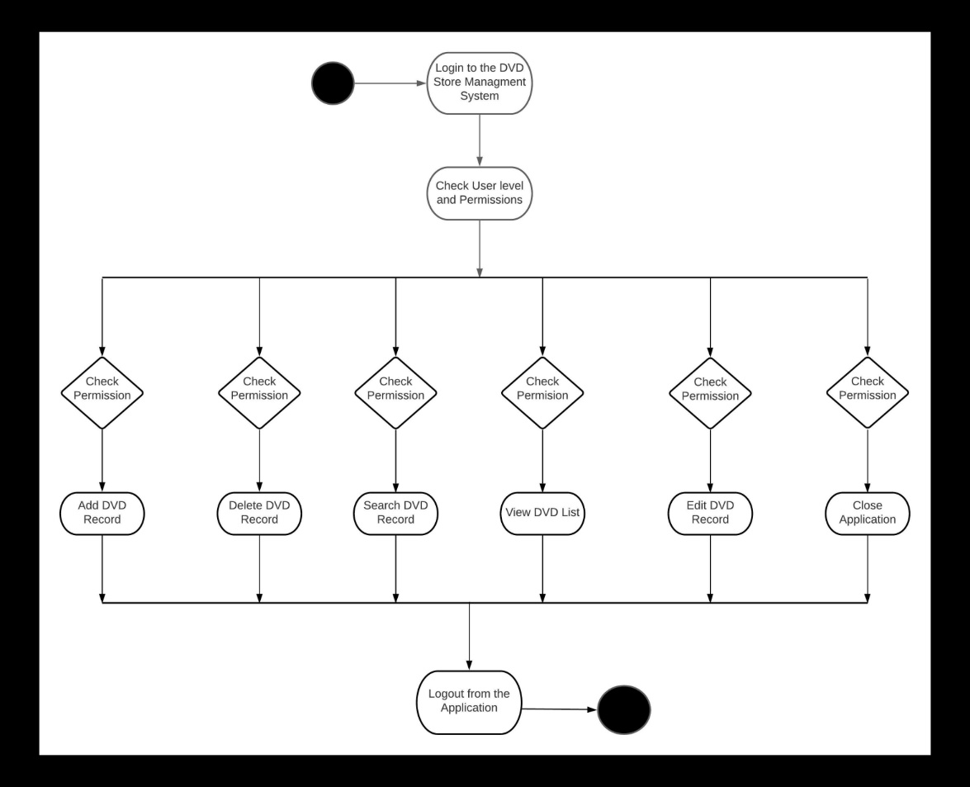](https://github.com/Keerthana-Basavaraj/Project-Centauri/blob/main/2_DESIGN/Structure%20Diagrams/Image2.jpg)

### **Usecase Diagram** :

[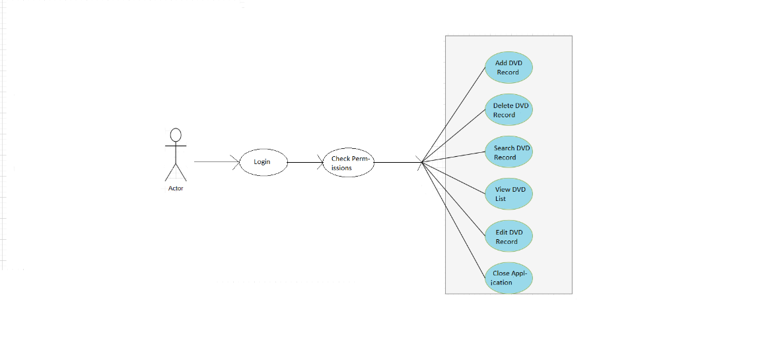](https://github.com/Keerthana-Basavaraj/Project-Centauri/blob/main/2_DESIGN/Behaviour%20Diagrams/Image1.png)

# **TEST PLAN**

## Table no: High level test plan:

| **Test ID** | **Description** | **Exp I/P** | **Exp O/P** | **Actual Out** | **Type Of Test** |
| --- | --- | --- | --- | --- | --- |
| H_01 | If User enters correct password - Checking the password | Data | Success - Program continues | Success - Program continues | Scenario based |
| H_02 | If User enters wrong password - Checking the password | Data | Fails - Program exit | Fails - Program exit | Scenario based |

## Table no: Low level test plan:

| **Test ID** | **H ID** | **Description** | **Exp IN** | **Exp OUT** | **Actual Out** | **Type Of Test** |
| --- | --- | --- | --- | --- | --- | --- |
| L_01 | H_01 | Add new DVD to store | Data | Add DVD | Add DVD | Requirement based |
| L_02 | H_01 | Delete DVD from store | Data | Delete DVD | Delete DVD | Requirement based |
| L_03 | H-01 | Search for specific DVD | Data | Search DVD | Search DVD | Requirement based |
| L_04 | H_01 | View the list of DVDs | Data | View DVD | View DVD | Requirement based |
| L_05 | H_01 | Edit DVD specific Information | Data | Edit DVD | Edit DVD | Requirement based |
| L_06 | H_01 | User wants to exit | Data | Exit | Exit | Requirement based |

IMPLEMENTATION

# **Implementation:**

## Folder Structure

| **Folder** | **description** |
| --- | --- |
| inc | All header files |
| src | Source code for DVD Store Management System |
| test | All source code and data for testing purposes |
| build | Build output (Not included in git) |

SNAPSHOTS

