PROJECT REPORT
TELECOM LOAN REPAYMENT PREDICTION USING MACHINE LEARNING
Submitted as part of Data Science Internship
at Intrnforte
Submitted by:
Keerthana Sivanandan
Submission date:
5.09.2026

ACKNOWLEDGEMENT
I would like to express my sincere gratitude to Intrnforte for providing me with the opportunity to undertake this Data Science Internship. This internship has provided me with valuable practical exposure to machine learning concepts and real-world data analysis.
I am deeply thankful to my internship mentors and the Intrnforte team for their guidance and support throughout the training. Their valuable learning resources greatly enhanced my understanding of data preprocessing, exploratory data analysis, machine learning algorithms, and model evaluation.
I would also like to thank my family and friends for their constant encouragement and support during the course of this project.

ABSTRACT
Telecom-based micro-loan services allow subscribers to borrow small amounts of credit against their mobile balance, which is expected to be repaid within a short period. Predicting whether a customer will repay such a loan on time is important for telecom operators and micro-lending partners, as it helps reduce financial risk and supports fair, data-driven lending decisions.
The primary objective of this project is to develop a machine learning model that predicts whether a customer will repay a telecom micro-loan, based on the customer's recharge behaviour, account age, rental payments, and prior loan history. The project uses a telecom loan dataset containing 209,593 customer records and 36 features, including recharge amounts, recharge frequency, rental values, loan counts, and payback duration.
The dataset was preprocessed by checking for missing values and duplicate records, removing non-informative identifier columns, and converting the recharge date into day, month, and day-of-week features. Exploratory Data Analysis (EDA) was performed to study the distribution of the target variable, identify class imbalance, detect outliers, and analyse the correlation between features and the repayment label.
Six classification models — Logistic Regression, Decision Tree, Random Forest, Gradient Boosting, Gaussian Naive Bayes, and a hyperparameter-tuned Gradient Boosting model — were implemented and compared using Log Loss, Precision, Recall, and the Area Under the ROC Curve (AUC). Among the models evaluated, the Gradient Boosting Classifier achieved the best overall performance, with a Log Loss of 0.2107, Precision of 0.9291, Recall of 0.9813, and an AUC of 0.9228, and was selected as the final model.
The results show that recharge behaviour over the previous 90 days, particularly the daily amount spent, is the strongest predictor of loan repayment. This project demonstrates how machine learning can be applied to telecom transactional data to support automated, data-driven credit risk assessment for micro-loan services.

TABLE OF CONTENTS
S.NO. | Contents | Page No.
1 | Acknowledgement | ii
2 | Abstract | iii
3 | Table of Contents | iv
4 | Introduction | 1
5 | Problem Statement | 1
6 | Objectives | 2
7 | Dataset Description | 3
8 | Methodology | 5
9 | Data Preprocessing | 6
10 | Exploratory Data Analysis | 6
11 | Model Building | 10
12 | Model Evaluation | 12
13 | Results and Discussion | 12
14 | Conclusion | 17
15 | Future Scope | 17
16 | References | 19

CHAPTER 1

1.1 INTRODUCTION
Machine learning is a branch of Artificial Intelligence that enables computers to learn patterns from historical data and make predictions without being explicitly programmed. It is widely used in domains such as healthcare, finance, education, agriculture, and telecommunications, including applications such as churn prediction, fraud detection, and credit risk assessment.
Telecom operators in many markets offer micro-loan or 'balance advance' services, where a subscriber who has run out of mobile balance can borrow a small amount of credit that is automatically deducted from a future recharge. Because these loans are issued instantly and without traditional credit checks, operators need a reliable way to estimate the likelihood that a given subscriber will repay the loan on time.
In this project, a telecom loan dataset is used to develop a predictive model for loan repayment. The dataset contains anonymised subscriber-level attributes describing recharge behaviour, account tenure, rental payments, and prior loan activity, along with a binary label indicating whether the loan was repaid. Before building the model, the dataset is preprocessed by checking for missing values and duplicates, removing non-informative columns, engineering date-based features, and performing Exploratory Data Analysis (EDA) to understand the characteristics of the data.
Six machine learning classifiers — Logistic Regression, Decision Tree, Random Forest, Gradient Boosting, Gaussian Naive Bayes, and a tuned Gradient Boosting model — are implemented and compared. Their performance is evaluated using Log Loss, Precision, Recall, and AUC. Based on the evaluation results, the Gradient Boosting Classifier achieved the best overall performance and was selected as the final model.
This project demonstrates how machine learning techniques can be applied to telecom transactional data to support automated, data-driven credit decision-making for micro-loan services.

1.2 PROBLEM STATEMENT
Deciding whether to grant a telecom micro-loan to a subscriber is a challenging task because repayment behaviour depends on multiple factors such as recharge frequency, average daily spend, account tenure, rental payments, and the subscriber's prior loan history. Because these loans are disbursed instantly, there is no time for manual assessment, and a poor decision can result in financial loss for the lender.
The objective of this project is to develop a machine learning model that accurately predicts whether a subscriber will repay a telecom micro-loan. The model should analyse historical recharge and loan data, learn the relationship between subscriber behaviour and repayment outcomes, and generate reliable predictions for new applicants.

1.3 OBJECTIVES
The main objectives of this project are:
- To develop a machine learning model for telecom loan repayment prediction.
- To preprocess the dataset by checking for missing values, duplicates, and irrelevant columns.
- To engineer useful features from the recharge date field.
- To perform Exploratory Data Analysis (EDA) to understand the data and the class balance of the target variable.
- To identify the features that most strongly influence loan repayment.
- To train multiple machine learning classification models.
- To compare the performance of different classification algorithms.
- To evaluate the models using Log Loss, Precision, Recall, and AUC.
- To tune the best-performing model using hyperparameter optimisation.
- To identify the best-performing model for predicting loan repayment.

1.4 SCOPE OF PROJECT
The scope of this project includes developing a machine learning-based system for predicting telecom micro-loan repayment using historical subscriber transaction data. The project demonstrates the complete workflow of a binary classification problem, including data preprocessing, visualisation, feature engineering, model training, hyperparameter tuning, and evaluation. The developed model can assist telecom operators and micro-lending partners in assessing credit risk more accurately and can be extended for use in real-world lending applications.

CHAPTER 2
DATASET DESCRIPTION

2.1 Dataset Overview
The dataset used in this project is a telecom micro-loan dataset containing anonymised subscriber-level records. It is a widely used dataset for binary classification problems related to telecom-based micro-lending. The objective of the dataset is to predict whether a subscriber will repay a short-term mobile balance loan, represented by the target column label.
The dataset consists of a single file containing both the input features and the target variable. Each row represents one subscriber, identified by an anonymised mobile number (msisdn), along with recharge history, rental payments, loan history, and the recharge date.

2.2 Dataset Information
Attribute | Description
Dataset Name | Telecom Micro-Loan Dataset (sample_data_intw.csv)
Source | Telecom subscriber transaction records
Problem Type | Binary Classification
Total Records | 209,593
Number of Features | 35 (excluding target variable)
Target Variable | label
Missing Values | None
Duplicate Records | 1

2.3 Target Variable
The target variable in this project is label. A value of 1 indicates that the subscriber repaid the loan, while a value of 0 indicates that the loan was not repaid. The dataset is imbalanced: approximately 87.5% of records belong to class 1 (repaid) and 12.5% belong to class 0 (not repaid). This imbalance was taken into account during model training and evaluation.

2.4 Important Features
Although the dataset contains many attributes, some of the most influential features identified during analysis include:
Feature | Description
aon | Age on network — number of days since the subscriber joined
daily_decr30 / daily_decr90 | Average daily amount spent from main account over the last 30/90 days
rental30 / rental90 | Average main account balance (rental) over the last 30/90 days
cnt_ma_rech30 / cnt_ma_rech90 | Number of times the main account was recharged in the last 30/90 days
sumamnt_ma_rech30 / sumamnt_ma_rech90 | Total amount of main account recharges in the last 30/90 days
last_rech_amt_ma | Amount of the most recent main account recharge
cnt_loans30 / cnt_loans90 | Number of loans taken in the last 30/90 days
payback30 / payback90 | Average number of days taken to repay loans in the last 30/90 days

These features significantly influence loan repayment behaviour and play an important role in building an accurate prediction model.

2.5 Dataset Challenges
Before training the machine learning models, several challenges in the dataset were addressed:
- Severe class imbalance, with repaid loans (label = 1) far outnumbering defaults (label = 0).
- Presence of a duplicate record.
- Identifier and constant-value columns (msisdn and pcircle) that do not contribute predictive information.
- The recharge date (pdate) stored as text, requiring conversion into usable numerical features.
- Presence of outliers in several numerical columns, such as recharge amounts and loan counts.
- Different feature scales and distributions across the 35 input features.
These issues were resolved during the data preprocessing stage to improve the performance and reliability of the machine learning models.
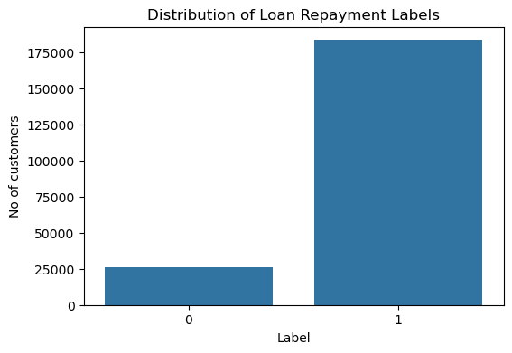
Figure 1: Distribution of Loan Repayment Labels

CHAPTER 3
METHODOLOGY

3.1 Overview
The methodology describes the sequence of steps followed to build the telecom loan repayment prediction model. The project started with collecting the dataset, followed by data preprocessing, exploratory data analysis, feature engineering, model training, hyperparameter tuning, and performance evaluation. The complete workflow is illustrated through the following stages.

3.2 Workflow
The methodology adopted for this project consists of the following steps:
- Data Collection
- Data Loading
- Data Preprocessing
- Exploratory Data Analysis
- Feature Engineering
- Data Splitting
- Feature Scaling
- Model Building
- Model Evaluation
- Hyperparameter Tuning
- Feature Importance Analysis

3.3 Data Collection
The dataset used for this project is a telecom micro-loan dataset (sample_data_intw.csv) containing 209,593 subscriber records with 36 columns, including recharge behaviour, rental payments, loan history, and the loan repayment label.

3.4 Data Loading
The dataset was loaded into Python using the Pandas library. The first few records were displayed using the head() function, and the structure of the dataset was examined using the info() and describe() functions. This confirmed that the dataset contained 209,593 rows and 36 columns, with 21 float, 12 integer, and 3 object-type columns.

3.5 Data Preprocessing
Data preprocessing was performed to improve the quality of the dataset before model training. The following operations were carried out:
- Checking for missing values across all columns (none were found).
- Identifying and noting duplicate records (one duplicate row was found).
- Examining the pcircle column, which was found to contain only a single unique value and therefore carried no predictive information.
- Dropping the identifier column (msisdn), the constant column (pcircle), and the raw date column (pdate) after feature extraction, since these do not contribute to prediction.

3.6 Feature Engineering
The recharge date column (pdate) was converted from text into a proper datetime format. Three new features were then derived from it: pdate_day (day of the month), pdate_month (month), and pdate_dayofweek (day of the week). These features help capture any time-based patterns in loan repayment behaviour, such as variation in repayment rates across different months or days of the week.

3.7 Exploratory Data Analysis
Exploratory Data Analysis was performed to understand the characteristics of the dataset. Various visualisation techniques were used to study the distribution of variables, the balance of the target class, relationships between features, and repayment patterns over time.
The following analyses were performed:
- Distribution of the loan repayment label.
- Histograms of all numerical features.
- Correlation analysis between features and the target variable.
- Box plots for outlier detection on key features.
- Loan repayment rate by month and by day of the week.
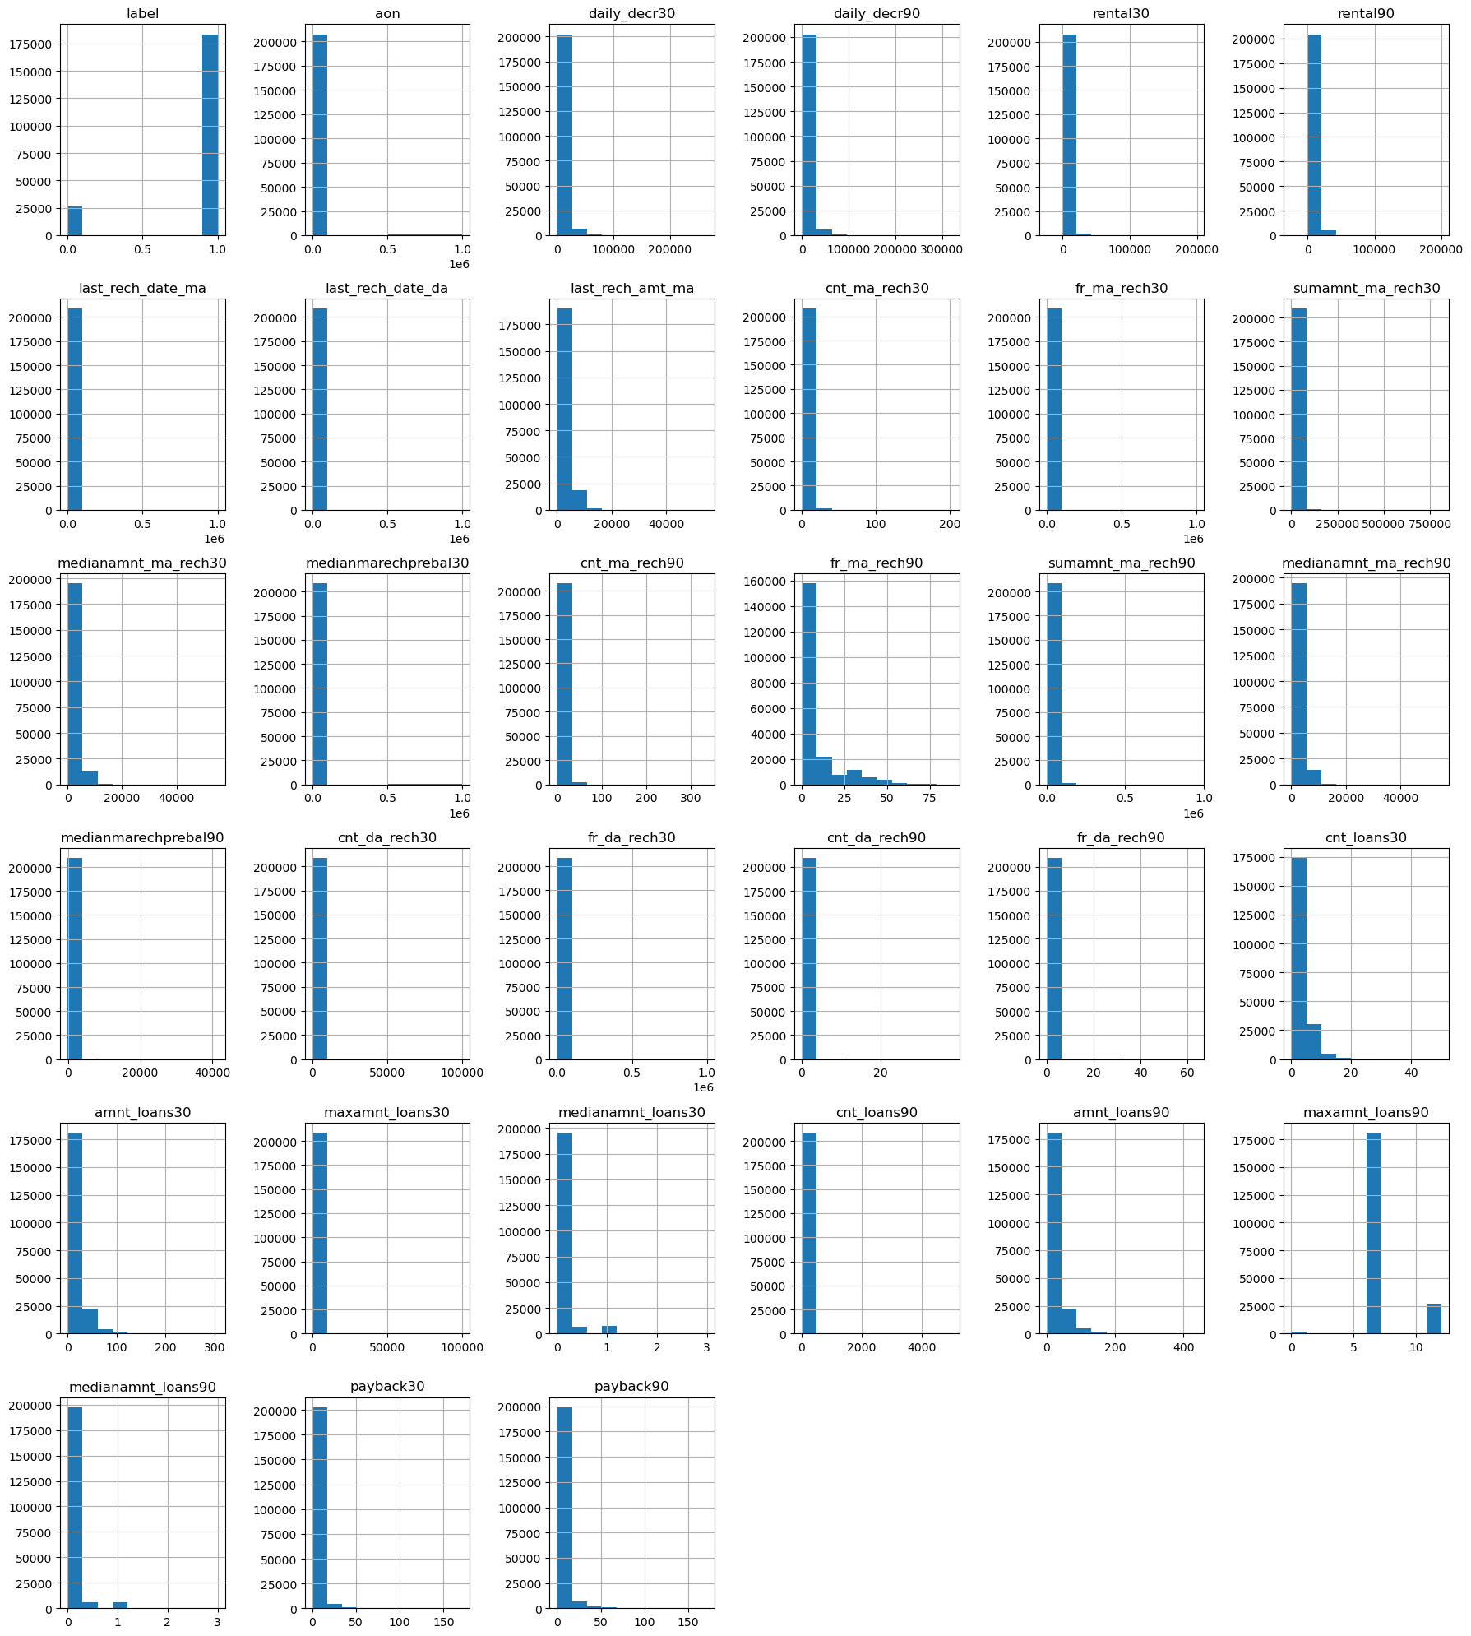
Figure 2: Histograms of Numerical Features in the Telecom Loan Dataset
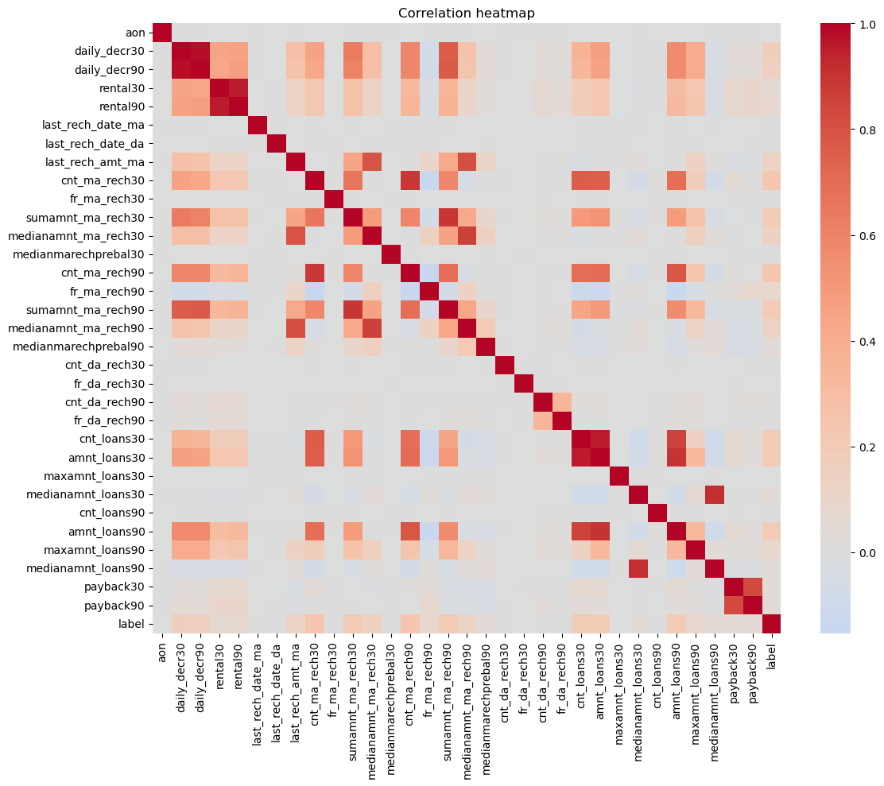
Figure 3: Correlation Heatmap of Features and the Repayment Label

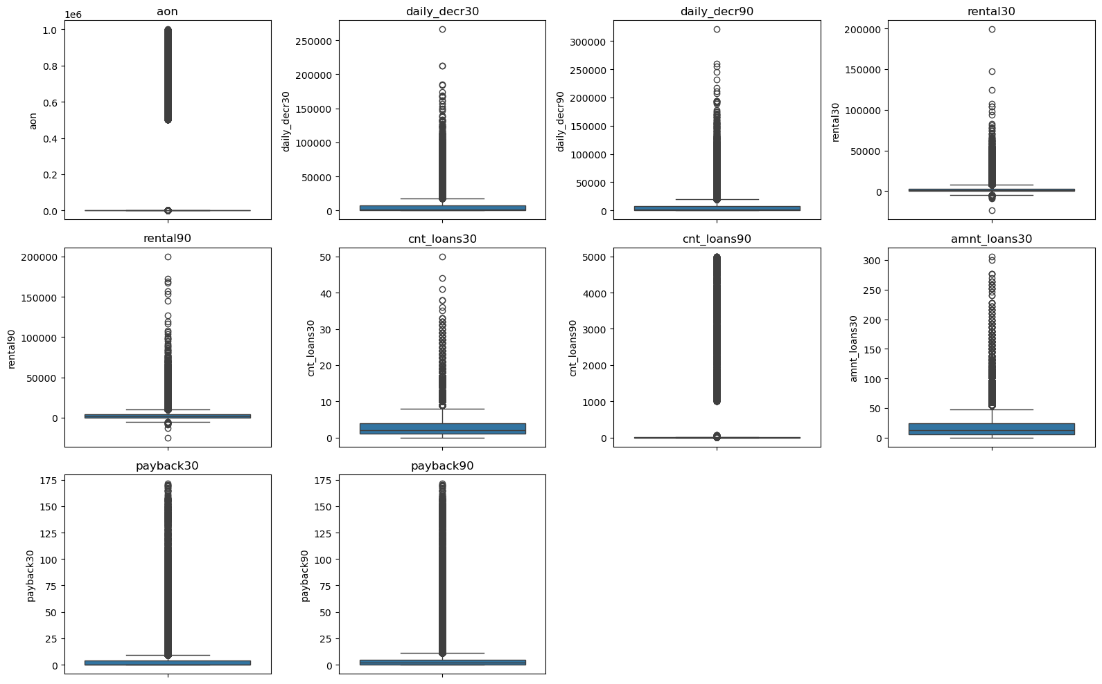
Figure 4: Box Plots for Outlier Detection on Key Features
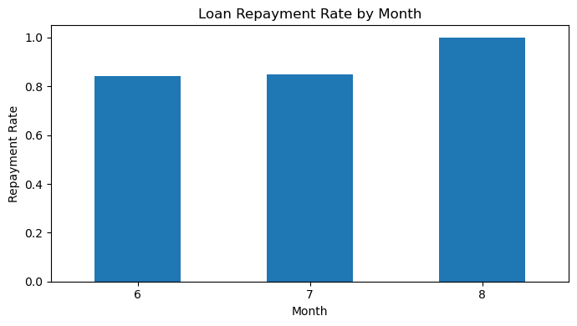
Figure 5: Loan Repayment Rate by Month
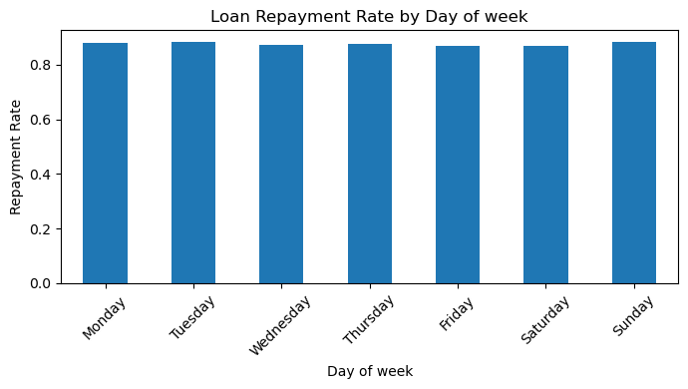
Figure 6: Loan Repayment Rate by Day of the Week

The correlation analysis showed that recharge-related features, particularly cnt_ma_rech30, cnt_ma_rech90, sumamnt_ma_rech30, and sumamnt_ma_rech90, had the strongest positive correlation with loan repayment, while columns such as aon and medianmarechprebal30 showed almost no linear relationship with the target variable.

CHAPTER 4
MODEL DEVELOPMENT AND EVALUATION

4.1 Data Preparation for Model Training
After completing Exploratory Data Analysis, the dataset was prepared for machine learning. The target variable, label, was separated from the input features. The identifier, constant, and raw date columns were already removed during preprocessing, leaving 35 input features.
The dataset was divided into:
- x — independent/input features (209,593 rows × 35 columns)
- y — dependent/target variable (label)

4.2 Train-Test Split
The processed dataset was divided into training and testing subsets using the train_test_split() function, with 80% of the data used for training (167,674 records) and 20% used for testing (41,919 records). The split was stratified on the target variable to preserve the same class proportion in both subsets.

4.3 Feature Scaling
Since Logistic Regression and Gaussian Naive Bayes are sensitive to differences in feature scale, the input features were standardised using StandardScaler, fitted on the training data and applied to both the training and test sets. Tree-based models (Decision Tree, Random Forest, and Gradient Boosting) were trained on the unscaled features, since these algorithms are not sensitive to feature scaling.

4.4 Machine Learning Models
Six classification models were implemented for telecom loan repayment prediction:

4.4.1 Logistic Regression
Logistic Regression was used as a baseline classification model. It estimates the probability of loan repayment using a linear combination of the input features, with class_weight set to 'balanced' to account for the class imbalance.

4.4.2 Decision Tree Classifier
The Decision Tree Classifier predicts loan repayment by splitting the data into smaller groups based on feature values. It can capture non-linear relationships between features and the target variable, and class_weight was set to 'balanced' to handle the class imbalance.

4.4.3 Random Forest Classifier
The Random Forest Classifier combines predictions from 100 decision trees trained on different subsets of the data. This ensemble approach generally provides better stability and reduces the risk of overfitting compared with a single decision tree.

4.4.4 Gradient Boosting Classifier
The Gradient Boosting Classifier builds an ensemble of decision trees sequentially, where each new tree corrects the errors made by the previous ones. It was configured with 100 estimators, a learning rate of 0.1, and a maximum depth of 3.

4.4.5 Gaussian Naive Bayes
Gaussian Naive Bayes is a probabilistic classifier based on Bayes' theorem, assuming that features are conditionally independent given the class label. It was trained on the standardised features as a lightweight baseline model.

4.4.6 Tuned Gradient Boosting Classifier
To further improve performance, the Gradient Boosting Classifier was tuned using RandomizedSearchCV over a grid of n_estimators, learning_rate, and max_depth values, optimised for negative log loss with 2-fold cross-validation. The best parameters found were n_estimators = 100, max_depth = 2, and learning_rate = 0.1.

4.5 Model Evaluation Metrics
The models were evaluated using the following metrics:
Log Loss:
Log Loss measures how close the predicted probabilities are to the actual class labels, penalising confident but incorrect predictions. Lower Log Loss indicates better performance.
Precision:
Precision measures the proportion of predicted repayments that were actually repaid. Higher precision indicates fewer false approvals.
Recall:
Recall measures the proportion of actual repayments that were correctly identified by the model. Higher recall indicates fewer missed repayers.
AUC (Area Under the ROC Curve):
AUC measures the model's ability to distinguish between the repaid and not-repaid classes across all classification thresholds. Higher AUC indicates better overall discriminative ability.

4.6 Model Performance
The performance of the six classification models was evaluated using Log Loss, Precision, Recall, and AUC. These metrics were used to compare the prediction accuracy of Logistic Regression, Decision Tree, Random Forest, Gradient Boosting, Gaussian Naive Bayes, and the tuned Gradient Boosting model.

4.6.1 Model Comparison

Model | Log Loss | Precision | Recall | AUC
Logistic Regression | 0.5193 | 0.9636 | 0.6918 | 0.8310
Decision Tree | 4.0155 | 0.9342 | 0.9388 | 0.7377
Random Forest | 0.2231 | 0.9314 | 0.9814 | 0.9274
Gradient Boosting | 0.2107 | 0.9291 | 0.9813 | 0.9228
Gaussian Naive Bayes | 3.4601 | 0.9697 | 0.5473 | 0.8039
Tuned Gradient Boosting | 0.2271 | 0.9120 | 0.9907 | 0.9092

4.6.2 Results and Discussion
The performance of the six classification models was compared. The Logistic Regression model achieved a reasonable AUC of 0.8310 but had the lowest recall (0.6918), meaning it missed a substantial number of subscribers who did repay their loans. The Decision Tree Classifier achieved a high recall (0.9388) but the highest Log Loss (4.0155) among all models, indicating poorly calibrated probability estimates despite reasonable class predictions.
The Gradient Boosting Classifier achieved the lowest Log Loss (0.2107) together with strong Precision (0.9291) and Recall (0.9813), making it the most balanced and reliable model overall. The Random Forest Classifier performed similarly, with the highest AUC (0.9274) and a slightly higher Log Loss (0.2231). Gaussian Naive Bayes obtained the highest Precision (0.9697) but the second-lowest Recall (0.5473), indicating that it was overly conservative in predicting repayment.
Hyperparameter tuning of the Gradient Boosting model improved Recall further to 0.9907 but slightly increased Log Loss to 0.2271 and reduced Precision to 0.9120, reflecting a trade-off between catching more repayers and avoiding false approvals. Based on the overall balance of Log Loss, Precision, and Recall, the untuned Gradient Boosting Classifier was selected as the final model for this project.
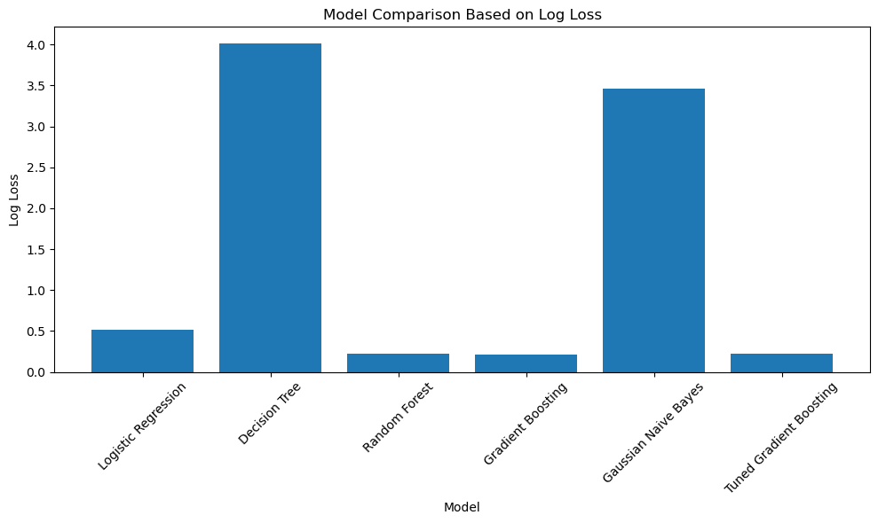
Figure 7: Model Comparison Based on Log Loss
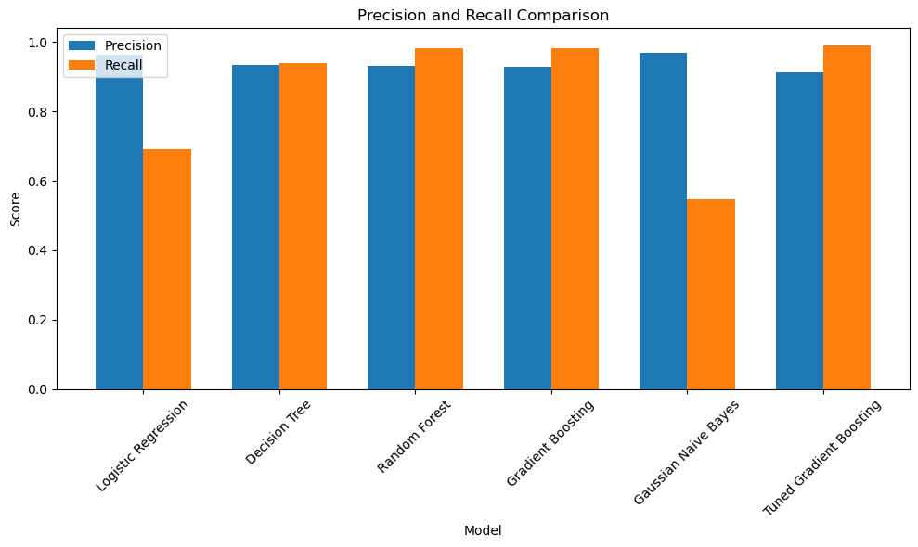
Figure 8: Precision and Recall Comparison Across Models

4.7 ROC Curve and AUC Comparison
The Receiver Operating Characteristic (ROC) curve was plotted for all six models to visualise the trade-off between the true positive rate and false positive rate at different classification thresholds. The Random Forest and Gradient Boosting models produced curves closest to the top-left corner, confirming their strong discriminative ability, while the Decision Tree model showed the weakest separation between classes.
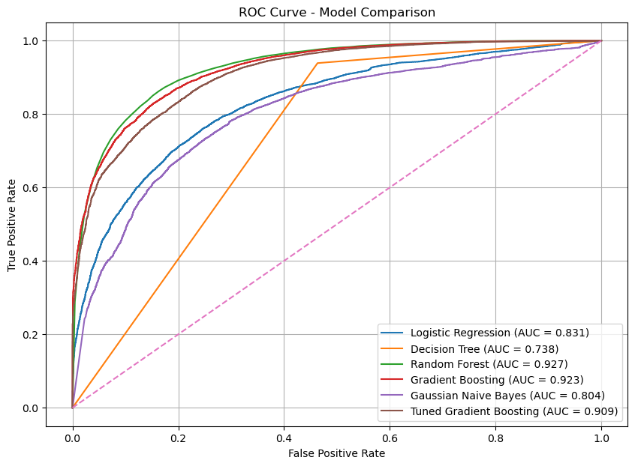
Figure 9: ROC Curve Comparison Across All Models

4.8 Confusion Matrix and Classification Report
The confusion matrix for the tuned Gradient Boosting model on the test set is shown below, along with the detailed classification report.
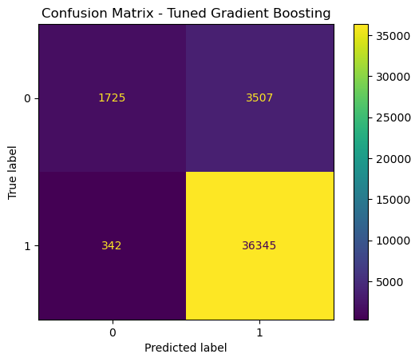
Figure 10: Confusion Matrix — Tuned Gradient Boosting Classifier
Class | Precision | Recall | F1-score | Support
0 (Not Repaid) | 0.83 | 0.33 | 0.47 | 5,232
1 (Repaid) | 0.91 | 0.99 | 0.95 | 36,687
Accuracy |  |  | 0.91 | 41,919
Macro Avg | 0.87 | 0.66 | 0.71 | 41,919
Weighted Avg | 0.90 | 0.91 | 0.89 | 41,919

The classification report confirms that the model performs very well at identifying subscribers who will repay their loans (class 1), with a recall of 0.99, but performs noticeably worse at identifying subscribers who will default (class 0), with a recall of only 0.33. This is a direct consequence of the class imbalance in the dataset, and highlights an area for further improvement.

4.9 Feature Importance Analysis
Feature importance analysis was performed using the Gradient Boosting model to identify the features that contributed most to predicting loan repayment. Features with higher importance values have a greater influence on the model's predictions.
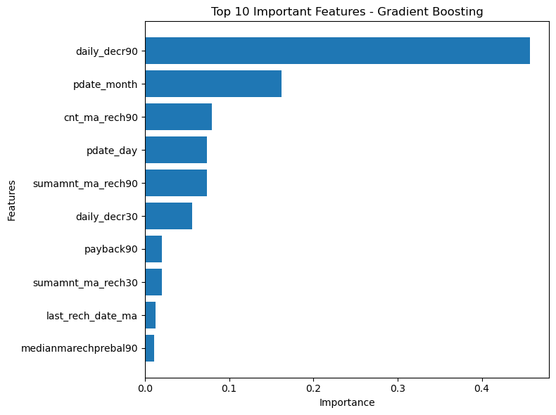
Figure 11: Top 10 Important Features for Telecom Loan Repayment Prediction
The daily amount spent from the main account over the last 90 days (daily_decr90) was, by far, the most important predictor of loan repayment, followed by the recharge month (pdate_month) and the number of main account recharges over the last 90 days (cnt_ma_rech90). This indicates that recent spending activity is a much stronger signal of a subscriber's ability to repay than static attributes such as account age.

4.10 Final Model Summary
Based on the evaluation across all metrics, the Gradient Boosting Classifier was selected as the final model for telecom loan repayment prediction, with the following test-set performance:
- Log Loss: 0.2107
- Precision: 0.9291
- Recall: 0.9813
- AUC: 0.9228

CHAPTER 5
CONCLUSION AND FUTURE SCOPE

5.1 Conclusion
This project focused on developing a machine learning-based system for predicting telecom micro-loan repayment using a large subscriber-level dataset. The project involved data preprocessing, exploratory data analysis, feature engineering, model development, hyperparameter tuning, and performance evaluation.
Exploratory Data Analysis was performed to understand the distribution of numerical features, the imbalance in the loan repayment label, relationships between features, and repayment patterns across time. The data was then prepared for machine learning by removing non-informative columns, engineering date-based features, and scaling features where required.
Six classification models, namely Logistic Regression, Decision Tree, Random Forest, Gradient Boosting, Gaussian Naive Bayes, and a tuned Gradient Boosting model, were implemented and evaluated using Log Loss, Precision, Recall, and AUC.
Among the six models, the Gradient Boosting Classifier performed the best overall, achieving a Log Loss of 0.2107, Precision of 0.9291, Recall of 0.9813, and an AUC of 0.9228. Therefore, the Gradient Boosting Classifier was selected as the best-performing model for this project.
The project demonstrates how machine learning techniques can be applied to real-world telecom transactional data to support automated credit risk assessment. The analysis also showed that recent recharge and spending behaviour contributes far more to predicting loan repayment than static subscriber attributes.

5.2 Future Scope
The project can be further improved by applying advanced machine learning and optimisation techniques. A more extensive hyperparameter search, using a wider parameter grid and higher cross-validation folds, could further improve the performance of the Gradient Boosting model. Other advanced algorithms such as XGBoost, LightGBM, or CatBoost could also be explored.
Techniques for handling class imbalance more directly, such as SMOTE oversampling or cost-sensitive learning, could be applied to improve the model's ability to correctly identify subscribers who are likely to default (class 0), which remains the weakest area of the current model.
Additional feature engineering could be performed to create more meaningful variables, such as recharge trend or spending volatility over time. Cross-validation could be used to obtain a more reliable estimate of model performance across different data splits. The trained model could also be deployed as a real-time scoring service that telecom operators can use to make instant lending decisions.
In the future, the system could be enhanced by incorporating additional data sources, such as call and data usage patterns, customer complaint history, and broader socio-economic indicators, to further improve prediction accuracy.

REFERENCES
- Telecom Micro-Loan Dataset (sample_data_intw.csv) — subscriber transaction and loan repayment records.
- Python Software Foundation. Python Documentation.
- Pandas Documentation — documentation for data manipulation and analysis.
- Scikit-learn Documentation — documentation for machine learning algorithms and evaluation metrics.
- Matplotlib Documentation — documentation for data visualisation.
- Seaborn Documentation — documentation for statistical data visualisation.

