**OUTPUT**

* **Output for task1_UsingAnonymous_IIFE_Functions.html**

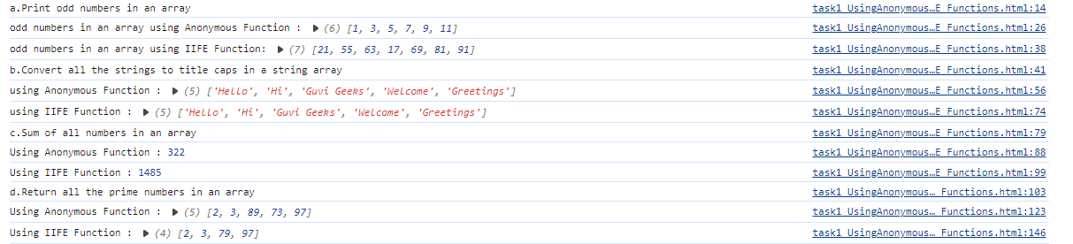

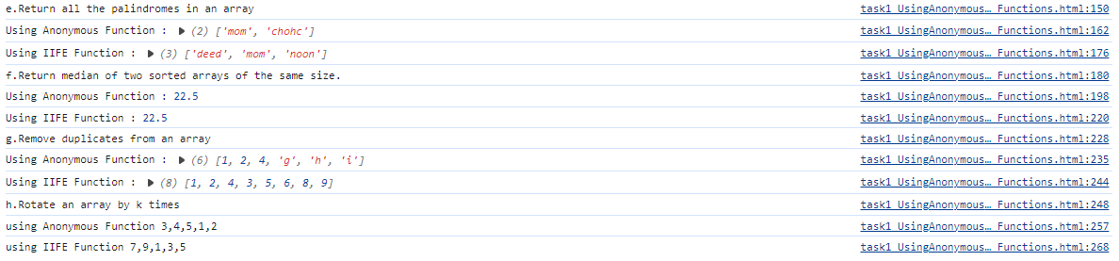

* **Output for task2_UsingArrowFunctions.html**

