**OUTPUT**

* **Output for task1_Resume_in_JSON_Format.html**

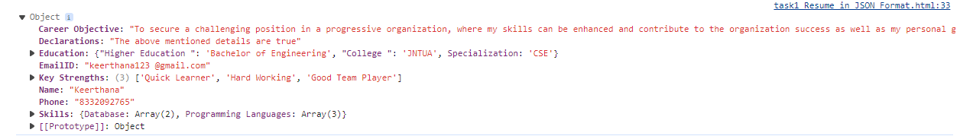

* **Output for task2_For_Loops.html**

