**OUTPUT**

* **Output for movie_class_task.html**



* **Output for circle_class_task.html**

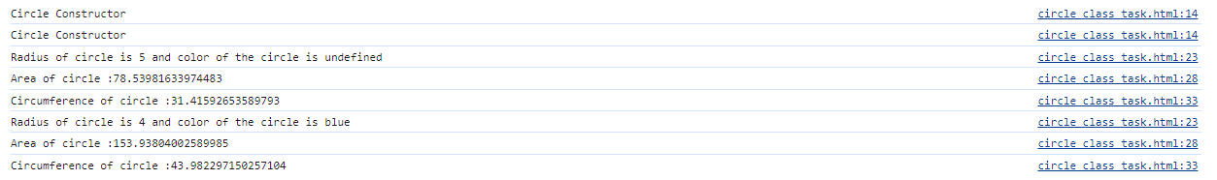

* **Output for person_class_task.html**

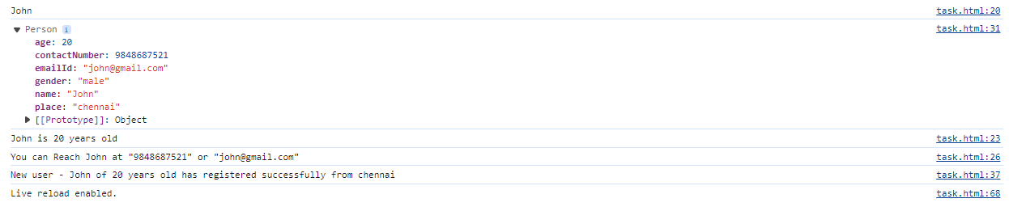

* **Output for uber_class_task.html**

