**Name: KEERTHANA DINESH A**

**Roll No:11**

**Batch:S2 RMCA-B**

**Date:08-04-22**

**ADVANCED DBMS LAB**

**EXPERIMENT NO: 2**

**AIM**

To familiarize with selecting data from single table

**QUESTION**

1. List all data from table deposite

2. List all data from borrow

3. List all data from customer

4. List all data from branch

5. Give account no and amount of deposite

6. Give customer name and account no of depositors

7. Give name of customers

8. Give name of branches

9. Give name of borrows

10. Give names of customer living in city Nagpur

11. Give names of depositors having amount greater than 4000

12. Give account date of Anil

13. Give name of all branches located in Bombay

14. Give name of borrower having loan number l206

15. Give names of depositors having account at VRCE

16. Give names of all branched located in city Delhi

17. Give name of the customers who opened account date ‘1996-03-27’

18. Give account no and deposit amount of customers having account opened between dates  ‘1995-03-01' AND '1995-12-17'

19. Give name of the city where branch KAROLBAGH is located

20. Give details of customer MADHURI

**PROCEDURE**

1.SELECT*FROM DEPOSIT;

**Output Screenshot**

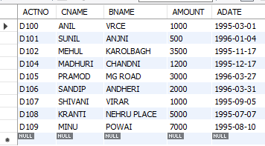

**PROCEDURE**

2.SELECT*FROM BORROW;

**Output Screenshot**

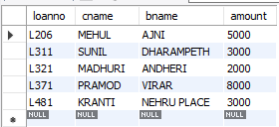

**PROCEDURE**

3.SELECT*FROM CUSTOMER;

**Output Screenshot**

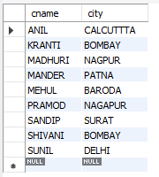

**PROCEDURE**

4.SELECT*FROM BRANCH;

**Output Screenshot**

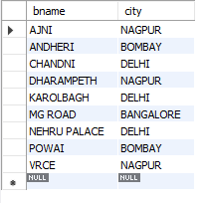

**PROCEDURE**

5.SELECT ACTNO,AMOUNT FROM DEPOSIT;

**Output Screenshot**

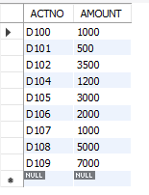

**PROCEDURE**

6.SELECT CNAME,ACTNO FROM DEPOSIT;

**Output Screenshot**

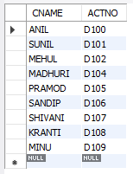

**PROCEDURE**

7.SELECT CNAME FROM CUSTOMER;

**Output Screenshot**

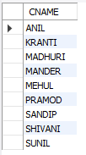

**PROCEDURE**

8.SELECT BNAME FROM BRANCH;

**Output Screenshot**

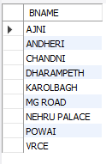

**PROCEDURE**

9.SELECT CNAME FROM BORROW;

**Output Screenshot**

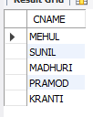

**PROCEDURE**

10.SELECT CNAME FROM CUSTOMER WHERE CITY='NAGPUR'

**Output Screenshot**



**PROCEDURE**

11.SELECT CNAME from DEPOSIT where AMOUNT>4000;

**Output Screenshot**

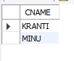

**PROCEDURE**

12.SELECT ADATE FROM DEPOSIT where CNAME='ANIL';

**Output Screenshot**



**PROCEDURE**

13.SELECT BNAME from BRANCH where CITY='Bombay';

**Output Screenshot**

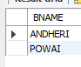

**PROCEDURE**

14.SELECT * from BORROW;

**Output Screenshot**

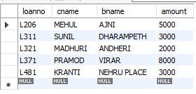

**PROCEDURE**

15.SELECT CNAME from BORROW where LOANNO='L206';

**Output Screenshot**



**PROCEDURE**

16.SELECT CNAME from DEPOSIT WHERE BNAME='VRCE';

**Output Screenshot**



**PROCEDURE**

17.SELECT BNAME from BRANCH WHERE CITY='Delhi';

**Output Screenshot**

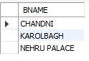

**PROCEDURE**

18.SELECT CNAME from DEPOSIT WHERE ADATE='1996-03-27';

**Output Screenshot**



**PROCEDURE**

19.SELECT ACTNO,AMOUNT from DEPOSIT WHERE ADATE BETWEEN '1995-03-01' AND '1995-12-17';

**Output Screenshot**

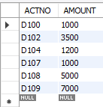

**PROCEDURE**

20.SELECT CITY from BRANCH WHERE BNAME='KAROLBAGH';

SELECT * from customer join borrow on customer.cname=borrow.cname join deposit on  deposit.cname=borrow.cname WHERE customer.cname='MADHURI';

**Output Screenshot**

