**Name: KEERTHANA DINESH A**

**Roll No: 11**

**Batch: BATCH B**

**Date: 08-04-2022**

**ADVANCED DBMS LAB**

**Experiment No: 3**

**Aim:**

To familiarize DDL Commands- ALTER,DROP,TRUNCATE,RENAME

**Questions:**

1. Create a table emp with attributes empno number(4)as primary key, ename char(10),hiredate,  salary, commission

insert 5 rows of data

|  |  |  |  |  |
| --- | --- | --- | --- | --- |
| 101 | Ramesh | 17-Jan  1980 | 5000 |  |
| 102 | Ajay | 05-Jul  1985 | 5000 | 500 |
| 103 | Ravi | 12-Aug  1981 | 1500 |  |
| 104 | Nikesh | 03-Mar  1983 | 3000 | 700 |
| 105 | Ravi | 05-jul  1985 | 3000 |  |

2. Modifying the structure of tables

a. .Add new columns: sal number(7,2)

b. Dropping a column from a table: sal

c. Modifying existing column :ename varchar2(15)

d. Renaming the tables: emp to emp1

e. truncating the tables:emp1

f. Destroying tables:emp

3. Create a table stud with sname varchar2(20) primary key , rollno number(10) not null,dob  date not null

4.Create a table student as regno number (6), mark number (3) check constraint (mark >=0 and  mark  <=100));

5.Create a table cust with(custid number(6) constraint unique, name char(10)

**Procedure**

CREATE TABLE emp(EMPNO INT(4) PRIMARY KEY, ENAME CHAR(10), HIREDATE DATE, SALARY INT(5),COMMISSION INT(5));

INSERT INTO emp(EMPNO,ENAME,HIREDATE,SALARY) VALUES (101,'RAMESH','1980-01-17',5000),(102,'AJAY','1985-07-05',5000), (103,'RAVI','1981-08-12',1500),(104,'Nikesh','1983-03-03',3000), (105,'Ravi','1985-07-05',3000);

**OUTPUT**

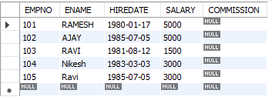

1. **ALTER TABLE emp ADD sal int;**

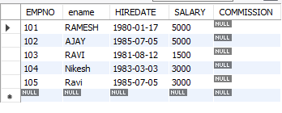

1. **ALTER TABLE emp DROP COLUMN salary;**

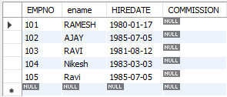

1. **ALTER TABLE emp MODIFY ename VARCHAR(15);**

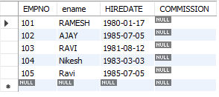

1. **RENAME table emp to emp1;**



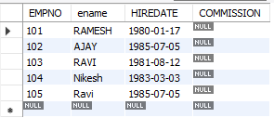

1. **TRUNCATE TABLE emp1; select * from emp1;**



desc emp1;

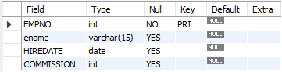

1. **DROP TABLE emp1;**



1. **CREATE TABLE stud(sname varchar(20) PRIMARY KEY, rollno int NOT NULL, dob date NOT NULL); select * from stud;**



1. **Create table student (regno int, mark int(3) check (mark >=0 and mark <=100));**

**SELECT * from STUDENT;**



1. **CREATE TABLE cust(custid int(6) UNIQUE, name char(10));**

**select * from cust;**

