EXPERIMENT NO: 7

**Name: KEERTHANA DINESH A**

**Roll No: 11**

**Batch: RMCAS2B**

**Date: 06-05-2022**

**Aim**

To familiarize with Group by and Having clause

**Questions**

1.List the branches having sum of deposit more than 5000.

2.List the branches having sum of deposit more than 500 and located in city BOMBAY

3.List the names of customers having deposited in the branches where the average deposit is

more than 5000.

4.List the names of customers having maximum deposit

5.List the name of branch having highest number of depositors?

6.Count the number of depositors living in NAGPUR.

7.Give names of customers in VRCE branch having more deposite than any other customer in

same branch

8.Give the names of branch where number of depositors is more than 5

9.Give the names of cities in which the maximum number of branches are located

10.Count the number of customers living in the city where branch is located

**Procedure & Output**

**1.**  SELECT D.BNAME FROM DEPOSIT D, BRANCH B WHERE

D.BNAME=B.BNAME AND B.CITY='BOMBAY' GROUP BY D.BNAME HAVING SUM(D.AMOUNT)>5000;

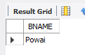

**2.** SELECT D.BNAME FROM DEPOSIT D, BRANCH B WHERE

    D.BNAME=B.BNAME GROUP BY D.BNAME HAVING SUM(D.AMOUNT)>5000;

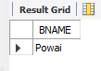

**3.** select CNAME from deposit where AMOUNT=(select AVG(Amount) from DEPOSIT GROUP BY BNAME having AVG(Amount)>5000);

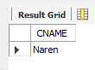

**4.**  SELECT MAX(AMOUNT),CNAME FROM deposit;

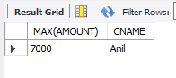

**5.**  SELECT D1.BNAME FROM DEPOSIT D1 GROUP BY D1.BNAME HAVING

COUNT(D1.CNAME) >= ALL (SELECT COUNT(D2.CNAME) FROM DEPOSIT D2

GROUP BY D2.BNAME);

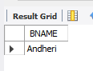

**6.**  select count(deposit.cname)from deposit,CUSTOMER where

     CUSTOMER.CITY='nagpur'**;**

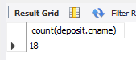

**7.**  Select CNAME from deposit where BNAME='VRCE' and amount=(select

    max(AMOUNT) from deposit where BNAME='VRCE');

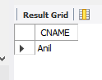

**8**. SELECT BNAME from deposit GROUP BY BNAME HAVING

    COUNT(BNAME)>5;

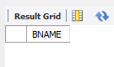

**9. s**elect C.CNAME ,count(B.BNAME) from CUSTOMER C inner join Branch B on

    C.CNAME=B.BNAME group by C.Cname order by count(B.BName) DESC;

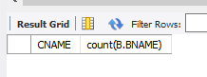

**10.** select count(b1.bname) From deposit d1 , borrow b1 , customer c1 Where

      c1.cname=d1.cname and d1.cname=b1.cname and c1.city in (select city from customer);

