|  |
| --- |
| Name : Keerthana Dinesh A  Roll No: 11  Batch: MCA B  Date06-05-2022 |

ADVANCED DBMS LAB

**EXPERIMENT :8**

# AIM

Perform CRUD Opertions

# Procedure & Output

**1.CREATE**

* Create Database



* Listing All Databases

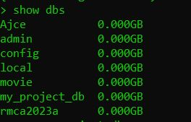

* Creating Collections(Tables)







* Show Collections

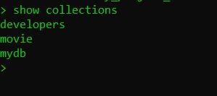

* Inserting Values to Collection





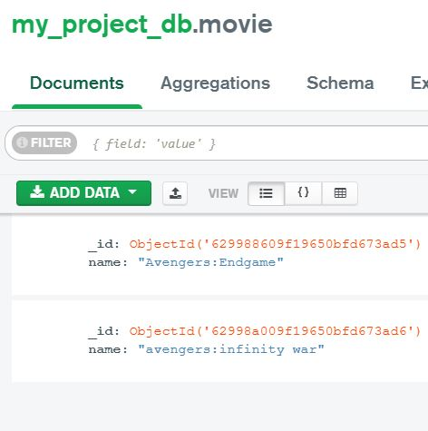

* Insert Multiple values to Collection

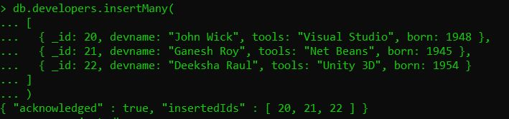

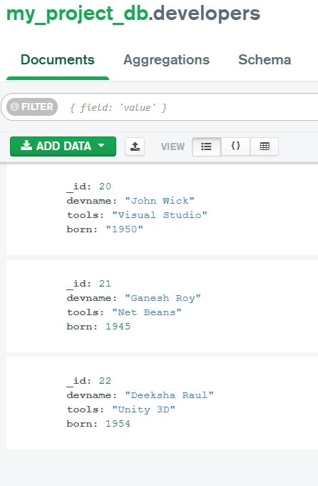

**2. READ**

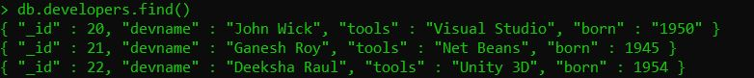

**3. UPDATE**



**4.DELETE**



