Name: Keerthana Dinesh A

Roll No: 11

Batch: RMCA B

Date:05/05/2022

**NETWORKING & SYSTEM ADMINISTRATION LAB**

**Experiment No: 8**

1.Write a shell script to print the basic details.

**PROCEDURE**

#!/bin/bash

echo "Enter Your Name:"

read name

echo "Enter Your RollNo:"

read rollno

echo "Enter Your Department:"

read department

echo "Enter Your Email:"

read mail

echo "Enter Your College:"

read college

echo $name

echo $rollno

echo $department

echo $mail

echo $college

**OUTPUT**

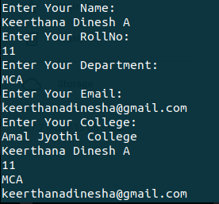

**2**. Write a shell script to find the sum of two numbers.

**PROCEDURE**

#!/bin/bash

echo "Enter the first number"

read num1

echo "Enter the second number"

read num2

sum=$(($num1+$num2))

echo "sum is "$sum

if [ $sum -ge 0 ]

then

echo "greater then 0"

else

echo "less then 0"

fi

**OUTPUT**

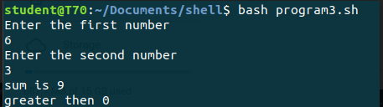

3. Write a shell script to find the largest of two numbers.

**PROCEDURE**

#!/bin/bash

echo "Enter the first number:"

read num1

echo "Enter the second number:"

read num2

if [ $num1 -gt $num2 ]

then

echo $num1 "is greater"

else

echo $num2 "is greater"

fi

**OUTPUT**

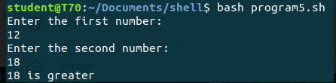

4. Write a shell script to find the largest of three numbers.

**PROCEDURE**

#!/bin/bash

echo "Enter the first Number:"

read num1

echo "Enter the second Number:"

read num2

echo "Enter the third Number:"

read num3

if [ $num1 -gt $num2 ] && [ $num1 -gt $num3 ]

then

echo $num1 "is greater"

elif [ $num2 -gt $num1 ] && [ $num2 -gt $num3 ]

then

echo $num2 "is greater"

else

echo $num3 "is greater"

fi

**OUTPUT**

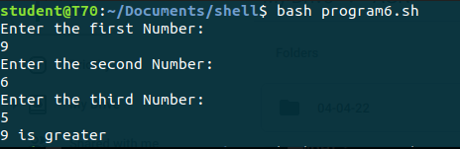

5. Write a shell script to find odd and even numbers.

**PROCEDURE**

#!/bin/bash

echo "Enter the number:"

read num

n=$((num % 2))

if [ $n -eq 0 ]

then

echo $num "is Even:"

else

echo $num "is Odd:"

fi

**OUTPUT**

