Customer Churn Prediction
-By:
Name: Venkatesh Maloth
Student Id:24094678

Introduction:
Customer churn refers to the situation where customers stop using a company’s product or service. By predicting churn in advance, companies can take preventive actions such as offering discounts, improving services, or providing better customer support. For subscription-based businesses such as telecom companies, retaining customers is extremely important.
In this project, machine learning models like XG-Boost, Random Forest are used to analyze customer behaviour and predict whether a customer will churn based on historical data.
Problem Statement:
Customer Churn Prediction:
The objective of this project is to build a machine learning model that predicts whether a customer churns form the company or not based on demographics and service usage.
Business Goal
- Identify customers who are likely to churn from the company.
- Help telecom companies take proactive retention strategies.
- Reduce revenue loss caused by customer churn.
Data Set used and how it is relevant:
Brief description of the Data set:
The dataset used in this project is the Telco Customer Churn dataset, which contains information about telecom customers and whether they leave the service or not. This data set includes both Categorical and Numerical features.
Few attributes in my data set are:
- Customer ID: A unique identifier assigned to each customer for record-keeping and tracking purposes.
- Gender: Indicates the gender of the customer.
- Tenure Months: Represents the number of months a customer has stayed with the company,
- Contract: Specifies the type of contract (Month-to-month, one year, or two year) that the customer has with the telecom provider.
- Monthly Charges: The amount a customer is billed every month for the services used.
- Total Charges: The total amount paid by the customer during their entire tenure with the company.
- Churn Label: The target variable indicating whether the customer has churned (Yes) or not (No).
How it is relevant:
This dataset is highly relevant for churn prediction because it contains key customer characteristics like service usage patterns, billing information, charges applied, churn score that influence customer retention. By analyzing these features, machine learning models can identify patterns associated with customer churn and help telecom companies to retain customers and reduce revenue loss.
Methodology:
The methodology for this project involved building a machine learning model to predict customer churn. Initially, the dataset was explored using exploratory data analysis (EDA) to understand feature distributions and to identify important features, patterns. Data preprocessing was then performed by handling missing values, conversion of data into valid data types, and removing features which could cause data leakage in further stages. Feature engineering techniques such as tenure bucketing and encoding categorical variables were applied to prepare the data for modelling. The dataset was then split into training and testing sets, and class imbalance was addressed using SMOTE. Finally, machine learning models including Logistic Regression, Random Forest, and XG-Boost were trained and evaluated using metrics such as accuracy, precision and recall to determine the best-performing model.
PLOT-1:
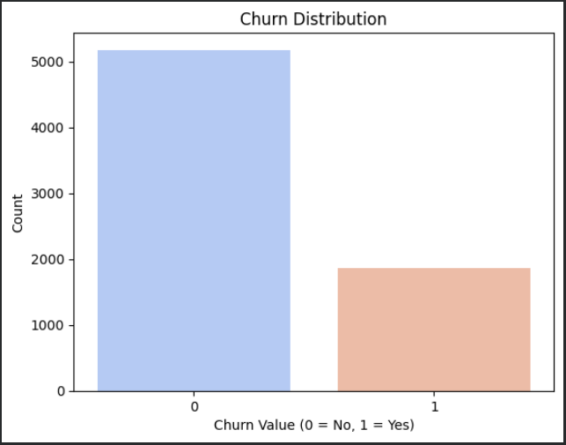
Figure -01: Distribution of customers based on churn status (0 = Retained, 1 = Churned).

Interpretation:
The count plot shows that the number of customers who did not churn (0) is significantly higher than those who churned (1). This indicates that the majority of customers remaining with the service.
Discussion:
This plot highlights the importance of identifying specific patterns and behaviours associated with the smaller churn group. Understanding these differences can help businesses to develop targeted retention strategies.
PLOT-2:
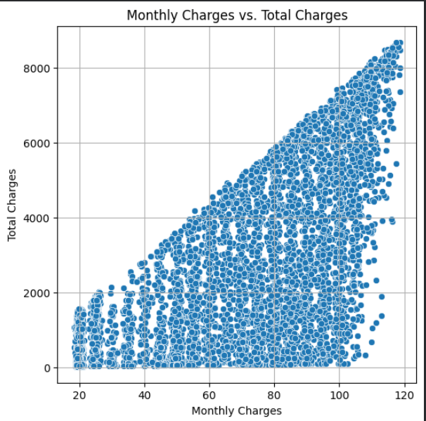
Figure -02: Scatter plot showing the relationship between monthly and total charges of customers.
Interpretation:
The scatter plot illustrates how total charges vary with monthly charges across customers. A positive relationship can be observed, where customers with higher monthly charges generally accumulate higher total charges over time. Customers with longer tenure tend to have higher total charges even with moderate monthly fees.
Discussion: The relationship between monthly and total charges highlights the combined effect of pricing and customer tenure on overall revenue. Understanding this relationship helps businesses focus on retaining long-term customers and optimizing pricing strategies to maximize customer lifetime value.

PLOT-3:
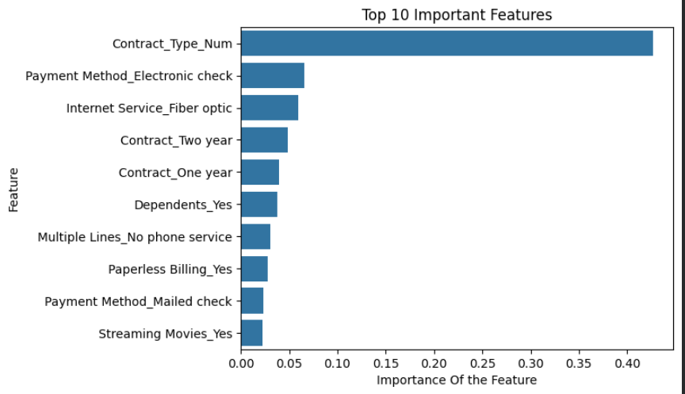
Figure-3: Top 10 most important features influencing customer churn as identified by the XG-Boost model.
Interpretation:
The bar plot displays the top features ranked by their importance scores in the XG-Boost model. Features with higher importance values contribute more significantly to predicting whether a customer will churn. Variables such as contract type, payment method and monthly charges appear among the most influential features.
Discussion:
Identifying the most important features helps businesses understand the primary factors that influence customer churn. These insights enable companies to focus on critical areas such as contract management, pricing strategies, and customer engagement. By addressing the factors with the highest impact, organizations can design more effective retention strategies and improve overall customer satisfaction

Overall statistical analysis of Customer Churn Behaviour
Category | Avg. Tenure (Months) | Avg. Monthly Charges | Avg. Total Charges | Customer Behaviour / Insight
Non-Churn Customers | High (long tenure) | Moderate | High | Loyal customers who stay longer with the service and contribute more to total revenue.
Churn Customers | Low (short tenure) | High | Low to Moderate | Customers with shorter tenure and relatively higher monthly charges are more likely to leave the service.
Month-to-Month Contract | Low | High | Low | Customers with flexible contracts tend to churn more frequently due to lack of long-term commitment.
One-Year Contract | Medium | Moderate | Moderate | Customers show moderate loyalty with reduced churn probability compared to month-to-month users.
Two-Year Contract | High | Moderate | High | Long-term contract customers show strong loyalty and have the lowest churn rates.

Conclusions:
The analysis of the Telco Customer Churn dataset successfully identified key factors influencing customer churn using data preprocessing, exploratory data analysis, and machine learning techniques. The results indicate that variables such as contract type, payment method and monthly charges play a major role in determining whether a customer is likely to leave the service. Customers with shorter tenure, higher monthly charges, and flexible month-to-month contracts show a higher tendency to churn. Feature importance analysis further confirms that customer service duration and contract commitment significantly influence customer retention.
Recommendations:
- Encourage customers to move from month-to-month contracts to longer-term contracts by offering discounts or loyalty benefits.
- Provide special retention offers for new customers with low tenure, as they are more likely to leave early.
- Monitor customers with high monthly charges and provide value-added services or personalized plans to improve satisfaction.
- Implement customer engagement programs and loyalty rewards to strengthen long-term relationships with customers.
- Use predictive churn models regularly to identify at-risk customers early and take proactive retention measures.
Overall, the results provide a strong foundation for data-driven marketing and business planning. The identified customer segments help the company better understand purchasing behaviour and target each group more effectively. Using these insights, the organization can design personalized strategies, improve customer engagement, and allocate resources more efficiently. This approach ultimately supports better decision-making and long-term business growth.

