BUILDING A SMARTER AI-POWERED SPAM CLASSIFIER

**PHASE-3**



**NAME:** R.keerthana

**REG.NO:** 513521106012

**DEPT&YEAR:** ECE/ IIIRD

**NM-ID:** au513521106012

**EMAIL-ID:kuttykeerthi213@gmail.com**

**COLLEGE NAME:** AMCET

DATA VISUALIZATION IN SPAM CLASSIFIER:

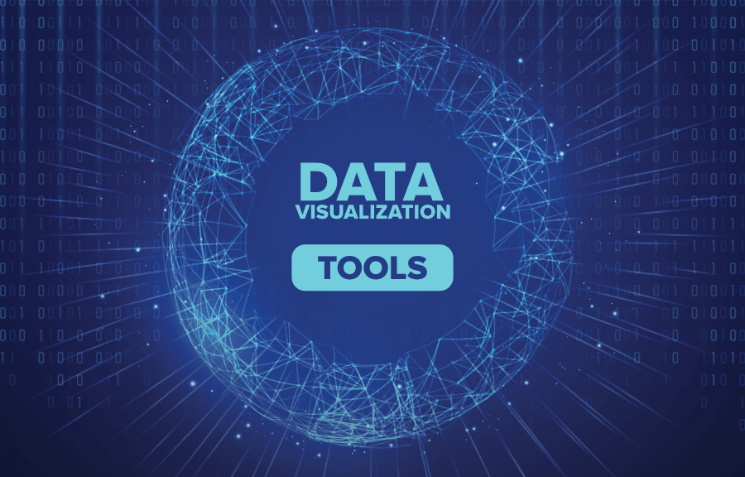

Data visualization can be a valuable tool in the context of an AI-powered spam classifier. Here's an explanation of how data visualization can be used for this specific application:

**Dataset Exploration:** Data visualization can help you explore the dataset used to train and test the spam classifier. You can create visualizations like bar charts or pie charts to show the distribution of spam and non-spam (ham) emails in the dataset. This provides an initial understanding of the dataset's balance and helps you identify potential issues like class imbalance.

**Feature Analysis:** Data visualization can be used to analyze the features or attributes of the emails. For example, you can create word clouds to visualize the most common words in spam emails or compare word frequency distributions between spam and non-spam emails. This insight can help in feature selection and engineering.

**Model Performance Visualization:** During model evaluation, you can use visualizations to assess the performance of the spam classifier. Create confusion matrices to visualize true positives, true negatives, false positives, and false negatives. You can also generate ROC curves to show the trade-off between true positive rate and false positive rate at different classification thresholds.

**Model Explainability:** Data visualization techniques like SHAP (SHapley Additive exPlanations) can be used to explain the model's predictions. This allows you to visualize which features are the most influential in classifying an email as spam, providing transparency and insights into the model's decision-making process.

**Real-time Monitoring:** If your spam classifier is deployed in a real-time system, you can use dashboards with visualizations to monitor its performance. This could include tracking the number of emails classified as spam over time, evaluating changes in false positive rates, and visualizing trends in email characteristics.Data visualization can be incorporated into user interfaces and reports generated by the spam classifier. Users can benefit from visual summaries of how the classifier is working and understand why certain emails were classified as spam.

**Analysis:** If your spam classifier incorporates user feedback to improve its performance, you can use data visualization to track and analyze this feedback. Visualizations can help identify patterns in user reports and guide model retraining. When false positives (legitimate emails classified as spam) and false negatives (spam emails classified as legitimate) occur, visual explanations can be provided to help users understand why these errors happened, potentially reducing user frustration.

**Model Robustness:**If you experiment with multiple spam classification models or algorithms, data visualization can help you compare their performance side by side. You can create visual summaries of accuracy, precision, recall, and F1-score to make informed decisions about the best-performing model.Visualization can assist in analyzing potential model vulnerabilities. By visualizing adversarial examples or manipulations that could bypass the spam classifier, you can work on improving its robustness.

Data visualization in an AI spam classifier not only aids in understanding and explaining model behavior but also plays a crucial role in enhancing user trust and facilitating the management and maintenance of the system. It allows users to interact with and interpret the AI's decisions and supports ongoing model improvement.

DATA COLLECTION:



Data collection is a crucial step in the process of gathering information and statistics for various purposes, such as research, analysis, or decision-making. Here's an overview of what a data collection process typically entails:

**Define Objectives:**The first step is to clearly define the objectives of your data collection. What do you want to learn or achieve? What questions do you need to answer?

**Select Data Sources**: Determine where you will get your data. This can include sources like surveys, databases, sensors, observations, or existing records.

**Data Types:** Identify the types of data you need to collect. Data can be quantitative (numbers) or qualitative (descriptive), and it can be structured (well-defined) or unstructured (e.g., text).

**Sampling:** If you can't collect data from an entire population, you'll need to use sampling techniques to select a representative subset. This helps in making inferences about the entire population.

**Data Collection Methods:**

- Surveys and Questionnaires: Design questions that are relevant to your objectives and distribute them to respondents.

- Interviews: Conduct one-on-one or group interviews to gather information.

- Observations: Collect data by observing events, behaviors, or processes.

- Existing Data: Utilize data that is already available, such as historical records or public datasets.

**Data Collection Tools:** Choose the tools and technology required for data collection, which could be paper forms, online survey platforms, sensors, or data collection apps. Before full-scale data collection, it's often beneficial to conduct a small-scale pilot test to ensure the data collection process works as intended.

**Data Collection Execution:** This is the stage where you collect data from your chosen sources using the methods and tools you've selected. Ensure that the collected data is accurate, complete, and consistent. This may involve data cleaning and validation processes.

Safely store the collected data in a secure and organized manner, ensuring data privacy and security compliance.

**Data Analysis:** Once you have your data, you can start analyzing it to draw conclusions and make decisions based on the objectives set at the beginning. Present your findings using charts, graphs, and other visual aids to make the data more understandable.Interpret the results and create a report or presentation that communicates your findings and insights.

Depending on regulations and data policies, decide how long to retain the data and how to dispose of it when it's no longer needed. Learn from the data collection process to refine your methods for future data collection efforts.

It's important to note that data collection should be conducted ethically and in compliance with relevant data protection and privacy laws. Additionally, clear documentation of the entire process is essential for transparency and reproducibility.

DATA PROCESSING:



Data processing is a fundamental step in the data analysis pipeline, where raw data is transformed, organized, and manipulated to extract meaningful information and insights. Here's an explanation of data processing:

**Data Cleaning:** Raw data often contains errors, inconsistencies, missing values, and outliers. Data cleaning involves identifying and correcting these issues to ensure the data is accurate and reliable. In many cases, data comes from various sources or systems. Data integration combines this disparate data into a unified format or structure for analysis. This may involve resolving inconsistencies in data formats or units.

**Data Transformation:** Data is often transformed to make it more suitable for analysis. This can include converting data types, aggregating data into different time intervals, and creating new variables or features.

**Data Reduction:** In situations with large datasets, reducing data can be necessary to improve processing efficiency. This may involve selecting a subset of relevant data or applying dimensionality reduction techniques.

**Data Encoding:** Categorical data may need to be encoded into numerical values to be used in statistical or machine learning models. One-hot encoding and label encoding are common methods for this Data is often scaled to ensure that all variables have a similar range. This is important for models like neural networks and k-means clustering.

Data can be aggregated to provide a higher-level summary. For example, daily sales data can be aggregated into monthly or yearly total

Missing values in the dataset can be filled in using various techniques, such as mean imputation, regression imputation, or using domain knowledge.

**Data validation:** Ensuring that processed data conforms to expected patterns and constraints. This includes checking for logical errors or inconsistencies. Sometimes, external data sources are used to enrich the dataset, adding more information or context to the existing data.

**Data Storage:** Processed data is stored in databases or file systems for further analysis. Data warehouses and data lakes are commonly used for this purpose. Continuous monitoring and maintenance of data quality to ensure that data remains accurate, up-to-date, and reliable over time.

The ultimate goal of data processing is to prepare the data for analysis and modeling, making it easier to extract meaningful patterns, trends, and insights.

The specific methods and tools used in data processing depend on the nature of the data and the objectives of the analysis. Data processing can be performed using various software tools and programming languages such as Python, R, SQL, and specialized data processing frameworks like Apache Spark.

FUTURE ENGINEERING:



Future engineering in the context of AI involves designing and developing advanced AI systems and technologies that will shape our world in the coming years. Here's an explanation of future engineering for AI:

**Advanced Algorithms:** Engineers will continue to research and develop more sophisticated machine learning algorithms, including deep learning, reinforcement learning, and natural language processing algorithms. These algorithms will be capable of handling complex tasks and making sense of vast amounts of data.

Future AI engineering will focus on creating specialized hardware to accelerate AI computations. This includes the development of AI-optimized processors (e.g., GPUs, TPUs) and neuromorphic computing that mimics the human brain's neural architecture.

**Explainable AI (XAI):** Engineers will work on making AI systems more transparent and interpretable. XAI aims to provide clear explanations of AI decisions, which is crucial for applications in healthcare, finance, and autonomous systems.

Future AI engineering will prioritize ethical considerations. Engineers will work on developing tools and techniques to identify and mitigate biases in AI systems, ensuring fairness and accountability.

**AI in Edge Devices:** Engineering AI for edge computing devices (e.g., smartphones, IoT devices) will become a focus. This involves creating lightweight AI models and optimizing AI algorithms for resource-constrained environments.Engineers will design AI systems for disease diagnosis, drug discovery, and personalized medicine. These systems will revolutionize healthcare by improving diagnostics and treatment options.

**Natural language:** Autonomous vehicles, drones, and robotics will benefit from future AI engineering. Engineers will enhance AI algorithms for real-time decision-making in complex, dynamic environments. Developing AI that understands and generates human language with a high degree of context and nuance will be a significant focus. This has applications in chatbots, translation, and content generation.

**Scientific Research:** Future AI engineering will empower scientific research by automating data analysis, simulations, and hypothesis testing. AI will accelerate discoveries in fields like genomics, materials science, and climate modelling. Engineers will use AI to address environmental challenges. This includes optimizing energy consumption, managing resources more efficiently, and monitoring climate change.

Exploring the intersection of quantum computing and AI, engineers will create AI systems capable of handling problems that are currently infeasible for classical computers.

Future engineering will also involve creating tools and frameworks for AI governance, regulation, and compliance with data privacy laws.

Engineers will develop AI systems that can collaborate seamlessly with humans, enhancing productivity and decision-making in various domains.

Future engineering for AI is a dynamic and evolving field that will continue to transform industries and society as a whole. It involves not only technical advancements but also ethical considerations to ensure AI .

MODEL SELECTION:



Model selection is a critical step in the process of developing machine learning and statistical models. It involves choosing the most appropriate model or algorithm for a given problem or dataset. Here's an explanation of model selection:

**Problem Definition:** Model selection begins with a clear understanding of the problem you want to solve. You need to define the type of task (e.g., classification, regression, clustering) and the goals you want to achieve.

**Data Collection and Preprocessing:** Before selecting a model, you collect and preprocess your data, including handling missing values, scaling features, and encoding categorical variables.To choose the right model, you need evaluation criteria. Common criteria include accuracy, precision, recall, F1-score, mean squared error, and many others, depending on the specific problem.

Consider a range of machine learning algorithms or models, such as linear regression, decision trees, random forests, support vector machines, neural networks, and more. These models have different characteristics and are suitable for different types of problems.

**Model Evaluation:** Train and evaluate each candidate model using a portion of your dataset (training set) and a separate portion (validation or test set). This helps you assess how well each model performs on unseen data.

**Cross-Validation:** To reduce the risk of overfitting and to get a more robust estimate of model performance, you can use techniques like k-fold cross-validation, where you split the data into multiple subsets and evaluate the model multiple times. Most models have hyperparameters that need to be set. This process involves finding the best combination of hyperparameters that optimize the model's performance. Techniques like grid search or random search can be used.

After evaluating and fine-tuning each model, compare their performance based on the chosen evaluation criteria. Select the model that performs the best on your validation or test data.

.Model selection is an iterative process, and it may involve going back to previous steps to fine-tune models or try different algorithms. It's a critical part of the machine learning workflow, as the choice of the model can significantly impact the success of your project.

MODEL TRAINING:

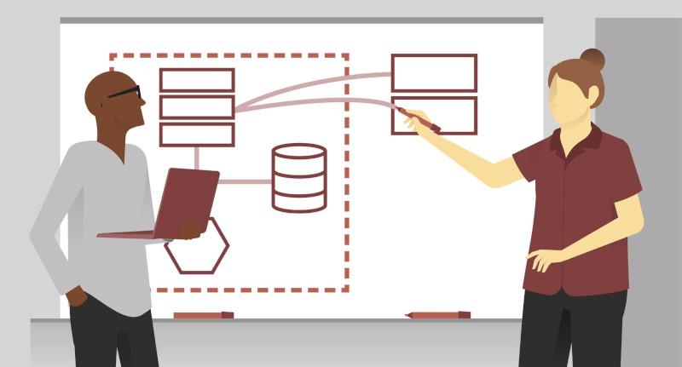

Building a smarter AI-powered spam classifier involves a series of steps, including model training. Here's an explanation of the model training process for this specific application:

**Data Collection:** The first step is to gather a substantial amount of data that includes both spam and non-spam (ham) emails. This dataset will be used to train and evaluate the spam classifier. Prepare the data by cleaning and preprocessing it. This includes tasks like removing HTML tags, normalizing text (lowercasing), and tokenizing the emails into words or phrases.

**Extraction:** Transform the text data into numerical features that can be used by machine learning algorithms. Common techniques include TF-IDF (Term Frequency-Inverse Document Frequency) and word embeddings like Word2Vec or GloVe.

**Data splitting:** Annotate the data, labeling each email as either spam or ham. This labeled dataset is used for supervised learning.Divide the dataset into training, validation, and test sets. The training set is used to train the model, the validation set helps in hyperparameter tuning, and the test set is reserved for evaluating the final model.

**Model Training:** Use the training data to train the chosen algorithm. The model learns to recognize patterns and features that distinguish spam from non-spam emails. Experiment with different hyperparameters of the chosen algorithm to optimize the model's performance. Grid search or random search can be used to systematically explore various combinations.

**Model Evaluation:** Assess the model's performance using the validation dataset. Common evaluation metrics include accuracy, precision, recall, F1-score, and receiver operating characteristic (ROC) curve analysis.In spam classification, there is often an imbalance between the number of spam and non-spam emails. Address this issue by using techniques such as oversampling, undersampling, or using synthetic data generation methods.

Building a smarter AI-powered spam classifier is an ongoing process that requires continuous data collection, model refinement, and adaptation to stay ahead of spammers' tactics and maintain high accuracy in classifying emails.

DATA VISUALIZATION:



Data visualization is the graphical representation of data to help people understand, interpret, and draw insights from complex datasets. It involves creating visual representations such as charts, graphs, maps, and more to make data more accessible and meaningful. Here's an explanation of data visualization:

**Visual Representation:** Data visualization uses various visual elements like points, lines, bars, and colors to represent data. By converting data into visual forms, it simplifies complex information and aids in the exploration and communication of data-driven insights.

**Types of Data Visualization:** There are numerous types of data visualizations, each suited to different data and purposes. Common examples include:

- Bar Charts: Display data in rectangular bars to compare categories.

- Line Charts: Show trends over time or continuous data points.

- Pie Charts: Illustrate parts of a whole, where each slice represents a portion of the data.

- Scatter Plots: Display individual data points as dots to show relationships between two variables.

- Heatmaps: Depict data using color intensity to reveal patterns, often used in correlation analysis.

**Exploratory Data Analysis:** Data visualization is a fundamental part of exploratory data analysis. It helps data analysts and scientists explore datasets to identify patterns, outliers, trends, and correlations, which can inform further analysis.

**Communication:** Data visualizations are powerful tools for conveying data-driven findings to a broad audience, making it easier for non-experts to grasp complex information. They can be used in reports, presentations, dashboards, and infographing. Data visualization helps tell a story. By combining visuals and narrative, it allows you to highlight key insights and guide the audience through the data, making the story more engaging and understandable.

**Data Cleaning and Quality Assurance:** Visualization can help identify data quality issues such as outliers, missing values, and inconsistencies, making it an essential tool in the data preparation process.

**Desing and Tools and Software:** Various software tools and libraries, such as Tableau, Power BI, Matplotlib, ggplot2, and D3.js, are available for creating data visualizations. The choice of tool depends on factors like data complexity and the desired type of visualization.Effective data visualization follows design principles, such as choosing appropriate chart types, using consistent color schemes, labeling data points, and maintaining a clear visual hierarchy.

When creating data visualizations, it's essential to be ethical and avoid misleading representations. Misleading visualizations can lead to incorrect conclusions or misunderstandings.

Data visualization is a powerful tool in the world of data science, as it helps transform raw data into meaningful insights, supports decision-making, and enhances data communication across various fields, from business analytics to scientific research.s developed and deployed responsibly.