Naan Mudhalvan Project

report on

A sleep Tracking App for a Better Night’s Rest

Submitted by

Team leader:

Keerthana. J

Team Members:

Dulsy. P

Hemashree. S

Kamini. k

Introduction:

‘sleep tracker” app, you can assess the quality of sleep they have had in a day. It has been time and again proven that a good quality sleep is pretty essential for effective functioning of both mind and body.

“sleep tracker” application enables you to start the timer when they are in the bed and about to fall asleep the timer will keep running in the background until it is stopped, whenever the user wakes up. Based on the sleep quality, the app will display an analysis of the kind of sleep, you had the previous night.

Overview:

Sleep tracking apps use smartphones built-in accelerometers to record and interpret sleep data each night. these apps commonly track movements during sleep record ,sound ,wake sleepers up during light stages of their sleep cycles and provide insights to help you interpret the data.

Purpose:

Tracks trackers apps often provide a breakdown of your different sleep phases, including how long you slept in each phase. A sleep tracker can help you identify the factors that are affecting your sleep quality. such as how much time you’re spending in bed .

Sleep quality: Trackers can detect interrupted sleep, letting you know when you’re tossing and turning or waking during the night.

Some Tracking systems tracks the phases of your sleep and time your alarm to go off during a period when you’re sleeping less deep.

Trailblazer profile public URL:

Team Leader: http://trailblazer.me/id/kjaikumar2

Team Member 1: http://trailblazer.me/id/dulap

Team Member 2: https://trailblazer.me/id/hemas129

Team Member 3: http;//trailblazer.me/id/kkumar2123

Team ideation & brainstorming Map:

Data access object

Room database

Entities

Data access object – room database:

Get entities from database and persist changes back to database.

Entities to room database:

Get and set entities to field value

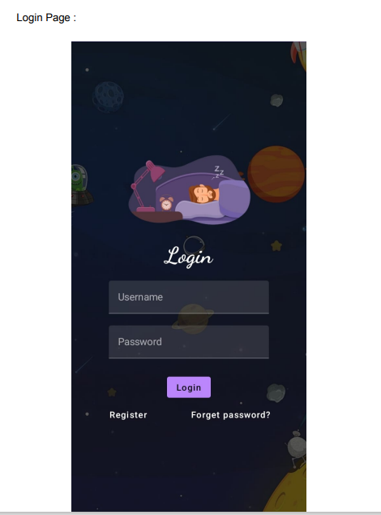Result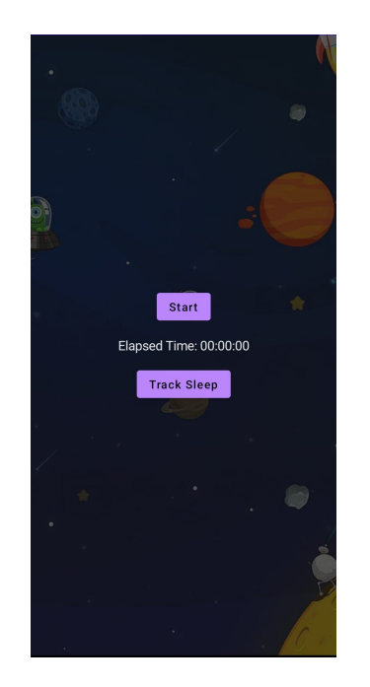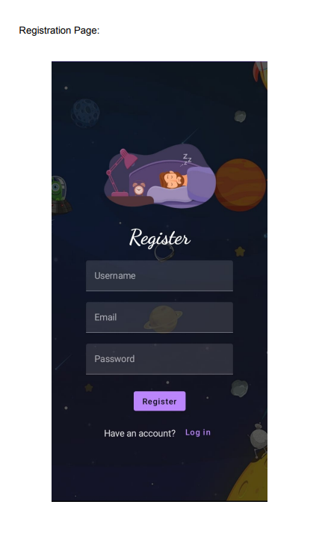:

Login page: Registration page: Main page:

Advantages:

1.Hinders sleep more than its helps:

You can sleep tracker app to track multiple aspects of your sleep, like your sleep phases, sleep debt and sleep goals. But what does all that sleep data mean and how do you use it. Graphs and records can be overwhelming and wreck your sleep rather than improve it. Use your sleep tracker app to give you more of a general idea of your sleep rather than solely relying on it. Don’t forget that what your body is telling you about your sleep is the most important thing to keep in mind.

2.Promotes nighttime screen use before bed:

Using your smartphone right before bedtime can be harmful . It’s best to limit your screen time, as artificial light can disrupt your circadian rhythm. There are, though, some mobile apps that can promote a healthy circadian rhythm. If you do want to use a sleep tracker app consider keeping your bed a phone-free-zone util you’re ready to sleep. Then collect your phone, switch on your sleep tracker and leave your phone alone for the rest of the night.