

Bachelor of Computer Applications
Semester – V
Business Analytics
Experiment No: 4
Title: Data Cleaning using Power Query

Submitted By
Name: Keerthana R
Reg. No.:2411021240021
Date:09-09-2026

Submitted To:
Faculty Name: Mr. Aman Kumar Sharma

Department of Computer Application
Alliance University
Chandapura - Anekal Main Road, Anekal
Bengaluru – 562106

Experiment No.: 4
Data Cleaning using Power Query

Problem Statement
A cafe company has received transaction data containing missing values, blank cells, ERROR entries, UNKNOWN entries, and inconsistent values. The objective is to clean and prepare the Dirty Cafe Sales dataset using Power Query so that it becomes consistent, reliable, and ready for business analysis.

Methodology / Steps Followed

Step 1: Data Collection
- Collected the Dirty Cafe Sales dataset in CSV format.
- The dataset contains transaction ID, item, quantity, price per unit, total spent, payment method, location, and transaction date.
- The raw dataset contains 10,000 transaction records and 8 columns.

Step 2: Data Import
- Opened Microsoft Power BI Desktop.
- Selected Get Data → Text/CSV.
- Imported the dirty_cafe_sales.csv dataset.
- Selected Transform Data to open Power Query Editor.
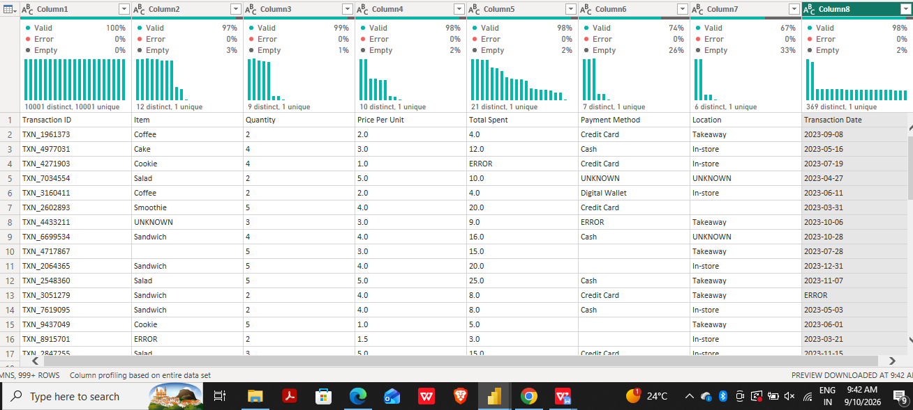

Step 3: Data Cleaning and Transformation
- Promoted the first row as column headers.
- Changed the data type of each column according to its contents.
- For categorical columns, blank and ERROR entries were standardized as UNKNOWN.
- Existing UNKNOWN entries were retained for consistency.
- Reviewed Quantity, Price Per Unit, and Total Spent for invalid entries.
- Records containing unrecoverable ERROR values were removed using the defined threshold of less than 2%.

Quantity Cleaning and Recovery
Quantity was handled separately because it can be derived when Price Per Unit and Total Spent are both reliable numeric values.
Formula used: Quantity = Total Spent ÷ Price Per Unit
A separate calculated/custom column was created. The calculation was applied to rows where Price Per Unit and Total Spent were non-problematic.
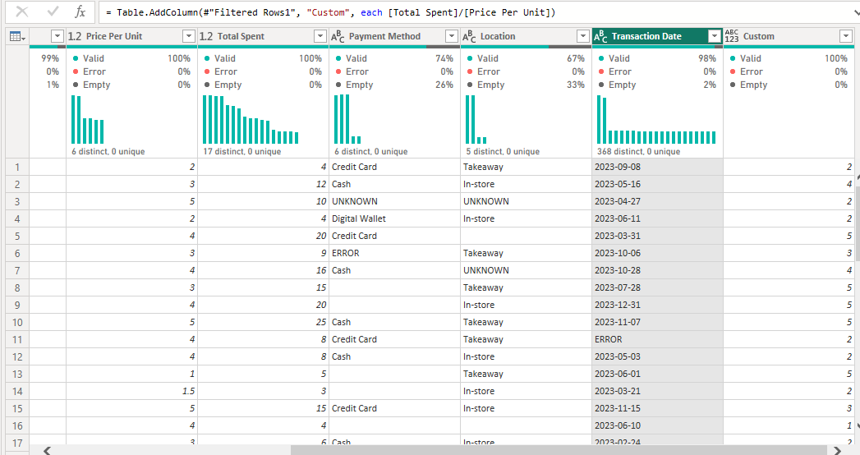

Step 4: Data Validation
- Verified that numeric columns were assigned appropriate numeric data types.
- Verified that Transaction Date was converted to Date format.
- Checked that categorical columns used a consistent UNKNOWN label.
- Verified that calculated Quantity values followed Total Spent ÷ Price Per Unit.
- Reviewed the transformed data for remaining errors before loading it for analysis.

Cleaning Rules Applied
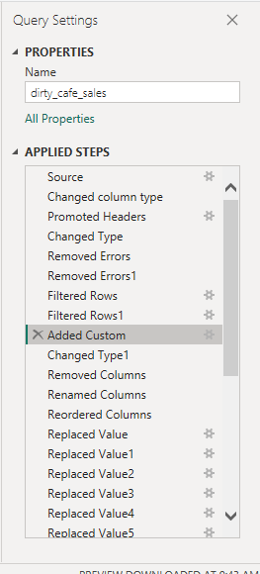

Output
- Consistent categorical values using UNKNOWN for missing or inconsistent category entries.
- Numeric fields converted to suitable numeric data types.
- Quantity values recovered where they could be reliably calculated.
- Transaction Date converted to Date format.
- Unrecoverable error records handled according to the defined cleaning rule.
- Dataset prepared for further analysis and visualization in Power BI.

Business Insights
- Data cleaning improves the reliability of transaction-level analysis.
- Recovering Quantity from reliable Price Per Unit and Total Spent preserves usable information.
- Standardizing categorical entries makes grouping and filtering more consistent.
- Removing a small proportion of unrecoverable errors reduces their effect on analysis.
- Clean data provides a stronger foundation for business reporting and decision-making.

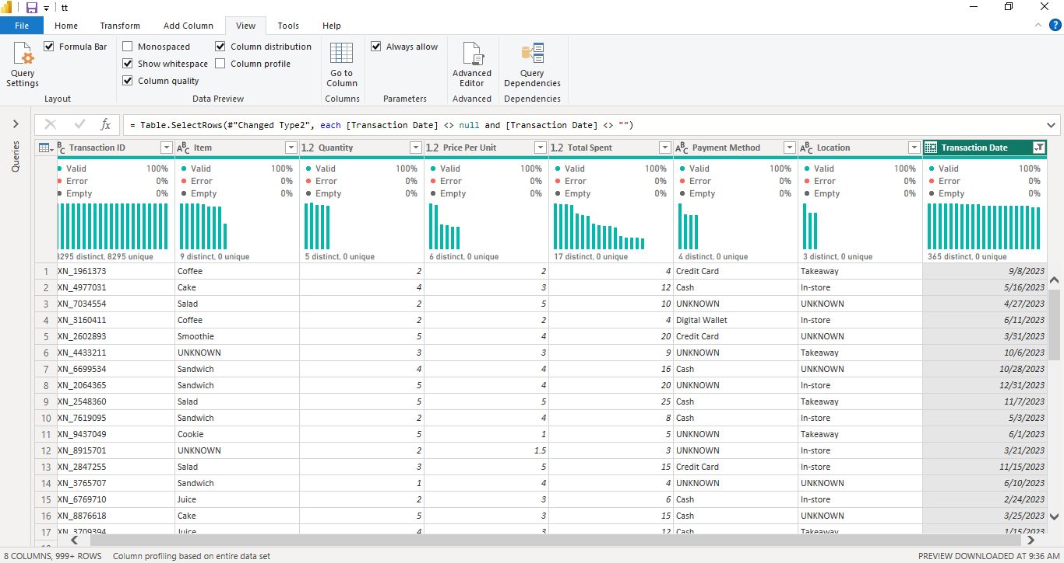

Conclusion
This experiment demonstrated the use of Power Query to clean the Dirty Cafe Sales dataset. The process included importing the CSV file, promoting headers, correcting data types, standardizing categorical entries, handling problematic numeric values, deriving Quantity from reliable Price Per Unit and Total Spent values, and validating the transformed data. The resulting dataset is more consistent and suitable for further business analysis.

Learning Outcomes
- Importing CSV data into Power BI and opening Power Query Editor.
- Using Power Query for data cleaning and transformation.
- Handling blank, ERROR, and UNKNOWN entries.
- Applying different cleaning strategies to categorical and numeric columns.
- Creating a calculated column using existing numeric fields.
- Validating data quality before analysis.
- Preparing datasets for business analytics and visualization.

GITHUB: Keerthana2562006/Business-Analytics

