Write a Pandas program to keep the rows with at least 2 NaN values in a

given DataFrame

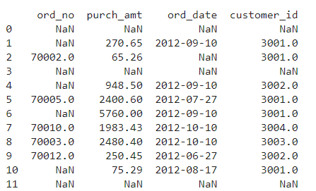

15.Write a Pandas program to keep the rows with at least 2 NaN values in a

given DataFrame.

INPUT:

import pandas as pd

import numpy as np

pd.set_option('display.max_rows', None)

#pd.set_option('display.max_columns', None)

df = pd.DataFrame({

'ord_no':[np.nan,np.nan,70002,np.nan,np.nan,70005,np.nan,70010,70003,70012,np.nan,np.nan],

'purch_amt':[np.nan,270.65,65.26,np.nan,948.5,2400.6,5760,1983.43,2480.4,250.45, 75.29,np.nan],

'ord_date': [np.nan,'2012-09-10',np.nan,np.nan,'2012-09-10','2012-07-27','2012-09-10','2012-10-10','2012-10-

10','2012-06-27','2012-08-17',np.nan],

'customer_id':[np.nan,3001,3001,np.nan,3002,3001,3001,3004,3003,3002,3001,np.nan]})

print("Original Orders DataFrame:")

print(df)

print("\nKeep the rows with at least 2 NaN values of the said DataFrame:")

result = df.dropna(thresh=2)

print(result)

OUTPUT:

