1. Write a Pandas program to split the following dataframe by school code and get mean, min, and max value of age for each school.

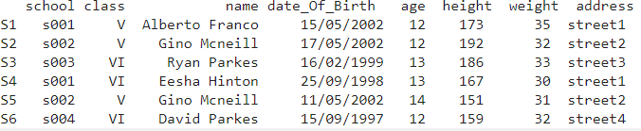

**INPUT:** import pandas as pd pd.set_option('display.max_rows', None) #pd.set_option('display.max_columns', None) student_data = pd.DataFrame({

'school_code': ['s001','s002','s003','s001','s002','s004'],

'class': ['V', 'V', 'VI', 'VI', 'V', 'VI'],

'name': ['Alberto Franco','Gino Mcneill','Ryan Parkes', 'Eesha Hinton', 'Gino Mcneill', 'David Parkes'], 'date_Of_Birth ': ['15/05/2002','17/05/2002','16/02/1999','25/09/1998','11/05/2002','15/09/1997'], 'age': [12, 12, 13, 13, 14, 12],

' height ': [173, 192, 186, 167, 151, 159],

'weight': [35, 32, 33, 30, 31, 32],

'address': ['street1', 'street2', 'street3', 'street1', 'street2', 'street4']},

index=['S1', 'S2', 'S3', 'S4', 'S5', 'S6'])

print("Original DataFrame:") print(student_data)

print('\nMean, min, and max value of age for each school with customized column names:')

grouped_single = student_data.groupby('school_code').agg(Age_Mean = ('age','mean'),Age_Max=('age',max),Age_Min=('age',min))

print(grouped_single)

**OUTPUT:**

