1. Write a Python program to draw a line with suitable label in the x axis, y axis and a title.

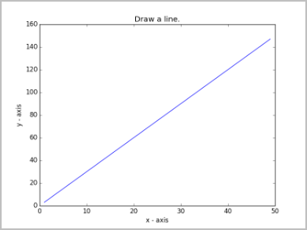

**INPUT:**

import matplotlib.pyplot as plt X = range(1, 50)

Y = [value * 3 for value in X] print("Values of X:") print(*range(1,50)) print("Values of Y (thrice of X):") print(Y)

# Plot lines and/or markers to the Axes. plt.plot(X, Y)

# Set the x axis label of the current axis. plt.xlabel('x - axis')

# Set the y axis label of the current axis. plt.ylabel('y - axis')

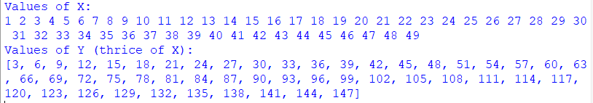# Set a title plt.title('Draw a line.') # Display the figure. plt.show() **OUTPUT:**

