1. Write a Python program to draw a line using given axis values taken from a text file, with suitable label in the x axis, y axis and a title.

*Test Data:*

test.txt

1 2

2 4

3 1

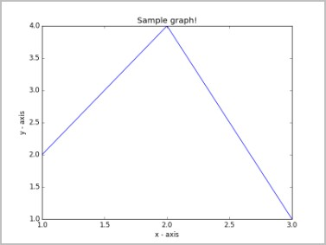

**INPUT:**

import matplotlib.pyplot as plt # x axis values

x = [1,2,3]

# y axis values y = [2,4,1]

# Plot lines and/or markers to the Axes. plt.plot(x, y)

# Set the x axis label of the current axis. plt.xlabel('x - axis')

# Set the y axis label of the current axis. plt.ylabel('y - axis')

# Set a title plt.title('Sample graph!') # Display a figure.

plt.show()

**OUTPUT:**

