1. Write a Python program to draw line charts of the financial data of Alphabet Inc. between October 3, 2016 to October 7, 2016.

Sample Financial data (fdata.csv): Date,Open,High,Low,Close

10-03-16,774.25,776.065002,769.5,772.559998

10-04-16,776.030029,778.710022,772.890015,776.429993

10-05-16,779.309998,782.070007,775.650024,776.469971

10-06-16,779,780.47998,775.539978,776.859985

10-07-16,779.659973,779.659973,770.75,775.080017

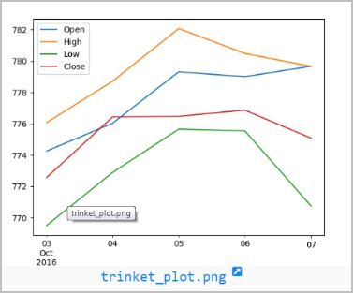

**INPUT:**

import matplotlib.pyplot as plt from datetime import datetime # Financial data

data = [

{"Date": "10-03-16", "Open": 774.25, "High": 776.065002, "Low": 769.5, "Close": 772.559998},

{"Date": "10-04-16", "Open": 776.030029, "High": 778.710022, "Low": 772.890015, "Close": 776.429993},

{"Date": "10-05-16", "Open": 779.309998, "High": 782.070007, "Low": 775.650024, "Close": 776.469971},

{"Date": "10-06-16", "Open": 779, "High": 780.47998, "Low": 775.539978, "Close": 776.859985},

{"Date": "10-07-16", "Open": 779.659973, "High": 779.659973, "Low": 770.75, "Close": 775.080017}

]

# Extract dates and close prices

dates = [datetime.strptime(entry["Date"], "%m-%d-%y") for entry in data] close_prices = [entry["Close"] for entry in data]

# Create a line chart plt.figure(figsize=(10, 5))

plt.plot(dates, close_prices, marker='o', linestyle='-') # Set labels and title

plt.xlabel('Date') plt.ylabel('Close Price (USD)')

plt.title('Alphabet Inc. Financial Data (Oct 3, 2016 to Oct 7, 2016)') # Format date on x-axis

plt.gcf().autofmt_xdate() # Show the chart plt.show()

**OUTPUT:**

