# Write a Python program to plot two or more lines with legends, different widths and colors.

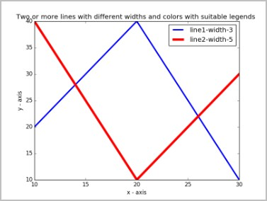

**INPUT:**

import matplotlib.pyplot as plt # line 1 points

x1 = [10,20,30]

y1 = [20,40,10]

# line 2 points x2 = [10,20,30]

y2 = [40,10,30]

# Set the x axis label of the current axis. plt.xlabel('x - axis')

# Set the y axis label of the current axis. plt.ylabel('y - axis')

# Set a title

plt.title('Two or more lines with different widths and colors with suitable legends ') # Display the figure.

plt.plot(x1,y1, color='blue', linewidth = 3, label = 'line1-width-3') plt.plot(x2,y2, color='red', linewidth = 5, label = 'line2-width-5') # show a legend on the plot

plt.legend()

plt.show()

**OUTPUT:**

