# Write a Python programming to display a bar chart of the popularity of programming Languages.

Sample data:

# Programming languages: Java, Python, PHP, JavaScript, C#, C++ Popularity: 22.2, 17.6, 8.8, 8, 7.7, 6.7

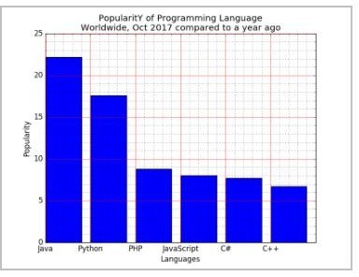

**INPUT:**

import matplotlib.pyplot as plt

x = ['Java', 'Python', 'PHP', 'JavaScript', 'C#', 'C++'] popularity = [22.2, 17.6, 8.8, 8, 7.7, 6.7]

x_pos = [i for i, _ in enumerate(x)] plt.bar(x_pos, popularity, color='blue') plt.xlabel("Languages") plt.ylabel("Popularity")

plt.title("PopularitY of Programming Language\n" + "Worldwide, Oct 2017 compared to a year ago") plt.xticks(x_pos, x)

# Turn on the grid plt.minorticks_on()

plt.grid(which='major', linestyle='-', linewidth='0.5', color='red') # Customize the minor grid

plt.grid(which='minor', linestyle=':', linewidth='0.5', color='black') plt.show()

**OUTPUT:**

