# Write a Python program to draw a scatter graph taking a random distribution in X and Y and plotted against each other.

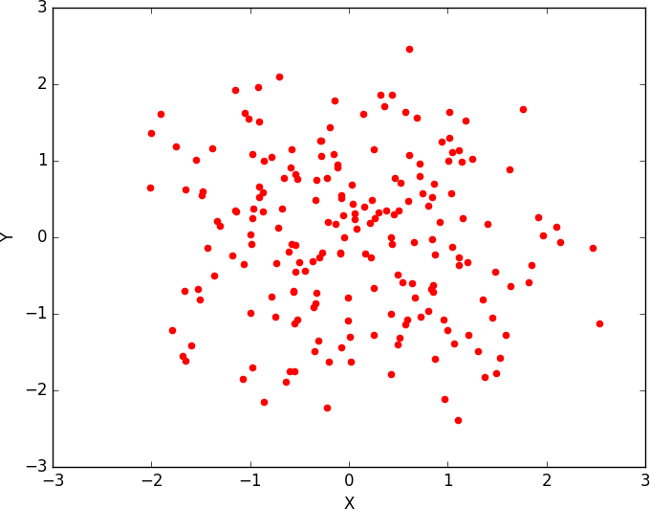

**INPUT:**

import numpy as np

import matplotlib.pyplot as plt N = 5

menMeans = (22, 30, 35, 35, 26)

womenMeans = (25, 32, 30, 35, 29)

menStd = (4, 3, 4, 1, 5)

womenStd = (3, 5, 2, 3, 3)

# the x locations for the groups ind = np.arange(N)

# the width of the bars width = 0.35

p1 = plt.bar(ind, menMeans, width, yerr=menStd, color='red')

p2 = plt.bar(ind, womenMeans, width, bottom=menMeans, yerr=womenStd, color='green') plt.ylabel('Scores')

plt.xlabel('Groups')

plt.title('Scores by group\n' + 'and gender')

plt.xticks(ind, ('Group1', 'Group2', 'Group3', 'Group4', 'Group5')) plt.yticks(np.arange(0, 81, 10))

plt.legend((p1[0], p2[0]), ('Men', 'Women')) plt.show()

**OUTPUT:**

