1. Create the students and grades collections and insert the sample documents into both collections.

Answer:- // Create and insert documents into students collection

db.students.insertMany([

{

_id: ObjectId("64b1fcd1f4a13a001e3d41a1"),

name: "Alice Johnson",

enrollmentYear: 2021,

major: "Computer Science",

email: "alice.johnson@example.com",

gender: "Female",

age: 20

},

{

_id: ObjectId("64b1fcd1f4a13a001e3d41a2"),

name: "Bob Smith",

enrollmentYear: 2020,

major: "Mathematics",

email: "bob.smith@example.com",

gender: "Male",

age: 22

},

{

_id: ObjectId("64b1fcd1f4a13a001e3d41a3"),

name: "Clara Lee",

enrollmentYear: 2022,

major: "Physics",

email: "clara.lee@example.com",

gender: "Female",

age: 19

},

{

_id: ObjectId("64b1fcd1f4a13a001e3d41a4"),

name: "Daniel Kim",

enrollmentYear: 2021,

major: "Engineering",

email: "daniel.kim@example.com",

gender: "Male",

age: 21

},

{

_id: ObjectId("64b1fcd1f4a13a001e3d41a5"),

name: "Eva Chen",

enrollmentYear: 2020,

major: "Biology",

email: "eva.chen@example.com",

gender: "Female",

age: 23

},

{

_id: ObjectId("64b1fcd1f4a13a001e3d41a6"),

name: "Frank Wright",

enrollmentYear: 2019,

major: "Chemistry",

email: "frank.wright@example.com",

gender: "Male",

age: 24

},

{

_id: ObjectId("64b1fcd1f4a13a001e3d41a7"),

name: "Grace Liu",

enrollmentYear: 2022,

major: "Economics",

email: "grace.liu@example.com",

gender: "Female",

age: 20

},

{

_id: ObjectId("64b1fcd1f4a13a001e3d41a8"),

name: "Henry Davis",

enrollmentYear: 2021,

major: "Philosophy",

email: "henry.davis@example.com",

gender: "Male",

age: 22

},

{

_id: ObjectId("64b1fcd1f4a13a001e3d41a9"),

name: "Ivy Zhang",

enrollmentYear: 2020,

major: "Statistics",

email: "ivy.zhang@example.com",

gender: "Female",

age: 21

},

{

_id: ObjectId("64b1fcd1f4a13a001e3d41aa"),

name: "Jack Lee",

enrollmentYear: 2023,

major: "Business",

email: "jack.lee@example.com",

gender: "Male",

age: 18

}

]);

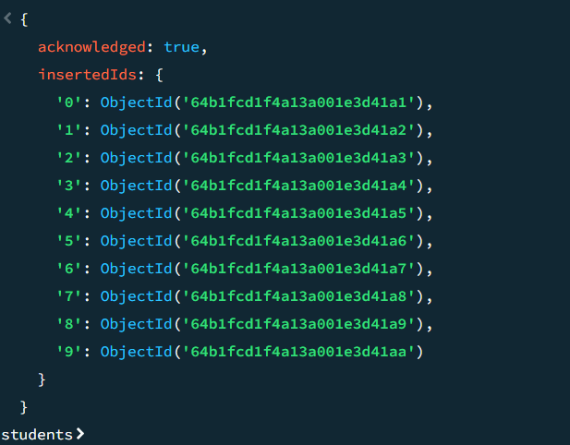

// Create and insert documents into grades collection

db.grades.insertMany([

{ subject: "Mathematics", score: 85, term: "Fall 2022", studentId: ObjectId("64b1fcd1f4a13a001e3d41a1") },

{ subject: "English", score: 90, term: "Fall 2022", studentId: ObjectId("64b1fcd1f4a13a001e3d41a1") },

{ subject: "Mathematics", score: 75, term: "Spring 2022", studentId: ObjectId("64b1fcd1f4a13a001e3d41a2") },

{ subject: "Statistics", score: 80, term: "Fall 2022", studentId: ObjectId("64b1fcd1f4a13a001e3d41a2") },

{ subject: "Physics", score: 92, term: "Fall 2022", studentId: ObjectId("64b1fcd1f4a13a001e3d41a3") },

{ subject: "Mathematics", score: 86, term: "Spring 2023", studentId: ObjectId("64b1fcd1f4a13a001e3d41a3") },

{ subject: "Engineering", score: 89, term: "Fall 2021", studentId: ObjectId("64b1fcd1f4a13a001e3d41a4") },

{ subject: "Mathematics", score: 84, term: "Spring 2022", studentId: ObjectId("64b1fcd1f4a13a001e3d41a4") },

{ subject: "Biology", score: 78, term: "Spring 2021", studentId: ObjectId("64b1fcd1f4a13a001e3d41a5") },

{ subject: "Chemistry", score: 82, term: "Fall 2021", studentId: ObjectId("64b1fcd1f4a13a001e3d41a5") },

{ subject: "Chemistry", score: 88, term: "Fall 2021", studentId: ObjectId("64b1fcd1f4a13a001e3d41a6") },

{ subject: "Physics", score: 79, term: "Spring 2022", studentId: ObjectId("64b1fcd1f4a13a001e3d41a6") },

{ subject: "Economics", score: 83, term: "Spring 2023", studentId: ObjectId("64b1fcd1f4a13a001e3d41a7") },

{ subject: "English", score: 89, term: "Fall 2022", studentId: ObjectId("64b1fcd1f4a13a001e3d41a7") },

{ subject: "Philosophy", score: 91, term: "Fall 2022", studentId: ObjectId("64b1fcd1f4a13a001e3d41a8") },

{ subject: "History", score: 77, term: "Spring 2023", studentId: ObjectId("64b1fcd1f4a13a001e3d41a8") },

{ subject: "Statistics", score: 79, term: "Spring 2022", studentId: ObjectId("64b1fcd1f4a13a001e3d41a9") },

{ subject: "Data Science", score: 88, term: "Fall 2022", studentId: ObjectId("64b1fcd1f4a13a001e3d41a9") },

{ subject: "Business", score: 87, term: "Fall 2023", studentId: ObjectId("64b1fcd1f4a13a001e3d41aa") },

{ subject: "Finance", score: 82, term: "Spring 2024", studentId: ObjectId("64b1fcd1f4a13a001e3d41aa") }

]);

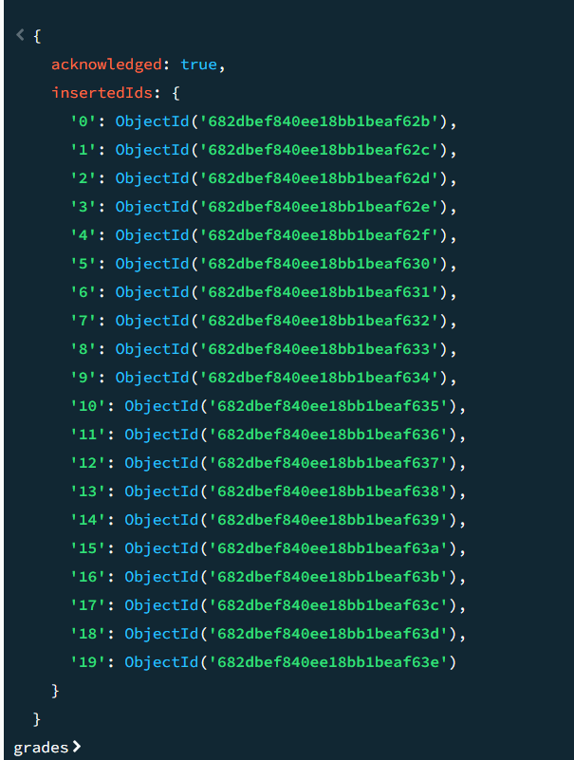

1. Show both collections in table view.

Answer:-

db.students.find().pretty();

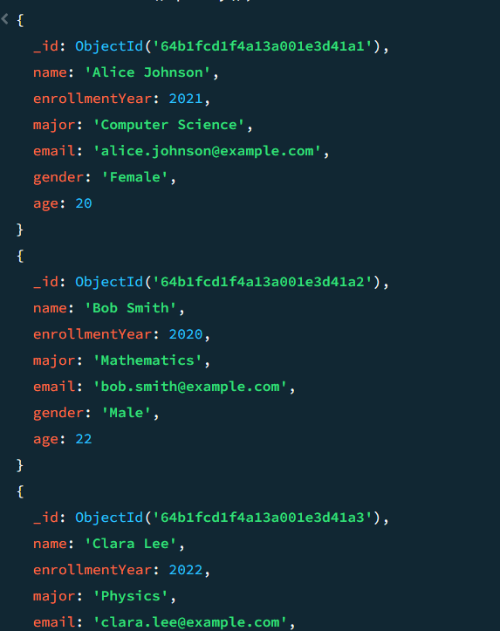

db.grades.find().pretty();

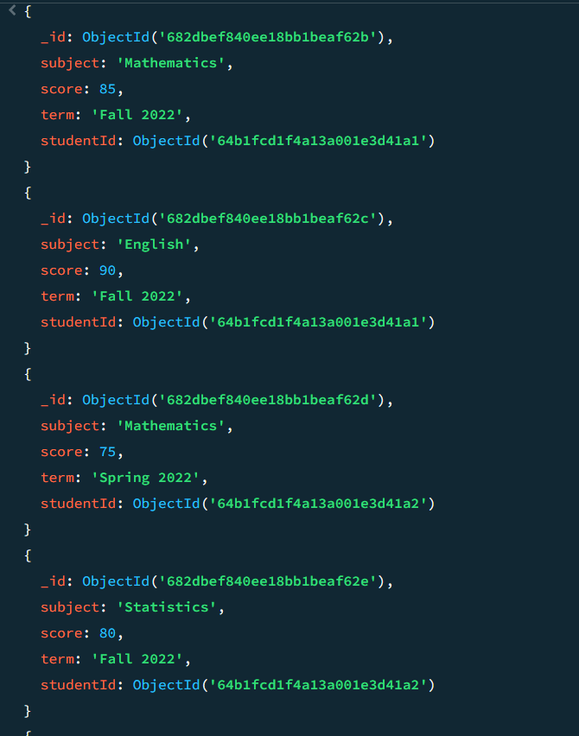

1. Find the female students and only display their name, age and gender.

Answer:- db.students.find(

{ gender: "Female" },

{ name: 1, age: 1, gender: 1, _id: 0 }

).pretty();

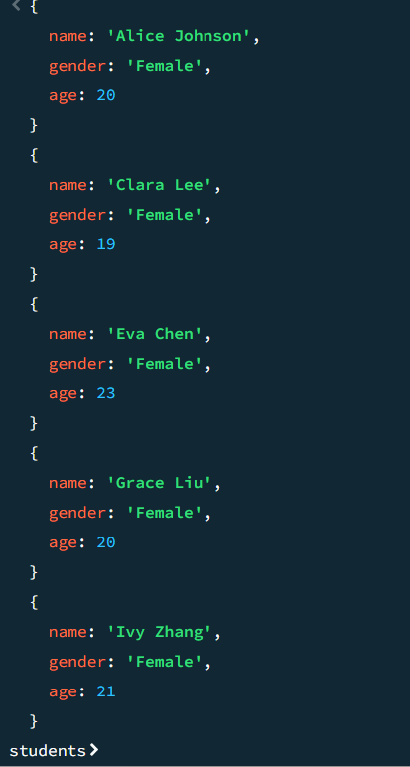

1. Find the students who are younger than 22 and enrolled after 2020.

Answer:- db.students.find({

age: { $lt: 22 },

enrollmentYear: { $gt: 2020 }

}).pretty();

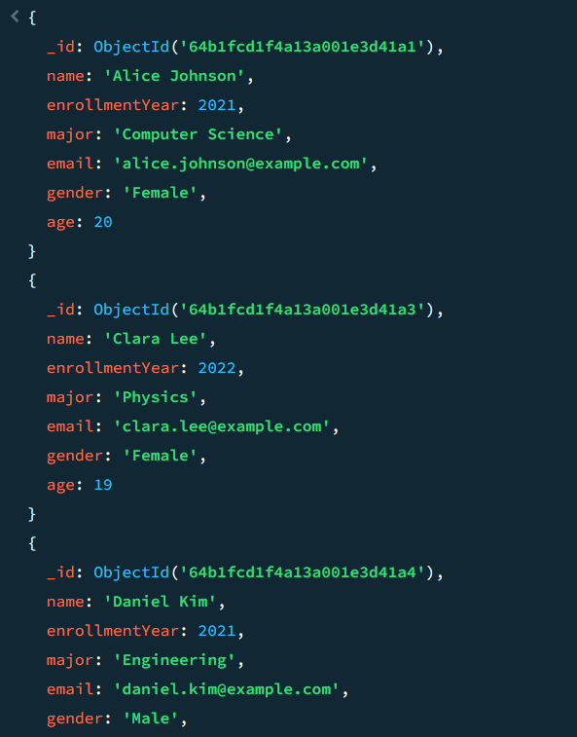

1. Find all grades for "Alice Johnson".

Answer:- db.grades.find({

studentId: ObjectId("64b1fcd1f4a13a001e3d41a1")

}).pretty();

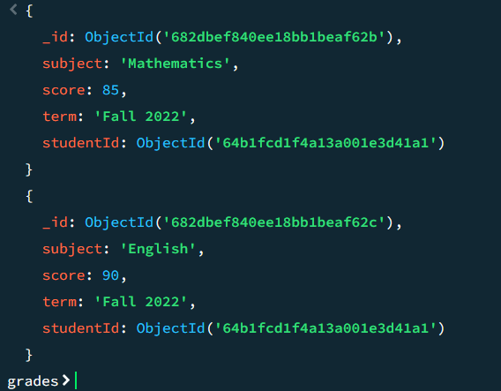

1. Find how many students followed the subject “Mathematics”.

Answer:- db.grades.aggregate([

{ $match: { subject: "Mathematics" } },

{ $group: { _id: "$studentId" } },

{ $count: "totalStudents" }

]);



1. Find all students with grades in the term "Fall 2022".

Answer:- db.grades.aggregate([

{ $match: { term: "Fall 2022" } },

{

$lookup: {

from: "students",

localField: "studentId",

foreignField: "_id",

as: "student"

}

},

{ $unwind: "$student" },

{ $group: { _id: "$studentId", student: { $first: "$student" } } },

{ $replaceRoot: { newRoot: "$student" } }

]);