**Exercise 1: Configuring a Basic Spring Application**

**Step1: pom.xml:**

<?xml version="1.0" encoding="UTF-8"?>

<project xmlns="http://maven.apache.org/POM/4.0.0" xmlns:xsi="http://www.w3.org/2001/XMLSchema-instance"

xsi:schemaLocation="http://maven.apache.org/POM/4.0.0 http://maven.apache.org/xsd/maven-4.0.0.xsd">

<modelVersion>4.0.0</modelVersion>

<groupId>com.library</groupId>

<artifactId>LibraryManagement</artifactId>

<version>0.0.1-SNAPSHOT</version>

<name>LibraryManagement</name>

<!-- FIXME change it to the project's website -->

<url>http://www.example.com</url>

<properties>

<project.build.sourceEncoding>UTF-8</project.build.sourceEncoding>

<maven.compiler.release>17</maven.compiler.release>

</properties>

<dependencies>

<dependency>

<groupId>org.springframework</groupId>

<artifactId>spring-core</artifactId>

<version>6.2.6</version>

</dependency>

<dependency>

<groupId>org.springframework</groupId>

<artifactId>spring-context</artifactId>

<version>6.2.7</version>

</dependency>

</dependencies>

</project>

**Step2: applicationContext.xml:**

<?xml version="1.0" encoding="UTF-8"?>

<beans xmlns="http://www.springframework.org/schema/beans"

xmlns:xsi="http://www.w3.org/2001/XMLSchema-instance"

xsi:schemaLocation="

http://www.springframework.org/schema/beans

http://www.springframework.org/schema/beans/spring-beans.xsd">

<bean id="bookRepository" class="com.library.repository.BookRepository"/>

<bean id="bookService" class="com.library.service.BookService"/>

</beans>

**Step3: BookService.java:**

package com.library.service;

public class BookService {

public void showMessage(){

System.*out*.println("BookService is ready.");

}

}

**BookRepository.java:**

package com.library.service;

public class BookService {

public void showMessage(){

System.*out*.println("BookService is ready.");

}

}

**Step4: Main.java:**

package com.library.main;

import com.library.service.BookService;

import com.library.repository.BookRepository;

import org.springframework.context.ApplicationContext;

import org.springframework.context.support.ClassPathXmlApplicationContext;

public class Main{

public static void main(String[] args) {

ApplicationContext context=new ClassPathXmlApplicationContext("applicationContext.xml");

BookRepository repository=(BookRepository) context.getBean("bookRepository");

String repo=repository.getBookRepository();

System.*out*.println(repo);

BookService service=(BookService) context.getBean("bookService");

service.showMessage();

}

}

**Output:**

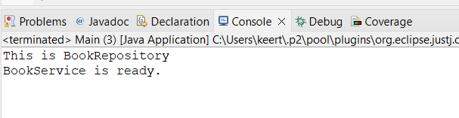

**Exercise 2: Implementing Dependency Injection**

**Step1: applicationContext.xml:**

<?xml version="1.0" encoding="UTF-8"?>

<beans xmlns="http://www.springframework.org/schema/beans"

xmlns:xsi="http://www.w3.org/2001/XMLSchema-instance"

xsi:schemaLocation="

http://www.springframework.org/schema/beans

http://www.springframework.org/schema/beans/spring-beans.xsd">

<bean id="bookRepository" class="com.library.repository.BookRepository"/>

<bean id="bookService" class="com.library.service.BookService">

<property name="bookRepository" ref="bookRepository"/>

</bean>

</beans>

**Step2: BookService.java:**

package com.library.service;

import com.library.repository.BookRepository;

public class BookService {

private BookRepository bookRepository;

public void setBookRepository(BookRepository bookRepository) {

this.bookRepository = bookRepository;

}

public void showMessage(){

System.*out*.println(bookRepository.getBookRepository()+" via BookService");

}

}

**Step3: Main.java:**

package com.library.main;

import com.library.service.BookService;

import org.springframework.context.ApplicationContext;

import org.springframework.context.support.ClassPathXmlApplicationContext;

public class Main{

public static void main(String[] args) {

ApplicationContext context=new ClassPathXmlApplicationContext("applicationContext.xml");

BookService service=(BookService) context.getBean("bookService");

service.showMessage();

}

}

**Output:**

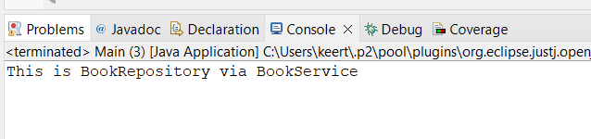

**Exercise 4: Creating and Configuring a Maven Project**

**pom.xml** with Spring Context, Spring AOP, Spring WebMVC, and Maven Compiler Plugin for Java 8:

<?xml version="1.0" encoding="UTF-8"?>

<project xmlns="http://maven.apache.org/POM/4.0.0"

xmlns:xsi="http://www.w3.org/2001/XMLSchema-instance"

xsi:schemaLocation="http://maven.apache.org/POM/4.0.0 http://maven.apache.org/xsd/maven-4.0.0.xsd">

<modelVersion>4.0.0</modelVersion>

<groupId>com.library</groupId>

<artifactId>LibraryManagement</artifactId>

<version>0.0.1-SNAPSHOT</version>

<name>LibraryManagement</name>

<url>http://www.example.com</url>

<properties>

<project.build.sourceEncoding>UTF-8</project.build.sourceEncoding>

<maven.compiler.source>1.8</maven.compiler.source>

<maven.compiler.target>1.8</maven.compiler.target>

</properties>

<dependencies>

<dependency>

<groupId>org.springframework</groupId>

<artifactId>spring-context</artifactId>

<version>5.3.34</version>

</dependency>

<dependency>

<groupId>org.springframework</groupId>

<artifactId>spring-aop</artifactId>

<version>5.3.34</version>

</dependency>

<dependency>

<groupId>org.springframework</groupId>

<artifactId>spring-webmvc</artifactId>

<version>5.3.34</version>

</dependency>

</dependencies>

<build>

<plugins>

<plugin>

<groupId>org.apache.maven.plugins</groupId>

<artifactId>maven-compiler-plugin</artifactId>

<version>3.11.0</version>

<configuration>

<source>1.8</source>

<target>1.8</target>

</configuration>

</plugin>

</plugins>

</build>

</project>