**Create a Spring Web Project using Maven**

1.Go to <https://start.spring.io/>

2.Fill in:

* Group: com.cognizant
* Artifact: spring-learn

3.Add dependencies:

* Spring Boot DevTools
* Spring Web

4.Click Generate, then extract the downloaded ZIP to your Eclipse workspace folder.

5. Move the extracted folder (spring-learn) into Eclipse Workspace.

6. Open Command Prompt or Terminal and navigate to the project folder and run following command:

mvn clean package -Dhttp.proxyHost=proxy.cognizant.com -Dhttp.proxyPort=6050 -Dhttps.proxyHost=proxy.cognizant.com -Dhttps.proxyPort=6050 -Dhttp.proxyUser=123456

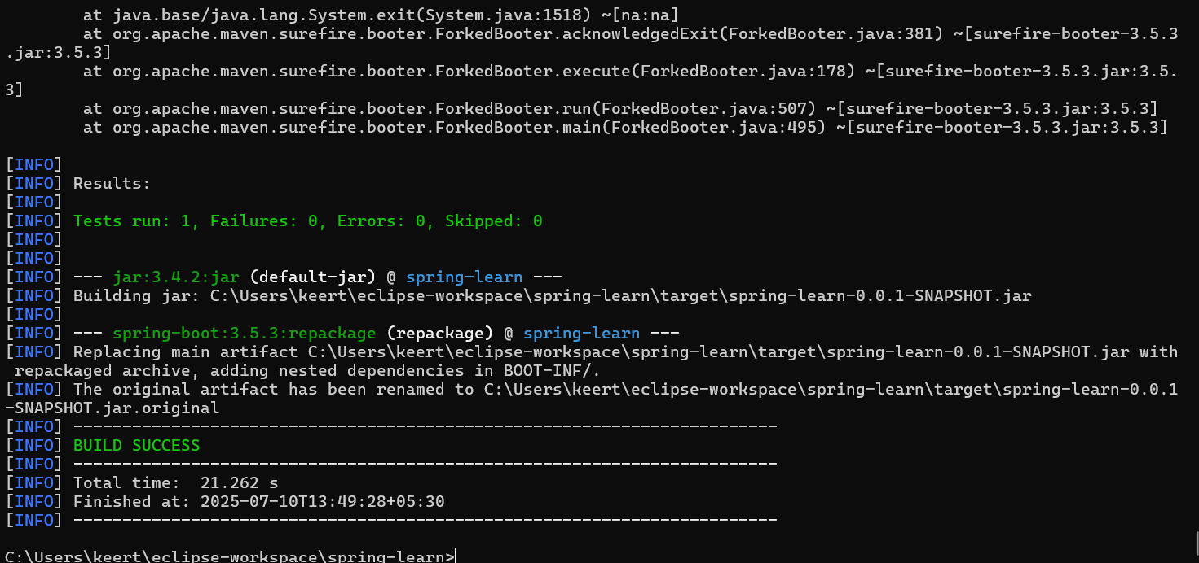

7. **In Eclipse:**  
File > Import > Maven > Existing Maven Projects,Select the extracted orm-learn folder.

Click Finish.

**pom.xml:**

<?xml version="1.0" encoding="UTF-8"?>

<project xmlns="http://maven.apache.org/POM/4.0.0" xmlns:xsi="http://www.w3.org/2001/XMLSchema-instance"

xsi:schemaLocation="http://maven.apache.org/POM/4.0.0 https://maven.apache.org/xsd/maven-4.0.0.xsd">

<modelVersion>4.0.0</modelVersion>

<parent>

<groupId>org.springframework.boot</groupId>

<artifactId>spring-boot-starter-parent</artifactId>

<version>3.5.3</version>

<relativePath/> <!-- lookup parent from repository -->

</parent>

<groupId>com.cognizant</groupId>

<artifactId>spring-learn</artifactId>

<version>0.0.1-SNAPSHOT</version>

<name>spring-learn</name>

<description>Demo project for Spring Boot</description>

<url/>

<licenses>

<license/>

</licenses>

<developers>

<developer/>

</developers>

<scm>

<connection/>

<developerConnection/>

<tag/>

<url/>

</scm>

<properties>

<java.version>17</java.version>

</properties>

<dependencies>

<dependency>

<groupId>org.springframework.boot</groupId>

<artifactId>spring-boot-starter-web</artifactId>

</dependency>

<dependency>

<groupId>org.springframework.boot</groupId>

<artifactId>spring-boot-devtools</artifactId>

<scope>runtime</scope>

<optional>true</optional>

</dependency>

<dependency>

<groupId>org.springframework.boot</groupId>

<artifactId>spring-boot-starter-test</artifactId>

<scope>test</scope>

</dependency>

</dependencies>

<build>

<plugins>

<plugin>

<groupId>org.springframework.boot</groupId>

<artifactId>spring-boot-maven-plugin</artifactId>

</plugin>

</plugins>

</build>

</project>

**SpringLearnApplication.java:**

package com.cognizant.spring_learn;

import org.springframework.boot.SpringApplication;

import org.springframework.boot.autoconfigure.SpringBootApplication;

@SpringBootApplication

public class SpringLearnApplication {

public static void main(String[] args) {

SpringApplication.run(SpringLearnApplication.class, args);

System.out.println("SpringLearnApplication started.");

}

}

**Output:**

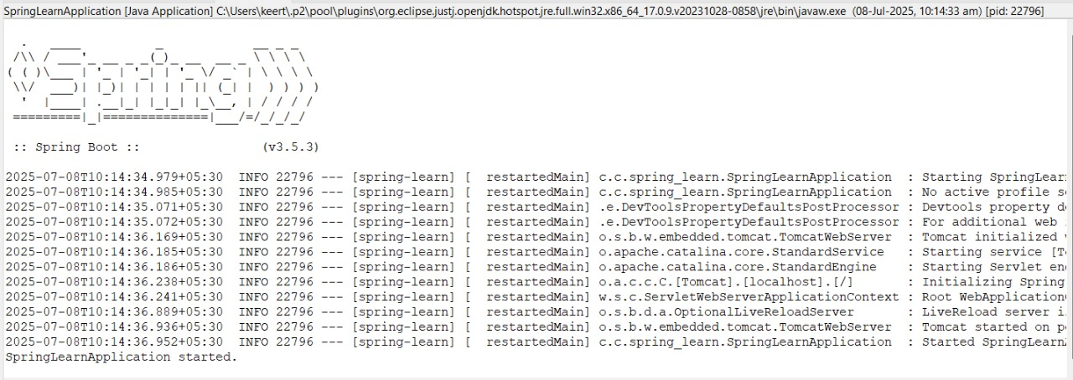

**Spring Core – Load Country from Spring Configuration XML**

**Country.java:**

package com.cognizant.spring_learn;

import org.slf4j.Logger;

import org.slf4j.LoggerFactory;

public class Country {

private static final Logger LOGGER = LoggerFactory.getLogger(Country.class);

private String code;

private String name;

public Country() {

LOGGER.debug("Inside Country Constructor.");

}

public String getCode() {

LOGGER.debug("Getter for Code");

return code;

}

public void setCode(String code) {

LOGGER.debug("Setter for Code");

this.code = code;

}

public String getName() {

LOGGER.debug("Getter for Name");

return name;

}

public void setName(String name) {

LOGGER.debug("Setter for Name");

this.name = name;

}

@Override

public String toString() {

return "Country [code=" + code + ", name=" + name + "]";

}

}

**country.xml:** (in src/main/resources)

<?xml version="1.0" encoding="UTF-8"?>

<beans xmlns="http://www.springframework.org/schema/beans"

xmlns:xsi="http://www.w3.org/2001/XMLSchema-instance"

xsi:schemaLocation="http://www.springframework.org/schema/beans

http://www.springframework.org/schema/beans/spring-beans.xsd">

<bean id="country" class="com.cognizant.spring_learn.Country">

<property name="code" value="IN"/>

<property name="name" value="India"/>

</bean>

</beans>

**application.properties:**

spring.application.name=spring-learn

logging.level.com.cognizant.spring_learn=DEBUG

logging.level.root=DEBUG

**SpringLearnApplication.java:**

package com.cognizant.spring_learn;

import org.springframework.boot.SpringApplication;

import org.springframework.boot.autoconfigure.SpringBootApplication;

import org.slf4j.Logger;

import org.slf4j.LoggerFactory;

import org.springframework.context.ApplicationContext;

import org.springframework.context.support.ClassPathXmlApplicationContext;

@SpringBootApplication

public class SpringLearnApplication {

private static final Logger LOGGER = LoggerFactory.getLogger(SpringLearnApplication.class);

public static void main(String[] args) {

SpringApplication.run(SpringLearnApplication.class, args);

System.out.println("SpringLearnApplication started.");

displayCountry();

}

public static void displayCountry() {

ApplicationContext context = new ClassPathXmlApplicationContext("country.xml");

Country country = (Country) context.getBean("country", Country.class);

LOGGER.debug("Country : {}", country.toString());

}

}

**Output:**

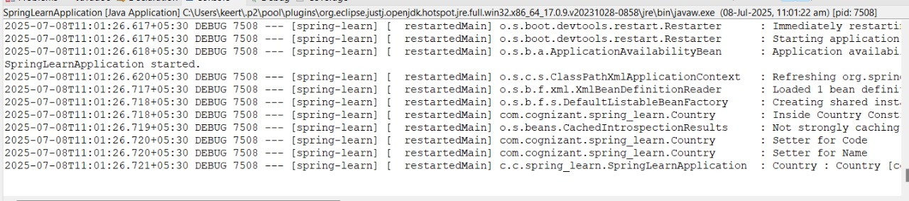

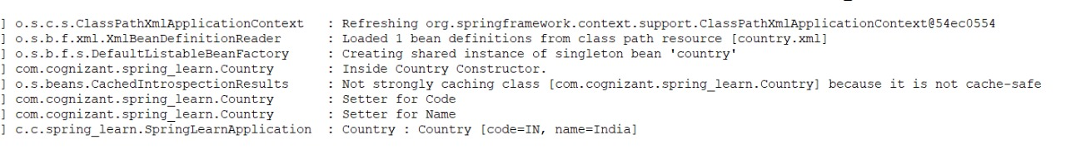

**Hello World RESTful Web Service**

**HelloController.java:** (in com.cognizant.spring_learn.controller package)  
package com.cognizant.spring_learn.controller;

import org.slf4j.Logger;

import org.slf4j.LoggerFactory;

import org.springframework.web.bind.annotation.GetMapping;

import org.springframework.web.bind.annotation.RestController;

@RestController

public class HelloController {

private static final Logger LOGGER = LoggerFactory.getLogger(HelloController.class);

@GetMapping("/hello")

public String sayHello() {

LOGGER.info("sayHello() started");

LOGGER.info("sayHello() ended");

return "Hello World!!";

}

}

**application.properties:**

spring.application.name=spring-learn

logging.level.com.cognizant.spring_learn=DEBUG

logging.level.root=DEBUG

server.port=8083

**SpringLearnApplication.java:**

package com.cognizant.spring_learn;

import org.springframework.boot.SpringApplication;

import org.springframework.boot.autoconfigure.SpringBootApplication;

@SpringBootApplication

public class SpringLearnApplication {

public static void main(String[] args) {

SpringApplication.run(SpringLearnApplication.class, args);

}

}

**Output:**

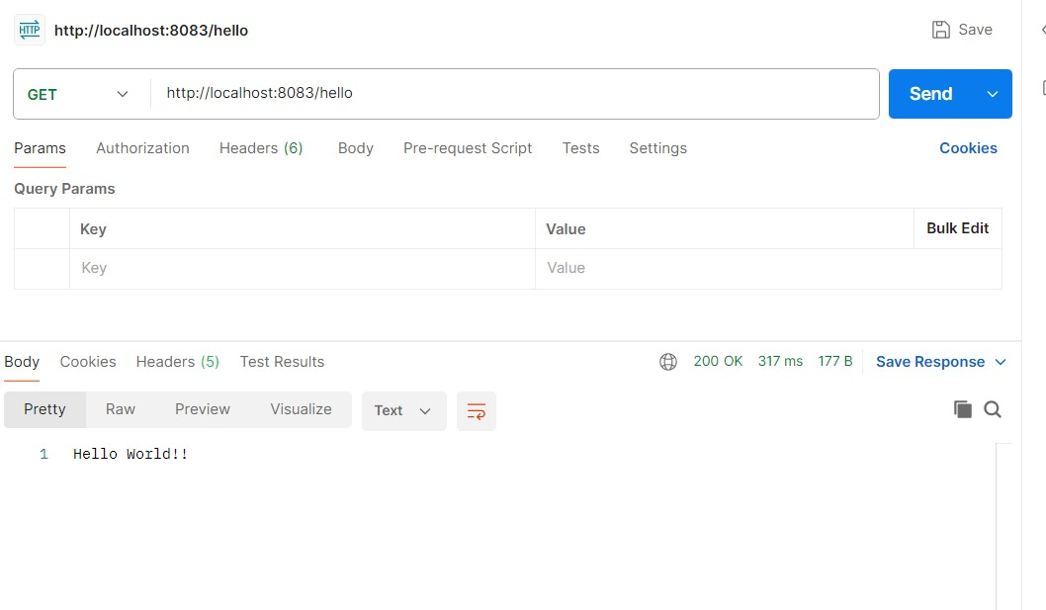

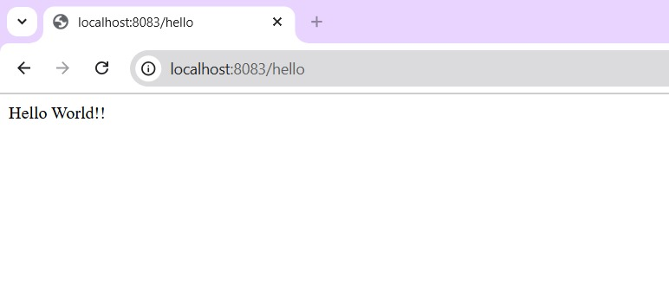

**REST - Country Web Service**   
**CountryController.java:** (in com.cognizant.spring_learn.controller package)

package com.cognizant.spring_learn.controller;

import com.cognizant.spring_learn.Country;

import org.slf4j.Logger;

import org.slf4j.LoggerFactory;

import org.springframework.context.ApplicationContext;

import org.springframework.context.support.ClassPathXmlApplicationContext;

import org.springframework.web.bind.annotation.RequestMapping;

import org.springframework.web.bind.annotation.RestController;

@RestController

public class CountryController {

private static final Logger LOGGER = LoggerFactory.getLogger(CountryController.class);

@RequestMapping("/country")

public Country getCountryIndia() {

LOGGER.info("getCountryIndia() started");

ApplicationContext context = new ClassPathXmlApplicationContext("country.xml");

Country country = (Country) context.getBean("country", Country.class);

LOGGER.info("getCountryIndia( ended)");

return country;

}

}

**Output:**

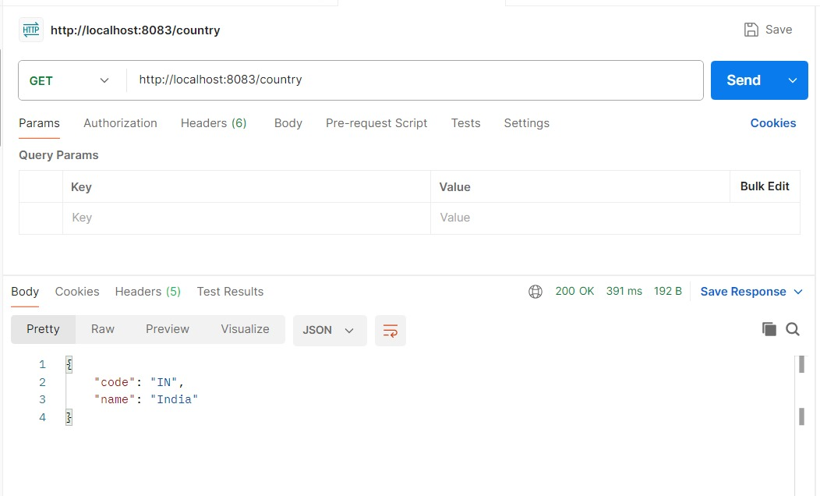

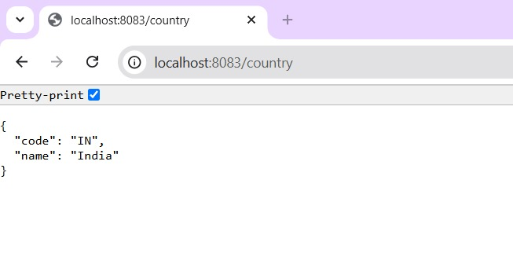

**REST - Get country based on country code**

**country.xml:**

<?xml version="1.0" encoding="UTF-8"?>

<beans xmlns="http://www.springframework.org/schema/beans"

xmlns:xsi="http://www.w3.org/2001/XMLSchema-instance"

xsi:schemaLocation="http://www.springframework.org/schema/beans

http://www.springframework.org/schema/beans/spring-beans.xsd">

<bean id="in" class="com.cognizant.spring_learn.Country">

<property name="code" value="IN"/>

<property name="name" value="India"/>

</bean>

<bean id="us" class="com.cognizant.spring_learn.Country">

<property name="code" value="US"/>

<property name="name" value="United States"/>

</bean>

<bean id="jp" class="com.cognizant.spring_learn.Country">

<property name="code" value="JP"/>

<property name="name" value="Japan"/>

</bean>

<bean id="countryList" class="java.util.ArrayList">

<constructor-arg>

<list>

<ref bean="in"/>

<ref bean="us"/>

<ref bean="jp"/>

</list>

</constructor-arg>

</bean>

</beans>

**CountryService.java:** (in com.cognizant.spring_learn.service package)

package com.cognizant.spring_learn.service;

import com.cognizant.spring_learn.Country;

import org.springframework.context.ApplicationContext;

import org.springframework.context.support.ClassPathXmlApplicationContext;

import org.springframework.stereotype.Service;

import java.util.List;

@Service

public class CountryService {

public Country getCountry(String code) {

ApplicationContext context = new ClassPathXmlApplicationContext("country.xml");

List<Country> countryList = context.getBean("countryList", List.class);

return countryList.stream()

.filter(c -> c.getCode().equals(code))

.findFirst()

}

}

**CountryController.java:**

package com.cognizant.spring_learn.controller;

import com.cognizant.spring_learn.Country;

import com.cognizant.spring_learn.service.CountryService;

import org.slf4j.Logger;

import org.slf4j.LoggerFactory;

import org.springframework.beans.factory.annotation.Autowired;

import org.springframework.web.bind.annotation.*;

@RestController

public class CountryController {

private static final Logger LOGGER = LoggerFactory.getLogger(CountryController.class);

@Autowired

private CountryService countryService;

@GetMapping("/countries/{code}")

public Country getCountry(@PathVariable String code) {

LOGGER.debug("START getCountry: {}", code);

Country country = countryService.getCountry(code);

LOGGER.debug("END getCountry");

return country;

}

}

**SpringLearnApplication.java:**

package com.cognizant.spring_learn;

import org.springframework.boot.SpringApplication;

import org.springframework.boot.autoconfigure.SpringBootApplication;

import org.springframework.context.annotation.ComponentScan;

@SpringBootApplication

@ComponentScan("com.cognizant.spring_learn")

public class SpringLearnApplication {

public static void main(String[] args) {

SpringApplication.run(SpringLearnApplication.class, args);

}

}

**Output:**

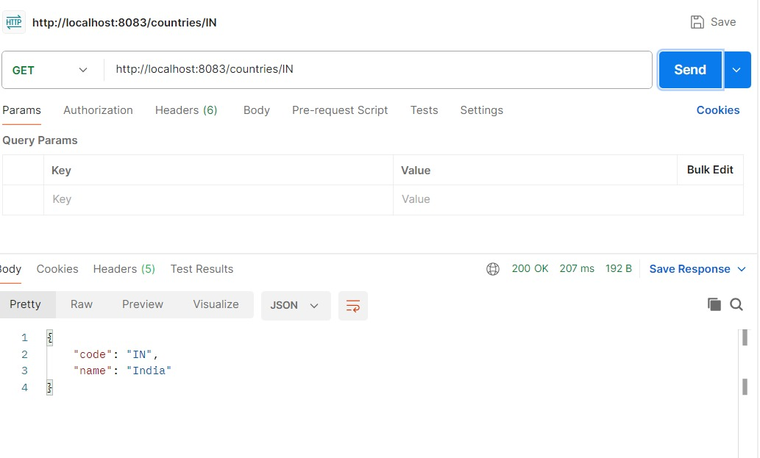

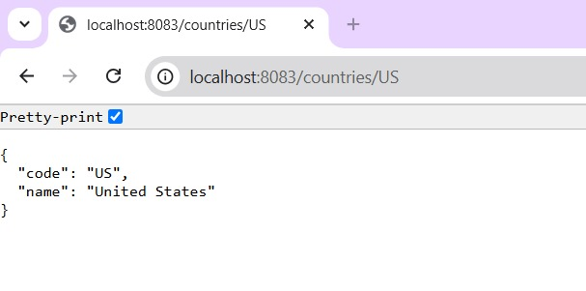

**Create authentication service that returns JWT**   
**pom.xml:**

<?xml version="1.0" encoding="UTF-8"?>

<project xmlns="http://maven.apache.org/POM/4.0.0" xmlns:xsi="http://www.w3.org/2001/XMLSchema-instance"

xsi:schemaLocation="http://maven.apache.org/POM/4.0.0 https://maven.apache.org/xsd/maven-4.0.0.xsd">

<modelVersion>4.0.0</modelVersion>

<parent>

<groupId>org.springframework.boot</groupId>

<artifactId>spring-boot-starter-parent</artifactId>

<version>3.5.3</version>

<relativePath/> <!-- lookup parent from repository -->

</parent>

<groupId>com.cognizant</groupId>

<artifactId>spring-learn</artifactId>

<version>0.0.1-SNAPSHOT</version>

<name>spring-learn</name>

<description>Demo project for Spring Boot</description>

<url/>

<licenses>

<license/>

</licenses>

<developers>

<developer/>

</developers>

<scm>

<connection/>

<developerConnection/>

<tag/>

<url/>

</scm>

<properties>

<java.version>17</java.version>

</properties>

<dependencies>

<dependency>

<groupId>org.springframework.boot</groupId>

<artifactId>spring-boot-starter-web</artifactId>

</dependency>

<dependency>

<groupId>org.springframework.boot</groupId>

<artifactId>spring-boot-starter-security</artifactId>

</dependency>

<dependency>

<groupId>org.springframework.boot</groupId>

<artifactId>spring-boot-devtools</artifactId>

<scope>runtime</scope>

<optional>true</optional>

</dependency>

<dependency>

<groupId>org.springframework.boot</groupId>

<artifactId>spring-boot-starter-test</artifactId>

<scope>test</scope>

</dependency>

<dependency>

<groupId>io.jsonwebtoken</groupId>

<artifactId>jjwt-api</artifactId>

<version>0.11.5</version>

</dependency>

<dependency>

<groupId>io.jsonwebtoken</groupId>

<artifactId>jjwt-impl</artifactId>

<version>0.11.5</version>

<scope>runtime</scope>

</dependency>

<dependency>

<groupId>io.jsonwebtoken</groupId>

<artifactId>jjwt-jackson</artifactId>

<version>0.11.5</version>

<scope>runtime</scope>

</dependency>

</dependencies>

<build>

<plugins>

<plugin>

<groupId>org.springframework.boot</groupId>

<artifactId>spring-boot-maven-plugin</artifactId>

</plugin>

</plugins>

</build>

</project>

**AuthController.java:**

package com.cognizant.spring_learn.controller;

import io.jsonwebtoken.JwtBuilder;

import io.jsonwebtoken.Jwts;

import io.jsonwebtoken.SignatureAlgorithm;

import io.jsonwebtoken.security.Keys;

import org.slf4j.Logger;

import org.slf4j.LoggerFactory;

import org.springframework.web.bind.annotation.*;

import java.util.Base64;

import java.util.Date;

import java.util.HashMap;

import java.util.Map;

@RestController

public class AuthController {

private Logger logger = LoggerFactory.getLogger(AuthController.class);

@GetMapping("/authenticate")

public Map<String, String> authenticate(@RequestHeader("Authorization") String authHeader) {

logger.info("START: authenticate()");

logger.debug("Authorization Header: {}", authHeader);

String user = getUser(authHeader);

logger.debug("Decoded User: {}", user);

String token = generateJwt(user);

Map<String, String> map = new HashMap<>();

map.put("token", token);

logger.info("END: authenticate()");

return map;

}

private String getUser(String authHeader) {

logger.info("START: getUser()");

String base64Credentials = authHeader.substring("Basic".length()).trim();

byte[] decoded = Base64.getDecoder().decode(base64Credentials);

String decodedString = new String(decoded);

String username = decodedString.split(":")[0];

logger.debug("Extracted Username: {}", username);

logger.info("END: getUser()");

return username;

}

private String generateJwt(String user) {

return Jwts.builder()

.setSubject(user)

.setIssuedAt(new Date())

.setExpiration(new Date(System.currentTimeMillis() + 20 * 60 * 1000))

.signWith(Keys.hmacShaKeyFor("mysecretkeymysecretkeymysecretkey!".getBytes()), SignatureAlgorithm.HS256)

.compact();

}

}

**SecurityConfig.java**: (in com.cognizant.spring_learn.config)

package com.cognizant.spring_learn.config;

import org.springframework.context.annotation.Bean;

import org.springframework.context.annotation.Configuration;

import org.springframework.security.config.Customizer;

import org.springframework.security.config.annotation.web.builders.HttpSecurity;

import org.springframework.security.core.userdetails.User;

import org.springframework.security.core.userdetails.UserDetailsService;

import org.springframework.security.provisioning.InMemoryUserDetailsManager;

import org.springframework.security.web.SecurityFilterChain;

@Configuration

public class SecurityConfig {

@Bean

public UserDetailsService userDetailsService() {

return new InMemoryUserDetailsManager(

User.withUsername("user").password("{noop}pwd").roles("USER").build(),

User.withUsername("admin").password("{noop}adminpwd").roles("ADMIN").build()

);

}

@Bean

public SecurityFilterChain filterChain(HttpSecurity http) throws Exception {

http.csrf().disable()

.authorizeHttpRequests(auth -> auth

.requestMatchers("/countries").hasRole("USER")

.requestMatchers("/authenticate").hasAnyRole("USER", "ADMIN")

.anyRequest().authenticated()

)

.httpBasic(Customizer.withDefaults());

return http.build();

}

}

**Output:**

