**9.REACTJS-HOL: “cricketapp”**

**1.** Create a React Application with the name of “cricketapp”.

npx create-react-app cricketapp

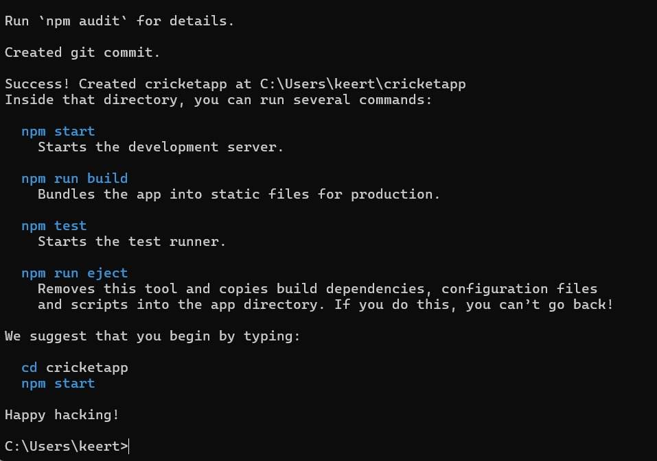

**2.** Open the folder of cricketapp in Visual Studio Code and inside src/ create components folder, create following components int that folder:

**ListofPlayers.js:**

import React from 'react';

const ListofPlayers = ({ players }) => {

return (

<ul>

{players.map((item, index) => (

<li key={index}>

Mr. {item.name} <span>{item.score}</span>

</li>

))}

</ul>

);

};

export default ListofPlayers;

**ScoreBelow70.js:**

import React from 'react';

const ScoreBelow70 = ({ players }) => {

const players70 = [];

players.map((item) => {

if (item.score <= 70) {

players70.push(item);

}

return null;

});

return (

<ul>

{players70.map((item, index) => (

<li key={index}>

Mr. {item.name} <span>{item.score}</span>

</li>

))}

</ul>

);

};

export default ScoreBelow70;

**OddPlayers.js:**

export function OddPlayers([first, , third, , fifth]) {

return (

<ul>

<li>First : {first}</li>

<li>Third : {third}</li>

<li>Fifth : {fifth}</li>

</ul>

);

}

**EvenPlayers.js:**

export function EvenPlayers([, second, , fourth, , sixth]) {

return (

<ul>

<li>Second : {second}</li>

<li>Fourth : {fourth}</li>

<li>Sixth : {sixth}</li>

</ul>

);

}

**ListofIndianPlayers.js:**

import React from 'react';

const ListofIndianPlayers = ({ IndianPlayers }) => {

return (

<ul>

{IndianPlayers.map((item, index) => (

<li key={index}>Mr. {item}</li>

))}

</ul>

);

};

export default ListofIndianPlayers;

**IndianTeamData.js:**

export const IndianTeam = ['Sachin1', 'Dhoni2', 'Virat3', 'Rohit4', 'Yuvaraj5', 'Raina6'];

const T20Players = ['First Player', 'Second Player', 'Third Player'];

const RanjiTrophyPlayers = ['Fourth Player', 'Fifth Player', 'Sixth Player'];

export const IndianPlayers = [...T20Players, ...RanjiTrophyPlayers];

**3.** Change the following files:

**App.js:**

import React from 'react';

import ListofPlayers from './components/ListofPlayers';

import ScoreBelow70 from './components/ScoreBelow70';

import { OddPlayers } from './components/OddPlayers';

import { EvenPlayers } from './components/EvenPlayers';

import ListofIndianPlayers from './components/ListofIndianPlayers';

import { IndianPlayers, IndianTeam } from './components/IndianTeamData';

function App() {

var flag = false;

const players = [

{ name: 'Jack', score: 50 },

{ name: 'Michael', score: 70 },

{ name: 'John', score: 40 },

{ name: 'Ann', score: 61 },

{ name: 'Elisabeth', score: 61 },

{ name: 'Sachin', score: 95 },

{ name: 'Dhoni', score: 100 },

{ name: 'Virat', score: 84 },

{ name: 'Jadeja', score: 64 },

{ name: 'Raina', score: 75 },

{ name: 'Rohit', score: 80 }

];

if (flag === true) {

return (

<div>

<h1>List of Players</h1>

<ListofPlayers players={players} />

<hr />

<h1>List of Players having Scores Less than 70</h1>

<ScoreBelow70 players={players} />

</div>

);

} else {

return (

<div>

<div>

<h1>Indian Team</h1>

<h1>Odd Players</h1>

{OddPlayers(IndianTeam)}

<hr />

<h1>Even Players</h1>

{EvenPlayers(IndianTeam)}

</div>

<hr />

<div>

<h1>List of Indian Players Merged:</h1>

<ListofIndianPlayers IndianPlayers={IndianPlayers} />

</div>

</div>

);

}

}

export default App;

**4.** Run the application using “npm start” command.

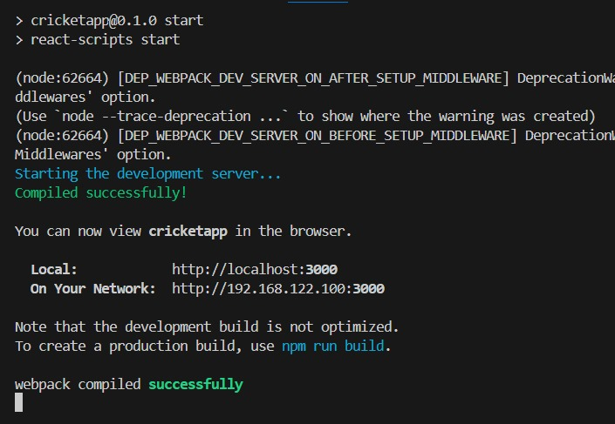

**Output:**

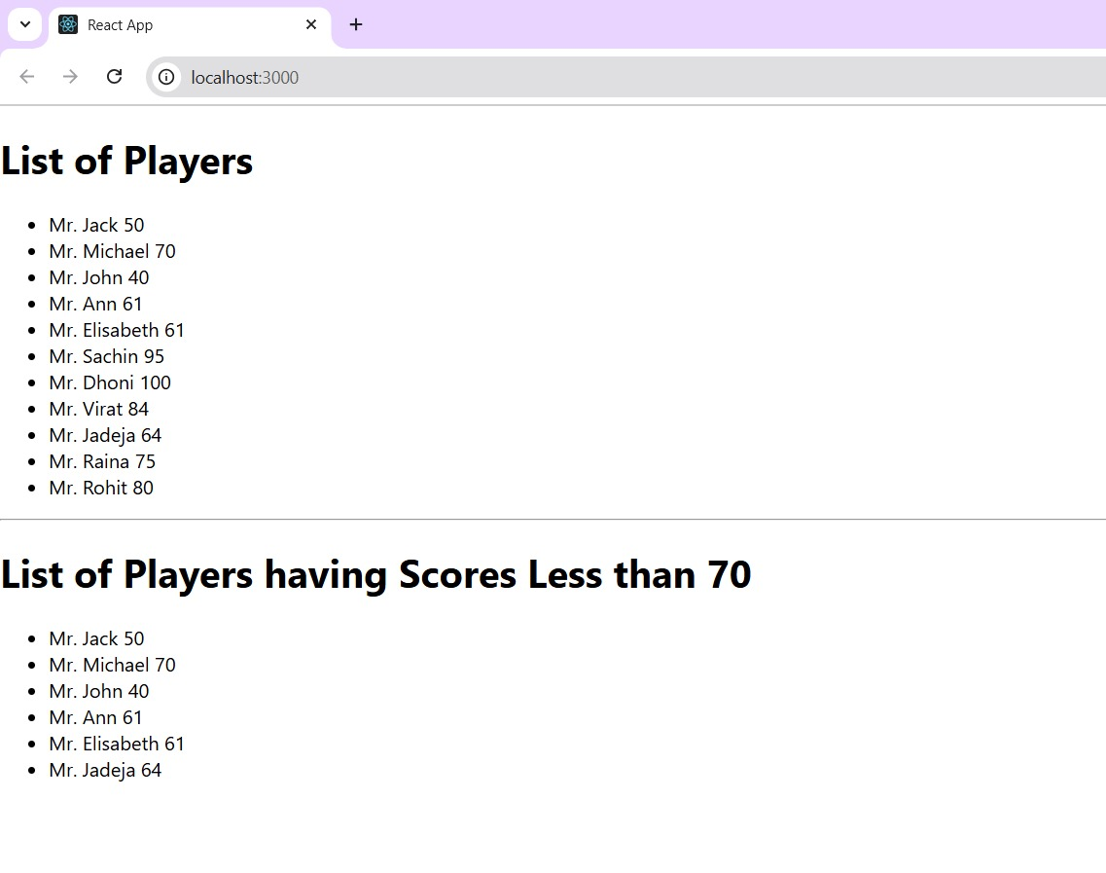When flag=true

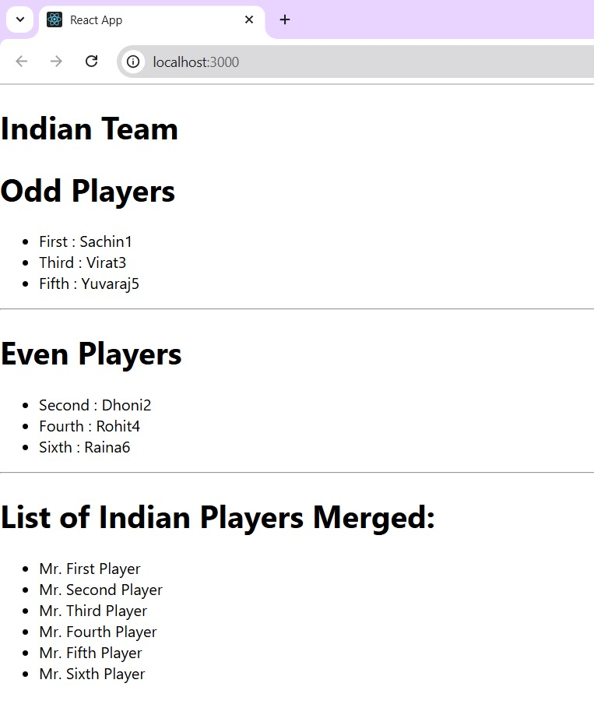When flag=false

**10.REACTJS-HOL: “officespacerentalapp”**

**1.** Create a React project named “officespacerentalapp”

npx create-react-app officespacerentalapp

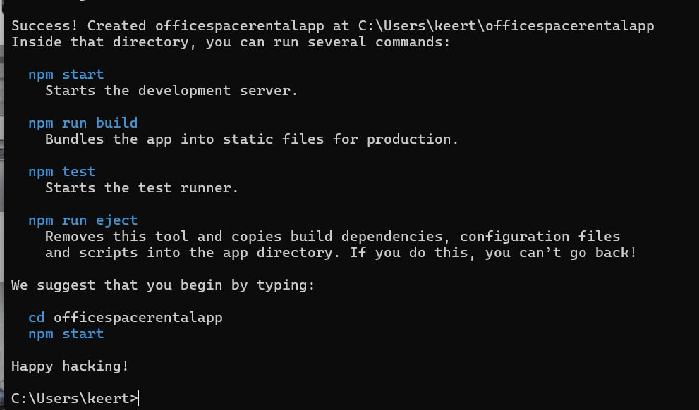

**2.** Openofficespacerentalapp in visual studio code and change the following files:

**App.js:**

import './App.css';

import sr from './office.jpg';

function App() {

const element = "Office Space";

const jsxatt = <img src={sr} width="25%" height="25%" alt="Office Space" />;

const offices = [

{ Name: "DBS", Rent: 50000, Address: "Chennai" },

{ Name: "WeWork", Rent: 70000, Address: "Bangalore" }

];

return (

<div className="App">

<h1>{element}, at Affordable Range</h1>

{jsxatt}

{offices.map((ItemName, index) => {

let colors = [];

if (ItemName.Rent <= 60000) {

colors.push('textRed');

} else {

colors.push('textGreen');

}

return (

<div key={index}>

<h1>Name: {ItemName.Name}</h1>

<h3 className={colors[0]}>Rent: Rs. {ItemName.Rent}</h3>

<h3>Address: {ItemName.Address}</h3>

</div>

);

})}

</div>

);

}

export default App;

**App.css:**

.App {

padding: 50px 200px;

font-family: Arial;

}

.textRed {

color: red;

font-weight: bold;

}

.textGreen {

color: green;

font-weight: bold;

}

**3.** Run the application using “npm start” command.

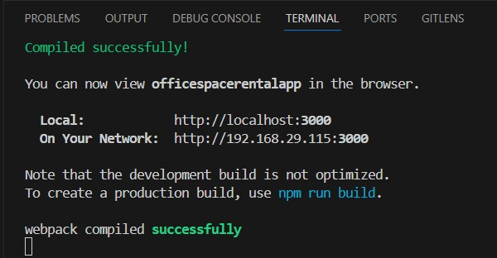

**Output:**

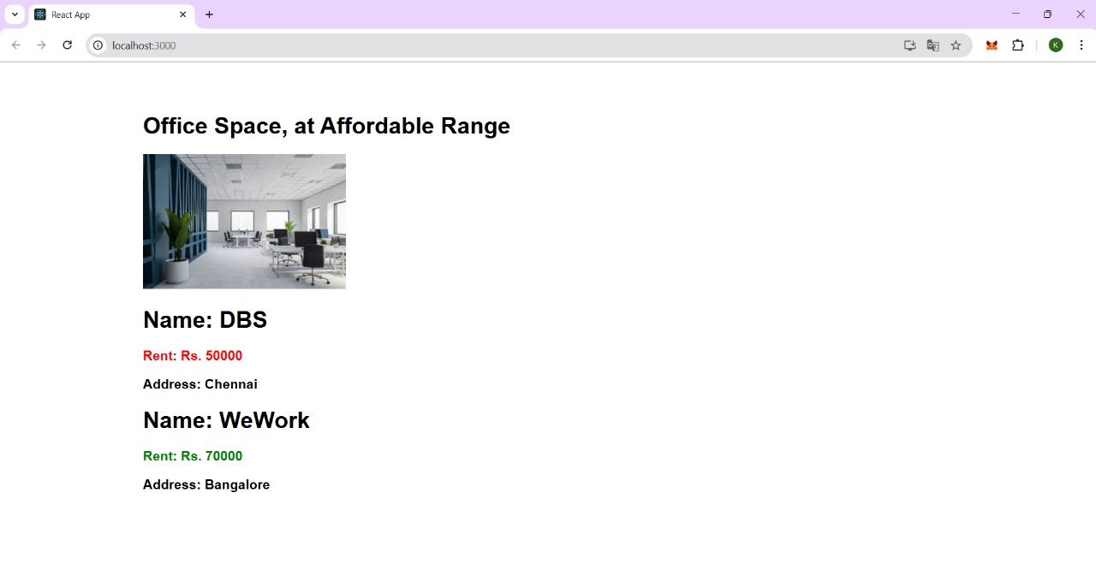

**11.REACTJS-HOL: “eventexamplesapp”**

**1.** Create a React project named “eventexamplesapp”.

npx create-react-app eventexamplesapp

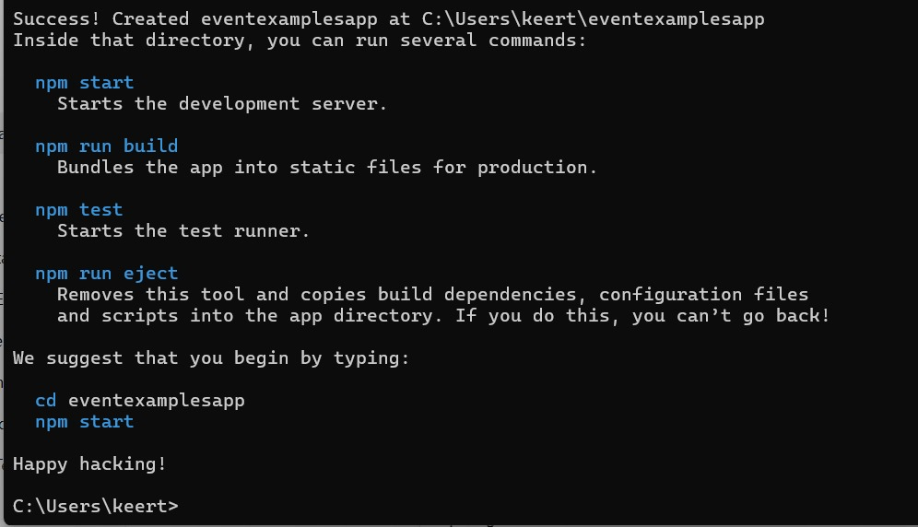

**2.** Openeventexamplesapp in visual studio code and change the following files:

**App.js:**

import React, { useState } from 'react';

import './App.css';

function App() {

const [count, setCount] = useState(0);

const [amount, setAmount] = useState('');

const [currency, setCurrency] = useState('');

const handleIncrement = () => {

setCount(count + 1);

alert("Hello! Member1");

};

const handleDecrement = () => {

setCount(count - 1);

};

const sayWelcome = (msg) => {

alert(msg);

};

const handleClick = () => {

alert("I was clicked");

};

const handleSubmit = (e) => {

e.preventDefault();

if (currency.toLowerCase() === "euro") {

const result = parseFloat(amount) * 80;

alert(Converting to Euro Amount is ${result});

} else {

alert("Currency not supported");

}

};

return (

<div className="App">

<p>{count}</p>

<button onClick={handleIncrement}>Increment</button><br />

<button onClick={handleDecrement}>Decrement</button><br />

<button onClick={() => sayWelcome("welcome")}>Say welcome</button><br />

<button onClick={handleClick}>Click on me</button>

<br /><br />

<div>

<h1 style={{ color: "green" }}>Currency Convertor!!!</h1>

<form onSubmit={handleSubmit}>

<label>Amount: </label>

<input type="text" value={amount} onChange={(e) => setAmount(e.target.value)} /><br />

<label>Currency: </label>

<textarea value={currency} onChange={(e) => setCurrency(e.target.value)} /><br />

<input type="submit" value="Submit" />

</form>

</div>

</div>

);

}

export default App;

**App.css:**

.App {

padding: 20px;

}

**3.** Run the application using “npm start” command.

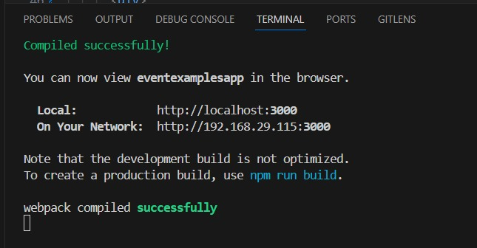

**Output:**

Increment:

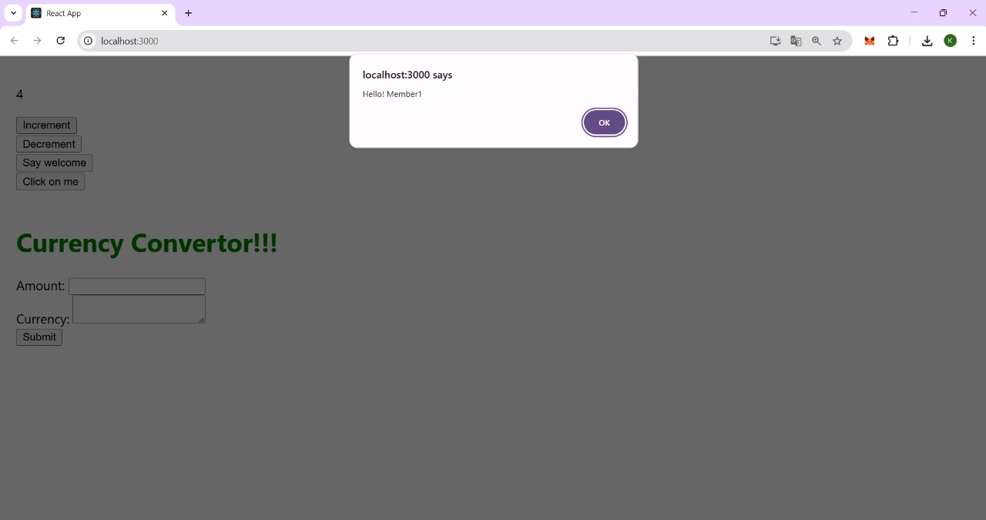

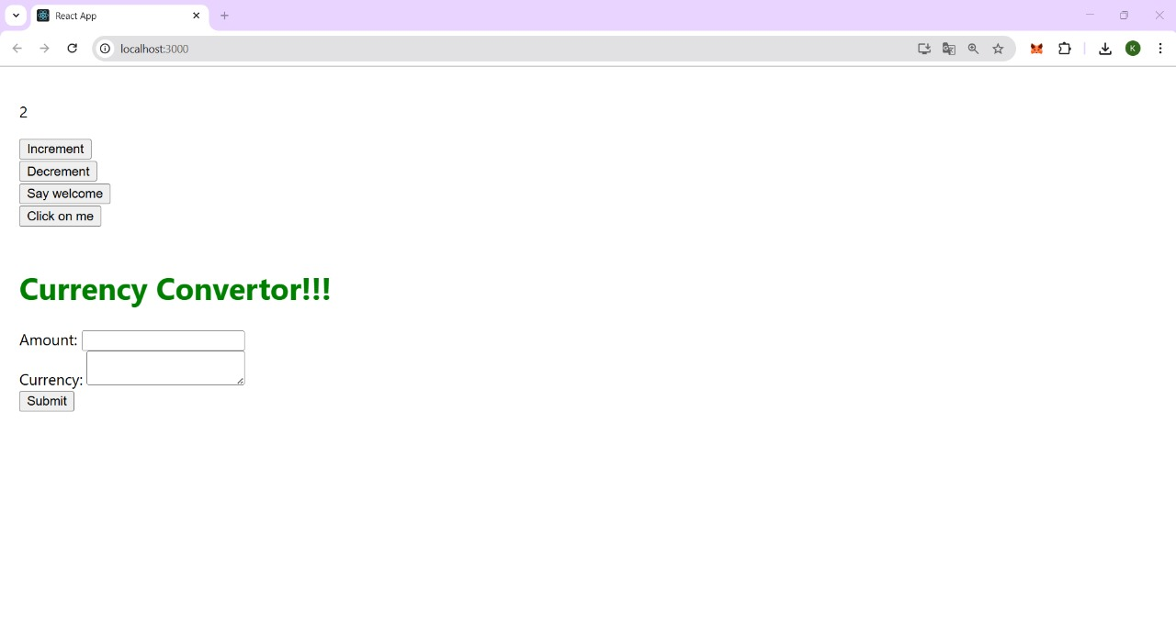Decrement:

Say Welcome:

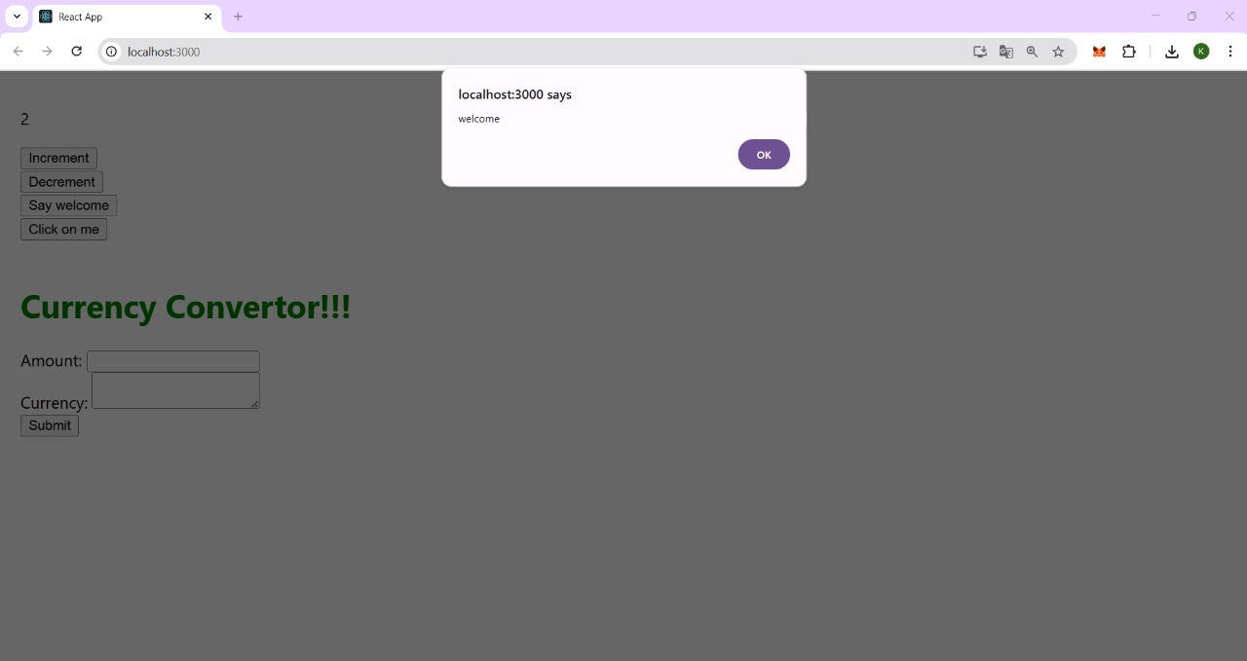

Click on me:

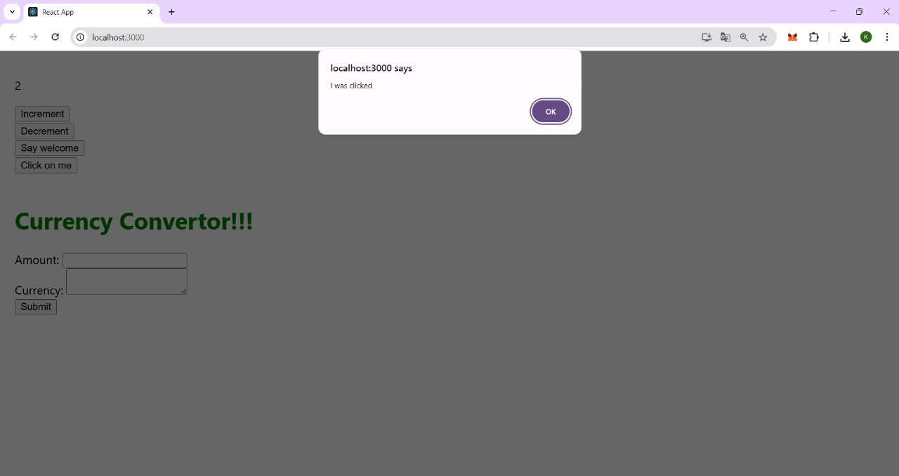

Currency Converter:

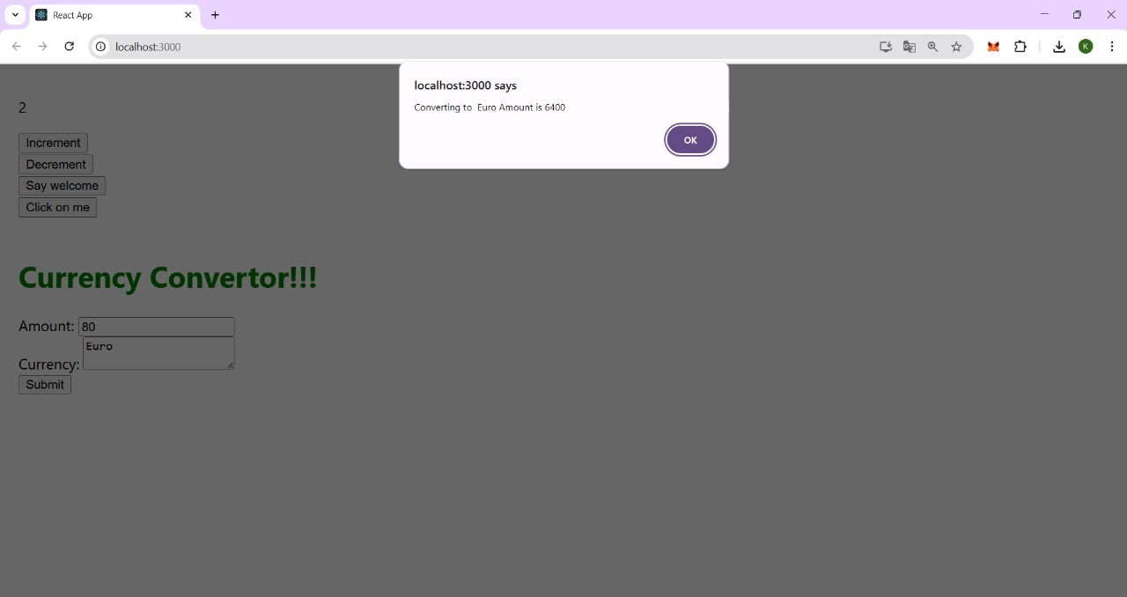

**12.REACTJS-HOL: “ticketbookingapp”**

**1.** Create a React project named “ticketbookingapp”.

npx create-react-app ticketbookingapp

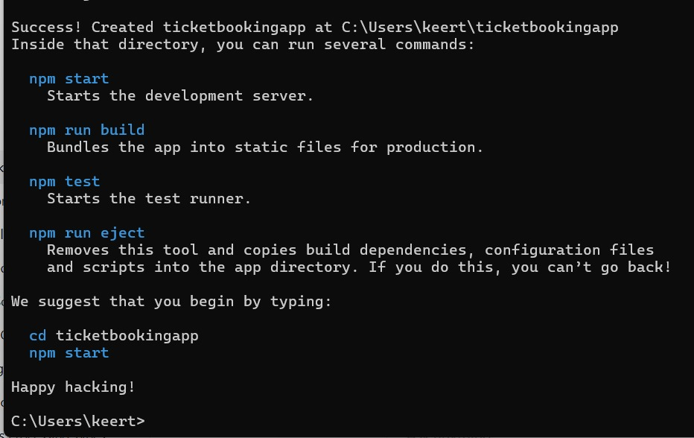

**2.** Openticketbookingapp in visual studio code and create the following files in src folder:

**GuestGreeting.js:**

function GuestGreeting() {

return <h1>Please sign up.</h1>;

}

export default GuestGreeting;

**UserGreeting.js:**

function UserGreeting() {

return <h1>Welcome back</h1>;

}

export default UserGreeting;

**LoginButton.js:**

function LoginButton(props) {

return <button onClick={props.onClick}>Login</button>;

}

export default LoginButton;

**LogoutButton.js:**

function LogoutButton(props) {

return <button onClick={props.onClick}>Logout</button>;

}

export default LogoutButton;

import UserGreeting from './UserGreeting';

import GuestGreeting from './GuestGreeting';

**Greeting.js:**

function Greeting(props) {

const isLoggedIn = props.isLoggedIn;

if (isLoggedIn) {

return <UserGreeting />;

}

return <GuestGreeting />;

}

export default Greeting;

**3.** Change the following files:

**App.js:**

import React, { useState } from 'react';

import Greeting from './Greeting';

import LoginButton from './LoginButton';

import LogoutButton from './LogoutButton';

import './App.css';

function App() {

const [isLoggedIn, setIsLoggedIn] = useState(false);

const handleLoginClick = () => {

setIsLoggedIn(true);

};

const handleLogoutClick = () => {

setIsLoggedIn(false);

};

let button;

if (isLoggedIn) {

button = <LogoutButton onClick={handleLogoutClick} />;

} else {

button = <LoginButton onClick={handleLoginClick} />;

}

return (

<div className='App'>

<Greeting isLoggedIn={isLoggedIn} />

{button}

</div>

);

}

export default App;

**App.css:**

.App {

padding: 100px 200px; }

**4.** Run the application using “npm start” command.

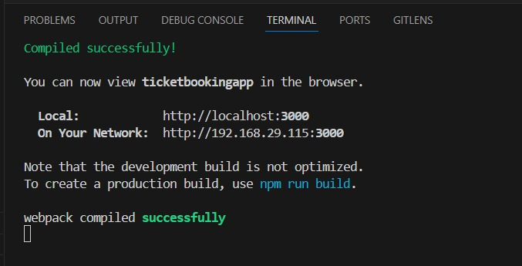

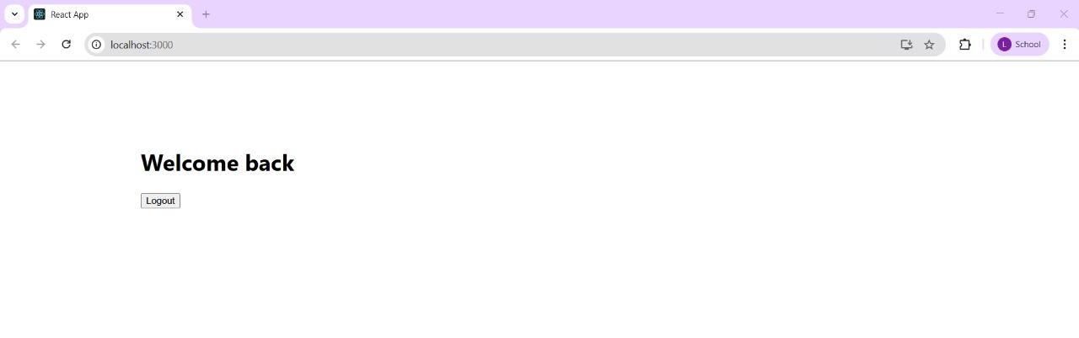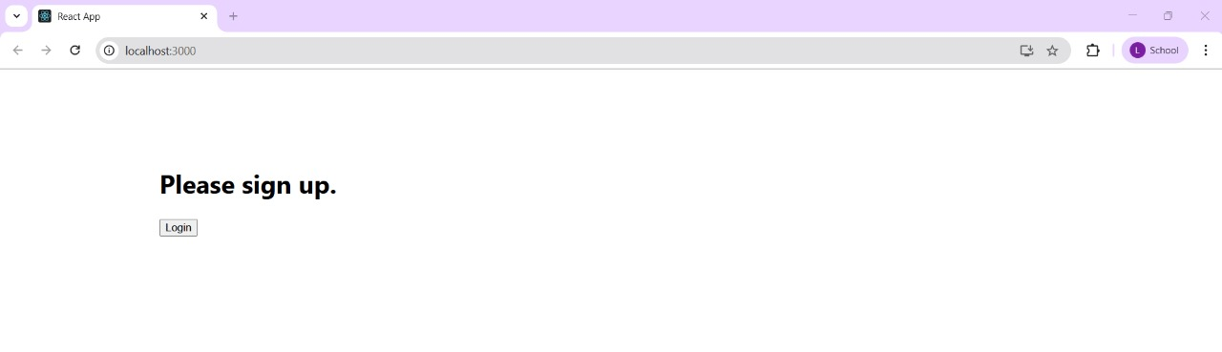**Output:**

**13.REACTJS-HOL: “bloggerapp”**

**1.** Create a React project named “bloggerapp”.

npx create-react-app bloggerapp

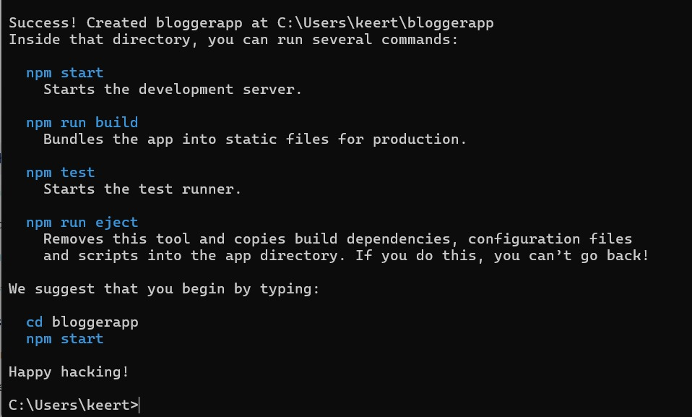

**2.** Openbloggerapp in visual studio code and create the following file in src folder:

**data.js:**

export const books = [

{ id: 101, bname: 'Master React', price: 670 },

{ id: 102, bname: 'Deep Dive into Angular 11', price: 800 },

{ id: 103, bname: 'Mongo Essentials', price: 450 },

];

export const courses = [

{ name: 'Angular', date: '4/5/2021' },

{ name: 'React', date: '6/3/20201' },

];

export const blogs = [

{

title: 'React Learning',

author: 'Stephen Biz',

content: 'Welcome to learning React!',

},

{

title: 'Installation',

author: 'Schwezdenier',

content: 'You can install React from npm.',

},

];

**3.** Change the following files:

**App.js:**

import React from 'react';

import './App.css';

import { books, courses, blogs } from './data';

function App() {

const bookdet = (

<ul>

{books.length > 0 ? (

books.map((book) => (

<div key={book.id}>

<h3>{book.bname}</h3>

<h4>{book.price}</h4>

</div>

))

) : (

<p>No book data available.</p>

)}

</ul>

);

const coursedet = (

<>

{courses.length > 0 ? (

courses.map((course, index) => (

<div key={index}>

<h2>{course.name}</h2>

<h4>{course.date}</h4>

</div>

))

) : (

<p>No course data available.</p>

)}

</>

);

const content = (

<>

{blogs.length > 0 ? (

blogs.map((blog, index) => (

<div key={index}>

<h2>{blog.title}</h2>

<h4><b>{blog.author}</b></h4>

<p>{blog.content}</p>

</div>

))

) : (

<p>No blog data available.</p>

)}

</>

);

return (

<div className='App'>

<div className="book">

<h1>Book Details</h1>

{bookdet}

</div>

<div className="blog">

<h1>Blog Details</h1>

{content}

</div>

<div className="course">

<h1>Course Details</h1>

{coursedet}

</div>

</div>

);

}

export default App;

**App.css:**

.course,

.blog,

.book {

display: inline-block;

vertical-align: top;

padding: 20px;

width: 25%;

}

.book {

border-right: 4px solid green;

}

.blog {

border-right: 4px solid green;

}

.App{

display: flex;

justify-content: center;

margin-top: 100px;

}

**4.** Run the application using “npm start” command.

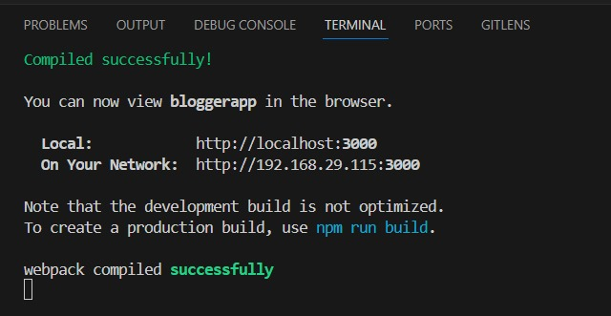

**Output:**

