IoT – Aquaculture Smart Monitoring System
Project Title:
Aqua Guard – IoT Based Water Quality Monitoring for Shrimp Farming
Scenario:
Monitor water quality parameters in shrimp ponds and trigger alerts when conditions become unsafe.
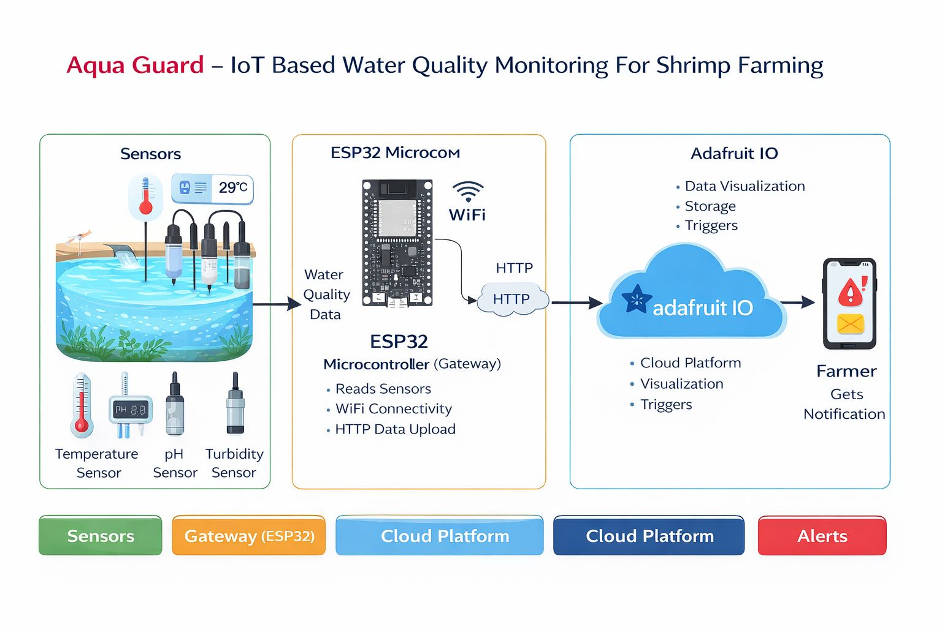
System Architecture Overview
The Aqua Guard system consists of three main layers:
- Sensor Layer – Collects real-time water parameters
- Gateway Layer – ESP32 processes and sends data
- Cloud Layer – Adafruit IO stores and visualizes data
- Alert Layer – IFTTT sends notifications to farmers
Flow:
Sensors → ESP32 Gateway → WiFi → Adafruit IO Cloud → IFTTT Alerts → Farmer Mobile

