“Best swimsuit for your body shape? “

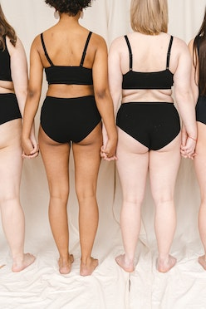

“We believe that fashion is all about feeling great about our own body! , We have created this quick easy quiz to find out what body shape you are, you might be surprised it’s nothing to do with size and is all about SHAPE. “

Your result will direct you to a hand-picked selection of swimsuits by our stylists for your body shape.

**Take our free body shape test below to discover your body shape and don’t forget to share this test with any person you feel could benefit from it!**

## 

TAKE THE QUIZ

Get results immediately!

1) Inverted Triangle (strawberry)

2) Triangle (pear)

3)Rectangle.

4)Hourglass

1) You tend to gain weight in which part of your body?

a)Hips and thighs, 4 , 2

b)upper body, 1

c)evenly throughout body 3

2) Your upper body (shoulders and chest) is _________ than your lower body?

a)Wider, 1 4

b)narrower, 2

c)about the same. 3

3)You will wear my swimsuit to?

a)lounge on the beach,

b)swim laps, go glam for a girls weekend,

c)on the dancefloor with skirt/pants

RESULTS:

Your results shows that your body type is _______________

# 