Are you taking care of yourself the right way?

or

What is your self-care type?

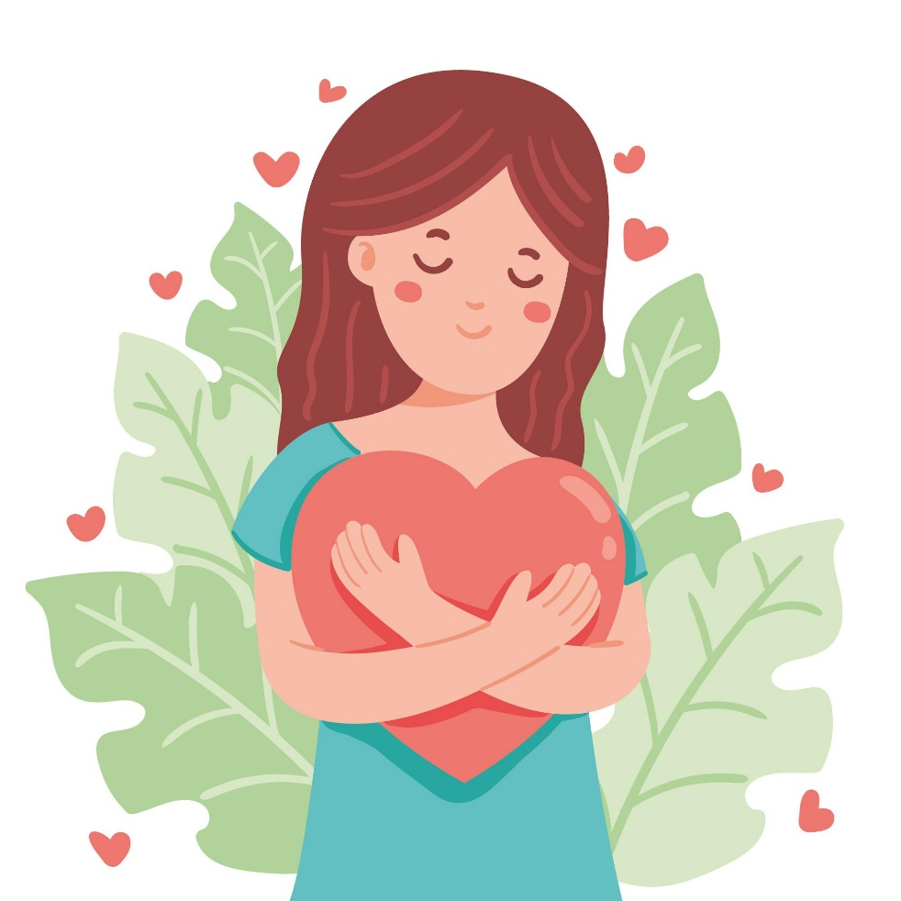

It is important to take time for yourself and find clarity. The most important relationship is the one you have with yourself.

Take this quick quiz to find out what type of self-care you need and make the most use of it.

START QUIZ

6 TYPES

1. Physical
2. Spiritual
3. Emotional
4. Social
5. Mental/Intectual
6. Practical
7. What is the first thing that comes to your mind when you hear ‘self care” ?
8. Doing Skin care ( physical)
9. Doing yoga (Spiritual)
10. Reading book (mental)
11. If you were given a chance to do any one of the following activities what would you choose ?
12. Journal (emotional)
13. Take a walk/workout (Physical)
14. Spend time with friends (social)
15. If you were given a 100$ , what would you spend on ?
16. Host a party/brunch with loved ones (social)
17. buy a course/ go to development class (Practical)
18. See a therapist / but a journal(Emotional)
19. What do you do on weekends ?
20. Tidy up living space (practical)
21. Visit the museum(mental)
22. Yoga/meditate (Spiritual)

How well do you agree questions

Emotional

1. Do you practise Grtitude
2. Do you journal

Physical

1. How well you you agree “I do exercise/yoga/dance on daily basics “
2. I like to take bubble bath / nap during my free/personal time

Social

1. I spend most of my free time with loved ones
2. I often find myself talking in the phone / hosting events

Mental

1. I read a lot of books
2. I would rather go to museum/ exhibition than spend time on unproductive things

Practical

1. I meal prep / set out cloth for the week in advance
2. I tidy up the space / spend time on organizing my schedule on my free time

**Results**

Physical

Well done🎉 , You’re skin care type is ‘Physical’

Physical type of self-care refers to **any activities you deliberately engage in to enhance your physical well-being.**

You prefer Taking a walk during lunch breaks, sleeping eight hours a day, staying hydrated, etc.

Spiritual

Well done🎉 , You’re skin care type is ‘Spiritual’

**Spiritual self-care encompasses any activities you engage in to connect with and nurture your soul.**This practice is fundamentally about connecting with your inner spirit. For some this may include activities that honor a belief in a higher power (God, the universe or whatever guides you).

You prefer Meditation, yoga, going to a place of worship, be in nature, dedicate time for self-reflection, etc.

Emotional

Well done🎉 , You’re skin care type is ‘Emotional ’

**emotional self-care—the actions we take to connect with our emotions and process them in a healthy way**

**You prefer** Seeing a therapist, writing in a journal, creating art, playing music etc

Social

Well done🎉 , You’re skin care type is ‘Social’

Social selfcare encompasses activities that nurtures and deepens the relationships with people in your life.

You prefer Brunch with friends, going on a date, making time to call your mom regularly, etc.

Mental

Well done🎉 , You’re skin care type is ‘Mental’

**Mental self-care encompasses anything you do specifically to stimulate your mind and cultivate a healthy psyche.**

It’s not about reaching a mental state of nirvana, it’s about understanding and developing a loving relationship with your mind.

You prefer Reading a book, solving a puzzle, playing chess, going to a museum, etc.

Practical

Well done🎉 , You’re skin care type is ‘Practical’

**Any actions you take to fulfill your core needs and reduce stress can be catalogued as practical self-care.**

Yes, even mundane, everyday activities. Think of how much better you feel when you clean your room or stick to a workout routine; these forms of self-care are admittedly less exciting than others, but not to be underestimated. They are huge sanity-savers and help create a greater sense of calm and control in our busy lives.

You prefer Creating a budget, taking professional development classes, organizing your closet, etc.