PHASE 3: PROJECT DESIGN

1. Project Title
AI BlogNest API

Team Details
Team ID: SWTID-2026-8851
Team Leader:
- Keerthana CK - 24bsccs15@cttewc.edu.in
Team Members:
- Kalai Selvi C- 24bsccs42@cttewc.edu.in
- Kaliswari T - 24bsccs02@cttewc.edu.in
- Rahima M - 24bsccs25@cttewc.edu.in

2. Introduction
The project design phase defines the overall architecture, modules, database structure, API structure, authentication flow, and interaction between different components of the AI BlogNest API.
The system is designed using a modular backend architecture to separate different responsibilities such as authentication, blog management, database operations, AI services, routing, and error handling.

3. System Architecture
AI BlogNest API follows a client-server based REST API architecture.
The main components of the system are:
- Client / API Testing Tool
- Express.js Server
- Authentication Middleware
- Controllers
- Routes
- MongoDB Database
- Gemini AI Service

System Flow
Client → Express.js Server → Routes → Middleware / Controllers → Database or AI Service → Response
The client sends an HTTP request to the backend API. The request is processed through the appropriate route and controller. Authentication middleware is applied to protected operations. Depending on the request, the controller communicates with MongoDB or the Gemini AI service and returns a response to the client.
Figure 1: System Architecture Diagram
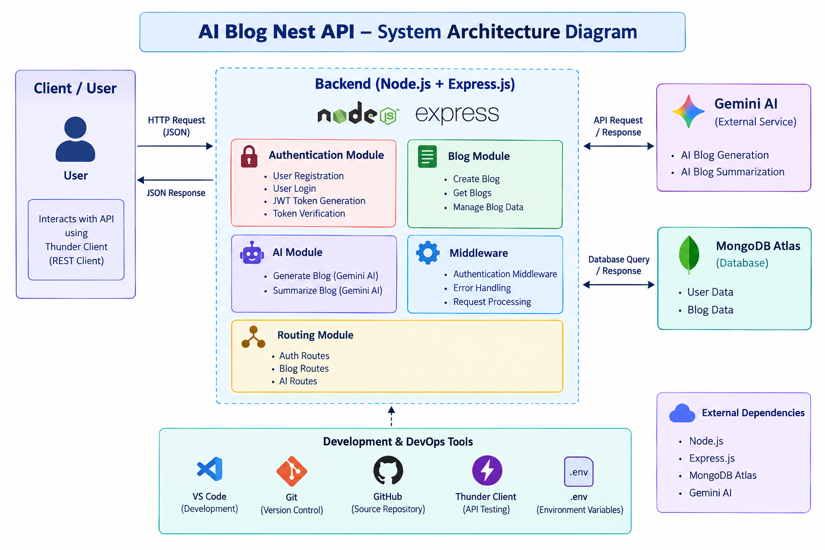

4. System Modules
The major modules of the system are:

4.1 Authentication Module
Responsible for:
- User registration
- User login
- Credential validation
- JWT generation
- Authentication-related operations

4.2 Blog Module
Responsible for:
- Creating blog posts
- Retrieving blog posts
- Managing blog-related data
- Communicating with the Blog model

4.3 AI Module
Responsible for:
- Receiving AI-related requests
- Communicating with Gemini AI
- Returning AI-assisted responses

4.4 Database Module
Responsible for:
- Establishing MongoDB connectivity
- Managing application data
- Providing database access to application modules

4.5 Middleware Module
Responsible for:
- Authentication verification
- Request processing
- Error handling
- Protecting authorized routes

4.6 Routing Module
Responsible for:
- Defining API endpoints
- Connecting endpoints to appropriate controllers
- Organizing authentication, blog, and AI routes

5. Backend Project Structure
The project follows a modular folder structure.
src/
│
├── config/
│ └── db.js
│
├── controllers/
│ ├── aiController.js
│ ├── authController.js
│ └── blogController.js
│
├── middleware/
│ ├── authMiddleware.js
│ └── errorMiddleware.js
│
├── models/
│ ├── Blog.js
│ └── User.js
│
├── routes/
│ ├── aiRoutes.js
│ ├── authRoutes.js
│ └── blogRoutes.js
│
├── services/
│ └── geminiService.js
│
├── app.js
└── server.js

This structure separates different responsibilities and improves maintainability.

6. Database Design
MongoDB is used as the database for the application.
The main data models are:

User
The User model stores information required for user authentication and account management.

Blog
The Blog model stores information related to blog posts.
The application communicates with MongoDB through the backend server.
Figure 2: Entity Relationship Diagram
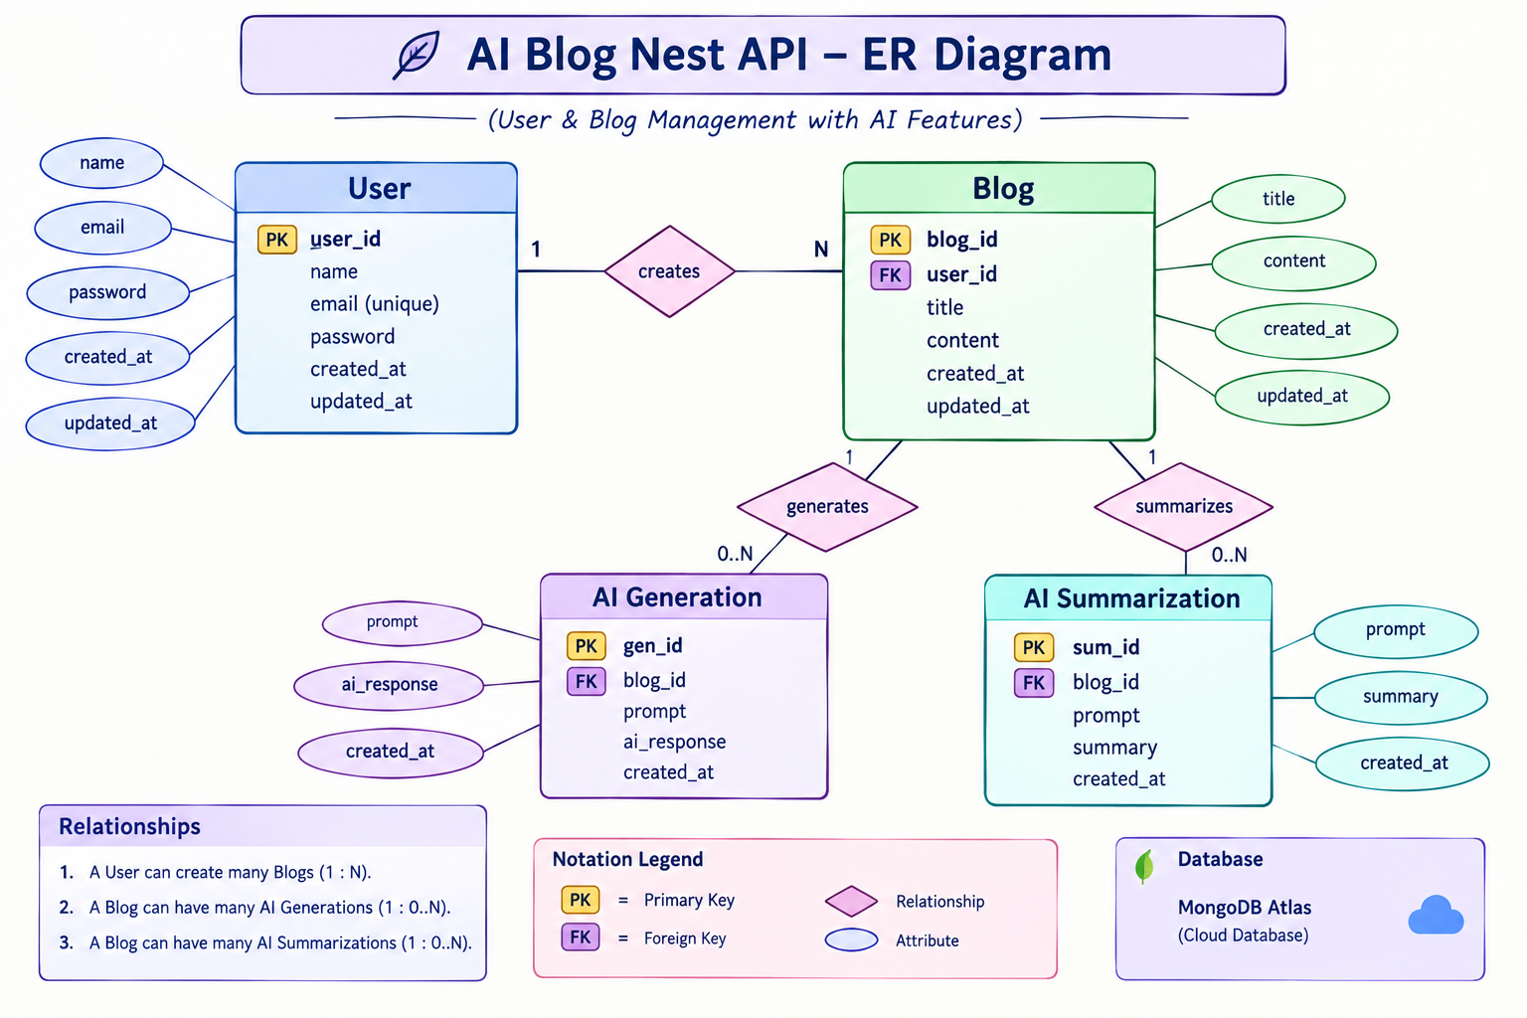

7. API Design
The application follows REST API principles.
The API is organized into different route groups:

Authentication Routes
Used for:
- User registration
- User login

Blog Routes
Used for:
- Blog creation
- Blog retrieval
- Blog-related operations

AI Routes
Used for:
- AI-assisted functionality
Each route is connected to its corresponding controller.
Figure 3: Use Case Diagram
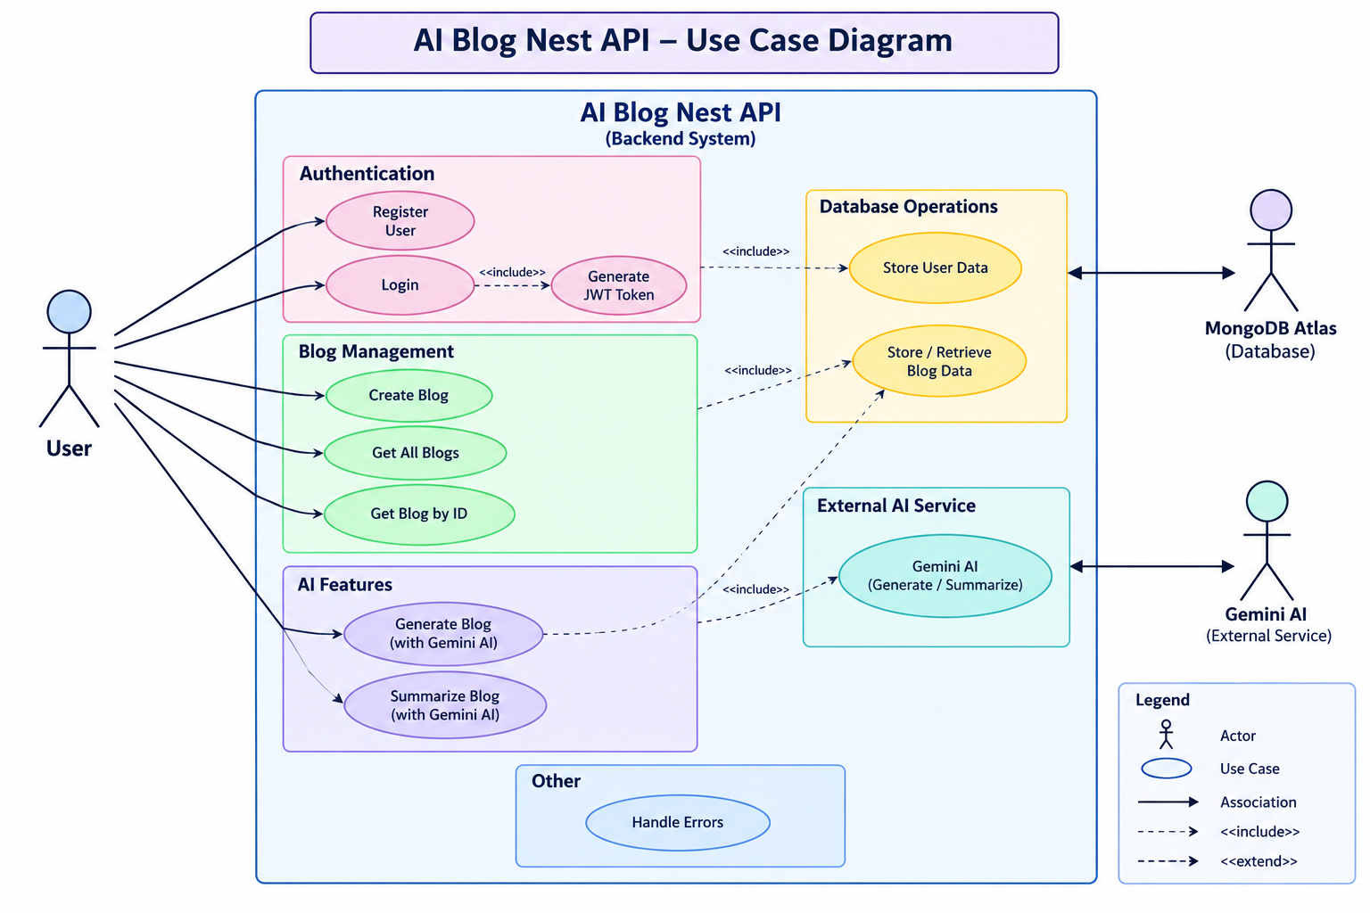

8. Authentication Design
The authentication process follows these steps:
- User registers using the registration API.
- User credentials are processed by the authentication controller.
- User information is stored in MongoDB.
- User logs in using valid credentials.
- The server verifies the credentials.
- A JWT token is generated after successful authentication.
- The token is used to access protected API routes.
- Authentication middleware verifies the token before allowing access.

Authentication Flow
Register → Login → JWT Token → Protected Request → Token Verification → Authorized Operation

9. Blog Management Design
The blog management process follows:
Client Request → Blog Route → Authentication Middleware → Blog Controller → Blog Model → MongoDB → Response
Authenticated users can perform supported blog operations through the API.

10. AI Integration Design
The AI module connects the backend application with the Gemini AI service.
The process is:
Client Request → AI Route → AI Controller → Gemini Service → Gemini AI → Response
The Gemini service is separated from the controller so that AI-related communication can be managed independently.

11. Error Handling Design
The application contains error-handling middleware to manage errors generated during API processing.
The system should return suitable error responses for situations such as:
- Invalid input
- Unauthorized requests
- Authentication failures
- Resource-related errors
- Server-side errors
- External service errors
This provides consistent error handling across the application.

12. Data Flow
The general data flow of the application is:
- The client sends an HTTP request.
- Express.js receives the request.
- The request is routed to the appropriate route.
- Authentication middleware verifies protected requests.
- The corresponding controller processes the request.
- The controller communicates with MongoDB or the AI service.
- The result is returned through the API response.
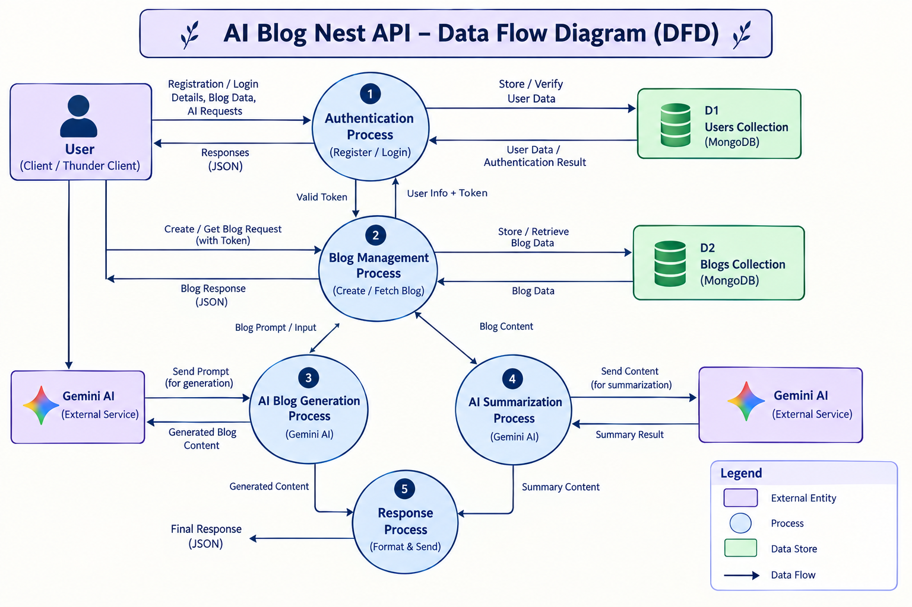

13. Overall System Workflow
The overall workflow of AI BlogNest API can be represented as:
Client
↓
Express.js Server
↓
API Routes
↓
Authentication Middleware
↓
Controllers
↓
MongoDB / Gemini AI Service
↓
API Response

14. Design Principles
The project design follows these principles:
- Modular architecture
- Separation of responsibilities
- RESTful API design
- Secure authentication
- Database abstraction through models
- Reusable middleware
- Independent AI service integration
- Centralized error handling

15. Design Outcome
The project design provides a clear structure for implementing and maintaining the AI BlogNest API.
The modular architecture allows authentication, blog management, database operations, AI integration, routing, and middleware to function as separate but connected components.
This design also provides flexibility for adding new features and API endpoints in future versions of the application.

