PHASE 7: PROJECT DOCUMENTATION

1. Project Title
AI Blog Nest API

Team Details
Team ID: SWTID-2026-8851
Team Leader:
- Keerthana CK - 24bsccs15@cttewc.edu.in
Team Members:
- Kalai Selvi C- 24bsccs42@cttewc.edu.in
- Kaliswari T - 24bsccs02@cttewc.edu.in
- Rahima M- 24bsccs25@cttewc.edu.in

2. Introduction
Project documentation provides a complete overview of the AI Blog Nest API, including its purpose, requirements, design, development process, testing, technologies, and usage.
The documentation is prepared to make the project easy to understand, maintain, demonstrate, and evaluate.

3. Project Overview
AI Blog Nest API is a backend REST API developed to provide user authentication, blog management, database operations, and AI-assisted functionality.
The application is developed using Node.js and Express.js. MongoDB is used for data storage, while JWT is used for authentication. Gemini AI is integrated as the AI service.
The API can be tested using Thunder Client.

4. Technologies Used
Technology | Purpose
Node.js | Backend runtime environment
Express.js | REST API development
JavaScript | Application development
MongoDB | Database
MongoDB Atlas | Cloud database hosting
JWT | User authentication
Gemini AI | AI-assisted functionality
Thunder Client | API testing
Visual Studio Code | Development environment
npm | Package and dependency management
Git | Version control
GitHub | Source code hosting

5. Main Modules
The project is divided into the following modules.

5.1 Authentication Module
The Authentication Module handles:
- User registration
- User login
- JWT authentication
- Protected API access

5.2 Blog Module
The Blog Module handles:
- Blog creation
- Blog-related API operations
- Blog data storage

5.3 AI Module
The AI Module handles:
- AI-related API requests
- Communication with Gemini AI
- AI service processing

5.4 Database Module
The Database Module handles:
- MongoDB connection
- User data
- Blog data

5.5 Middleware Module
The Middleware Module handles:
- Authentication verification
- Error handling

5.6 Routing Module
The Routing Module organizes API endpoints according to their functionality.

6. Project Structure
The project follows a modular backend structure.
AI Blog Nest API
│
├── node_modules
│
├── src
│ ├── app.js
│ ├── server.js
│ │
│ ├── config
│ │ └── db.js
│ │
│ ├── controllers
│ │ ├── aiController.js
│ │ ├── authController.js
│ │ └── blogController.js
│ │
│ ├── middleware
│ │ ├── authMiddleware.js
│ │ └── errorMiddleware.js
│ │
│ ├── models
│ │ ├── Blog.js
│ │ └── User.js
│ │
│ ├── routes
│ │ ├── aiRoutes.js
│ │ ├── authRoutes.js
│ │ └── blogRoutes.js
│ │
│ └── services
│ └── geminiService.js
│
├── .env
├── .gitignore
├── package.json
├── package-lock.json
└── README.md

7. Installation and Setup
The project requires Node.js and npm to be installed.

Step 1: Open the Project
Open the project folder in Visual Studio Code.

Step 2: Install Dependencies
Run the following command in the project terminal:
npm install

This installs the dependencies required by the project.

Step 3: Configure Environment Variables
The required configuration values are maintained in the .env file.
The environment configuration includes values required for:
- MongoDB connection
- JWT authentication
- Gemini AI configuration
- Server configuration
The .env file should not be uploaded to the public repository because it may contain sensitive information such as database credentials and API keys.

Step 4: Start the Application
Run:
npm run dev

The backend server starts using the configured development environment.

8. Database Configuration
The application uses MongoDB for data storage.
MongoDB Atlas is used as the cloud database environment.
The database connection is handled through:
src/config/db.js

The main database models are:
- User
- Blog
The database stores the information required for user authentication and blog management.

9. Authentication
Authentication is implemented using JSON Web Tokens (JWT).
The general authentication flow is:
User Registration
↓
User Login
↓
Authentication
↓
JWT Token
↓
Protected API Request
↓
Authentication Verification
↓
Controller

JWT authentication helps ensure that protected API operations are accessed through authenticated requests.

10. Blog Management
The Blog Module manages blog-related operations.
The module contains functionality for:
- Creating blogs
- Retrieving blog information
- Managing blog-related API operations
- Storing blog data in MongoDB
The blog functionality is implemented using the Blog model, controller, and routes.

11. AI Integration
Gemini AI is integrated into the project to provide AI-assisted functionality.
The AI service is maintained separately from the main application modules.
The Gemini service is implemented in:
src/services/geminiService.js

The AI controller is maintained in:
src/controllers/aiController.js

The AI routes are maintained in:
src/routes/aiRoutes.js

This modular structure allows the AI functionality to be maintained independently from the authentication and blog modules.

12. API Testing
Thunder Client is used to test the REST API.
The testing process includes:
- Starting the backend server.
- Connecting the application to MongoDB.
- Sending API requests through Thunder Client.
- Verifying the response received from the server.
- Checking database changes where applicable.
- Recording successful and unsuccessful test cases.
The API testing process helps verify the functionality of the backend modules.

13. Version Control and Repository
Git is used for version control and GitHub is used to host the project source code.
The project repository contains the application source code and supporting project files.
Sensitive configuration files such as .env are excluded using .gitignore.
The project source code is maintained in the GitHub repository for project submission and accessibility.

14. Project Documentation Structure
The complete project documentation is organized according to the SmartBridge project phases:
01_Brainstorming_and_Ideation
02_Requirement_Analysis
03_Project_Design
04_Project_Planning
05_Project_Development
06_Project_Testing
07_Project_Documentation
08_Project_Demonstration

Each phase contains the corresponding documentation and supporting files.

15. Project Benefits
The AI Blog Nest API provides the following benefits:
- Provides a structured REST API for blog-related operations.
- Supports user authentication.
- Provides database-backed blog management.
- Separates application functionality into modular components.
- Provides a foundation for AI-assisted functionality.
- Can be tested using API testing tools.
- Can be extended with additional features in the future.
- Provides a backend foundation for future frontend integration.

16. Limitations
The current project has some limitations:
- AI functionality depends on the availability of the external Gemini AI service.
- AI model access may depend on the configured API access and model availability.
- Some advanced blog management features may require further development.
- The current project mainly focuses on backend API functionality.
- Final AI response testing may depend on external service availability.

17. Future Enhancements
Possible future enhancements include:
- Advanced blog search and filtering.
- Blog categories and tags.
- Comment and interaction features.
- Improved AI-assisted blog generation and editing.
- Additional authentication and authorization features.
- API documentation using tools such as Swagger.
- Deployment to a cloud hosting platform.
- Development of a dedicated frontend application.
- Improved user interface integration.

18. Security Considerations
Security considerations included in the project are:
- JWT-based authentication.
- Protected API routes.
- Environment variables for sensitive configuration.
- .gitignore protection for the .env file.
- Authentication verification before protected operations.
- Error handling for API failures.
- Separation of application modules for maintainability.

19. Project Outcome and Screenshots
The AI Blog Nest API was developed and tested through API requests using Thunder Client. The following screenshots demonstrate the major functionalities and working outputs of the project.

19.1 User Registration
The registration API allows a new user to create an account by providing the required user details.
Figure 1: Successful User Registration
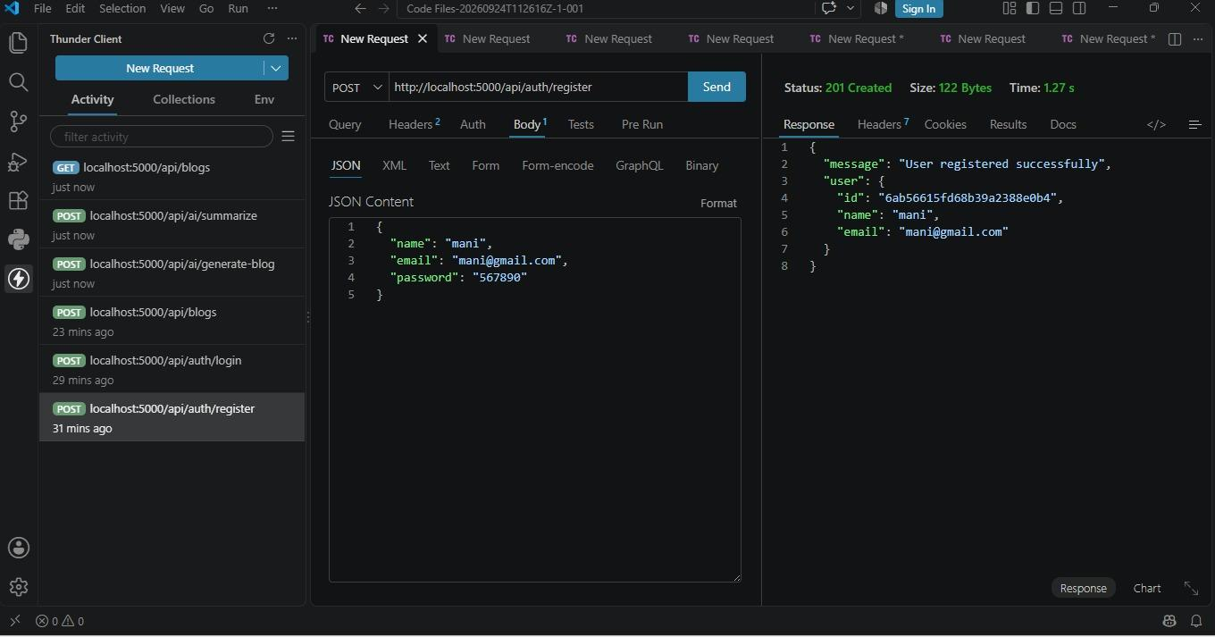

19.2 User Login
The login API authenticates a registered user and provides the required authentication response for accessing protected operations.
Figure 2: Successful User Login
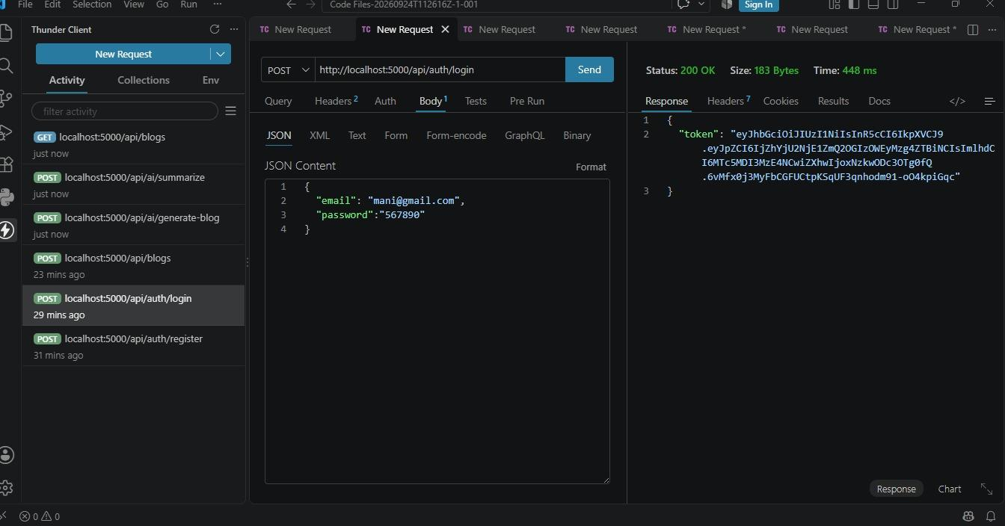

19.3 Blog Creation
The blog creation API allows an authenticated user to create and store a new blog.
Figure 3: Successful Blog Creation
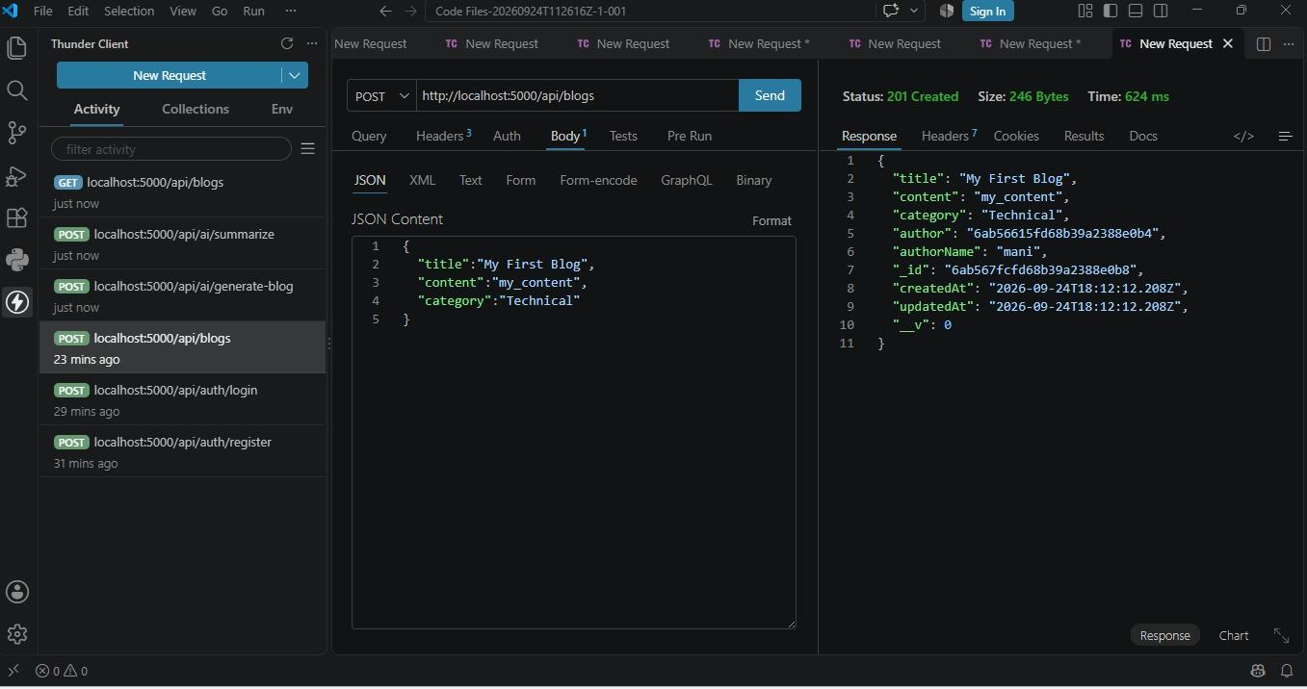

19.4 Fetch Blog
The fetch blog API retrieves the available blog information from the backend and database.
Figure 4: Successful Blog Retrieval
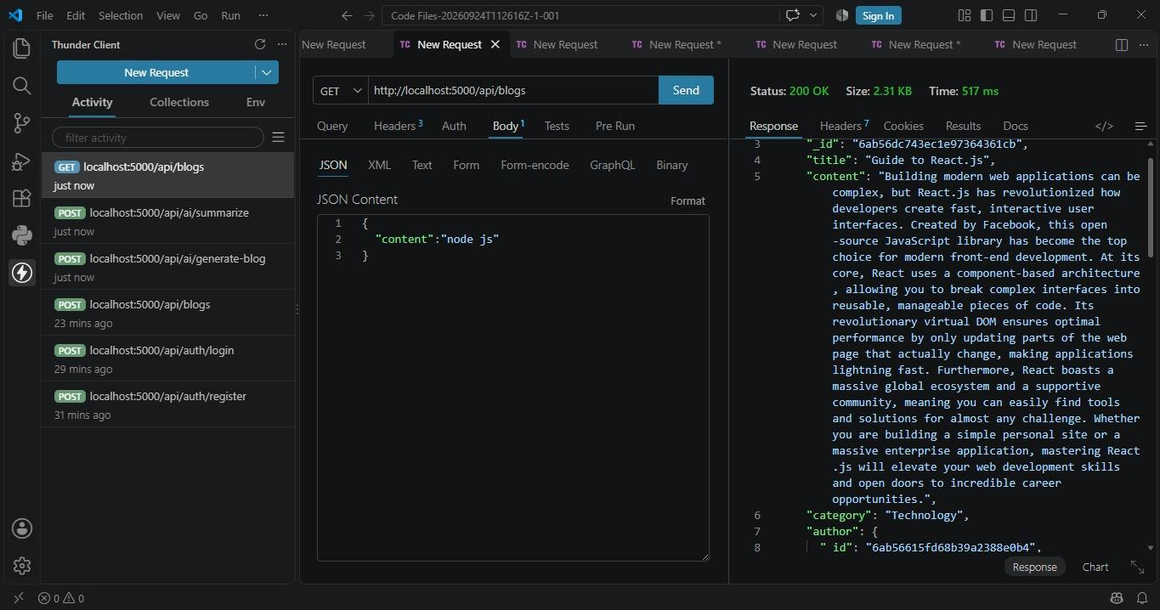

19.5 AI Blog Generation
The AI generation functionality uses the configured Gemini AI service to assist in generating blog content through the API.
Figure 5: AI-Generated Blog Output
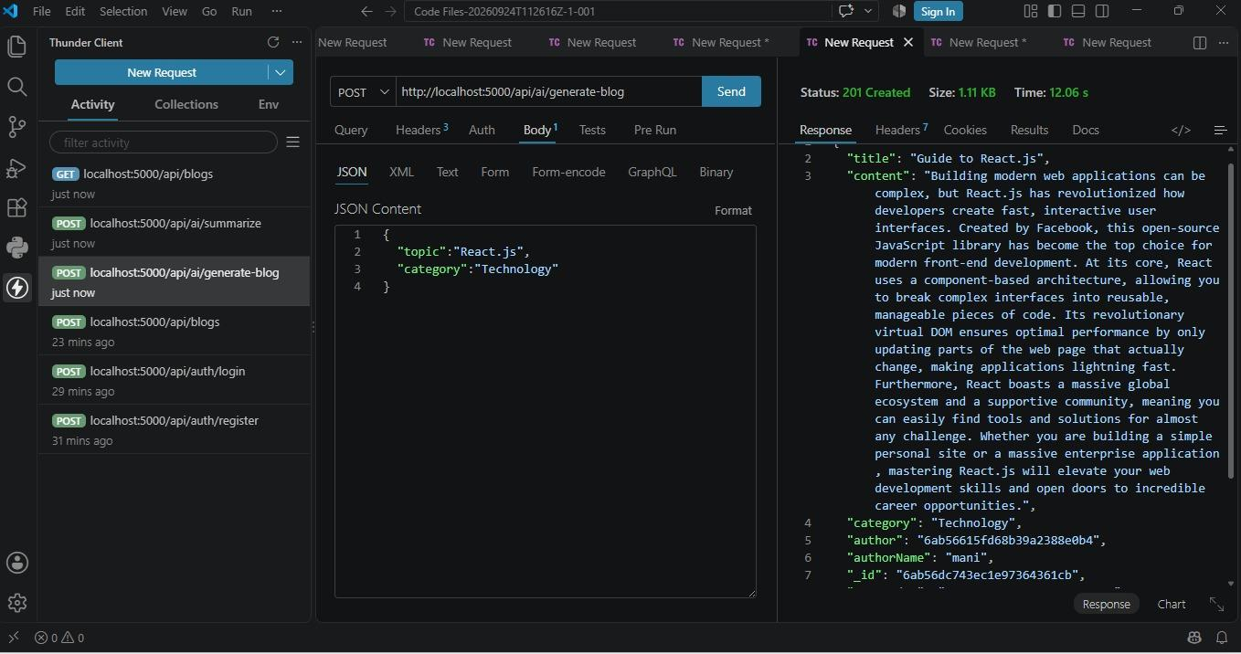

19.6 AI Blog Summarization
The AI summarization functionality processes blog content and generates a concise summary through the AI service.
Figure 6: AI Blog Summarization Output
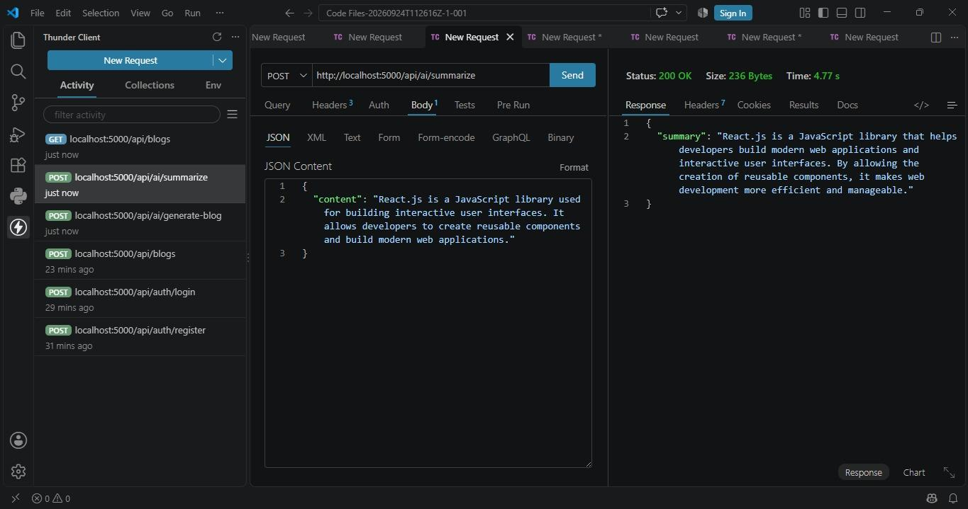

20. Documentation Outcome
The documentation phase provides a structured reference for understanding the AI Blog Nest API.
The documented project includes user registration, authentication, blog creation, blog retrieval, AI-assisted blog generation, and AI-powered summarization.
The screenshots included in this section provide visual evidence of the major API functionalities and their corresponding outputs.
The documentation can be used for:
- Project evaluation
- Project demonstration
- Application maintenance
- Future development
- Understanding the system architecture
- Verifying project implementation

21. Conclusion
AI Blog Nest API demonstrates the development of a modular backend application using Node.js, Express.js, MongoDB, JWT authentication, and Gemini AI.
The project provides user authentication, blog management, database integration, API routing, middleware, AI-assisted blog generation, and AI-powered blog summarization.
The project was developed using a structured approach covering ideation, requirement analysis, design, planning, development, testing, documentation, and demonstration.
The completed documentation provides a clear reference to the project's implementation, testing process, working outputs, limitations, and possible future enhancements.

