**Connecting db with python and apis**

**Tedss** -> we have created azure sql db ( it has ip address and credentials, which will use to connect from sql server management studio)

Sql server management studio -> click on connect then give db name and server name and password.

To connect to apis -> we have to create connection string with db name and password. I have to create connection and pass it to sql query when we r fetching data from db.

Eg: pd.read_sql(query,engine)

**Following Ineuron master in datascience content:**

Created account in pwskills (which has diff comb environment with sofwares installed, like mysql , python…)

For creating db and connecting it to api using python -> now we are using mysql+python lab

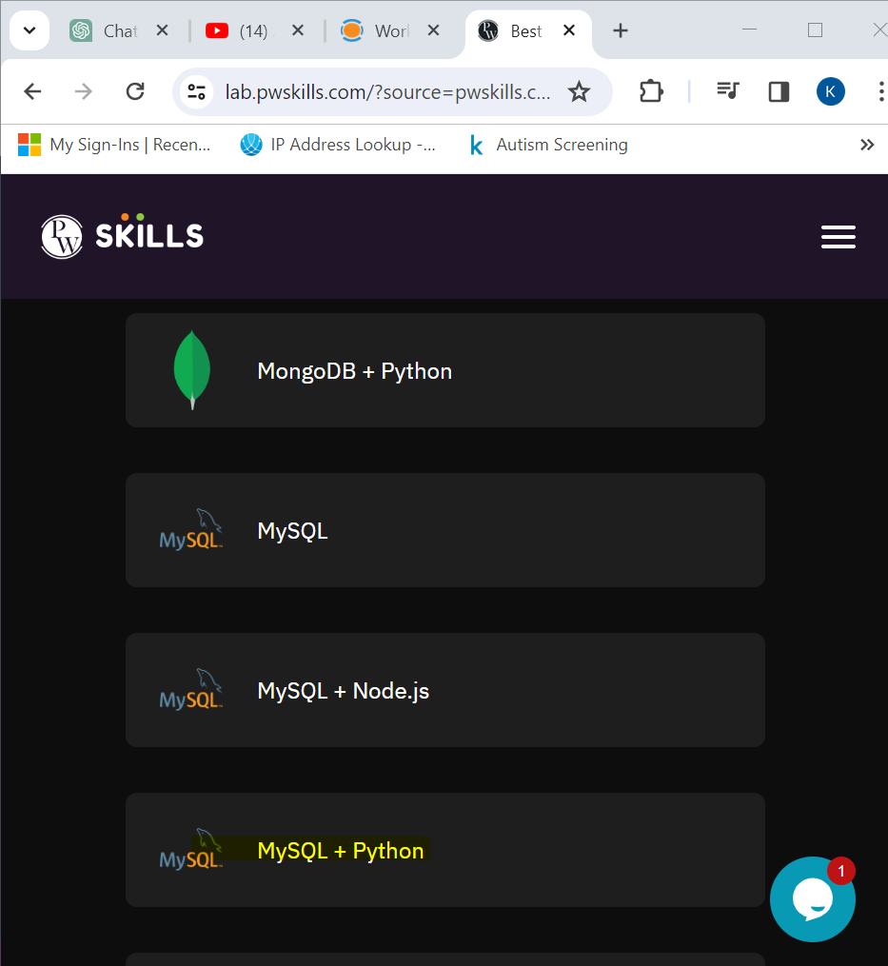

**Databases :**

1. **SQL**
   1. **Mysql**
   2. **Mssql**
   3. **Db2**
   4. **oracle**
2. **NoSQL (not only structured query language)**
   1. **Mongodb**
   2. **Cassandra**
   3. **Hbase**
   4. **Influx**
   5. **Neo4J**

**Diff:**

Storing data to sql system : data is structured (rows and columns)

Nosql : unstructured data (audio,video,text or relational data)

**Creating DB:**

Db -> store multiple tables

We can create mul databases

Click on create connection

After filling details click on save and connect. It shows my connection left side

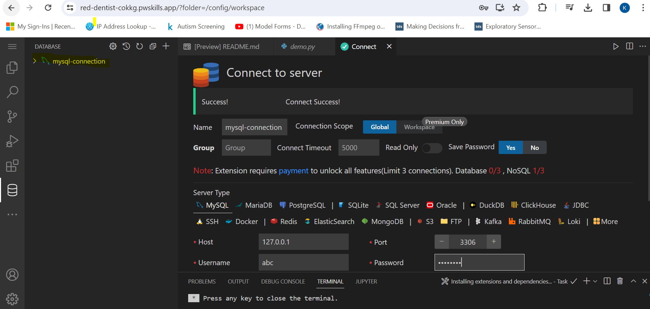

Once u click on + symbol

If we try to create database already exist, it will throw an error message. To avoid this we can write as create database if not exists test;

Now here we are writing queries in sql but we can do all these things from python also. How can we do that..

TO create samething with python first we need to create communication between python with database.

If we join new company, below code will not change. Host,user name and password is provided by admin .

Mydb.cursor() // it will enable u to perform and kind of query operation son database.

mycursor.execute("SHOW DATABASES")

for x in mycursor:

  print(x)

above snippet fetch all databases present in the mysql..we can write required query in place of sow databases.

o/p

**What is web API?**

Gpay -> sending 100->xyz

First it will connect to the bank account and ask if 100 is there or not in particular account. If available, the transaction will be successful.

Here on every click on gpay it is communicating with the bank application. Both gpay and bank app both are on different languages.

Eg: bank: python

Gpay : java

We can interact with each other using api’s

Diff lang or diff app can interact with each other using api’s

We are communicating with web(means http) 🡪 called web api

Diff between api and web api:

Api -> we follow tcp, smtp, http protocol

Web api -> we should follow only http protocol

**Rest and Soap Architecture:**

**Rest:** Representational state transfer

**Soap :** Simple object access protocol

Both we can use to create api’s

Rest : Http

Put

Get

Post

Delete

Soap : tcp,smtp

Not simple as rest

Send data in the form of xml

Rest is known for :

Simplicity

Scalable

Not secure as SOAP

Flask and Fast api