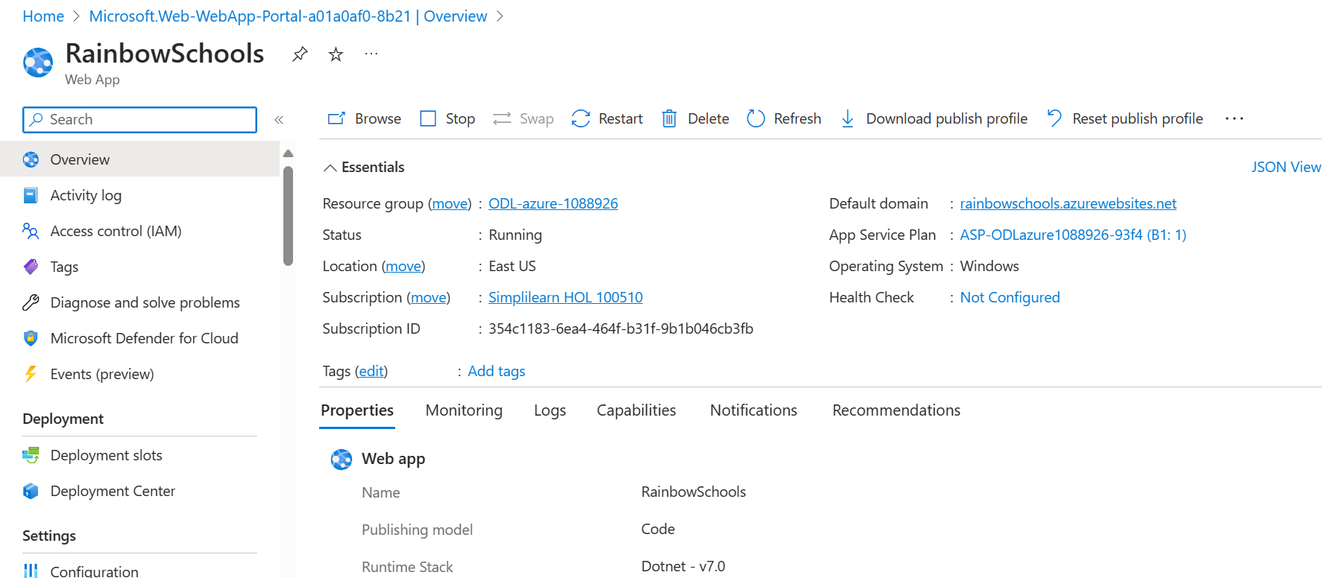

[Home Page - RainBowSchool (rainbowschools.azurewebsites.net)](https://rainbowschools.azurewebsites.net/)

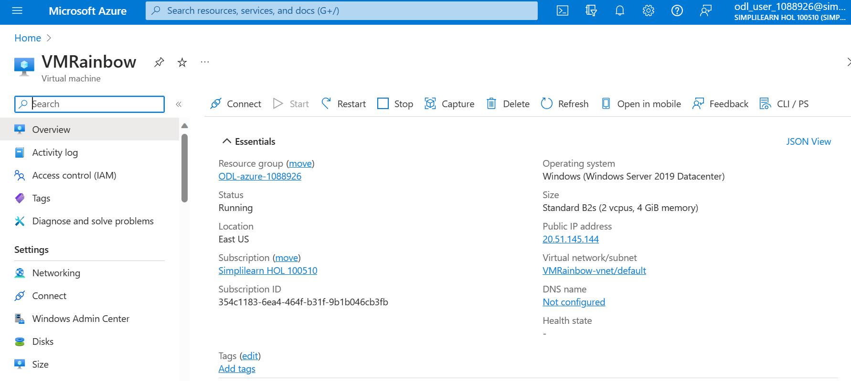

Click connect

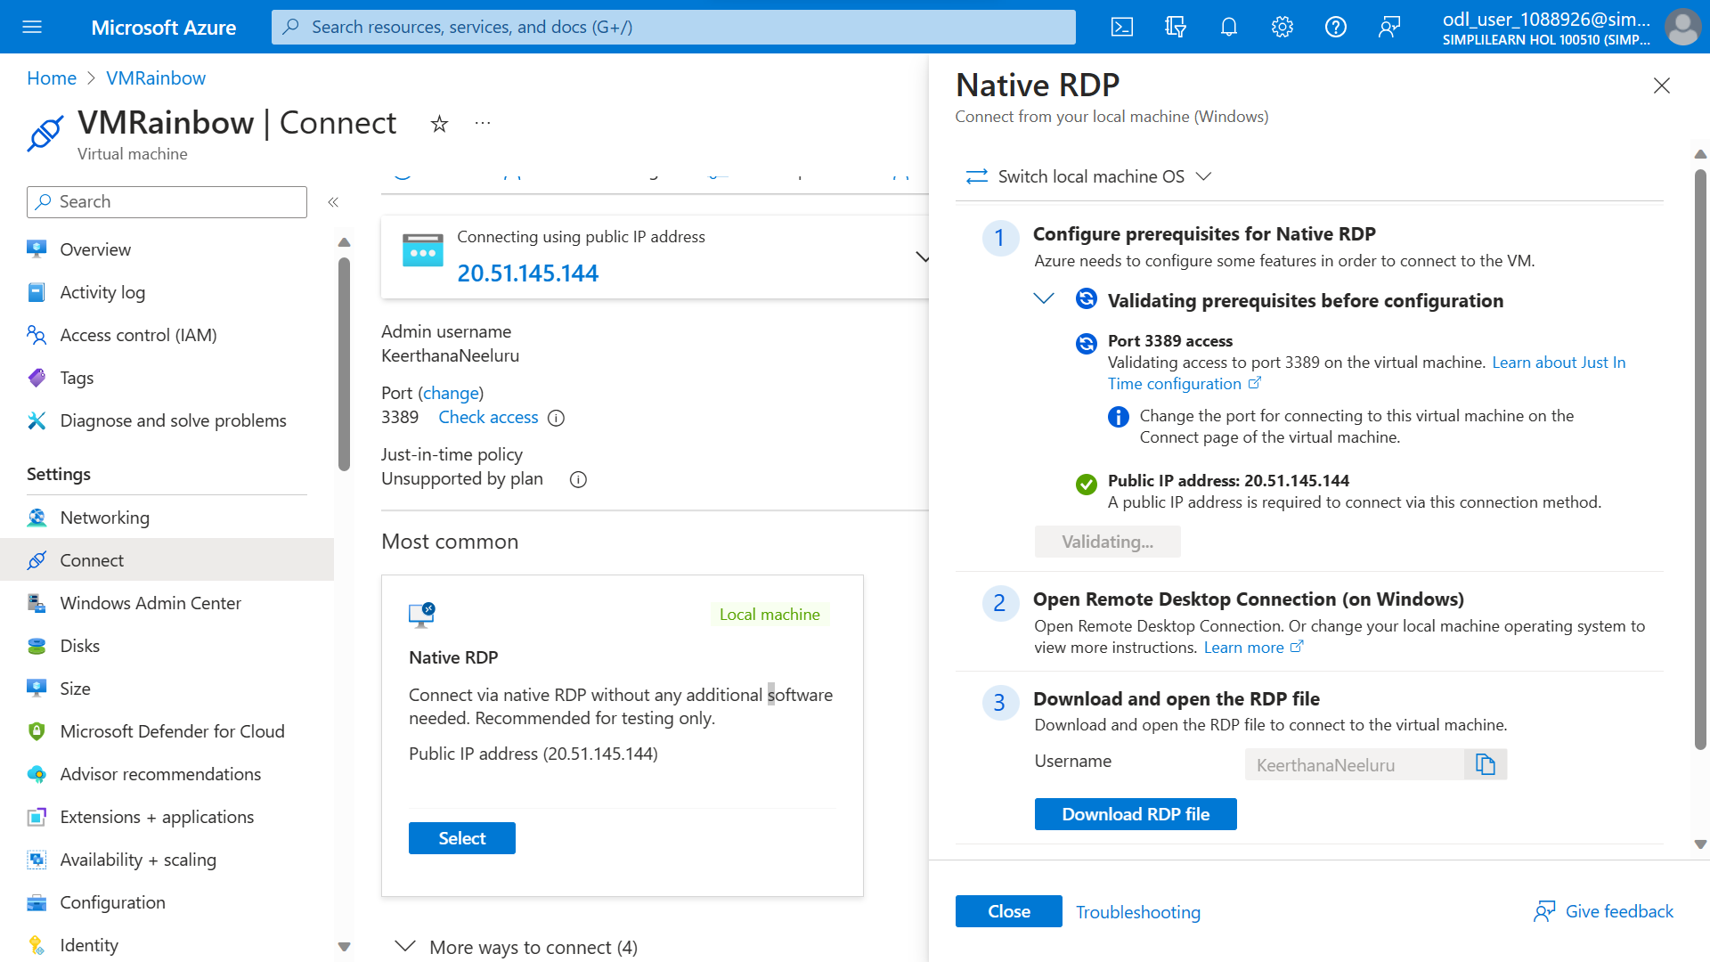

Select native and download RDP file

