**Renting A Car Mobile Application**

Keerthana Nimmagadda 1893679

Durga priya Kalam 1892807

Sai Manasa Goka 1892793

Padma Prabhasa Inturi 1893686

Navya Damuluri 1892832

Kowkshitha idamakanti ranga 1893145   
Rajwinder singh 1795544

Navdeep kaur

**Software Requirements Specification**

**Document**

**Version: 1** **Date: 05/10/2019**

**1.Introduction**

Renting A Car Mobile Application was designed and implemented to Rent cars better than the traditional methods. Renting A Car is an Android based mobile application will be helpful to the people who are looking for cars for rent in temporary bases. The project Renting A Car System keeping all these things in mind provides a total solution to the field of auto rental industry. The idea behind the proposed mobile application is to develop consistent, robust and user-friendly App that allows customers to rent any vehicle as per his/her needs. This Application will maintain the information about the customer details, vehicle details, booking details and transaction details of the customer.

This App feature enables customers to quickly rent a car without any hassle. By using this app, customers can easily get a rental car. This makes the app more useful who don't have an own car. Renting a car is an app built for android smart phones using the ADT bundle (64 bit) package. Renting a car uses technologies such as Android SDK and XML as front-end technology and PHP as middleware, JAVA and MYSQL database as backend technology.

Smartphones are designed to enhance flexibility, usability, and functionality of the communication system. There are a variety of operating systems available for smartphones and android platform was the choice of preference for the app development in this project. Android architecture consists of Linux kernels, libraries and APIs written in C and inbuilt java compatible libraries for developers and an inbuilt server, a free type of software and open source license, aspect that makes it very attractive among developers. Hence Android architecture was used to develop an application for this project.

**1.1 PURPOSE**

Renting A Car Mobile Application is a car rental service application. This application is managed by Rental service Team. A car rental is a vehicle that can be used temporarily for a fee during a specified period. Getting a rental, a car helps people get around despite the fact they do not have access to their own personal vehicle or don't own a vehicle at all. The individual who needs a car must contact a rent a car company and contract out for a vehicle with valid documents like license. This system increases customer retention and simplify vehicle and staff management.

**AIMS AND OBJECTIVES**

* To produce a mobile based application that allow customer to register and reserve cars through this application and for the company to effectively manage their car rental business
* To ease customers task whenever they need to rent a car

**1.1 SCOPE**

This project traverses a lot of areas ranging from business concept to computing field, and required to perform several researches to be able to achieve the project objects.

The area covers include:

* Car rental mobile application : This includes study on how the car rental business is being done, process involved and opportunity that exists for improvement.
* Android used for the development of the application.
* Company’s staff will be able to use the system effectively.
* Mobile platform means that the system ease to use and will be available for access 24/7 except when there is a temporary server issue which is expected to be minimal.
* It increases the efficiency of the management at offering quality services to the customers.
* It provides custom features development and support with the software

This section describes the features which are in the scope of the developed application.

* View the main screen with options
  + clerk login - For existing Clerk's login.
  + Admin login - For Admin.
* Clerk Login
* Upon login Clerk can view a Dashboard with options
  + - Home screen
    - View cars
    - Search cars
    - Add new cars
    - Rent a car
    - Reserve a car
    - Return service
    - Reports (Daily/ Weekly and monthly)
* Admin Login
* Upon login Admin can view a Dashboard with options
  + - Home screen
    - Add or register, modify and delete Staff(Clerk role)
    - View transactions
    - Search transactions
    - View cars
    - Search cars
    - Add new cars
    - Reports or Transactions (Daily/ Weekly and monthly)
  + Upon registration, the Admin can register clerks by using their name, username, password, mobile number and email address. The details are stored in the database.
  + Upon giving the valid credentials, the staff (clerk) will be successfully registered with the application. Now the staff can log in and use all the features of the application.

**3. Specific Requirements**

**3.1. Functional Requirements**

Functional requirements define specific functionality that define what a system is supposed to accomplish. A function is described as a set of inputs, the behavior, and outputs. Requirement analysis is a software engineering technique that is composed of the various tasks that determine the needs or conditions that are to be met for a new or altered product, taking into consideration the possible conflicting requirements of the various users.

Functional requirements are those requirements that are used to illustrate the internal working nature of the system, the description of the system, and explanation of each subsystem. It consists of what task the the system should perform, the processes involved, which data should the system holds and the interfaces with the user

Following are some functional requirements:

* **Log in**
* The system should allow clerk to login to the system using their username and password. Here user can change his password and also have an option to logout.
* The system should allow Admin to login to the system using their username and password.
* The system shall allow the Admin to create new clerk’s account and also modify or delete.
* **Renting, Reservation and Returning vehicles**
* The system shall allow the customer to view detail description of particular vehicle based on his need. After he has to check selection of unavailable vehicles while reservation that he can register for reservation
* The system shall present an option for advanced search to limit the vehicle search to specific categories of vehicles search. E.g. By Brand, Type and Model.
* The system must allow the customers to view list of available vehicles during reservation and select specific vehicle using different search category while reservation.
* The system allows clerks to cancel reservations too. To cancel reservation using reservation confirmation number. By using this unique number clerk can updated information while returning vehicle.
* The system shall allow the clerk to view reservations made by customers. And able to check reservation summary for successfully when it is needed.
* The system shall allow clerk’s to register customers into rental list. And to update about customer rent record details in the rental list.
* The system shall allow clerk’s to search rent record of customers using specific categories.
* The system shall allow staff to display all customers rent record.
* **Viewing and searching the Vehicle catalogue.**
* The system should allow clerk’s or admin to add new vehicles. So customers will have an option to see more vehicles whenever they added.
* The system shall allow clerk’s to select vehicles in the list. And also allow customer to select vehicles in the list.
* The system shall allow clerk’s and customers to Search vehicles by specific type, model or year.
* The system shall allow staff to update information of the vehicle in need of modification.
* The system shall allow clerks to display all lists of vehicles. So, customers can see in the catalogue.
* **Administrator**
* The system shall allow admin to search history of transactions per client, per vehicle or by the due date.

**3.2. Non-functional requirements**

Non-functional requirements, as the name suggests, are requirements that are not directly concerned with the specific services delivered by the system to its users. They may relate to emergent system properties such as reliability, response time, and store occupancy. Alternatively, they may define constraints on the system implementation such as the capabilities of I/O devices or the data representations used in interfaces with other systems. Non-functional requirements, such as performance, security, or availability, usually specify or constrain characteristics of the system as a whole.

**Usability**

The system provides help and support menu in all interfaces for the user to interact with the system. The user can use the system by reading help and support.

**Security**

The system provides username and password to prevent the system from unauthorized access.

**Performance**

The system response time for every instruction conducted by the user must not exceed more than a minimum of 10 seconds. The system should have high performance rate when executing user’s input and should be able to provide a response within a short time span usually 50 second for highly complicated task and 20 to 25 seconds for less complicated task.

**Error handling**

Error should be considerably minimised and an appropriate error message that guides the user to recover from an error should be provided. Validations of user’s input is highly essential. Also the standard time taken to recover from an error should be 15 to 20 seconds

**Availability**

The system should always be available for access at 24 hours, 7 days a week. Also in the occurrence of any major system malfunctioning, the system should be available in 1 to 2 working days, so that business process is not severely affected.

**Ease of use**

The user interface should be developed to make it easy to understand and required less training.

**3.3. OTHER REQUIREMENTS**

**Hardware Requirements**

* Device: Android Smartphone
* Memory Space: 32 GB of disk space, 4 GB of RAM for development machine
* Connector: USB cable to export the app from development machine to Android device.
* 1 GB for Android SDK, emulator system images and cache.

**Software Requirements**

* Eclipse JAVA IDE EE for web developers.
* Android SDK and AVD installed on development machine.
* Java(JDK) 1.6
* Android Plug-in
* MYSQL for database

**Usecase Diagram for clerk**

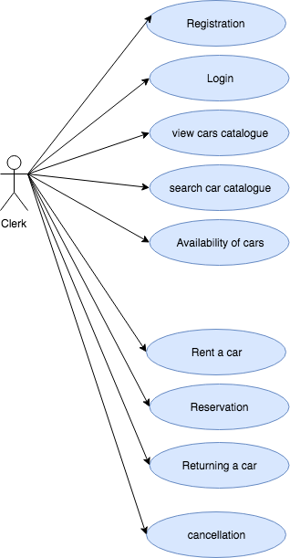

**Usecase Diagram for Admin**

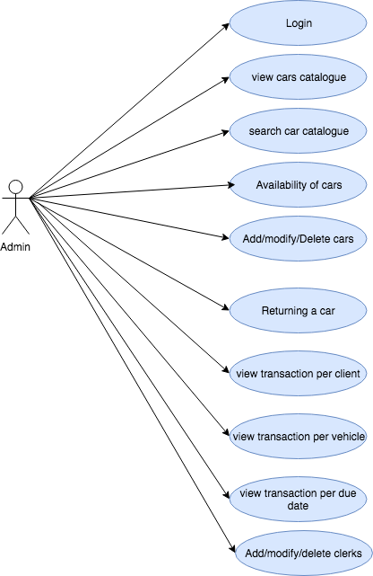

**Usecase Diagram for Customer or user**

