**Name: Keerthana P**

**Roll No:12**

**Batch:MCA**

**Date:25/03/2022**

**ADVANCED DBMS LAB**

**EXPERIMENT NO.: 1**

**AIM**

To study various DDL commands – CREATE, INSERT

**QUESTION**

Create the following Tables and Insert values.

**Table 1: DEPOSIT**

ACTNO VARCHAR (5) PRIMARY KEY, FIRST LETTER MUST START WITH ‘D’

CNAME VARCHAR (20) FOREIGN KEY REFERENCES CUSTOMER

BNAME VARCHAR (20) FOREGIGN KEY REFERENCES BRANCH

AMOUNT NUMBER (8,2) NOT NULL, CANNOT BE 0

ADATE DATE

**Table 2: BRANCH**

BNAME VARCHAR2(20) PRIMARY KEY

CITY VARCHAR2(30) NOT NULL , any one of NAGPUR, DELHI, BANGALORE, BOMBAY

**Table 3: CUSTOMER**

CNAME VARCHAR (15) PRIMARY KEY

CITY VARCHAR (20) NOT NULL

**Table 4: BORROW**

LOANNO VARCHAR (28) PRIMARY KEY / FIRST LETTER MUST START WITH ‘L’

CNAME VARCHAR (15) FOREIGN KEY REFERENCES CUSTOMER

BNAME VARCHAR2(20) FOREIGN KEY REFERENCES BRANCH

AMOUNT NUMBER(8,2) NOT NULL, CANNOT BE 0

**PROCEDURE**

**1.CUSTOMER TABLE(CREATE AND INSERT)**

CREATE TABLE CUSTOMER (CNAME VARCHAR(15) PRIMARY KEY ,CITY VARCHAR(20) NOT NULL );

INSERT INTO CUSTOMER VALUES('ANIL','CALCUTTA');

INSERT INTO CUSTOMER VALUES('SUNIL','DELHI');

INSERT INTO CUSTOMER VALUES('MEHUL','BARODA');

INSERT INTO CUSTOMER VALUES('MANDAR','PATNA');

INSERT INTO CUSTOMER VALUES('MADHURI','NAGPUR');

INSERT INTO CUSTOMER VALUES('PRAMOD', 'NAGPUR');

INSERT INTO CUSTOMER VALUES('SANDIP','SURAT');

INSERT INTO CUSTOMER VALUES('SHIVANI','BOMBAY');

INSERT INTO CUSTOMER VALUES('KRANTI','BOMBAY');

INSERT INTO CUSTOMER VALUES('NAREN','BOMBAY');

**2.BRANCH TABLE(CREATE AND INSERT)**

CREATE TABLE BRANCH(BNAME VARCHAR(20) PRIMARY KEY,CITY VARCHAR(30) CHECK (CITY IN ('NAGPUR','DELHI','BANGALORE','BOMBAY')) NOT NULL);

INSERT INTO BRANCH VALUES('VRCE','NAGPUR');

INSERT INTO BRANCH VALUES('AJNI','NAGPUR');

INSERT INTO BRANCH VALUES('KAROLBAGH','DELHI');

INSERT INTO BRANCH VALUES('CHANDNI','DELHI');

INSERT INTO BRANCH VALUES('DHARAMPETH','NAGPUR');

INSERT INTO BRANCH VALUES('MG ROAD','BANGALORE');

INSERT INTO BRANCH VALUES('ANDHERI','BOMBAY');

INSERT INTO BRANCH VALUES('NEHRU PALACE','DELHI');

INSERT INTO BRANCH VALUES('POWAI','BOMBAY');

**3.BORROW TABLE(CREATE AND INSERT)**

CREATE TABLE BORROW (LOANNO VARCHAR(8) CHECK (LOANNO LIKE 'L%') PRIMARY KEY,CNAME VARCHAR(15) REFERENCES CUSTOMER(CNAME),BNAME VARCHAR(20) REFERENCES BRANCH(BNAME),AMOUNT FLOAT(8) CHECK (AMOUNT>0) NOT NULL);

INSERT INTO BORROW VALUES('L201','ANIL','VRCE',1000.00);

INSERT INTO BORROW VALUES('L206','MEHUL','AJNI',5000.00);

INSERT INTO BORROW VALUES('L311','SUNIL','DHARAMPETH',3000.00);

INSERT INTO BORROW VALUES('L321','MADHURI','ANDHERI',2000.00);

INSERT INTO BORROW VALUES('L371','PRAMOD','VIRAR',8000.00);

INSERT INTO BORROW VALUES('L481','KRANTI','NEHRU PLACE',3000.00);

**4.DEPOSIT TABLE(CREATE AND INSERT)**

CREATE TABLE DEPOSIT (ACTNO VARCHAR(5) CHECK (ACTNO LIKE 'D%') PRIMARY KEY ,CNAME VARCHAR(15) REFERENCES CUSTOMER(CNAME),BNAME VARCHAR(20) REFERENCES BRANCH(BNAME),AMOUNT FLOAT(8) CHECK (AMOUNT>0) NOT NULL, ADATE DATE);

INSERT INTO DEPOSIT VALUES('D100','ANIL','VRCE',1000.00,'95-3-1');

INSERT INTO DEPOSIT VALUES('D101','SUNIL','ANJNI',500.00,'96-1-4');

INSERT INTO DEPOSIT VALUES('D102','MEHUL','KAROLBAGH',3500.00,'95-11- 17');

INSERT INTO DEPOSIT VALUES('D104','MADHURI','CHANDNI',1200.00,'95-D12-17');

INSERT INTO DEPOSIT VALUES('D105','PRAMOD','MG ROAD',3000.00,'96-3-27');

INSERT INTO DEPOSIT VALUES('D106','SANDIP','ANDHERI',2000.00,'31-MAR-96');

INSERT INTO DEPOSIT VALUES('D107','SHIVANI','VIRAR',1000.00,9'5-SEP-95');

INSERT INTO DEPOSIT VALUES('D108','KRANTI','NEHRU PLACE',5000.00,'95-7- 2');

INSERT INTO DEPOSIT VALUES('D109','MINU','POWAI',7000.00,'95-8-10');

**Output Screenshot**

**CUSTOMER TABLE**

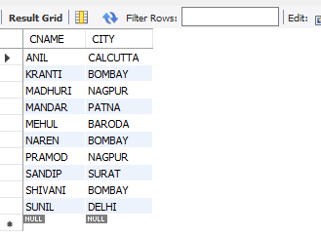

1. **BRANCH TABLE**

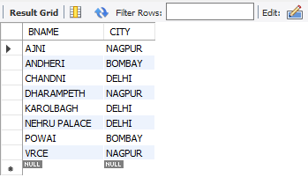

1. **BORROW TABLE**

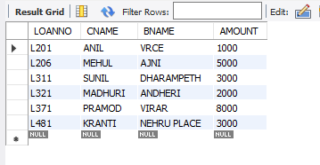

**4.DEPOSIT TABLE**

