**Name: Keerthana P**

**Roll No:12**

**Batch:S2 RMCA-B**

**Date:08/04/2022**

**ADVANCED DBMS LAB**

**EXPERIMENT NO.: 1**

**AIM**

TO FAMILIARIZE DDL COMMANDS- ALTER,DROP,TRUNCATE,RENAME

**QUESTION**

CREATE A TABLE EMP WITH ATTRIBUTES EMPNO NUMBER(4)AS PRIMARY KEY, ENAME CHAR(10),HIREDATE,  SALARY, COMMISSION

INSERT 5 ROWS OF DATA

2. .MODIFYING THE STRUCTURE OF TABLES

a.. ADD NEW COLUMNS: SAL NUMBER(7,2)

b. DROPPING A COLUMN FROM A TABLE: SAL

c. MODIFYING EXISTING COLUMN :ENAME VARCHAR2(15)

d. RENAMING THE TABLES: EMP TO EMP1

e. TRUNCATING THE TABLES :EMP1

f. DESTROYING TABLES :EMP

3.CREATE A TABLE STUD WITH SNAME VARCHAR2(20) PRIMARY KEY , ROLLNO NUMBER(10) NOT NULL,DOB  DATE NOT NULL

4.CREATE A TABLE STUDENT AS REGNO NUMBER (6), MARK NUMBER (3) CHECK CONSTRAINT (MARK >=0 AND  MARK  <=100));

5.CREATE A TABLE CUST WITH(CUSTID NUMBER(6) CONSTRAINT UNIQUE, NAME CHAR(10)

**PROCEDURE**

CREATE TABLE emp(EMPNO INT(4) PRIMARY KEY, ENAME CHAR(10), HIREDATE DATE, SALARY INT(5),COMMISSION INT(5));

INSERT INTO emp(EMPNO,ENAME,HIREDATE,SALARY,COMMISSION)

VALUES(101,'RAMESH','1980-01-17',5000,null);

INSERT INTO emp(EMPNO,ENAME,HIREDATE,SALARY,COMMISSION)

VALUES(102,'AJAY','1985-07-05',5000,500);

INSERT INTO emp(EMPNO,ENAME,HIREDATE,SALARY,COMMISSION)

VALUES(103,'RAVI','1981-08-12',1500,null);

INSERT INTO emp(EMPNO,ENAME,HIREDATE,SALARY,COMMISSION)

VALUES(104,'Nikesh','1983-03-03',3000,700);

INSERT INTO emp(EMPNO,ENAME,HIREDATE,SALARY)

VALUES(105,'Ravi','1985-07-05',3000);

SELECT * FROM EMP;

**OUTPUT**

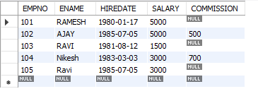

**2.a** ALTER TABLE emp ADD sal int;

SELECT * FROM EMP;

**OUTPUT**

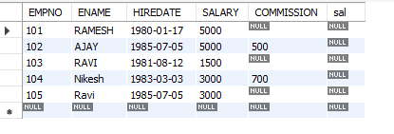

**2.b** ALTER TABLE emp DROP COLUMN sal;

SELECT * FROM EMP;

**OUTPUT**

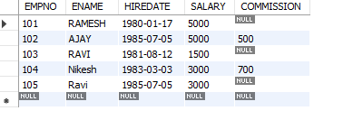

**2.c** ALTER TABLE emp MODIFY ename VARCHAR (15);

SELECT * FROM EMP;

**OUTPUT**



**2.d**  RENAME table emp to emp1;

SELECT * FROM EMP;

**OUTPUT**

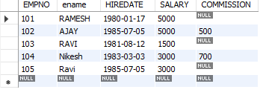

**2e**. TRUNCATE TABLE emp1;

SELECT * FROM EMP;

**OUTPUT**



**2.f** . DROP TABLE emp1;

SELECT * FROM EMP;

**OUTPUT**



**3** . CREATE TABLE stud (sname varchar(20) PRIMARY KEY, rollno int NOT NULL, dob date  NOT

NULL);

SELECT * FROM stud;

**OUTPUT**

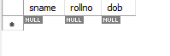

**4.** .Create table student (regno int, mark int(3) constraint b check (mark >=0 and mark <=100));

SELECT * from STUDENT;

**OUTPUT**

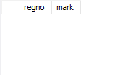

**5.** CREATE TABLE cust(custid number(6) UNIQUE, name char(10));

SELECT * FROM CUST;

**OUTPUT**

