|  |
| --- |
| **Name: Keerthana P**  **Roll No:12**  **Batch:RMCA(B)**  **Date: 06/04/2022** |

**NETWORKING & SYSTEM ADMINISTRATION LAB**

**Experiment No.: 2**

# **Aim**

Identify major components of a computer system such as

Motherboard

Ram modules

Daughter cards

Bus slots

SMPS

Internal storage devices

Interfacing ports

**Procedure**

# Motherboard

A motherboard is the main printed circuit board [(PCB)](https://whatis.techtarget.com/definition/printed-circuit-board-PCB) in a computer. The motherboard is a computer’s central communications backbone connectivity point, through which all components and external peripherals connect.

The large PCB of a motherboard may include 6-14 layers of fiberglass, copper connecting traces and copper planes for power and signal isolation. Additional components can be added to a motherboard through its expansion slots. These may include processor sockets, [DIMM,](https://www.techtarget.com/searchstorage/definition/DIMM) HTX, PCI, [PCIe](https://www.techtarget.com/searchdatacenter/definition/PCI-Express) and M.2 slots as well as power supply connections. Typically motherboards offer additional connectivity through a [Southbridge](https://whatis.techtarget.com/definition/Southbridge) chip such as PCI, SATA, Thunderbolt, USB and more. [CPU](https://whatis.techtarget.com/definition/processor) to [RAM](https://www.techtarget.com/searchstorage/definition/RAM-random-access-memory) and PCIe are generally connected through point-to-point interconnects such as hypertransport (HT), quick path interconnect (QPI) or Ultrapath interconnect (UPI). Often, choosing a motherboard determines many of the features a desktop will have.

The most common motherboard design in desktop computers today is [ATX,](https://whatis.techtarget.com/definition/ATX) an Intel improvement on the AT design by IBM. Other form factors include extended ATX mini-ATX, microATX, BTX, microBTX mini ITX, micro ITX and nano ITX.

The integration of components has eliminated the [Northbridge](https://whatis.techtarget.com/definition/Northbridge) chips that managed memory from motherboards. With the advent of memory controllers built into CPU, integrated video too has moved from motherboard to CPU. On AMD’s new [Ryzen,](https://whatis.techtarget.com/definition/Ryzen-AMD-Ryzen) even the Southbridge is optional due to the [SOC](https://internetofthingsagenda.techtarget.com/definition/system-on-a-chip-SoC) (system on a chip) nature of the CPU. This integration into the CPU reduces the cost for motherboard manufacturers who wish to offer base systems for workstations and entry level computers while also enabling highly customized implementations that support a range of processors to allow for platform upgradabillity.

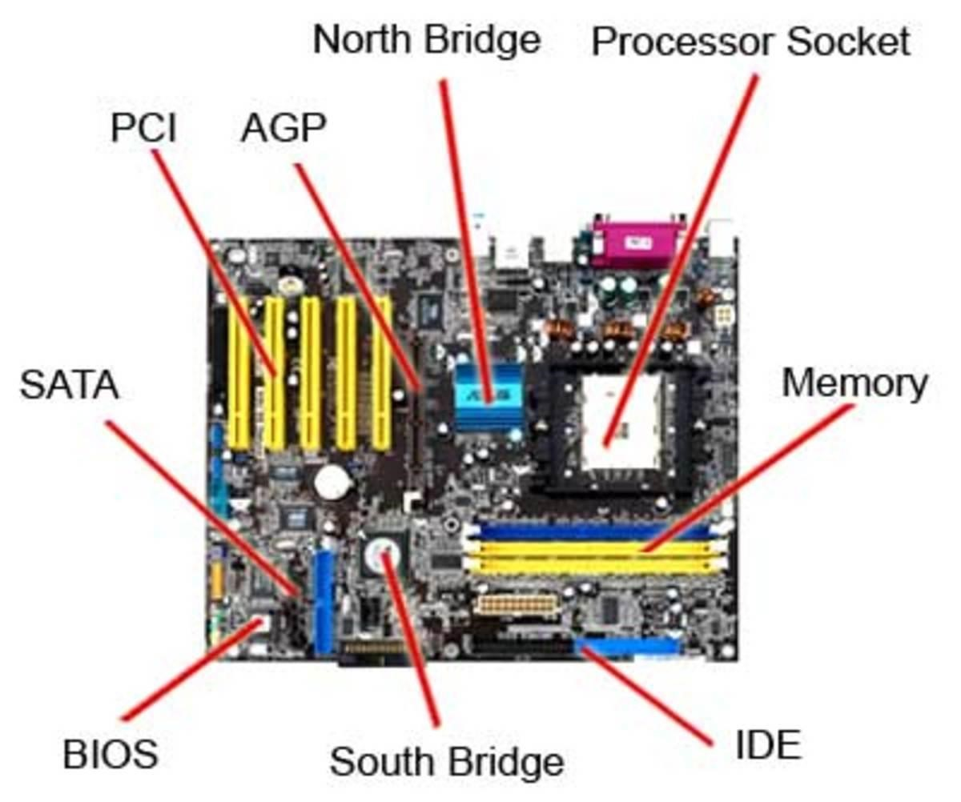

## Ram modules

RAM, which stands for random-access memory, which temporarily stores data while the central processing unit (CPU) is executing other tasks. With more RAM on the computer, the less the CPU has to read data from the external or secondary memory (storage device), allowing the computer to run faster. RAM is fast but it is volatile, which means it will not retain data if there is no power. It is therefore important to save data to the storage device before the system is turned off. There are two main types of RAM: Dynamic RAM (DRAM) and Static RAM (SRAM).

DRAM (pronounced DEE-RAM), is widely used as a computer’s main memory. Each DRAM memory cell is made up of a transistor and a capacitor within an integrated circuit, and a data bit is stored in the capacitor. Since transistors always leak a small amount, the capacitors will slowly discharge, causing information stored in it to drain; hence, DRAM has to be refreshed (given a new electronic charge) every few milliseconds to retain data.

SRAM (pronounced ES-RAM) is made up of four to six transistors. It keeps data in the memory as long as power is supplied to the system unlike DRAM, which has to be refreshed periodically. As such, SRAM is faster but also more expensive, making DRAM the more prevalent memory in computer systems.

Synchronous DRAM (SDRAM) “synchronizes” the memory speed with CPU clock speed so that the memory controller knows the exact clock cycle when the requested data will be ready. This allows the CPU to perform more instructions at a given time. Typical SDRAM transfers data at speeds up to 133 MHz.

Rambus DRAM (RDRAM) takes its name after the company that made it, Rambus. It was popular in the early 2000s and was mainly used for video game devices and graphics cards, with transfer speeds up to 1 GHz.

Double Data Rate SDRAM (DDR SDRAM) is a type of synchronous memory that nearly doubles the bandwidth of a single data rate (SDR) SDRAM running at the same clock frequency by employing a method called "double pumping," which allows transfer of data on both the rising and falling edges of the clock signal without any increase in clock frequency.

DDR1 SDRAM has been succeeded by DDR2, DDR3, and most recently, DDR4 SDRAM. Although operating on the same principles, the modules are not backward-compatible. Each generation delivers higher transfer rates and faster performance. The latest DDR4 modules, for example, feature fast transfer rates at 2133/2400/2666and even 3200 MT/s.

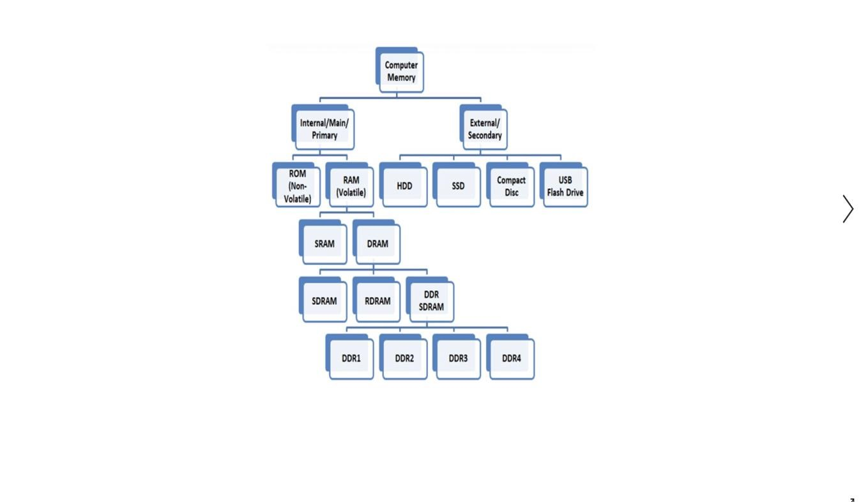

## Daughter cards

A daughterboard is type of circuit board that plugs in or is attached to the motherboard or similar expansion card to extend its features and services. A daughterboard complements the existing functionality of a motherboard or an expansion card.

A mezzanine card is a kind of daughterboard that is installed in the same plane as but on a second level above the motherboard.

Daughtercards are different from some other types of additional circuit boards that tech enthusiasts call “expansion cards.” In expansion cards, the circuit board is often plugged in through a gap in the housing of a computer or device. These expansion boards help to give a device more functionality, often for additional sound play or for better visuals on a high-tech monitor or screen.

In contrast to the way expansion boards are used, a daughtercard can be a more fundamental enhancement for a device. Adding a daughtercard often requires getting into the guts of a device. That’s why some users might hire a professional to install it. Companies that make an electronic device might offer a daughtercard as part of an essential upgrade that allows the product to be used in more various ways.

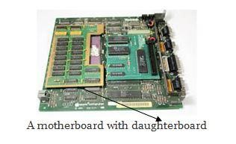

## Bus slots

Bus slot is also known as a expansion port, an expansion slot is a connection or port inside a computer on the motherboard or riser card. It provides an installation point for a hardware expansion card to be connected.

Expansion slots help users to add new devices to their computer.Most common expansion slot is PCI Express expansion slot.

Computers have expansion slots to give the user the ability to add new devices to their computer. For example, a computer gamer may upgrade their [video card](https://www.computerhope.com/jargon/v/video-card.htm) to get better performance in their games. An expansion slot allows them to remove the old video card and add a new video card without replacing the motherboard.

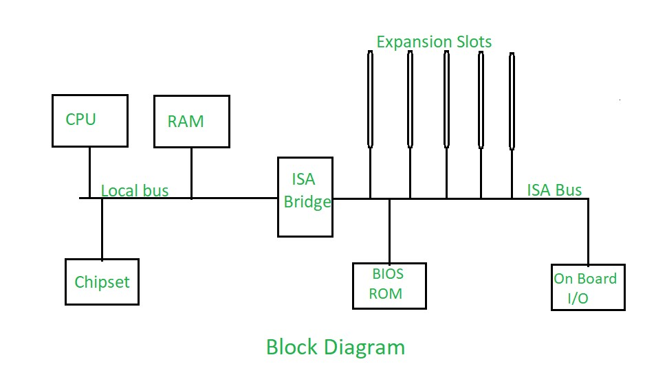

## SMPS

SMPS stands for Switched-Mode Power Supply. It is an electronic power supply that uses a switching regulator to convert electrical power efficiently. It is also known as Switching Mode Power Supply. It is power supply unit (PSU) generally used in computers to convert the voltage into the computer acceptable range.

This device has the power handling electronic components that converts electrical power efficiently. Switched Mode Power Supply uses a great power conversion technique to reduce overall power loss.

The SMPS device uses switching regulators that switches the load current on and off to regulate and stabilize the output voltage. The average of the voltage between the off and on produces the appropriate power for a device. Unlike the linear power supply, the pass transistor of SMPS switches between low dissipation, full-on and full-off mode, and spends very less time in the high-dissipation transitions, which minimizes wasted energy.

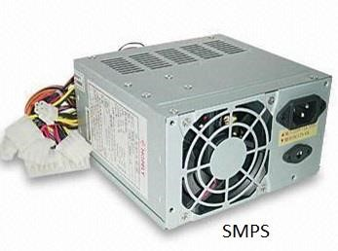

## Internal storage devices

### Magnetic storage devices

**Magnetic storage** is also known as “**Magnetic Media**” or “**Magnetic Memory**” or “**Magnetic Medium**“.

In the **Magnetic storage devices**, all data are stored with using magnetized medium, and those types of data saved in that medium in the binary form like as 0 and 1. This magnetic storage has also non-volatile storage nature. Today’s, mostly people are preferred to **magnetic medium** because on the **magnetic storage devices** can be performed read/write activities very easily.

Floppy diskette

Hard drive

Magnetic strip

Compact Disc or CD

### Optical storage devices

**optical storage**, electronic storage medium that uses low-power [laser](https://www.britannica.com/technology/laser) [beams](https://www.britannica.com/dictionary/beams) to record and retrieve digital (binary) data. In optical-storage [technology,](https://www.britannica.com/technology/technology) a laser beam encodes digital data onto an optical, or laser, disk in the form of tiny pits arranged in a spiral track on the disk’s surface. A low-power laser scanner is used to “read” these pits, with variations in the intensity of reflected [light](https://www.britannica.com/science/light) from the pits being converted into electric signals. This technology is used in the [compact disc,](https://www.britannica.com/technology/compact-disc) which records sound; in the [CD-ROM](https://www.britannica.com/technology/CD-ROM) (compact disc read-only memory), which can store text and images as well as sound; in WORM (write-once read-many), a type of disk that can be written on once and read any number of times; and in newer disks that are totally rewritable.

Optical storage uses lasers and lights as its method of reading and writing data. Blu-ray disc

CD-ROM disc

CD-R and CD-RW disc.

DVD-R, DVD+R, DVD-RW, and DVD+RW disc. **Solid-state storage devices**

Solid-state storage (flash memory) has replaced most magnetic and optical media as it becomes cheaper because it's the more efficient and reliable solution.

USB flash drive

Memory card

MMC

SDHC Card

SD card

SSD

## Interfacing ports

A port is a physical opening point using which an external device can be connected to the computer. It can also be programmatic docking point through which information flows from a program to the computer or over the Internet.

Characteristics of Ports

A port has the following characteristics −

* External devices are connected to a computer using cables and ports.
* Ports are slots on the motherboard into which a cable of external device is plugged in.
* Examples of external devices attached via ports are the mouse, keyboard, monitor, microphone, speakers, etc.

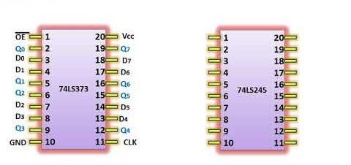

# Serial Port

In [computing,](https://en.wikipedia.org/wiki/Computing) a **serial port** is a [serial communication](https://en.wikipedia.org/wiki/Serial_communication) [interface](https://en.wikipedia.org/wiki/Interface_(computing)) through which information transfers in or out sequentially one [bit](https://en.wikipedia.org/wiki/Bit) at a time. This is in contrast to a [parallel port,](https://en.wikipedia.org/wiki/Parallel_port) which communicates multiple bits simultaneously in [parallel.](https://en.wikipedia.org/wiki/Parallel_communication) Throughout most of the history of [personal computers,](https://en.wikipedia.org/wiki/Personal_computer) data has been transferred through serial ports to devices such as [modems,](https://en.wikipedia.org/wiki/Modem) [terminals,](https://en.wikipedia.org/wiki/Computer_terminal) various [peripherals,](https://en.wikipedia.org/wiki/Peripheral) and directly between computers.

While interfaces such as [Ethernet,](https://en.wikipedia.org/wiki/Ethernet) [FireWire,](https://en.wikipedia.org/wiki/FireWire) and [USB](https://en.wikipedia.org/wiki/Universal_Serial_Bus) also send data as a serial [stream,](https://en.wikipedia.org/wiki/Stream_(computing)) the term *serial port* usually denotes [hardware](https://en.wikipedia.org/wiki/Computer_hardware) compliant with [RS-232](https://en.wikipedia.org/wiki/RS-232) or a related standard, such as [RS-485](https://en.wikipedia.org/wiki/RS-485) or [RS-422.](https://en.wikipedia.org/wiki/RS-422)

Modern consumer [personal computers](https://en.wikipedia.org/wiki/Personal_computer) (PCs) have largely replaced serial ports with higher-speed

standards, primarily USB. However, serial ports are still frequently used in applications demanding simple, low-speed interfaces, such as industrial automation systems, scientific instruments, [point of sale](https://en.wikipedia.org/wiki/Point_of_sale) systems and some industrial and consumer products.

[Server](https://en.wikipedia.org/wiki/Server_(computing)) computers may use a serial port as a control console for diagnostics, while [networking hardware](https://en.wikipedia.org/wiki/Networking_hardware) (such as [routers](https://en.wikipedia.org/wiki/Router_(computing)) and [switches)](https://en.wikipedia.org/wiki/Network_switch) commonly use serial console ports for configuration, diagnostics, and emergency maintenance access. To interface with these and other devices, [USBto-serial converters](https://en.wikipedia.org/wiki/USB-to-serial_converter) can quickly and easily add a serial port to a modern PC.

* Used for external modems and older computer mouse
* Two versions: 9 pin, 25 pin model
* Data travels at 115 kilobits per second
* 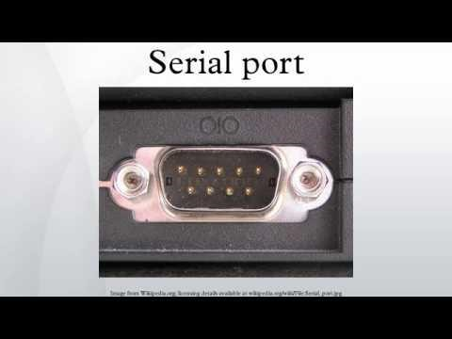

# Parallel Port

A parallel port is an interface allowing a personal computer (PC) to transmit or receive data down multiple bundled cables to a peripheral device such as a printer. The most common parallel port is a printer port known as the Centronics port. A parallel port has multiple connectors and in theory allows data to be sent simultaneously down several cables at once. Later versions allow bi-directional communications. This technology is still used today for low-data-rate communications such as dot-matrix printing.

The standard for the bi-directional version of a parallel port is the Institute of Electrical and Electronics Engineers (IEEE) 1284. This standard defined bi-directional parallel communication between computers and other peripheral devices allowing data bits to be transmitted and received simultaneously.

* Used for scanners and printers
* Also called printer port
* 25 pin model
* IEEE 1284-compliant Centronics port
* 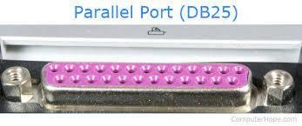

# PS/2 Port

* Used for old computer keyboard and mouse
* Also called mouse port
* Most of the old computers provide two PS/2 port, each for the mouse and keyboard
* IEEE 1284-compliant Centronics port
* 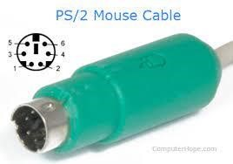

# Universal Serial Bus (or USB) Port

* It can connect all kinds of external USB devices such as external hard disk, printer, scanner, mouse, keyboard, etc.
* It was introduced in 1997.
* Most of the computers provide two USB ports as minimum.
* Data travels at 12 megabits per seconds.
* USB compliant devices can get power from a USB port.
* 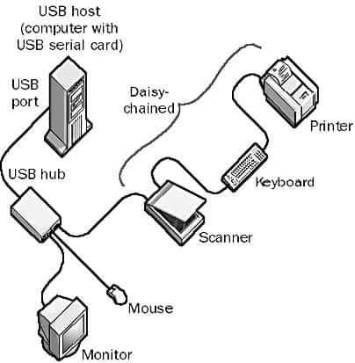

# VGA Port

The [**Video Graphics Array**](https://en.wikipedia.org/wiki/Video_Graphics_Array) (**VGA**) **connector** is a standard connector used for computer video output. Originating with the 1987 [IBM PS/2](https://en.wikipedia.org/wiki/IBM_PS/2) and its VGA graphics system, the 15-pin connector went on to become ubiquitous on PCs, as well as many monitors, projectors and [high-definition television](https://en.wikipedia.org/wiki/High-definition_television) sets.

Other connectors have been used to carry VGA-compatible signals, such as [mini-VGA](https://en.wikipedia.org/wiki/Mini-VGA) or BNC, but "*VGA connector*" typically refers to this design.

Devices continue to be manufactured with VGA connectors, although newer digital interfaces such as [DVI,](https://en.wikipedia.org/wiki/Digital_Visual_Interface) [HDMI](https://en.wikipedia.org/wiki/HDMI) and [DisplayPort](https://en.wikipedia.org/wiki/DisplayPort) are increasingly displacing VGA, and many modern computers and other devices do not include it.

* Connects monitor to a computer's video card.
* It has 15 holes.
* Similar to the serial port connector. However, serial port connector has pins, VGA port has holes.

# Power Connector

* Three-pronged plug.
* Connects to the computer's power cable that plugs into a power bar or wall socket.

# Firewire Port

* Transfers large amount of data at very fast speed.
* Connects camcorders and video equipment to the computer.
* Data travels at 400 to 800 megabits per seconds.
* Invented by Apple.
* It has three variants: 4-Pin FireWire 400 connector, 6-Pin FireWire 400 connector, and 9Pin FireWire 800 connector.

# Modem Port

* Connects a PC's modem to the telephone network.
* Generally, a modem has one LAN port (to connect to a router's WAN port, or to an Ethernet-ready device) and one service-related port, such as a telephone port (DSL modems) or a coaxial port (cable modems), that connects to the service line.
* 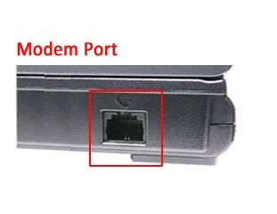

# Ethernet Port

* Connects to a network and high speed Internet.
* Connects the network cable to a computer.
* This port resides on an Ethernet Card.
* Data travels at 10 megabits to 1000 megabits per seconds depending upon the network bandwidth.
* 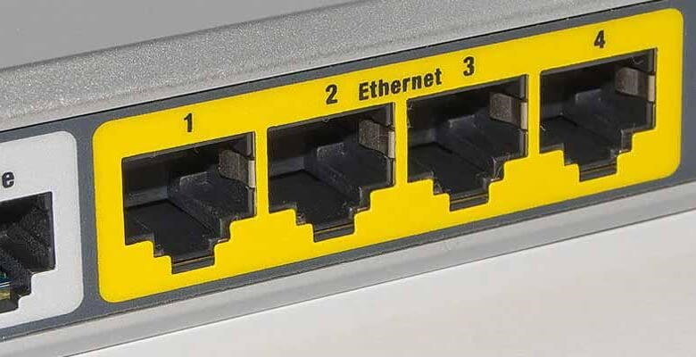

# Game Port

The **game port**, originally introduced on the Game Control Adapter, is a [device port](https://en.wikipedia.org/wiki/Computer_port_(hardware)) that was found on [IBM PC compatible](https://en.wikipedia.org/wiki/IBM_PC_compatible) and other computer systems throughout the 1980s and 1990s. It was the traditional connector for [joystick](https://en.wikipedia.org/wiki/Joystick) input, and occasionally [MIDI](https://en.wikipedia.org/wiki/MIDI) devices, until obsoleted by [USB](https://en.wikipedia.org/wiki/USB) in the late 1990s.

Originally located on a dedicated [expansion card,](https://en.wikipedia.org/wiki/Expansion_card) the game port was later integrated with PC [sound cards,](https://en.wikipedia.org/wiki/Sound_card) and still later on the PC's motherboard. During the transition to USB, many input devices used the game port and a USB adapter dongle was included for systems without a game port.

* Connect a joystick to a PC
* Now replaced by USB

# Digital Video Interface, DVI port

Short for **Digital Visual Interface**, **DVI** is a video display [interface.](https://www.computerhope.com/jargon/i/interfac.htm) It was developed to be an industry standard for transmitting digital video content to display devices at resolutions as high as

2560 x 1600. Common devices that utilize the DVI connection are [computer monitors](https://www.computerhope.com/jargon/m/monitor.htm) and [projectors.](https://www.computerhope.com/jargon/p/projecto.htm) DVI can even be used with some [TVs,](https://www.computerhope.com/jargon/t/tv.htm) although [HDMI](https://www.computerhope.com/jargon/h/hdmi.htm) is more common as only some DVI cables can transmit [audio](https://www.computerhope.com/jargon/a/audio.htm) signals. The DVI connector (shown below) may have one of three names depending on the signals it supports: **DVI-A** (analog only), **DVI-D** (digital only), or **DVI-I** (both digital and analog).

* Connects Flat panel LCD monitor to the computer's high-end video graphic cards.
* Very popular among video card manufacturers.

# Sockets

* Sockets connect the microphone and speakers to the sound card of the computer.
* Normally, a server runs on a specific computer and has a socket that is bound to a specific port number. The server just waits, listening to the socket for a client to make a connection request.
* On the client-side: The client knows the hostname of the machine on which the server is running and the port number on which the server is listening. To make a connection request, the client tries to rendezvous with the server on the server's machine and port. The client also needs to identify itself to the server so it binds to a local port number that it will use during this connection. This is usually assigned by the system.
* 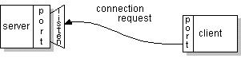
* If everything goes well, the server accepts the connection. Upon acceptance, the server gets a new socket bound to the same local port and also has its remote endpoint set to the address and port of the client. It needs a new socket so that it can continue to listen to the original socket for connection requests while tending to the needs of the connected client.
* 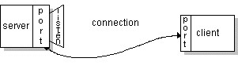
* On the client side, if the connection is accepted, a socket is successfully created and the client can use the socket to communicate with the server.
* The client and server can now communicate by writing to or reading from their sockets.