**Name: Keerthana P**

**Roll No:12**

**Batch:RMCA-B**

**Date:23/05/2022**

**NETWORKING & SYSTEM ADMINISTRATION LAB**

**Experiment No.: 20**

**Aim**

Installing Docker

**Procedure**

**Step1:**Open the terminal on Ubuntu.

**Step2**:Remove any Docter files that are running in the system, using the following

Command.

sudo apt-get remove docker docker-engine docker.io

After entering the above command, you will need to enter the password of the root

and press enter.



**Step3**: Check if the system is up-to-date using the following command:

$ sudo apt-get update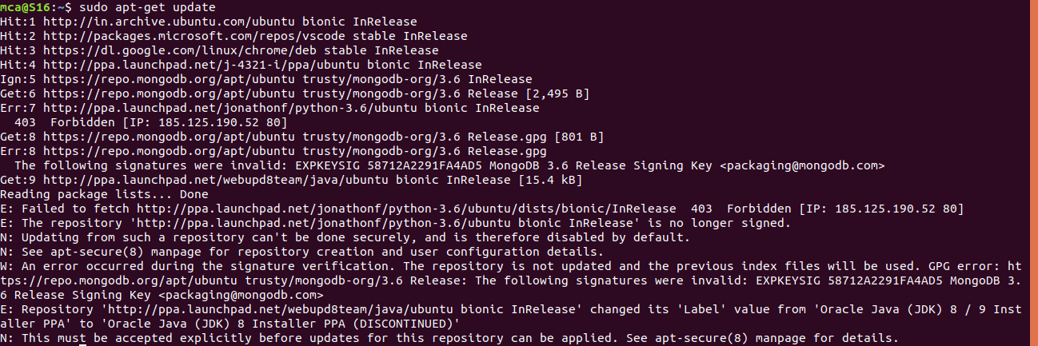

Step4: Install Docker using the following command:

$ sudo apt install docker.io

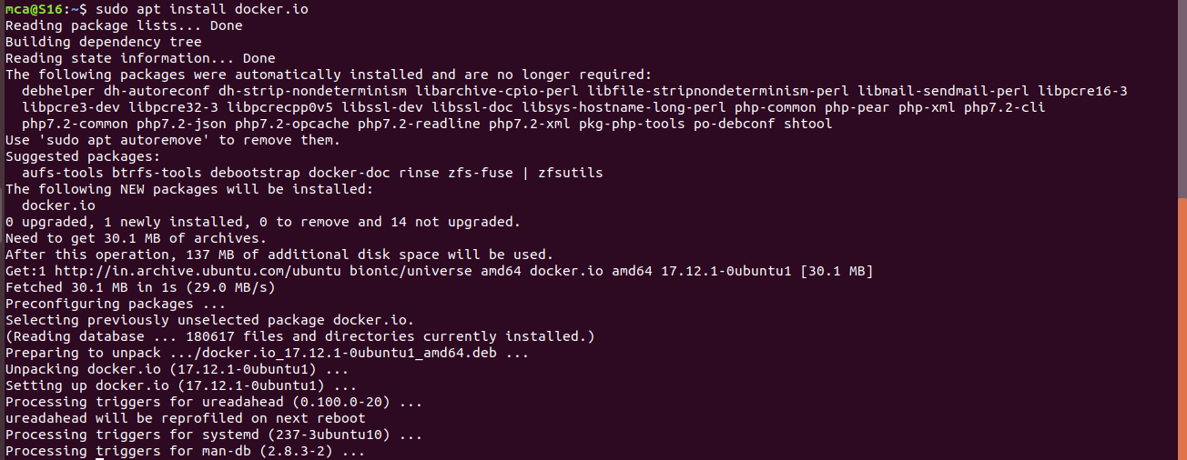

Step5: Install all the dependency packages using the following command:

$ sudo snap install docker



Step6: Before testing Docker, check the version installed using the following command:

$ docker –version.



Step7: Pull an image from the Docker hub using the following command:

$ sudo docker run hello-world

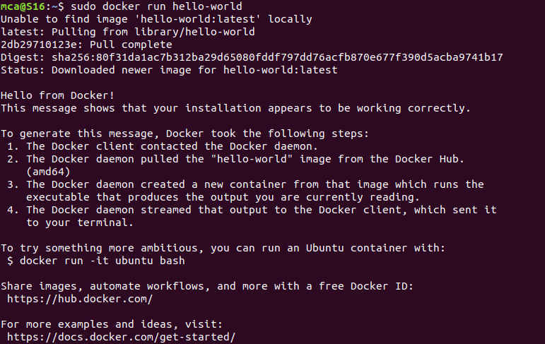

Step8: Check if the docker image has been pulled and is present in your system using the

following command

$ sudo docker images



Step9: To display all the containers pulled, use the following command:

$ sudo docker ps –a



Step10: To check for containers in a running state, use the following command.

$ sudo docker ps



**Output Screenshot**