**Name: Keerthana P**

**Roll No:12**

**Batch:RMCA(B)**

**Date:28/03/2022**

**NETWORKING & SYSTEM ADMINISTRATION LAB**

**Experiment No.: 4**

**Aim**

Familiarization of Linux commands

**Procedure**

1. **$cat -n filename.txt:** This command is used to number each lines in a file.

**Output:**

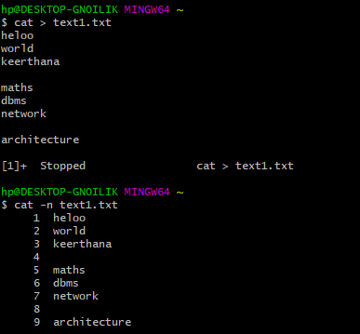

1. **$cat -b filename.txt:** This command is used to remove empty lines**.**

**Output:**

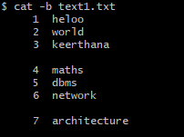

1. **$touch filename.txt:** This command is used to create empty files

**Output:**



1. **$echo //contents// >>b3.txt:** it is used to add contents to an empty file

**Output:**

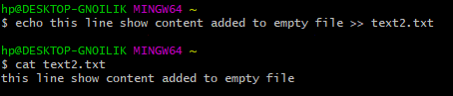.

# 

# **$head filename.txt:** It is used to display 10 lines from the top.

**Output:**

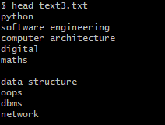

# 

1. **$head -number filename.txt:** It is used to display specific number of lines from top

**Output:**

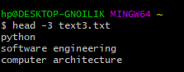

1. **$tail filename.txt:** This command is used to display 10 lines from bottom

**Output:**

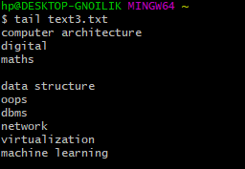

1. **$tail -number filename.txt:** This command is used to display specific number of lines from bottom.

**Output:**

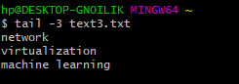

1. **$cut -d- -f1(/f2) filename.txt:** This command is used to display a particular column

**Output:**

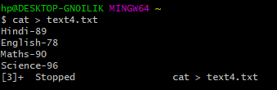

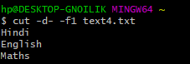

1. **$rmdir filename.txt:** This command is used to remove a directory

**Output:**

