**Name: Keerthana P**

**Roll No:12**

**Batch:RMCA(B)**

**Date: 31/03/2022**

**NETWORKING & SYSTEM ADMINISTRATION LAB**

**Experiment No.: 5**

**Aim**

Familiarization of Linux commands.

**Procedure**

1. **$cut -d ‘ ‘ –(f1/f2) filename.txt :** This command is used to display a particular column on behalf of space delimiter.

**Output:**

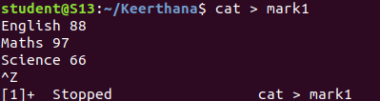

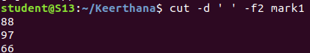

1. **$cut -b (number) filename.txt :** This command is used to display the particular

Column.

**Output:**

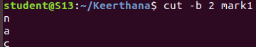

# **$cut –complement -c (number) filename.txt:** This command is used to display

all columns except the column specified in the column.

**Output:**

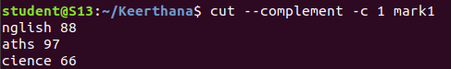

1. **$paste filename1.txt filename2.txt:** it is used to append contents of two files in

column order.

**Output:**

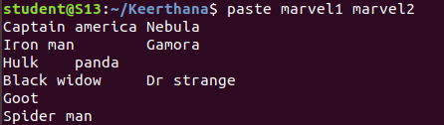

# **$paste filename1.txt filename2.txt > filename3.txt:** It is used to append content

of two files in column order and paste into another file.

**Output:**

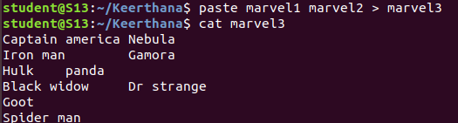

1. **$paste -d ‘-’ filename1.txt filename2.txt:** It is used to append contents of two

files in column order seperated by hyphen delimiter.

**Output:**

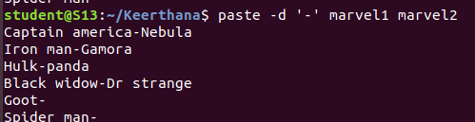

1. **$paste -d ‘--’ filename1.txt filename2.txt fielname3.txt:** This command is used seperate contents of 3 file with hyphen delimiterin column order

**Output:**

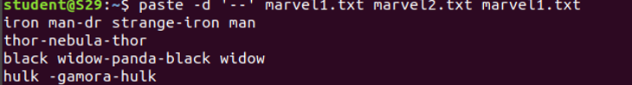

1. **$ paste -s filename1.txt filename2.txt:** This command is used append contents in

Two files in row order.

**Output:**

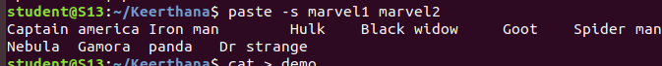

1. **$ more filename1.txt:** This command is used to view the text files in the

command prompt, displaying one screen at a time in case the file is large.

**Output:**

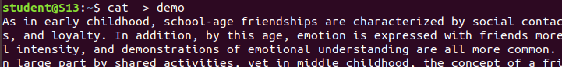



1. **$more -s filename.txt:** This command is used to squeeze multiple blank lines into

one single blank line.

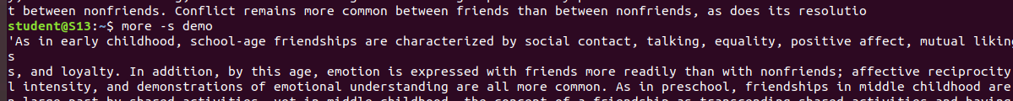 **Output:**

1. **$more +number filename.txt:**This command helps to specify from where you want to start displaying the text content.

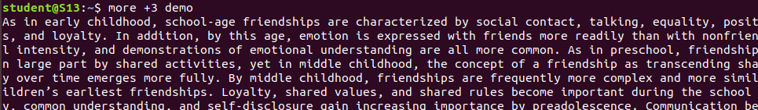**Output:**