**Name: Keerthana P**

**Roll No:12**

**Batch:RMCA(B)**

**Date:04/04/2022**

**NETWORKING & SYSTEM ADMINISTRATION LAB**

**Experiment No: 6**

**Aim**

Familiarization of Linux commands.

**Procedure**

1. **$ cp:** This command is used to copy contents of one file to another.

**Output:**

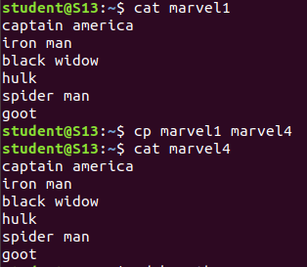

1. **$ cp -r**:This command is used to copy entier directory.

**Output:**



1. **$ cp -**i:This command is used to ask permission to overwrite.

**Output:**

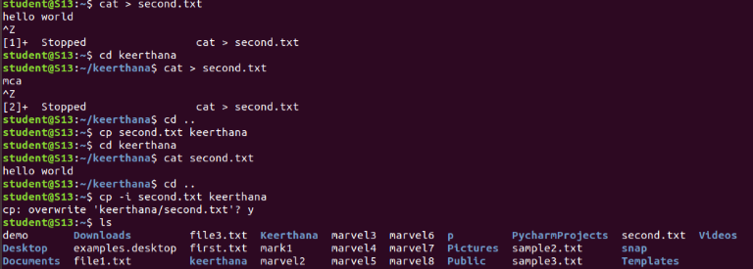

1. $**mv:**This command is used to move a file to another directory.

**Output:**

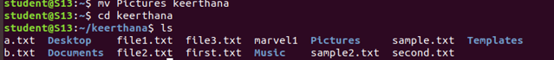

1. **$ mv -i :**This command is used to ask permission to move one directory to another

directory .